Logos – Answer Sheet
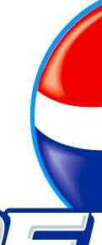
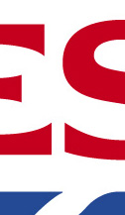
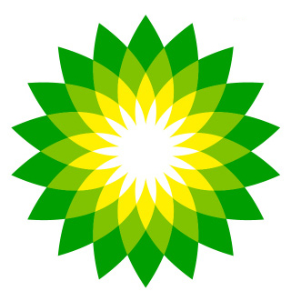

Name: TESCO SUPERMARKET Name: BP PETROL Name: PEPSI COLA

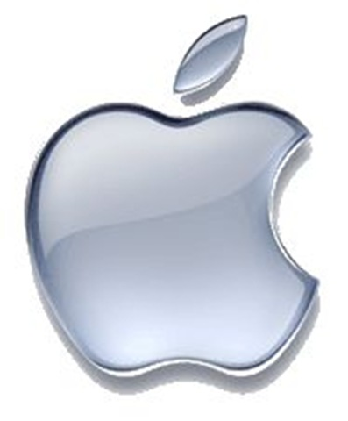

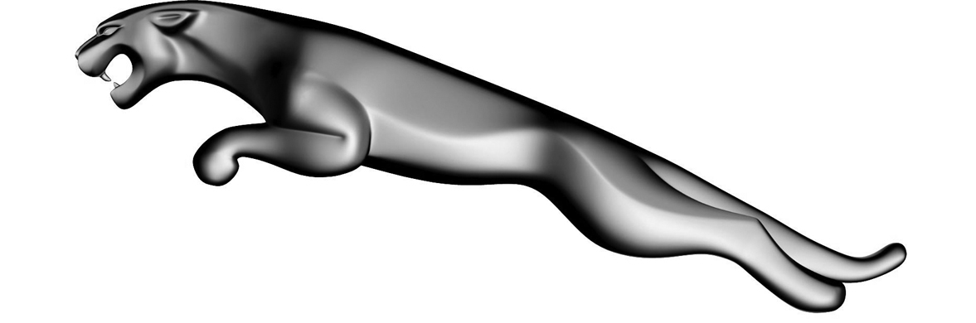

Name: APPLE PRODUCTS Name: JAGUAR CARS Name: ADIDAS TRAINERS

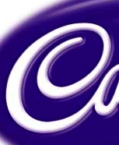
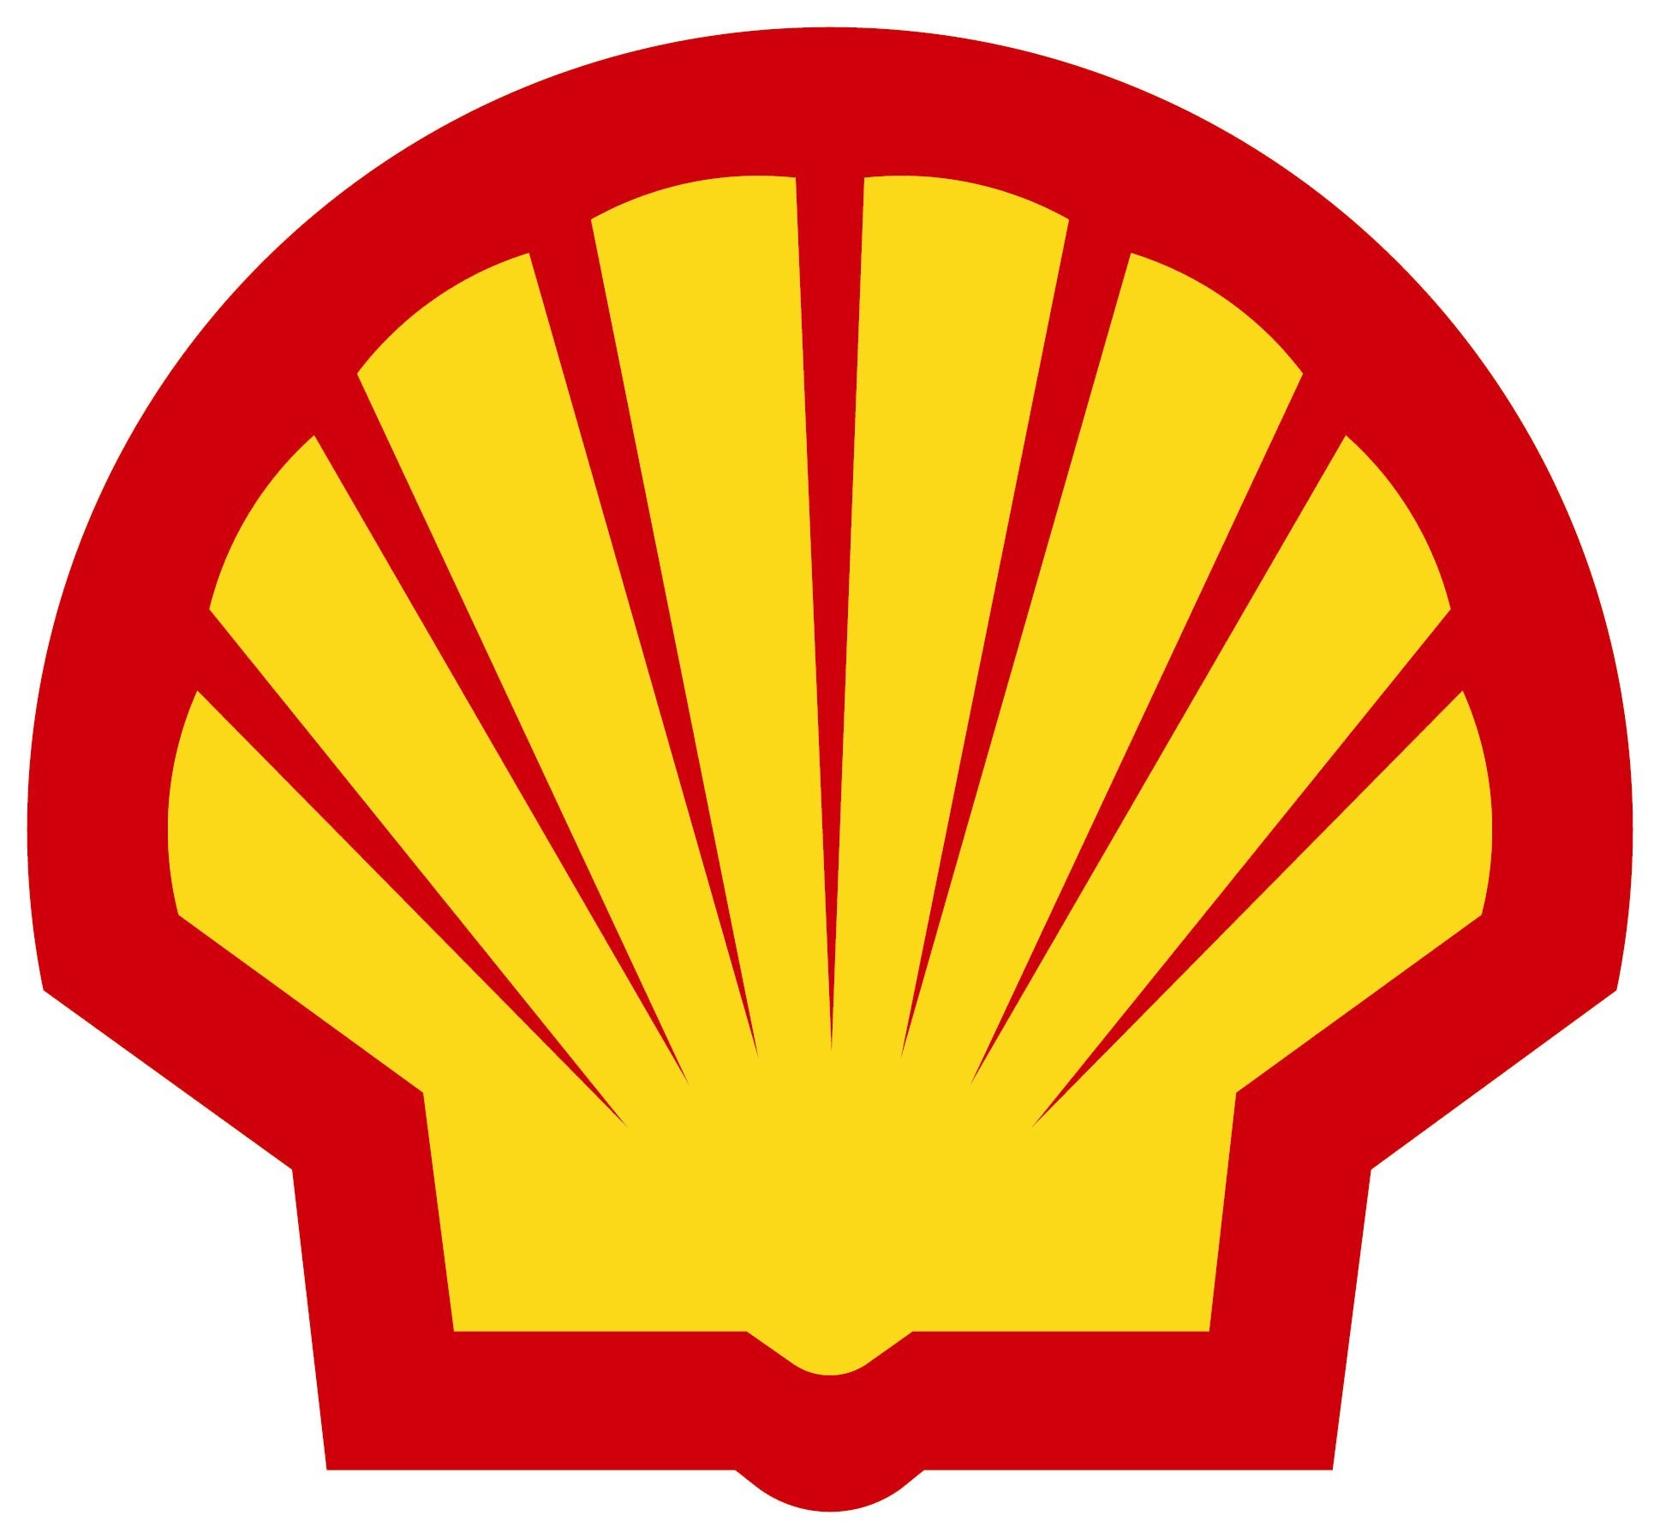

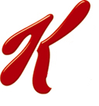

Name: CADBURY CHOCOLATE Name: KELLOGG’S BREAKFAST Name: SHELL PETROL

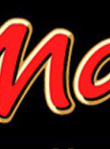
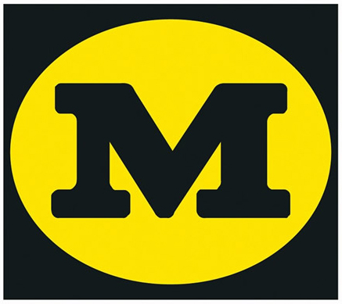
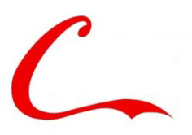

Name: COKE COLA Name: MORRISONS SUPERMARKET Name: MARS BAR CHOCOLATE

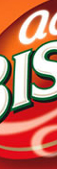

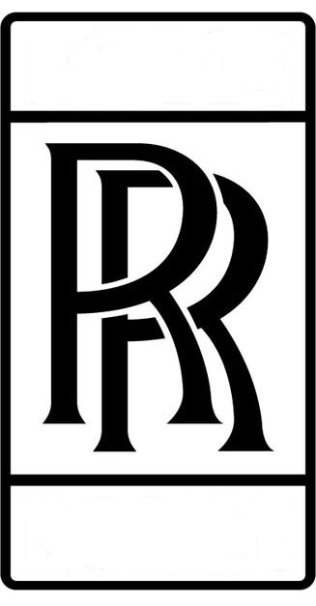

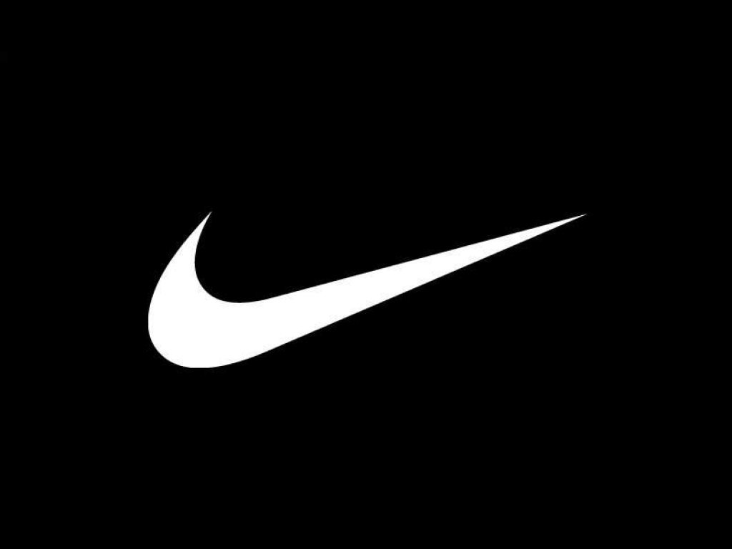

Name: NIKE TRAINERS Name: ROLLS ROYCE ENGINES Name: BISTO GRAVY

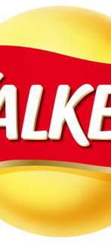
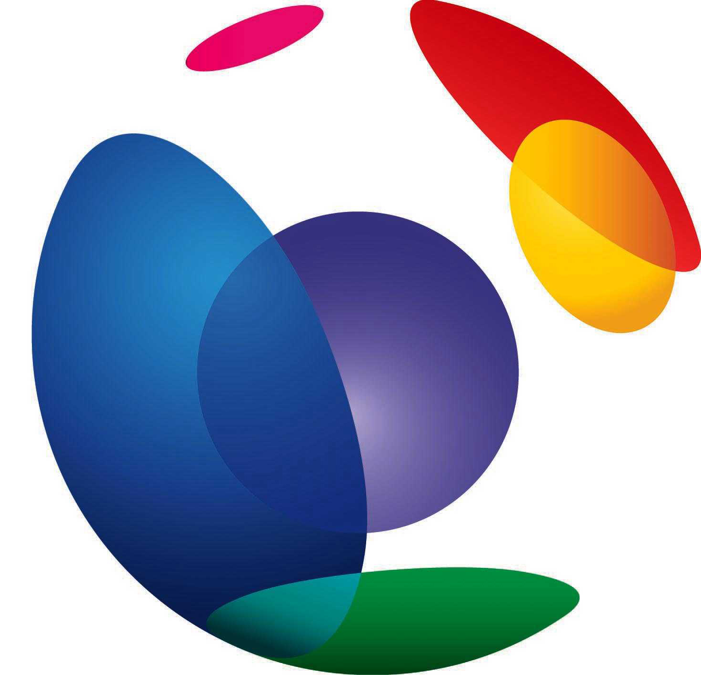
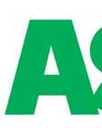

Name: BT TELECOM Name: WALKERS CRISPS Name: ASDA SUPERMARKET

