Logos

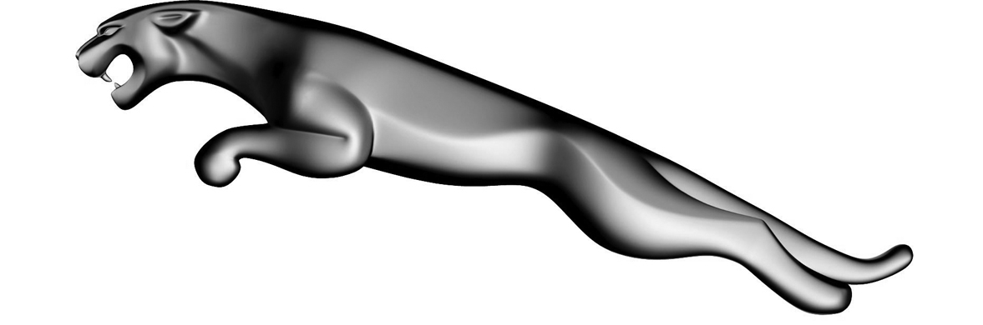

Name ______________ Name ______________ Name _______________ Name ______________ Name ______________ Name _______________



Name ______________ Name ______________ Name _______________ Name ______________ Name ______________ Name _______________



Name ______________ Name ______________ Name _______________ Name ______________ Name ______________ Name _______________