Deadline Assignment 7 - V&A Promotion

The V&A has approached you to produce a series of teaser posters to promote the museum. They have a series of 4 templates they require you to use.
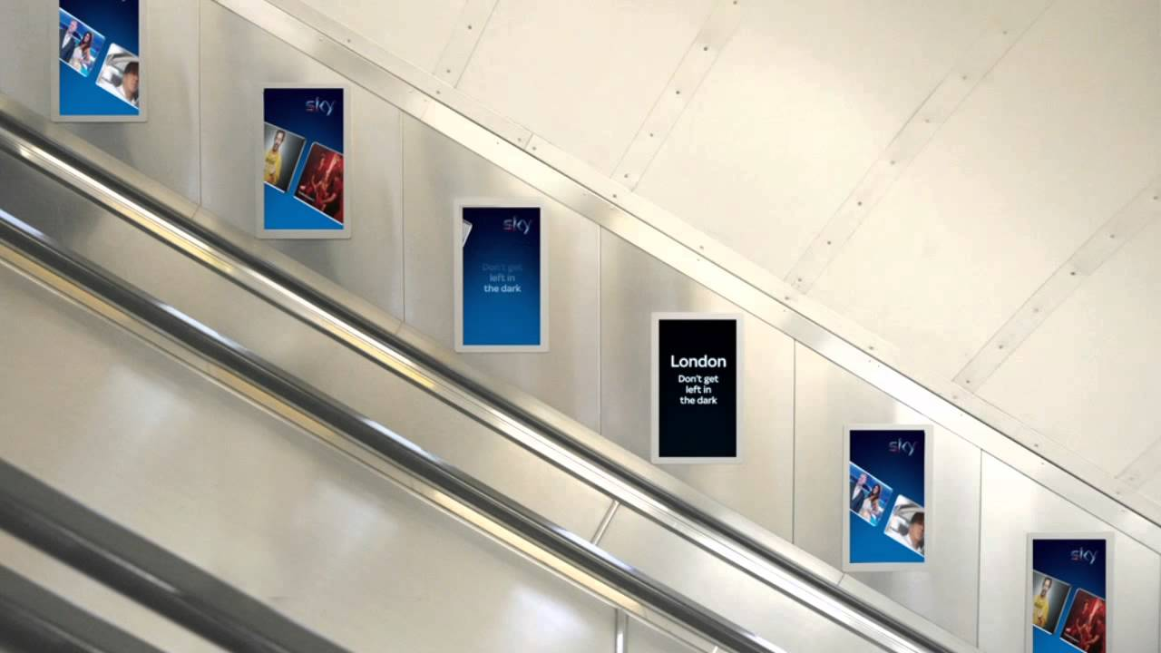
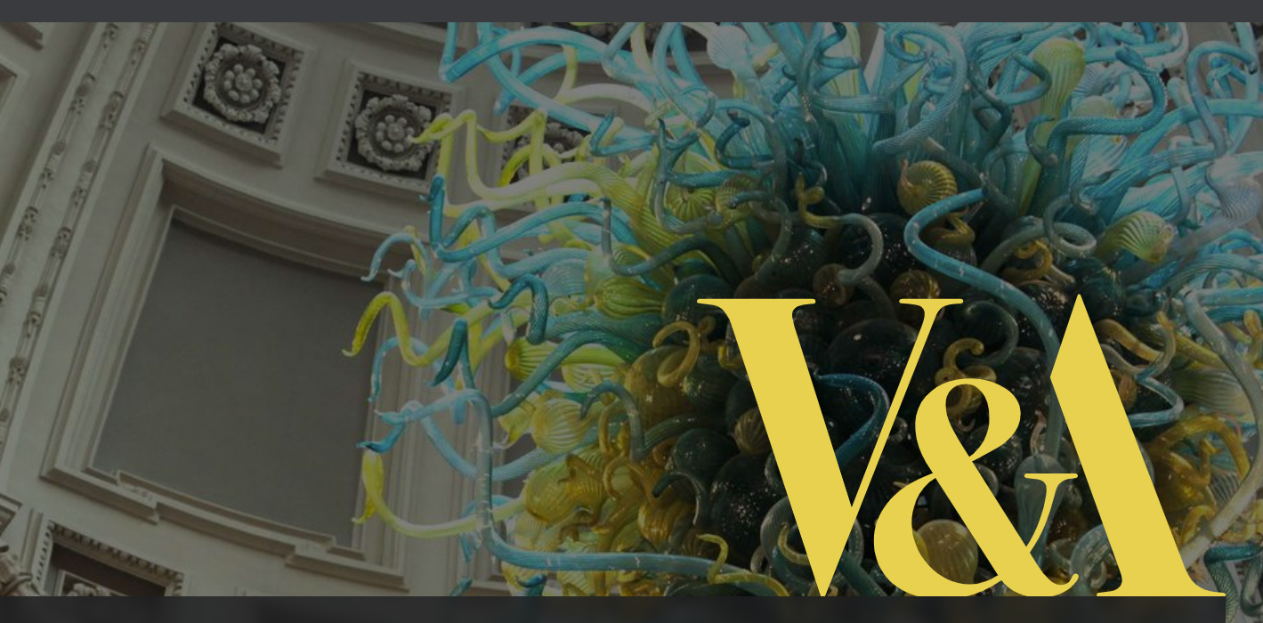

The teaser posters are to be used mainly on the underground.

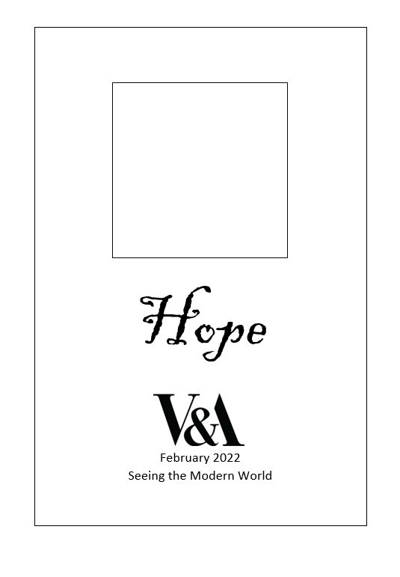
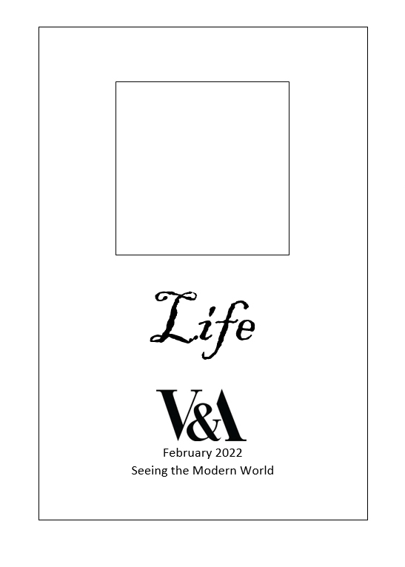
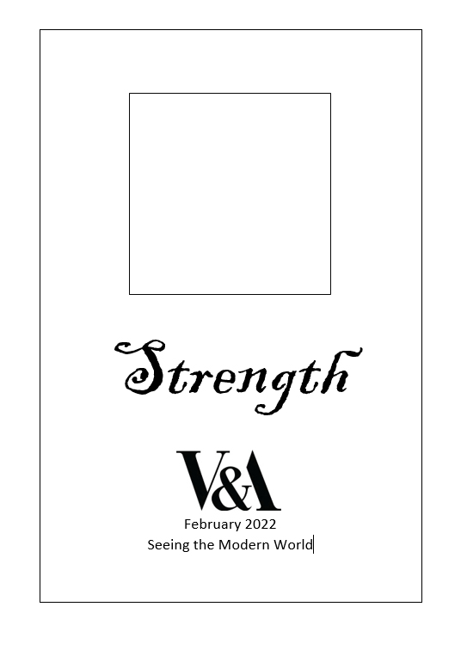
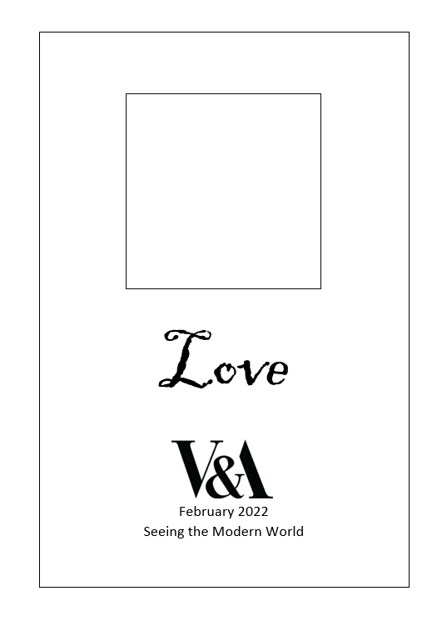

You are required to produce an image to fit into each of the four central boxes. It must be a photograph. The photo can be B/W or colour, but post-production, such as cropping and enhancements, must be kept to a minimum.
The photo can be anything, but must reflect the theme titles shown on each poster template
Outcomes
- 4 A4 Teaser Posters, using the templates provided
- Supporting Designs & Notes, including the original photos before any alterations
Assessment
Quality of finished poster/outcome | 4 marks for each poster | Total – 16
Quality of idea for each poster | 6 marks for each poster | Total – 24
Quality of support information | 10 marks | Total – 10
 | Total | 40 marks

Deadline

