Town Centres – The New Railway Station

THE SITUATION
The developments for Harchester are well underway and Network Rail has announced the redevelopment of Harchester West, which is currently a small station outside Harchester, just west of the bypass. It is intended to expand its use as two main lines run through it and there is space to develop both the station facilities, its layout and to have a decent size car park, which Harchester central does really have. The land currently used as a car park at Harchester Central is up for development and no alternative space has been found to replace it. For Harchester West Station you will need to consider how to get from the building to the platforms, either by underpass or bridge, as well as what facilities should be at the main building. The car park will also be enlarged and become part of the Park and Ride scheme.
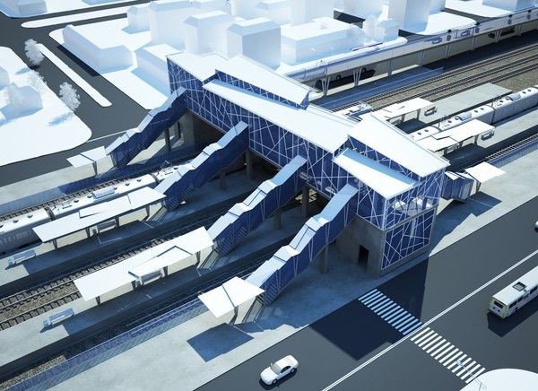
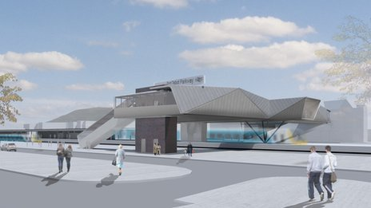

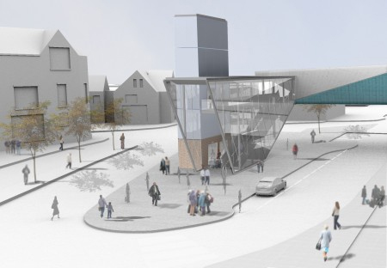
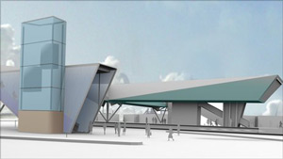

AIM
To design a new station to replace Harchester West, it needs to be modern and have all the facilities needed for a commuter town railway station. It needs six platforms (Three islands – See support sheets for layout) and access to these needs to be considered carefully, you do not need to worry about the car park element of the project as this is being dealt with by the Council.
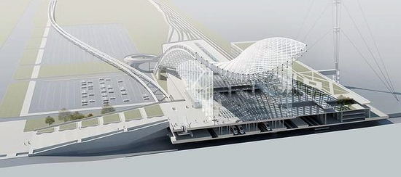
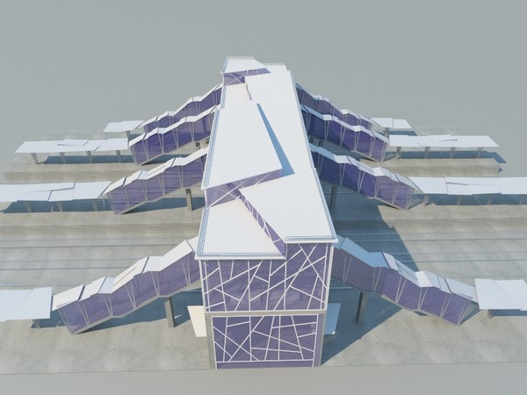

For the design task complete the sections list below, on the pages shown.

- Design Specification (4 marks)
- Research (10 Marks )
- Initial Ideas (12 marks)
- Development (12 marks)
- Final design (8 marks)
- Product Testing (4 marks)

