Town Centres – Market Square – Pedestrian Area

THE SITUATION
As work has started in the other areas of the town regeneration and improvement programme, so has the renewal of the Market Square. It has been decided to pave the area around the Market square, up to the station to create a pedestrian area only.

Cars will be routed round the back of the shops in the east. The roads here will be widened and the viaduct will be altered to allow cars from the north to flow through. They cannot use the west as this has been earmarked for a future project which is under-discussion and very secret. This would mean the loss of some of the railway’s car parking space. But they have agreed.

The council will pave the area and the only vehicles allowed access would be delivery vans at late at night after 12.00 and early morning before seven. Use the support sheet to help with the selection of materials.
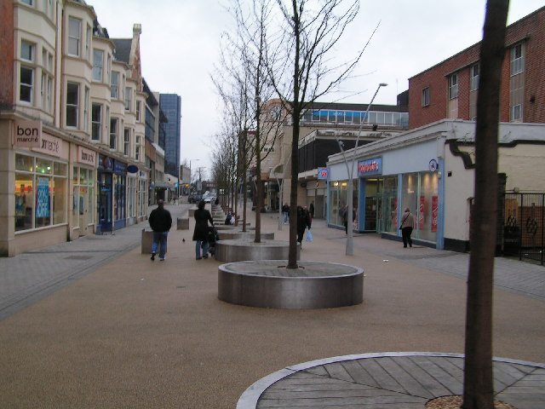
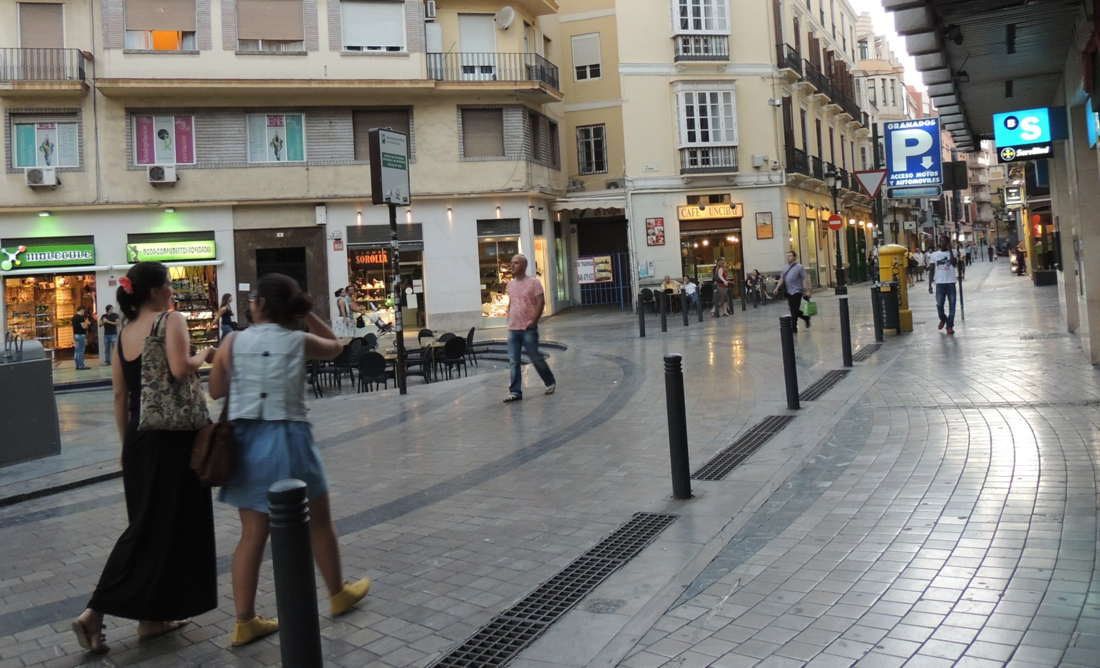

AIM
To design the pavement layout for the pedestrian areas around the market square. Work out the pattern and select the brick colour. You need to come up with a range of alternatives. It is intended to use blocks shown on the support sheet. You also need to come up with some design feature which will be used around the base of the trees.
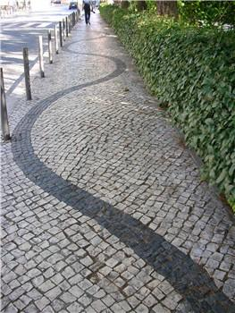

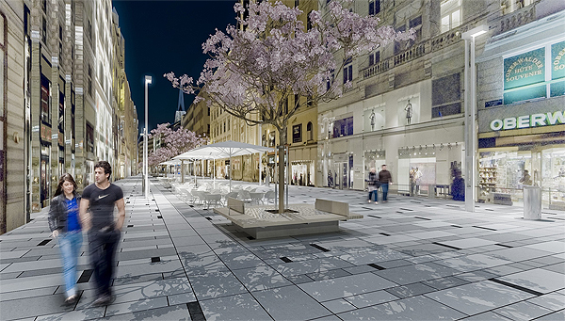
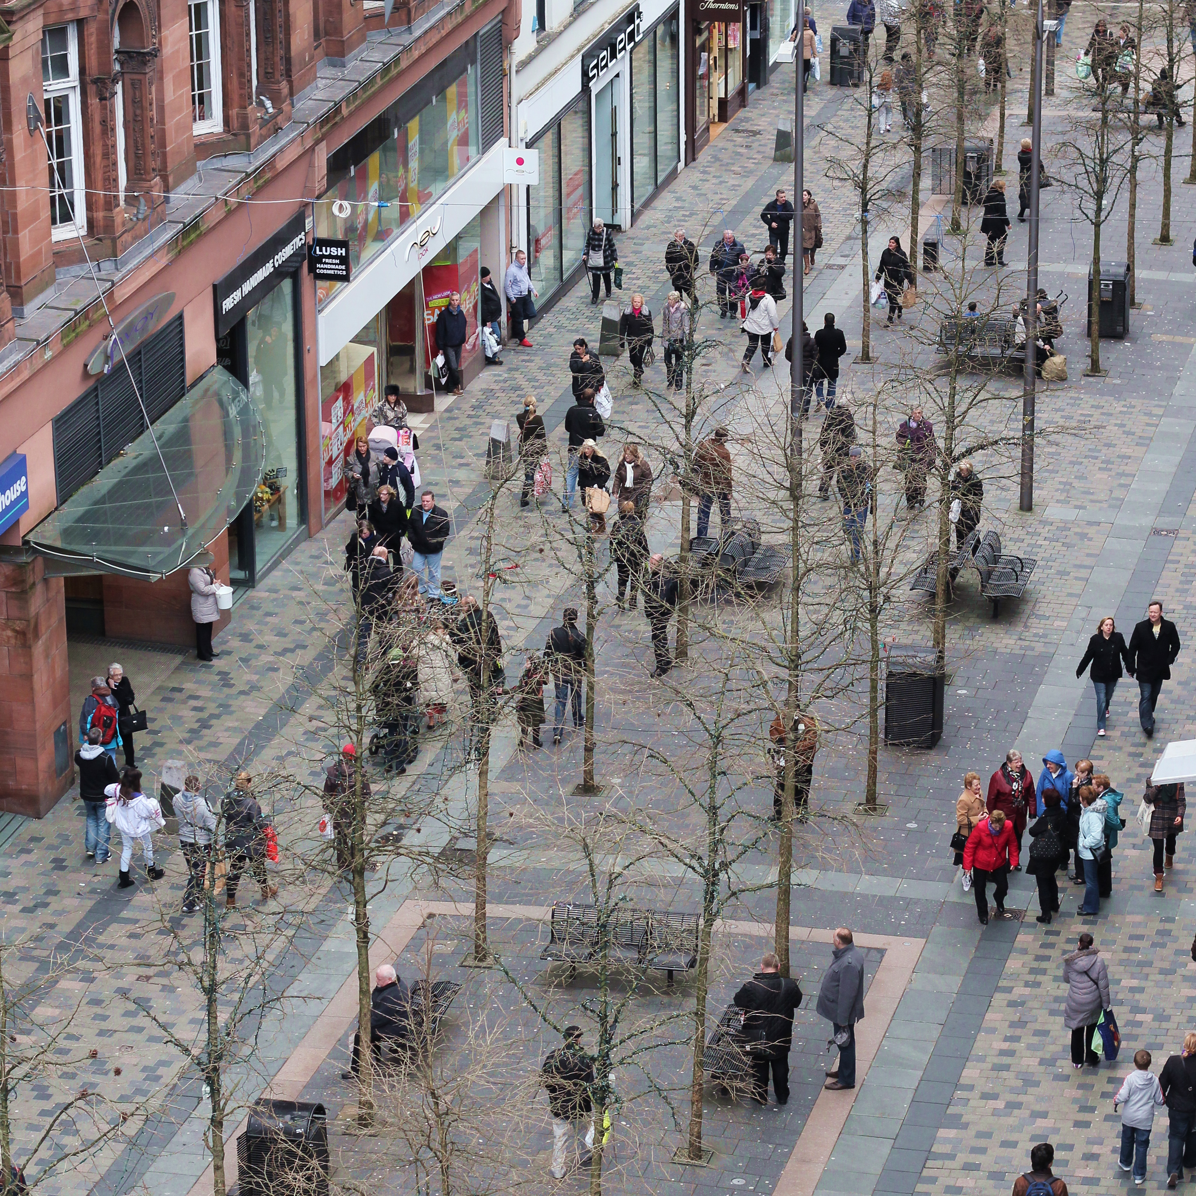

For the design task complete the sections list below, on the pages shown.

- Design Specification (4 marks)
- Research (10 Marks )
- Initial Ideas (12 marks)
- Development (12 marks)
- Final design (8 marks)
- Product Testing (4 marks)

