Town Centres – Market Square – Litter Bins

THE SITUATION
It has been agreed by Harchester Council to invest in a new approach in ensuring that the town is kept clean. This is very important to them as they wish visitors to get a good impression. Part of the project is to replace the existing set of litter bins with a new range. The main area around the central zone of the town which will be car free will have their bins emptied quickly throughout the day. It is intended to use a small fleet of dustcarts the size of a small van, to undertake the task as some of the roads are small and narrow. Shop waste will be emptied at night by the same fleet and during the day if there is an emergency or it is becoming an issue. The council has hired new staff and has bought 4 new vehicles.
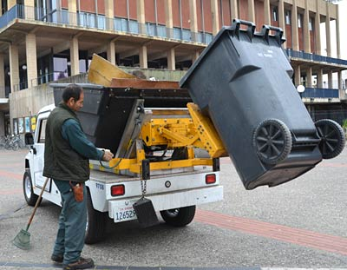
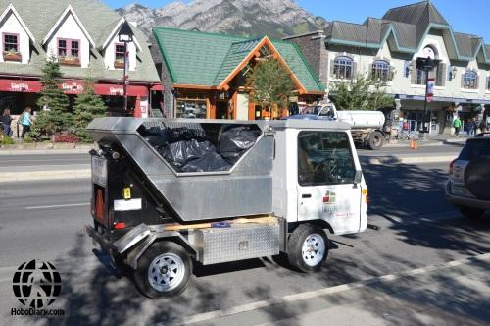

AIM
To design and make a range of litter bins which will reflect the tradition and style of Harchester, but also be modern and new in their appearance. It is up to you to decide whether or not to make them free-standing or attached to a lamppost. They will need some form of liner, which can be removed quickly. Any material can be used if you feel it is appropriate.
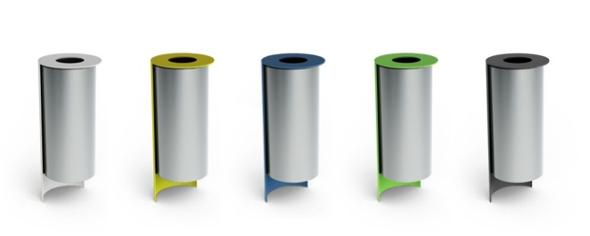
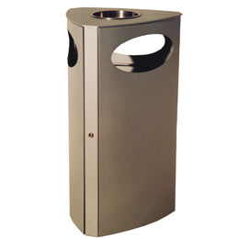

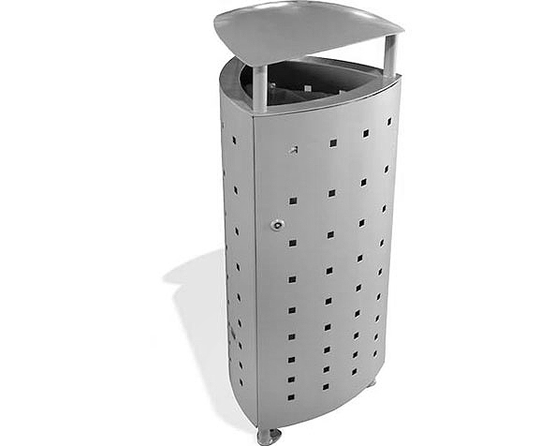

For the design task complete the sections list below, on the pages shown.

- Design Specification (4 marks)
- Research (10 Marks )
- Initial Ideas (12 marks)
- Development (12 marks)
- Final design (8 marks)
- Product Testing (4 marks)

