Service Pack 2

Design

PASS COMMAND VERBS

DESCRIBE

Give a clear description that includes all the relevant features. Think of it as `painting a picture with words'.

DEFINE

Clearly explain what a particular term means and give an example, if appropriate, to show what you mean.

DESIGN

Create a plan, proposal or outline to illustrate a straightforward concept or idea.

EXPLAIN

Set out in detail the meaning of something, with reasons. More difficult than describing or listing so it can help to give an example to show what you mean. Start by introducing the topic then give the `how' or `why'.

IDENTIFY

Point out (ie choose the right one) or give a list of the main features.

ILLUSTRATE

Include examples or a diagram to show what you mean.

INTERPRET

Define or explain the meaning of something.

LIST

Provide the information in a list, rather than in continuous writing.

OUTLINE

Write a clear description but not a detailed one.

PLAN

Work out and plan how you would carry out a task or activity.

STATE

Write a clear and full account.

SUMMARISE

Write down the main points or essential features.

MERIT COMMAND VERBS

ANALYSE

Identify separate factors, say how they are related and how each one contributes to the topic.

COMPARE/CONTRAST

Identify the main factors that apply in two or more situations and explain the similarities and differences or advantages and disadvantages.

DEMONSTRATE

Provide several relevant examples or related evidence which clearly support the arguments you are making. This may include showing practical skills.

DESIGN

Create a plan, proposal or outline to illustrate a relatively complex concept or idea.

ASSESS

Give careful consideration to all the factors or events that apply and identify which are the most important or relevant.

EXPLAIN IN DETAIL

Provide details and give reasons and/or evidence to clearly support the argument you are making.

HOW/WHY JUSTIFY

Give reasons or evidence to support your opinion or view to show how you arrived at these conclusions.

DISTINCTION COMMAND VERBS

APPRAISE

Consider the plus and minus points and give a reasoned judgement.

ASSESS

Must make a judgement on the importance of something (similar to evaluate).

COMMENT CRITICALLY

Give your view after you have considered all the evidence. In particular decide the importance of all the relevant positive and negative aspects.

CRITICISE

Review a topic or issue objectively and weigh up both plus and minus points before making a decision.

DRAW CONCLUSIONS

Use the evidence you have provided to reach a reasoned judgement.

EVALUATE

Review the information then bring it together to form a conclusion. Give evidence for each of your views or statements.

EVALUATE CRITICALLY

Decide the degree to which a statement is true or the importance or value of something by reviewing the information. Include precise and detailed information and assess possible alternatives, bearing in mind their strengths and weaknesses if they were applied instead.

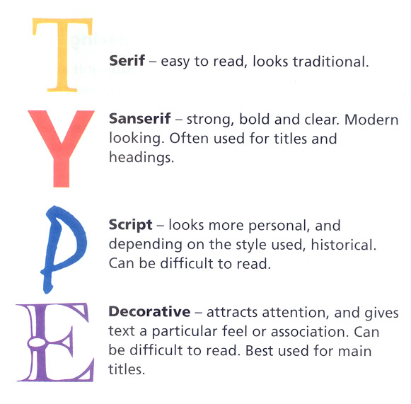

This is made up of three basic elements:

1. Hue, which is the actual colour or complexion, i.e. whether it is red, yellow, orange etc.
2. Chroma, which in the brilliance of colour (intensity)

(c) Tone, which is the amount of black or white in a colour. The maximum contrast one can gain is by the use of black and white alongside each other.

Primary colours are the basic pigments from which other colours (secondary colours etc.) can be mixed.

Complementary colours are those colours that are opposite each other on the colour wheel (spectrum). They give maximum contrast.

Harmony comes from using colours that are close to each other around the colour wheel. Harmony can also be gained when using complementary colours, by toning down both colours with equal amounts of black or white.

Opacity. If we can see through the material, it in transparent. If we cannot see through it, but light shines through, it in translucent. If we cannot see light through the material at all, it is opaque.

HARMONIUS COLOURS - ADJACENT COLOURS

COMPLEMENTARY COLOURS - OPPOSITE ON CIRCLE

PRIMARY COLOURS – Red – Yellow – Blue

SECONDARY

- Orange (Red & Yellow)

- Green (Blue & Yellow)

- Violet (Red & Blue)

- Green (Blue & Yellow)

- Violet ( - Oran - Green (Blue & Yellow) - Violet (Red & Blue)

TERTIARY - PRIMARY & SECONDARY MIXES

Paper Sizes

A0 841 x 1189

## A1 594 x 841

A2 420 x 594

A3 297 x 420

A4 210 x 297

A5 148 x 210

A6 105 x 148

# Key Words

Consider:

## Function - How well does it work? Does it do the job? How does it do the job?

### Shape - Outline, edges, curves, size. Has the whole shape been considered?

### Colour - Primary, secondary, complementary, harmonious, contrast, focal point, bright, pastel. Soft, hard.

### Ergonomics - How it suits the user, the relationship between user and item. Special ergonomic features.

## Texture - Feel, surface, finish, how is it used on the product?

## Proportion - How it fits in around similar items, too much, too little, too big or too small?



Art of Venice

Venice, especially during the [Middle-Ages](http://en.wikipedia.org/wiki/Middle-Ages), [Renaissance](http://en.wikipedia.org/wiki/Renaissance) and [Baroque](http://en.wikipedia.org/wiki/Baroque), was a major centre of art and developed a unique style known as the [Venetian School](http://en.wikipedia.org/wiki/Venetian_School_%28art%29).

In the Middle-Ages and the Renaissance, Venice, along with [Florence](http://en.wikipedia.org/wiki/Florence) and Rome, became one of the most important centres of art in Europe, and numerous wealthy Venetians became patrons of the arts. Venice at the time was a rich and prosperous [Maritime Republic](http://en.wikipedia.org/wiki/Maritime_Republics), which controlled a vast sea and trade empire.

By the end of the 15th century, Venice had become the European capital of printing, being one of the first cities in Italy (after Subiaco and Rome) to have a printing press after those established in Germany, having 417 printers by 1500. The most important printing office was the [Aldine Press](http://en.wikipedia.org/wiki/Aldine_Press) of [Aldus Manutius](http://en.wikipedia.org/wiki/Aldus_Manutius), which in 1499 printed the [Hypnerotomachia Poliphili](http://en.wikipedia.org/wiki/Hypnerotomachia_Poliphili), considered the most beautiful book of [Renaissance](http://en.wikipedia.org/wiki/Renaissance), and established modern [punctuation](http://en.wikipedia.org/wiki/Punctuation), the page format and [italic type](http://en.wikipedia.org/wiki/Italic_type), and the first printed work of [Aristotle](http://en.wikipedia.org/wiki/Aristotle).

In the sixteenth century Venetian painting was developed through influences from the Paduan School and [Antonello da Messina](http://en.wikipedia.org/wiki/Antonello_da_Messina), who introduced the oil painting technique of the van Eyck brothers. It is signified by a warm colour scale and a picturesque use of colour. Early masters where the Bellini and Vivarini families, followed by [Giorgione](http://en.wikipedia.org/wiki/Giorgione) and [Titian](http://en.wikipedia.org/wiki/Titian), then [Tintoretto](http://en.wikipedia.org/wiki/Tintoretto) and [Veronese](http://en.wikipedia.org/wiki/Paolo_Veronese).

[Canvases](http://en.wikipedia.org/wiki/Canvas) (the common painting surface) originated in Venice during the early renaissance. These early canvases were generally rough.

In the eighteenth century Venetian painting had a renaissance because of [Tiepolo](http://en.wikipedia.org/wiki/Giovanni_Battista_Tiepolo)'s decorative painting and [Canaletto](http://en.wikipedia.org/wiki/Canaletto)'s and [Guardi](http://en.wikipedia.org/wiki/Guardi)'s panoramic views.

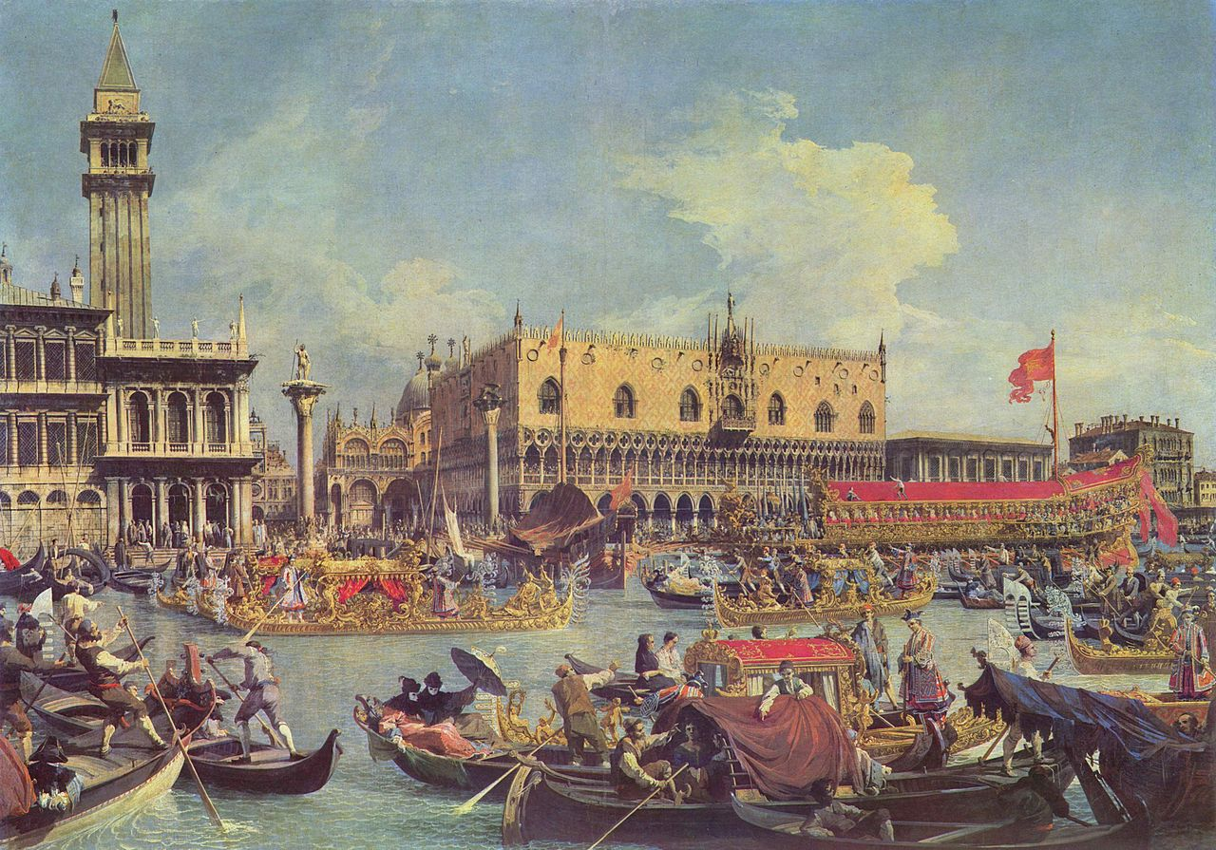

Other artists since then have visited Venice for inspiration including Monet and Turner.

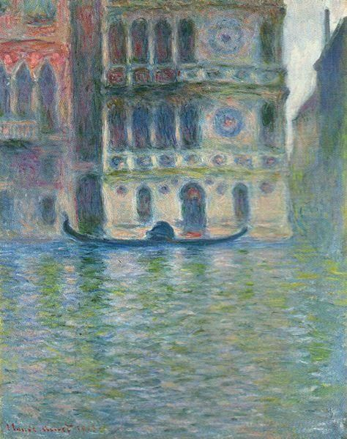

Monet – Palazzo Dario, Venice - 1908

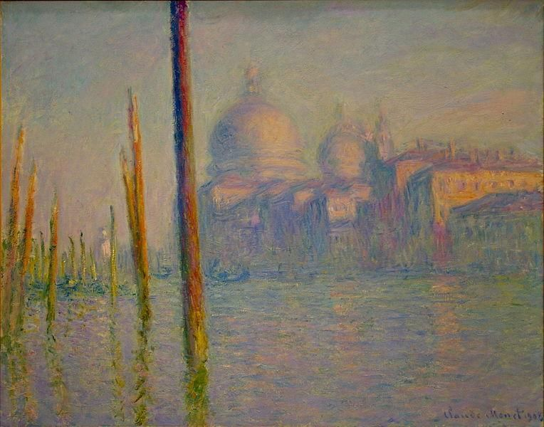

Monet – Grand Canal, Venice - 1908

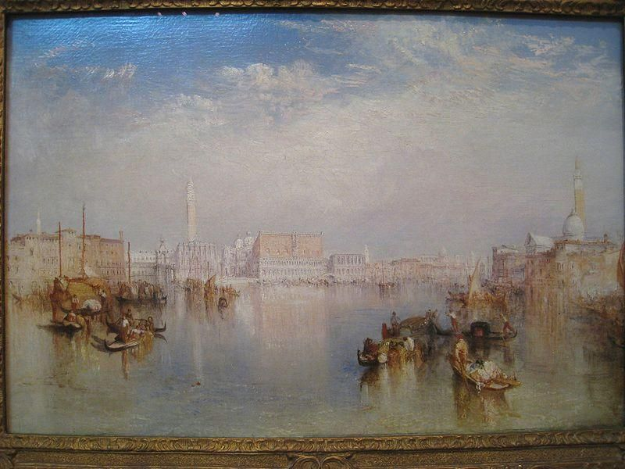

View of Venice: Ducal Palace, Dogana, and San Giorgio" (1841) by J. M. W. Turner