Service Pack 1

Design

Quality Book Cover Websites

* http://bookcoverarchive.com/
* http://www.youthedesigner.com/2010/03/19/86-beautiful-book-covers/
* http://wellmedicated.com/lists/45-beautifully-designed-book-covers/
* http://www.abebooks.co.uk/books/RareBooks/book-design-collectible-famous/iconic-book-covers.shtml
* http://www.smashingmagazine.com/2008/04/14/excellent-book-covers-and-paperbacks/

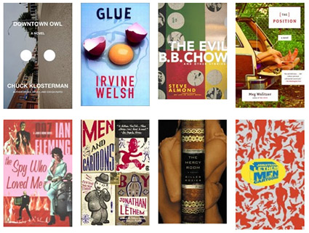

Author & Book Information

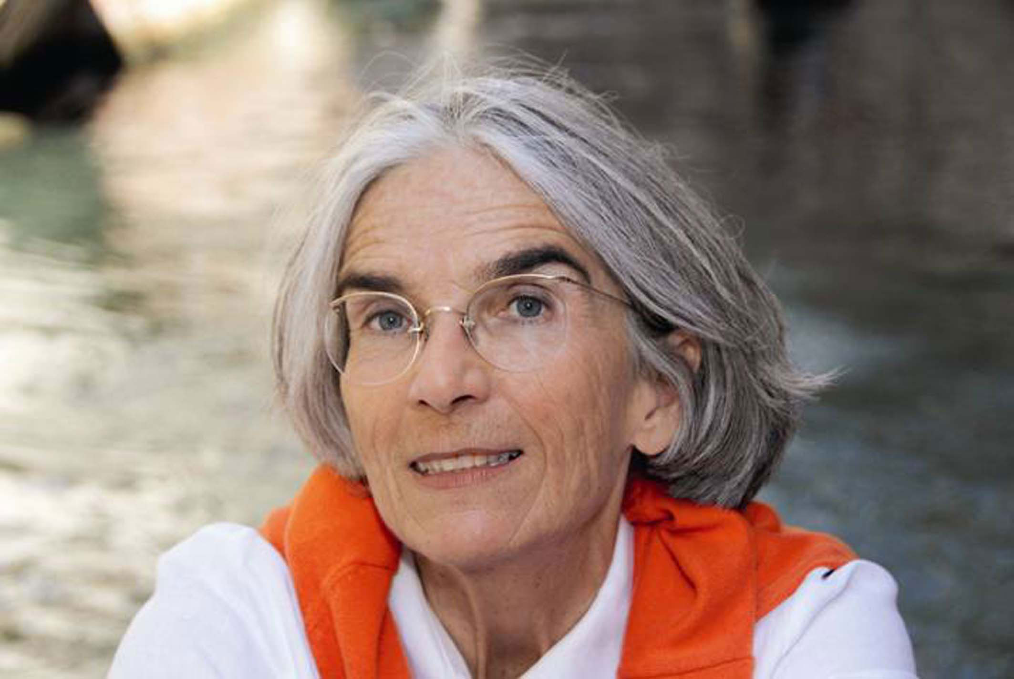

Donna Leon (born 1942) is an American author who lives in Venice and has been an English lecturer at a range of American Universities and Institutions in Italy after working around the world.

This series of crime books is based around the character of Guido Brunetti, a police commissioner who lives and works in Venice. As these books progress you learn about his family especially about his wife, who is also a hereditary Venetian Contessa.

Burnetti has gained a reputation of being incorruptible and will always solve the crime even if sometimes justice is not done.

The books titles are a play on words and can mean a number of things, i.e. ‘Friends in High Places’ is about corruption in the offices of high up officials but it also reflects the fact the main murder takes place in a high place as the character falls from a building. ‘A Sea of Trouble’ is about fisherman as well as trouble against a group of characters.

**List of Brunetti novels**

1. [Death at La Fenice](http://en.wikipedia.org/wiki/Death_at_La_Fenice) (1992)
2. [Death in a Strange Country](http://en.wikipedia.org/wiki/Death_in_a_Strange_Country) (1993)
3. [The Anonymous Venetian](http://en.wikipedia.org/w/index.php?title=The_Anonymous_Venetian_%28novel%29&action=edit&redlink=1) (1994) aka Dressed for Death
4. [A Venetian Reckoning](http://en.wikipedia.org/w/index.php?title=A_Venetian_Reckoning&action=edit&redlink=1) (1995) aka Death and Judgment
5. [Acqua Alta](http://en.wikipedia.org/w/index.php?title=Acqua_Alta_%28novel%29&action=edit&redlink=1) (1996) aka Death in High Water



1. [The Death of Faith](http://en.wikipedia.org/w/index.php?title=The_Death_of_Faith&action=edit&redlink=1) (1997) aka Quietly in Their Sleep
2. [A Noble Radiance](http://en.wikipedia.org/w/index.php?title=A_Noble_Radiance&action=edit&redlink=1) (1998)
3. Fatal Remedies (1999)
4. [Friends in High Places](http://en.wikipedia.org/w/index.php?title=Friends_in_High_Places_%28novel%29&action=edit&redlink=1) (2000)
5. [A Sea of Troubles](http://en.wikipedia.org/w/index.php?title=A_Sea_of_Troubles&action=edit&redlink=1) (2001)
6. [Wilful Behaviour](http://en.wikipedia.org/w/index.php?title=Wilful_Behaviour&action=edit&redlink=1) (2002)
7. [Uniform Justice](http://en.wikipedia.org/w/index.php?title=Uniform_Justice&action=edit&redlink=1) (2003)
8. [Doctored Evidence](http://en.wikipedia.org/w/index.php?title=Doctored_Evidence&action=edit&redlink=1) (2004)
9. [Blood from a Stone](http://en.wikipedia.org/w/index.php?title=Blood_from_a_Stone&action=edit&redlink=1) (2005)
10. [Through a Glass, Darkly](http://en.wikipedia.org/w/index.php?title=Through_a_Glass,_Darkly_%28Brunetti_novel%29&action=edit&redlink=1) (2006)
11. [Suffer the Little Children](http://en.wikipedia.org/w/index.php?title=Suffer_the_Little_Children_%28novel%29&action=edit&redlink=1) (2007)



1. [The Girl of His Dreams](http://en.wikipedia.org/w/index.php?title=The_Girl_of_His_Dreams&action=edit&redlink=1) (2008)
2. [About Face](http://en.wikipedia.org/w/index.php?title=About_Face_%28novel%29&action=edit&redlink=1) (2009)
3. [A Question of Belief](http://en.wikipedia.org/w/index.php?title=A_Question_of_Belief&action=edit&redlink=1) (2010)
4. [Drawing Conclusions](http://en.wikipedia.org/w/index.php?title=Drawing_Conclusions&action=edit&redlink=1) (2011)
5. [Beastly Things](http://en.wikipedia.org/w/index.php?title=Beastly_Things&action=edit&redlink=1) (2012)

Printing



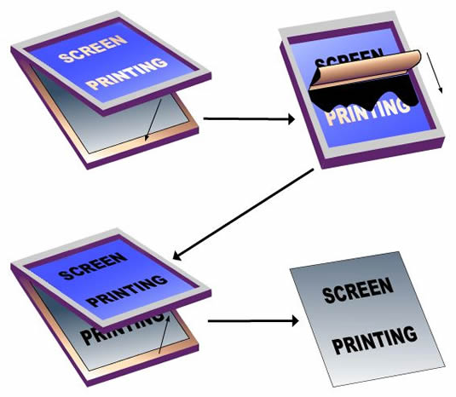



Off-set Lithography Screen Printing



Flexography





Gravure

Letter Press

Printing Press

Cyan Magenta Yellow Black





Printing

**Colour bars Lines**

To check the quality For cutting

of the ink



**Bleed Registration Marks**

The ink needs To align the 4 process

go over the colours on the printing

edge so when press

you cut it there

will be no white

4 printing plates will be produced for each colour through colour separation

Venice

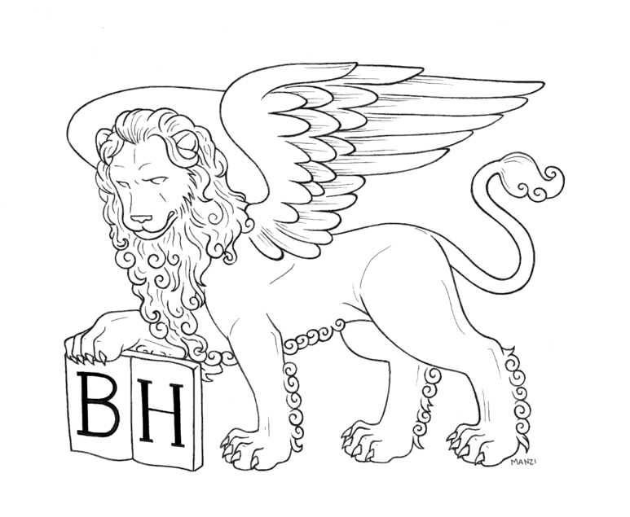



Venice was founded in AD421, after the people of Veneto had fled from invading forces from the north; they sought refuge among the uninhabited islands of their muddy coast and Venice was born.

During the Middle ages Venice expanded its power and by the 16 century, Venice held a monopoly on Mediterranean trade becoming very rich and powerful.



