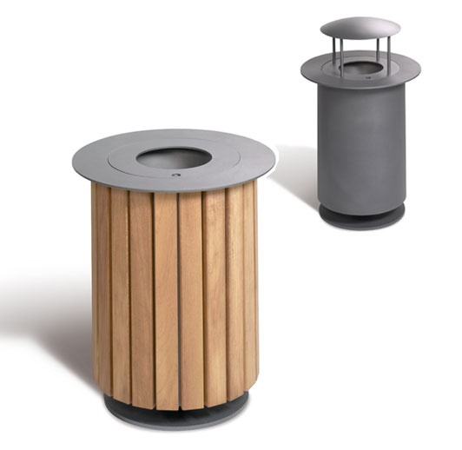

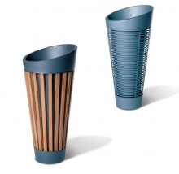

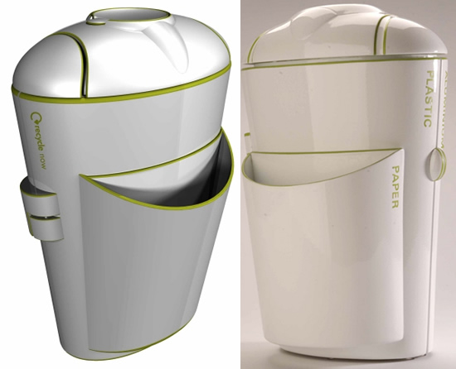

INTRODUCTION/SCENARIO:

It has been agreed by Harchester Council to invest in a new approach in ensuring that the town is kept clean. This is very important to them as they wish visitors to get a good impression of the town. Part of the project is to replace all the existing set of litter bins with a new, modern range. The main area will be around the central zone and will have their bins emptied quickly, possibly two or three times during the day. It is intended to use a small fleet of specially designed dustcarts, the size of a small van, to undertake this task and shop waste will be emptied at night by a bigger fleet. The Council intends to pave areas within the town to help and create people friendly zones.

CLIENT:

Harchester Council

TASK:

To design and make a range of litter bins which will reflect the new and modern style of Harchester. They must be free-standing, and they will have a liner which will be made of galvanised steel, and which can be removed quickly. Any material can be used for the main body you feel it is appropriate. It is advised that you look at some existing products.

OUTCOMES:

* A portfolio which deals with the production of the product
* A scale model, which shows the possibilities for the product.

EVIDENCE YOU MUST PRODUCE FOR THIS TASK

Portfolio containing:

* records of relevant production details and H&S issues
* progress journal of the construction and the products evolution
* annotation – what skills, materials, techniques, process have been used, what technical information has been explored

Final Model:

* Made to scale, accurate model using a variety of materials

RESOURCES:

* DT Library, DT Magazines, DT Website – www.inspirationindesign.uk
* 2D Design, Photoshop, Sketchup
* Design Studio, ICT Suite, Workshops

EDO4 – Litter Bin

*D&T*

*Inspiration in Design*