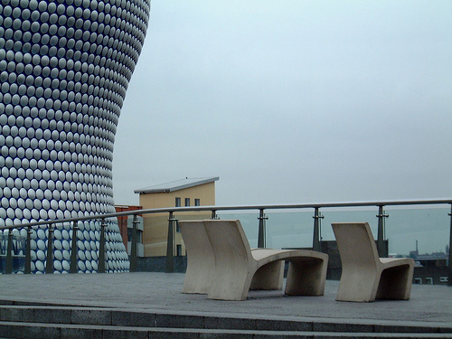

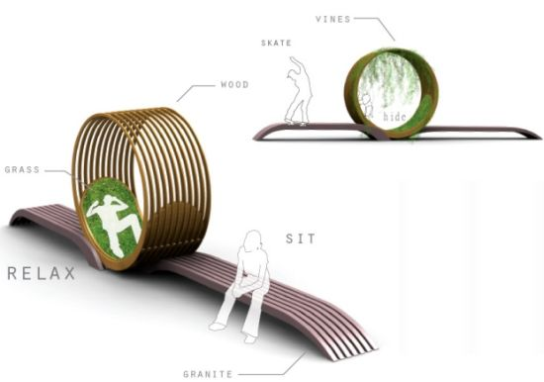

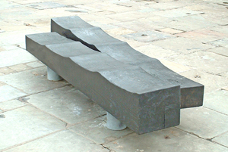

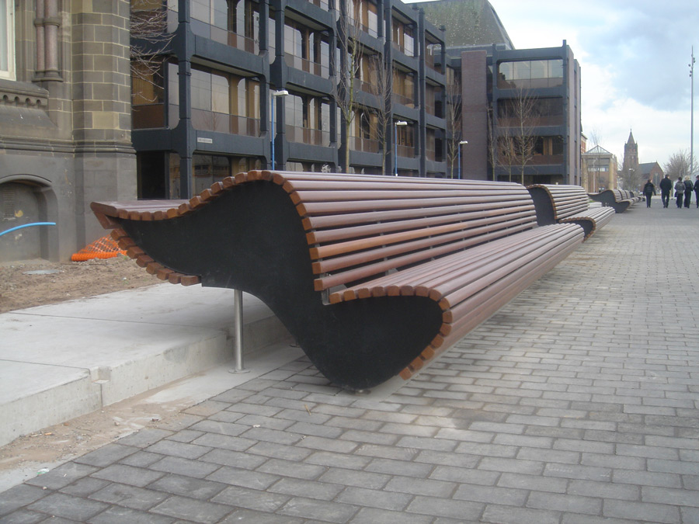

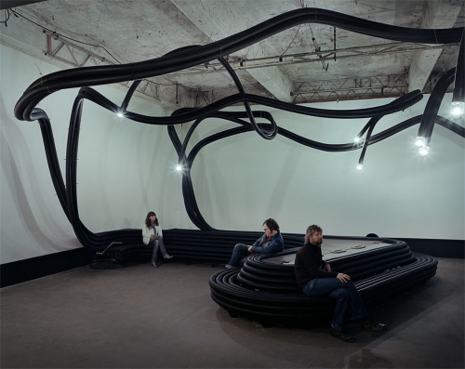

You have been asked to develop a range of outdoor seating, which can be used around pedestrianized town centres and open public spaces. It needs to be flexible enough in its design to enable it to be used in the widest possible range of outside situations, such as the outside areas of cafes and shops and even enclosed courtyards. This is to maximise its future sales capability.

CLIENT: Harchester Council

##### TASK: To design & make some form of outdoor seating.

OUTCOMES:

* Portfolio of work to support the project, to include a range of annotated ideas to be presented to the council, in a form of your choice.
* A scale concept model, which will show a range of possibilities.

You must also explain how it can be made if it was to go into production, as well as what materials or range of materials you could use, but remember it must be long lasting, robust and hard wearing. It also needs to be well designed and not old fashioned, as you need to ensure it can’t date. You must consider the environment it will be used in and remember the need for easy maintenance. You must consider all these conditions in your design.

RESOURCES:

* DT Library, DT Magazines, DT Website – www.inspirationindesign.uk
* 2D Design, Photoshop, Sketchup
* Design Studio, ICT Suite, Workshops

EDO3 – Outdoor Seating Area

*D&T*

*Inspiration in Design*