Things you should know about The Imperial War Museum North

**First building in the UK by Daniel Libeskind**

**The AirShard is neither an outside or inside space** Libeskind wanted visitors to feel the unsettling nature of war. He used a variety of techniques within the architecture to achieve this.

**It’s purposely disorientating.** The AirShard entrance is small and bunker-like, quite different from the grand entrances of traditional museums. When visitors enter they have to follow a pathway through the AirShard that goes back on itself - creating a feeling of disorientation.

**The floor of the main exhibition space slopes by eight feet**. There is a distinct lack of right angles in the [main exhibition space](http://www.iwm.org.uk/exhibitions/iwm-north/main-exhibition-space-0), no natural light, and even the temperature fluctuates at different points - all features intended to intensify the visitors’ experience.

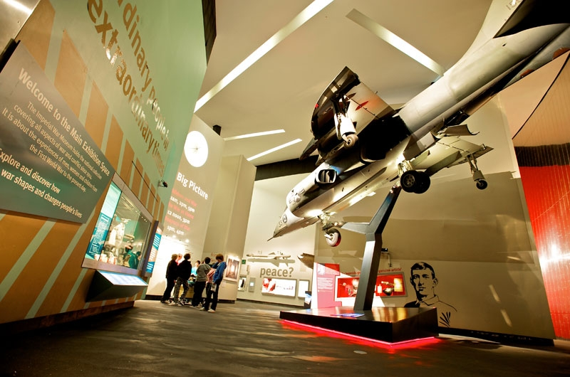

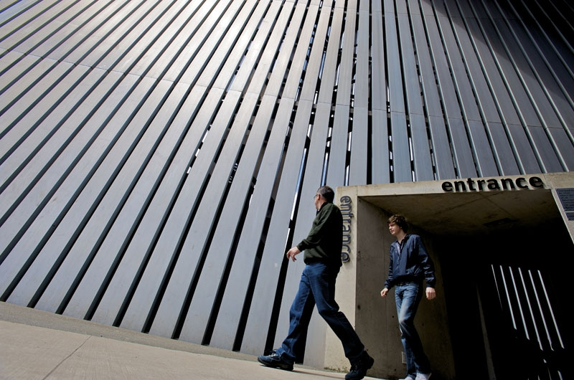

**It represents a shattered Globe**

Libeskind wanted the building to be a symbol of the effects of war, so he came up with the concept of a globe shattered into three pieces - and though it’s been put back together,  it will never be the same again. That’s why IWM North is made up of the EarthShard, WaterShard and the AirShard – a piece of the building to represent conflict on land, sea and in the air.

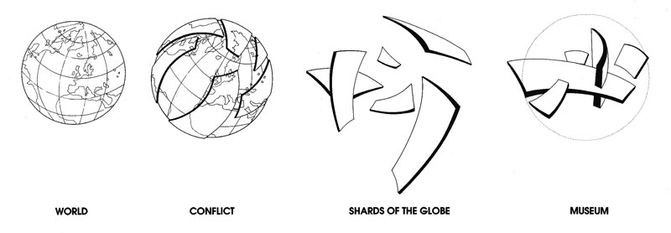

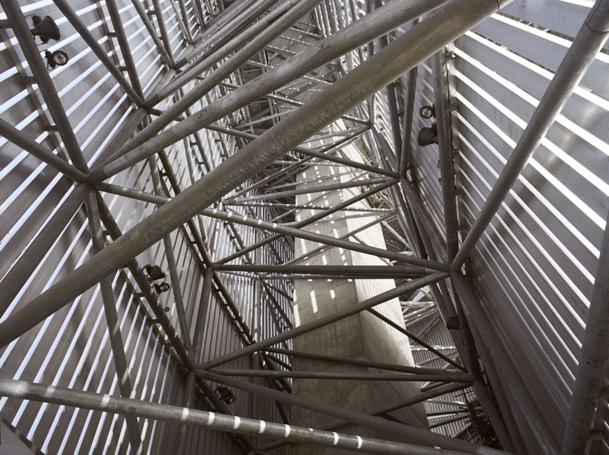

Daniel Libeskind, who designed the Jewish Museum in Berlin and was recently behind the masterplan for the Ground Zero site in New York. Daniel Libeskind was born in Poland, the second child of Polish Jewish parents who had survived the Holocaust. His insistence that the architecture of a museum should give richer meaning to its subject matter.

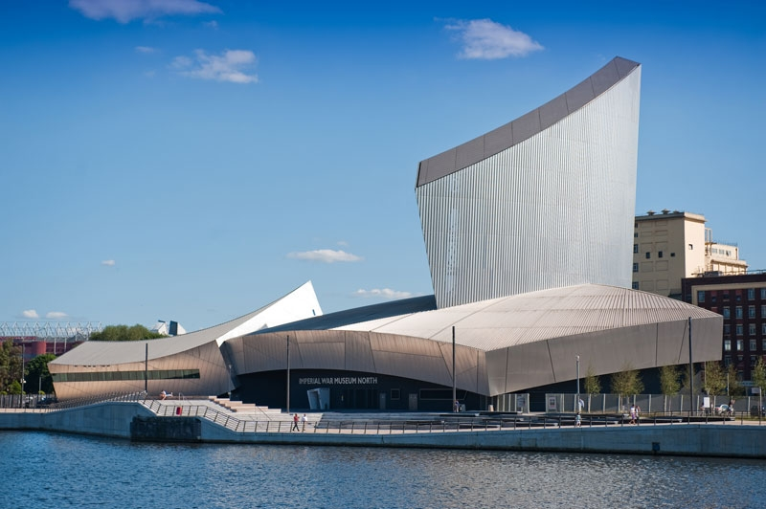

**It is built on a bombsite**

