

Design

Either using a building you have been too or will visit in the near future, even one locally, such as the development in the town centre. Write about it, adding photos and information, explain any special features, and any extra details you can find, such as cost or the Architect, etc. Consider layout and presentation of your work & write in your own, and photos can be taken from the internet, although photos taken by yourself will be preferred.

The Building

The Building

Mark:

## Town Centres – Market Square – Litter Bins

### THE SITUATION

It has been agreed by Harchester Council to invest in a new approach in ensuring that the town is kept clean. This is especially important to them as they wish visitors to get a good impression. Part of the project is to replace the existing set of litter bins with a new range. The main area around the central zone of the town which will be car free, will have their bins emptied quickly throughout the day. It is intended to use a small fleet of dustcarts the size of a small van, to undertake the task as some of the roads are small and narrow. Shop waste will be emptied at night by the same fleet and during the day if there is an emergency or if it is becoming an issue. The council has hired new staff and has bought 4 new vehicles.

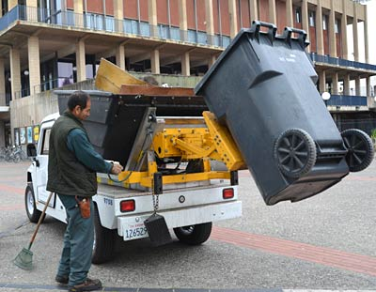

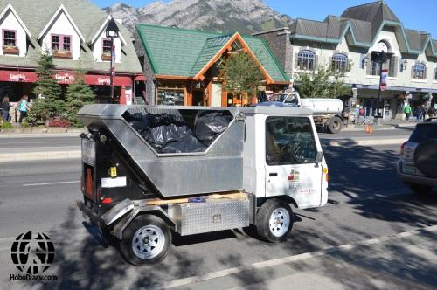

AIM

To design and make a range of **litter bins** which will reflect the tradition and style of Harchester, but also be modern and new in their appearance. It is up to you to decide whether to make them free-standing or attached to a lamppost. They will need some form of liner, which can be removed quickly. Any material can be used if you feel it is appropriate.

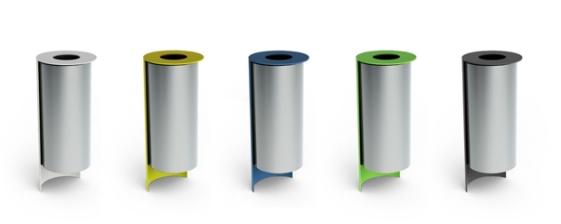

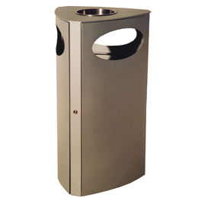

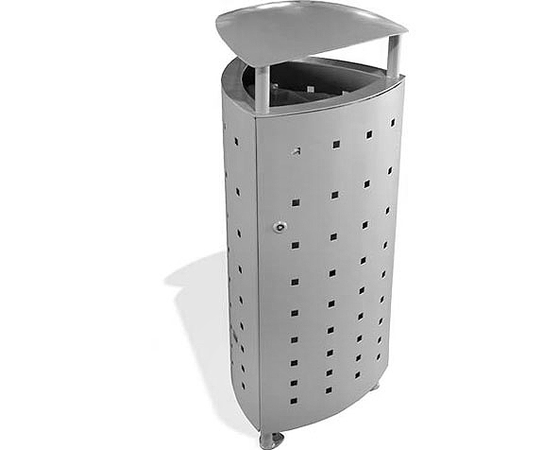

For the design task complete the sections list below, on the pages shown.

1. Design Specification *(4 marks)*
2. Research *(10 marks)*
3. Initial Ideas *(12 marks)*
4. Development *(12 marks)*
5. Final design *(8 marks)*
6. Product Testing *(4 marks)*
7. **Design Specification**

List **four** design requirements for the specification of the product you are designing.

Requirement 1: ___________________________________________________________________

________________________________________________________________________________

Requirement 2: ___________________________________________________________________

________________________________________________________________________________

Requirement 3: ___________________________________________________________________

________________________________________________________________________________

Requirement 4: ___________________________________________________________________

________________________________________________________________________________

*(4 marks)*

List **two** places you can find information from:

Source 1: ___________________________________________________________________

________________________________________________________________________________

Source 2: ___________________________________________________________________

________________________________________________________________________________

Mark

**(b) Research**

**(b) Research**

List down **four** things you have learned from the research

Element 1: ___________________________________________________________________

________________________________________________________________________________

Element 2: ___________________________________________________________________

________________________________________________________________________________

Element 3: ___________________________________________________________________

________________________________________________________________________________

Element 4: ___________________________________________________________________

________________________________________________________________________________

*(10 marks)*

Mark

**(c) Show a range of Initial Ideas**

**(c) Show a range of Initial Ideas**

*(12 marks)*

Mark

**(d) Development of Initial Idea(s)**

**(d) Development of Initial Idea(s)**

*(12 marks)*

Mark

**(e) Final Design - Include all necessary detail**

*(8 marks)*

Mark

**(f) Product Testing**

Explain **two** different methods of testing your final design.

Method 1: ________________________________________________________________

_________________________________________________________________________

_________________________________________________________________________

_________________________________________________________________________

Method 2: ________________________________________________________________

_________________________________________________________________________

_________________________________________________________________________

_________________________________________________________________________

Evaluate your final design against the Design Specification, does it answer each point?

If so how?

Design Requirement 1: ______________________________________________________

Design Requirement 2: ______________________________________________________

Design Requirement 3: ______________________________________________________

Design Requirement 4: ______________________________________________________

________________________________________________________________________

|  |  |
| --- | --- |
| Total | /50 |
| Percentage | % |
| Final Grade |  |

*(4 marks)*

Mark

Planning for next year

**Essential Equipment needed by students:**

* USB pen or access to a OneDrive/iCloud Account
* Range of 2H/HB/2B Pencils
* Ruler
* Colouring pencils
* Compass
* Sharpener
* Eraser

Items above are needed every lesson

**Extras supplied to students by the department**

* A3 Card Folder, stored at school – Each group has a designated box
* A4 Card Folder to store notes and information
* A3 Plastic Flip File to be issued for assessment

**Extra Requirements**

* A3 and A4 Carrying Case – To bring work to and from home
* Computer & Email Access outside the department
* Minimum 1 hour a week extension time – work issued in class, with additional copies online

ICT & Design Studios can be accessed at school during lunchtime, before and afterschool

**Sketchup**

* Use the resources on Sketchup from the DT website, have a go and see what you can create!

**Lesson Structure**

You will have 3 lessons a week

Lesson 1 – Design to include drawing, theory and designing

Lesson 2 – Workshop to include manufacturing leading up to more complex work by year 11

Lesson 3 – ICT to include Photoshop, Sketchup, General DTP and Research

**Support Mechanisms**

All the resources, homework tasks and additional materials will always be posted on the DT website, either in a secure area or an open access page. It also has a dates and information page for term times, major events, parent’s evenings and deadlines. Students can contact staff through their school email if they need further assistance.