

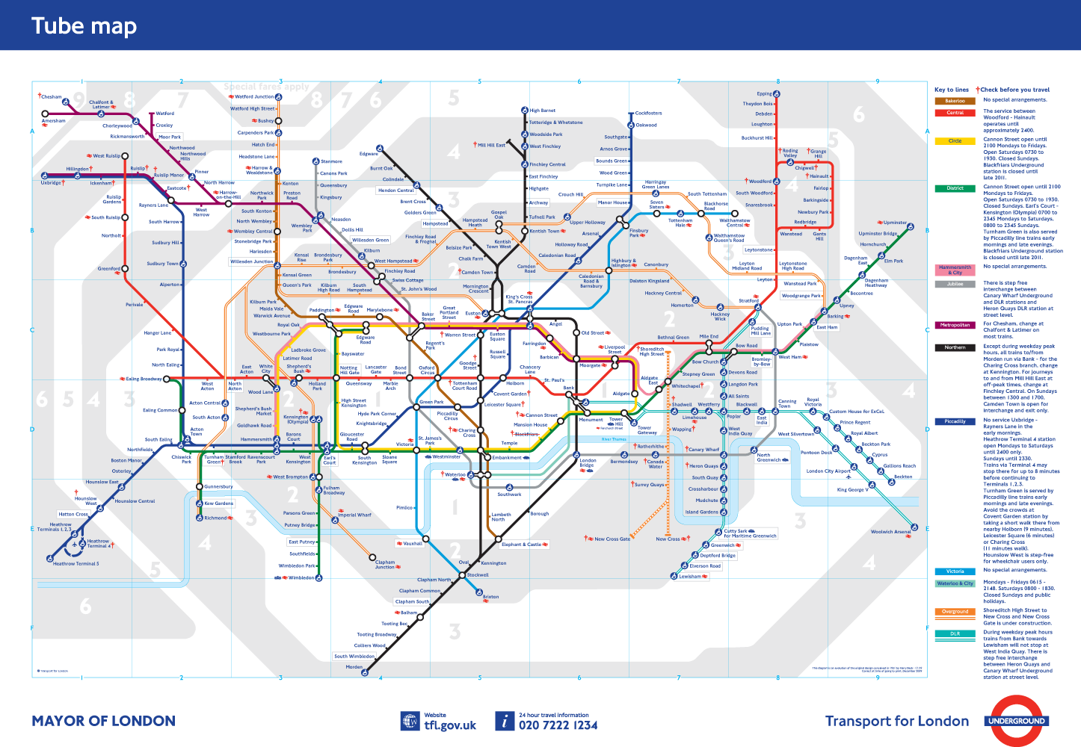

Design in the Built Environment

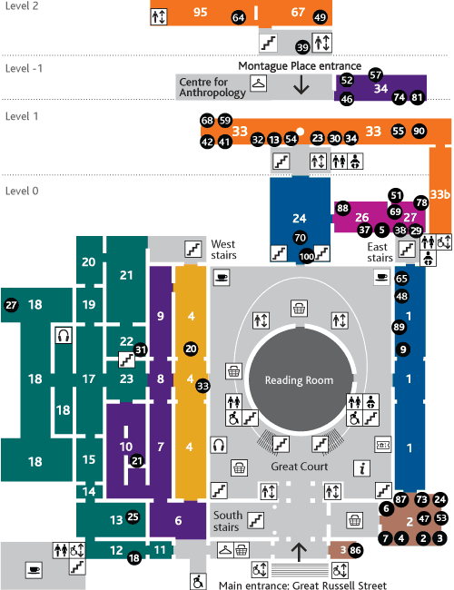

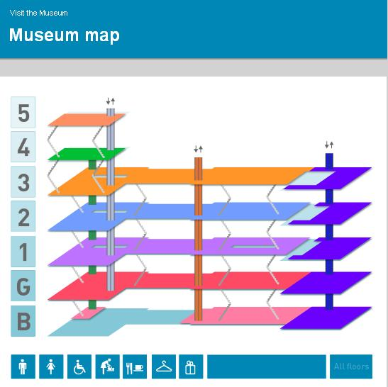

Deadline Assignment 6 – Museum Map

Background

Harchester Museum has undergone a major re-development. You have been approached to produce a new map for visitors, which incorporates the changes and improvements made by the building programme. However, there is a strict deadline as you only have two weeks to produce the outcome ready for the client and final agreement. Printing will commence almost immediately. It must be assessed by 4.00pm fifteen days from the point the brief is issued. To miss this deadline will have serious consequences for the company and its reputation, as well as for you.

Task

Your task is to produce a new visitor map for Harchester Museum. Following an in-depth investigation which will form the basis for the specification for the map you need to produce a range of thumbnails followed by detailed designs. You must produce a final piece of work which is ready for producing the printing plates.

Learning Objective

To be able to describe ways in which visual language is used to communicate ideas and meaning

|  |  |
| --- | --- |
| Deadline | By latest |
|  |  |

Suggested Process

Stage 1 – Investigation

* Museum Map Investigation
* Study into Harry Beck
* Produce a specification from the analysis of the research

Stage 2 – Design

* Thumbnails for ideas, mood boards
* Range of ideas for evaluation with client

Stage 3 – Development

* Mock ups more detail for client
* Idea taken forward

Stage 4 – Final Outcome

* Print ready sheet – Max size A3













**Museum Websites**

Victoria and Albert Museum http://www.vam.ac.uk/

British Museum http://www.britishmuseum.org/

Natural History Museum http://www.nhm.ac.uk/

Science Museum http://www.sciencemuseum.org.uk/

London Museum http://www.museumoflondon.org.uk/

Imperial War Museum http://www.iwm.org.uk/