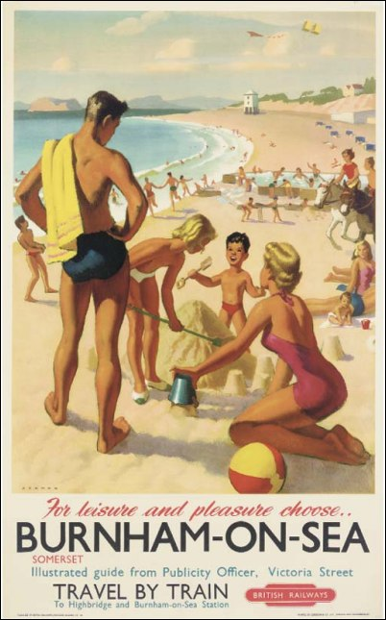

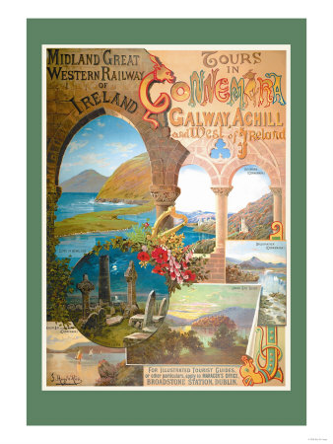

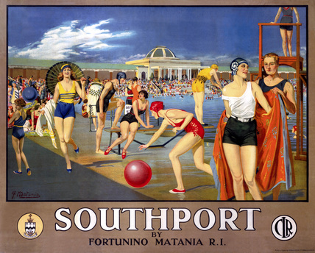

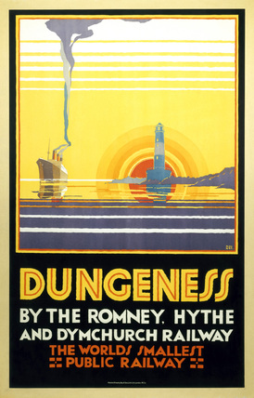



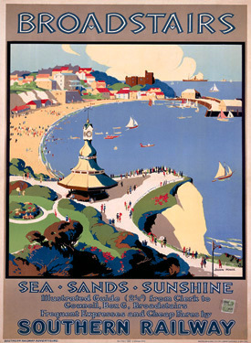

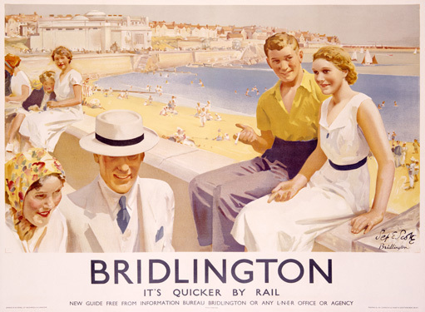

Design in the Built Environment

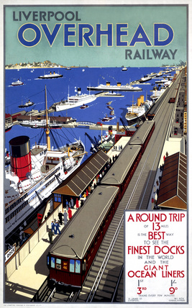

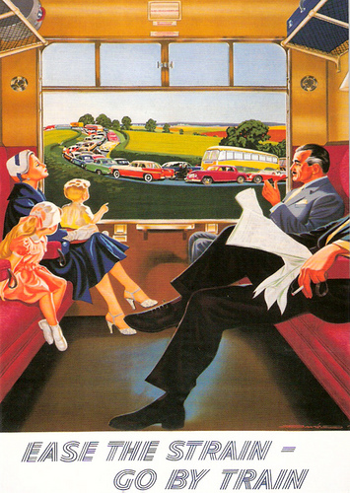

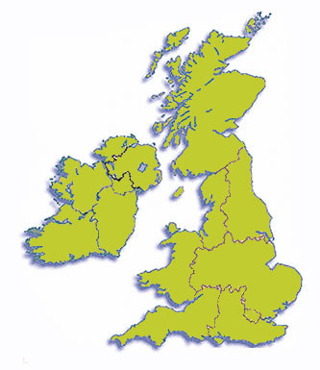

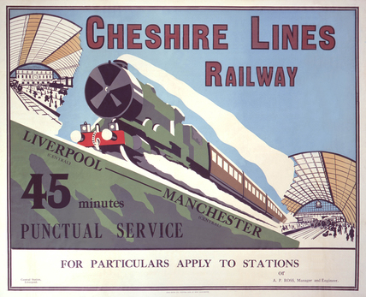

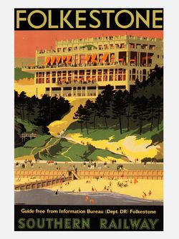

Deadline Assignment 5 – Tourist Board Poster

Deadline Assignment – Tourist Board Poster

You have been approached by the official tourist board of an international city to organise a major promotion for its autumn and winter tourist push.

At the heart of the promotion will be a poster campaign.

Initially, you need to design a poster for a city which will be posted up around the country at a range of venues, such as tourist information centres and railway stations, it will be also put into the range of local papers and magazines, and this is to raise the profile of the city and what it has to offer.

Your poster is to be to promote the city, suggesting a day trip or weekend visit to see some form of attraction.

You can choose any city

You must also produce 5 small A5 poster/leaflets which must be in the same style as the main poster and reflect five additional attractions to the one already produced. These will be given out, put into magazines and newspapers as well put into display stands at a range of venues such as hotels, information centres and cafes.

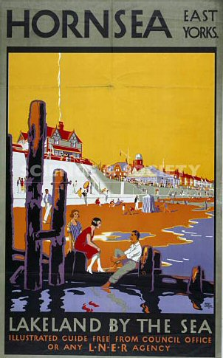

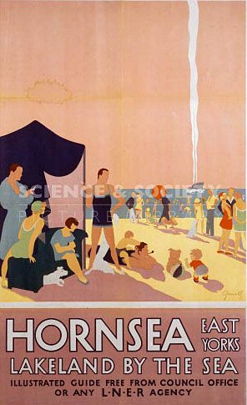

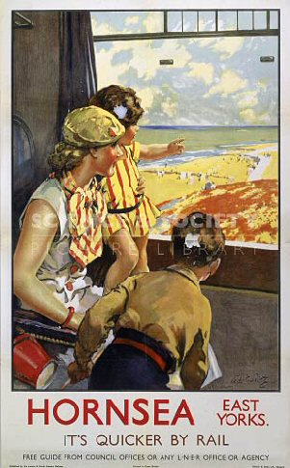

You can also explore other methods of promotion if you wish, but these must be outlined at the Stage 1 – Initial Meeting. These are not essential, but they do help you access the higher levels of work more easily.

During this assignment there are 2 assessment activities

Stage 1 – Initial Design Meeting W/B

You must present your ideas and initial designs to the client for approval and agreement. You cannot progress onto Stage 2 unless this has been done and that design decisions have been made with the agreement of the client. This is an essential stage in any project as a client can refuse to pay if you have finalised your ideas without their involvement. You can arrange the final design meeting at this time.

Stage 2 – Final Design Meeting

Present final designs to the client before they go into production. You need to explain the virtues of the designs and your thinking, remember there should be no surprises for the client as you are only realising what was agreed at the Stage 1 meeting.



Some Background Thoughts

It would be advisable to do some initial research into poster design, specifically those used for promoting travel. It will help you by looking at others work, but also to consider materials and styles used by others and reflect upon why they have used them.















Think about how they have used their materials and styles to project their ideas and what those ideas are.

Impact is key, remember, we are bombarded by images every day and how are you going to make someone look and respond to yours, rather than just put them straight into the bin.