Deadline Assignment 4 - Packaging
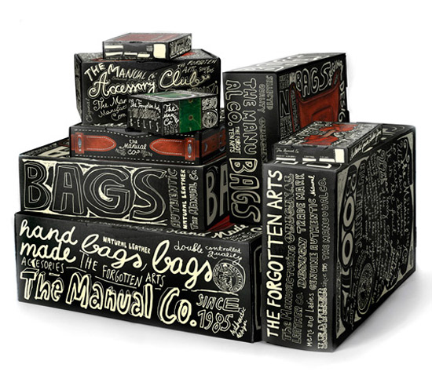
Select a food store product of your choice and re-design its
packaging. It must be imaginative, creative and exciting. It
must present the product as if it is really special.
It is intended to use this to promote your design company.
However, the main intention is to present it to a large Food Store
and to enable your design company to bid for more packaging products in their in-store range.
Assessment Criteria
Presentation | Brief and Selection of Product
 | Research & Analysis
Design | Thumb Nails of possible designs – Both Visual and Construction
Development | Visuals
 | Net development/Packaging construction
Final Design | Mock-up
Outcome | Completion & Quality of Final Prototype
Concept | Quality of Solution

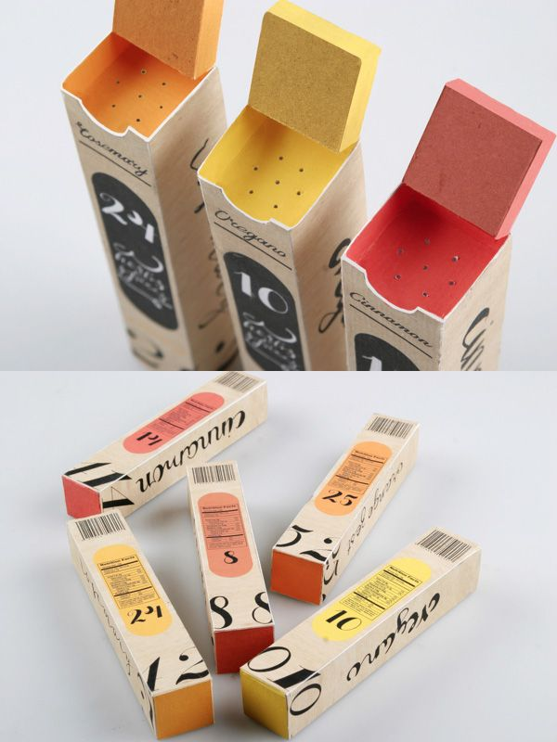
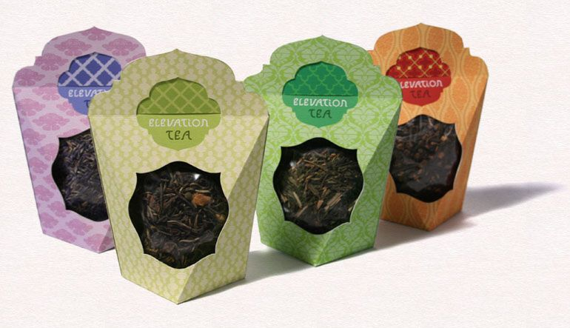

Deadline

