Deadline Assignment 3 - Italian Visitors Information Leaflet
INTRODUCTION/SCENARIO:
The development of the Italian Visitors Centre at Kings Cross Station is well underway, and they are now moving towards the next stage and preparing the materials needed to support its work.
TASK:
You have been asked to develop a leaflet format, which would be used for a range of leaflet products. They will be used to promote a range of attractions, cities places or areas throughout Italy.
The leaflet can only be 2 sides of A4 maximum, but folds can be used.
AIM:
Design a leaflet format to be used across a range of attractions, places, and cities, to present a uniform and unified approach
CLIENT:
Italian Tourist Board, UK
OUTCOMES:
- One Leaflet mocked up – Complete and detailed about one city, place, attraction, or area
- 4 Leaflets mock-ups to show the unified formats (Cover/Title only, with body type) for a range of attractions/Cities showing the unform approach (i.e. Cities Titles in blue, Specific places in yellow, Ancient Rome attraction in red, etc)
- Portfolio of research, thinking and designs
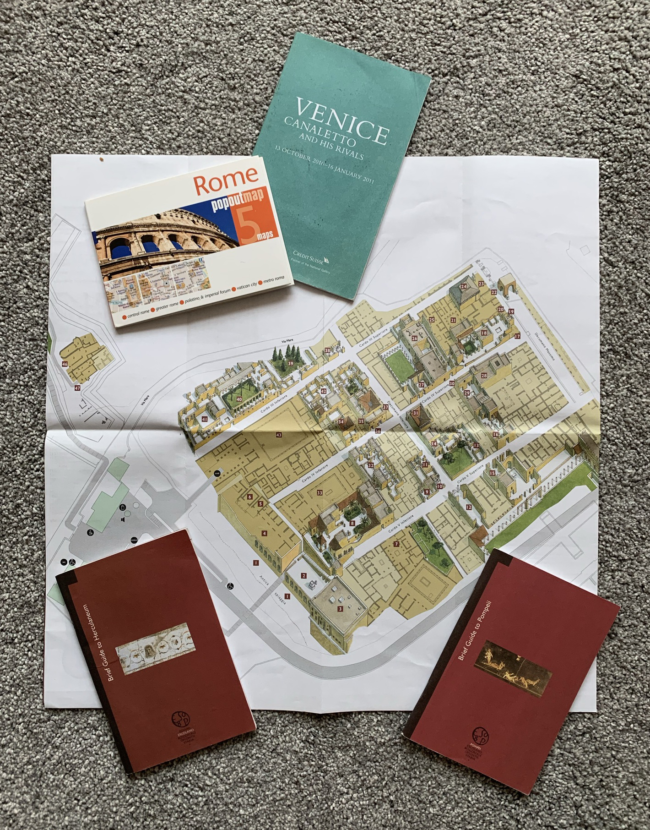
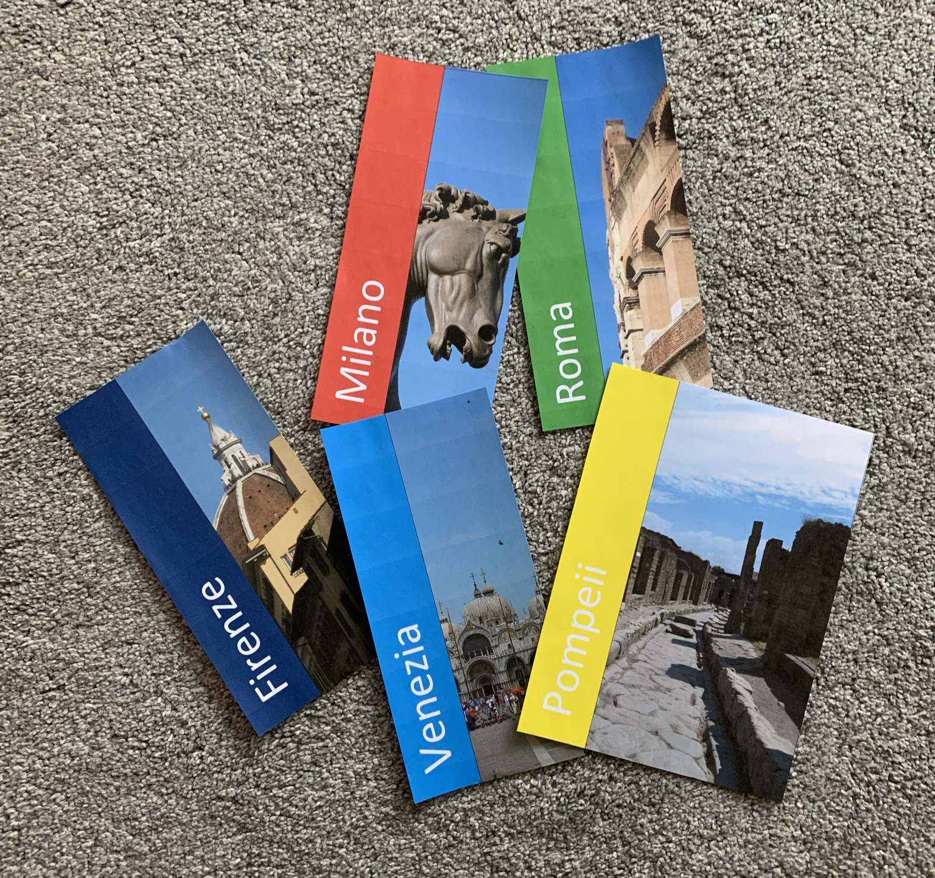

Key terms
- Thumbnail: Small drawing made to help with design ideas. Thumbnails are not very detailed and are produced quickly.
- Rough: Larger drawing selected from thumbnail, containing more detail.
Assessment & Approach
Area | Notes | Assessment
Research | Research existing leaflets and do an analysis for the main features. Also do some technical analysis dealing with size, layout and production and quality.  Research an Italian city, attraction, or place to base your information upon, including the style and what makes it special. | This is needed to inform your ideas both visually and with regards to the layout and presentation of the leaflet. So be selective when choosing leaflets to analyse.  Create a mood board focusing upon the Italian area your main leaflet is based upon, but remember to pull out the information to help you from it
Ideas | Good range of different ideas must be evident, these must be produced using thumbnails to stimulate and ensure pace when creating possible solutions.  Remember to consider how the design/format could be used for other attractions and places | Using thumbnails will enable you to be effective. Remember, you must also show a range of techniques, as well as good digital techniques in your development and final leaflet and you must have a quality final version.  We need to see a range of techniques, both studio and digital.  You need to show initiative and work independently, with creativity to hit these top grades
Development | This is to be done by producing models, one rough, one colourway and one paste up/mock-up.  Remember, the design must be transferable to other products.
Final Design | This must be a final mock-up in ICT which shows quality of finish and could be shown to a client.  4 mock-ups for alternative places, attractions, and cities

Resources
Photo Libraries for Italy
Available on the DT Website – www.inspirationindesign.uk – ‘Design in the World’ Tab

Body Type:
Available on the DT Website – www.inspirationindesign.uk – ‘Resources’ – ‘Design Theory & Support’ Tab

Similar Project:
GD04a – Promotional Leaflet
Available on the DT Website – www.inspirationindesign.uk – Assignments – Graphic Design

Deadline
Hand-in Date

