Amazing Spaces Assignment

You must design a building,
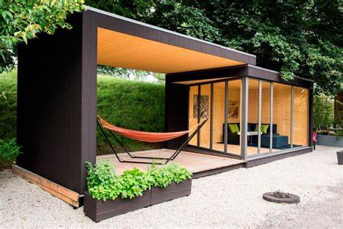
which is special, original and unique, but small.
It can be no bigger than 6000 x 6000 in total,
in its footprint
Its purpose and location are up to you

Sort of buildings it could be
- Tree House
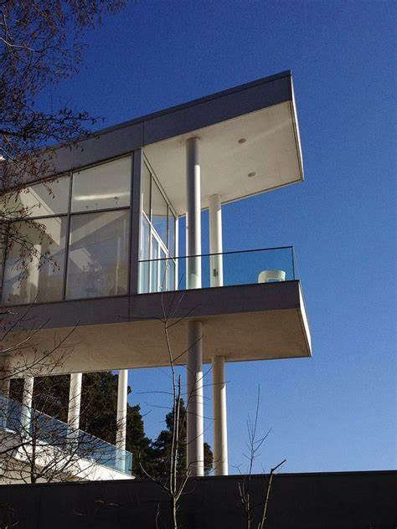
- Beach Hut
- Holiday Cabin
- Summer/Winter Cabin in the country
- Something special in the garden
- A person’s retreat
- A cabin at a tourist attraction/event place

You must produce:

Portfolio
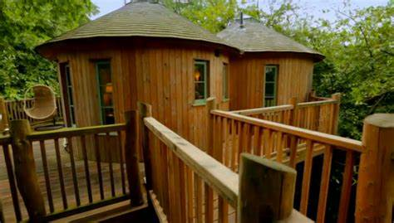
To Include:
- Introduction to include Brief
- Research
- Final Specification
- Design Ideas
- Development
- Plan of Construction
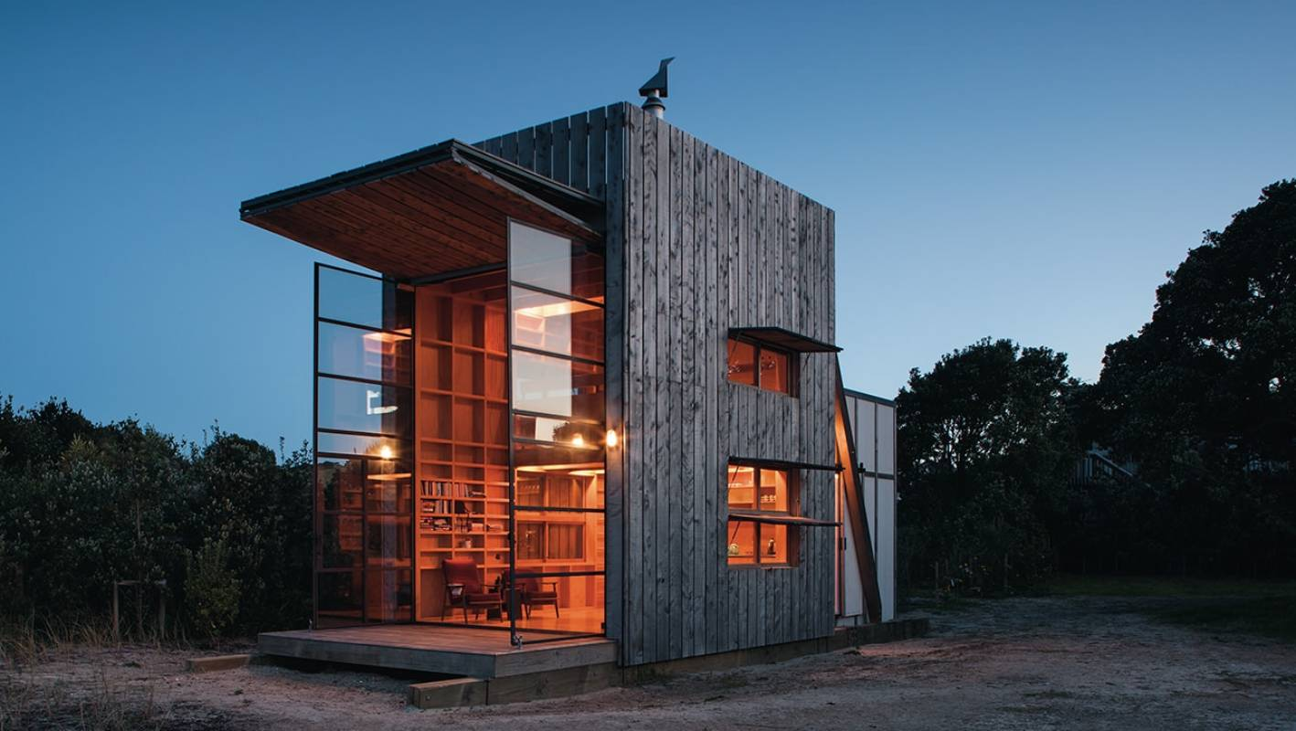
Model
1.12 scale

Hand in date – Monday 18th June – 3.45pm

