Task – To Design a Catering Kiosk for Blackfriars Station
Having a food-based kiosk on any station is a must these days, to cater for the vast numbers travelling through from early morning to late night, either going to and from work or out socializing or visiting the attractions.
Blackfriars Station has been redeveloped and now needs to have this issue addressed. It has gone from a minor London terminus to a major transport hub with the development of Thameslink, feeding people from the North as far as Cambridge, Peterborough, and Bedford and from the South from Brighton, Gatwick airport and Sutton. This station feeds the Southbank attractions and offices, as well as the City of London itself, and links the north and southsides of the river. With the arrival of the Elizabeth line two stops away, it is expected to become even busier.
Aim:
Your task is to design a small catering kiosk, which can be moved about easily about the station, and will be open from 5.00am through to 12 midnight, serving hot drinks, jacket potatoes and other hot snack food.
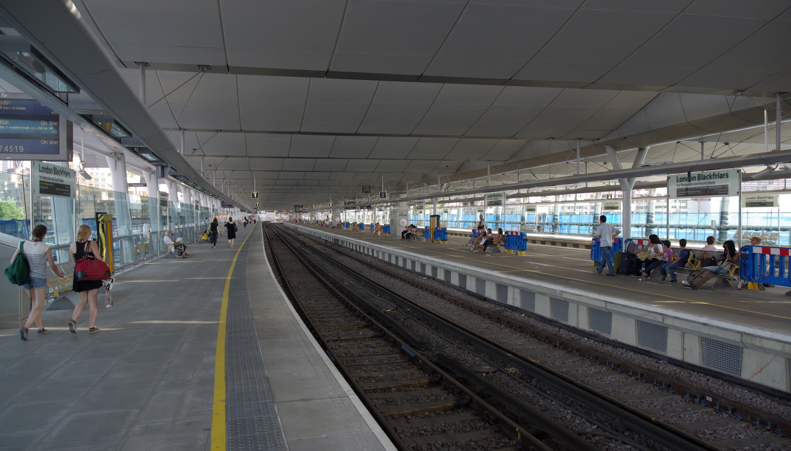
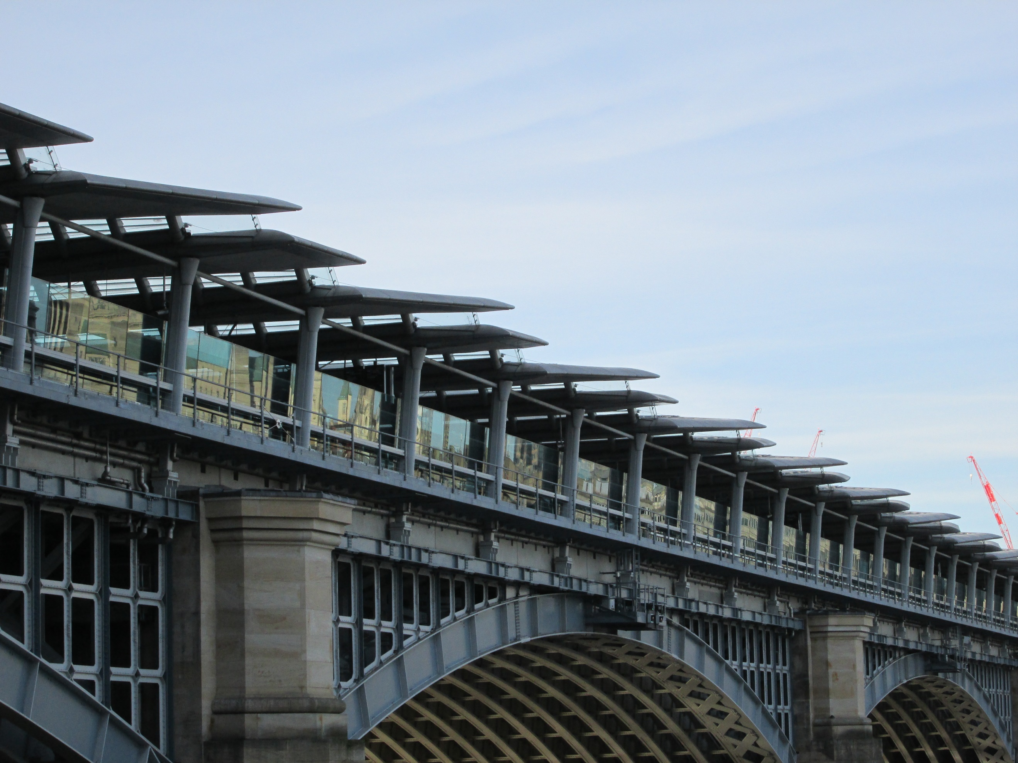

The Outcome:
A final design for the front of the unit and a simple layout plan of the inside
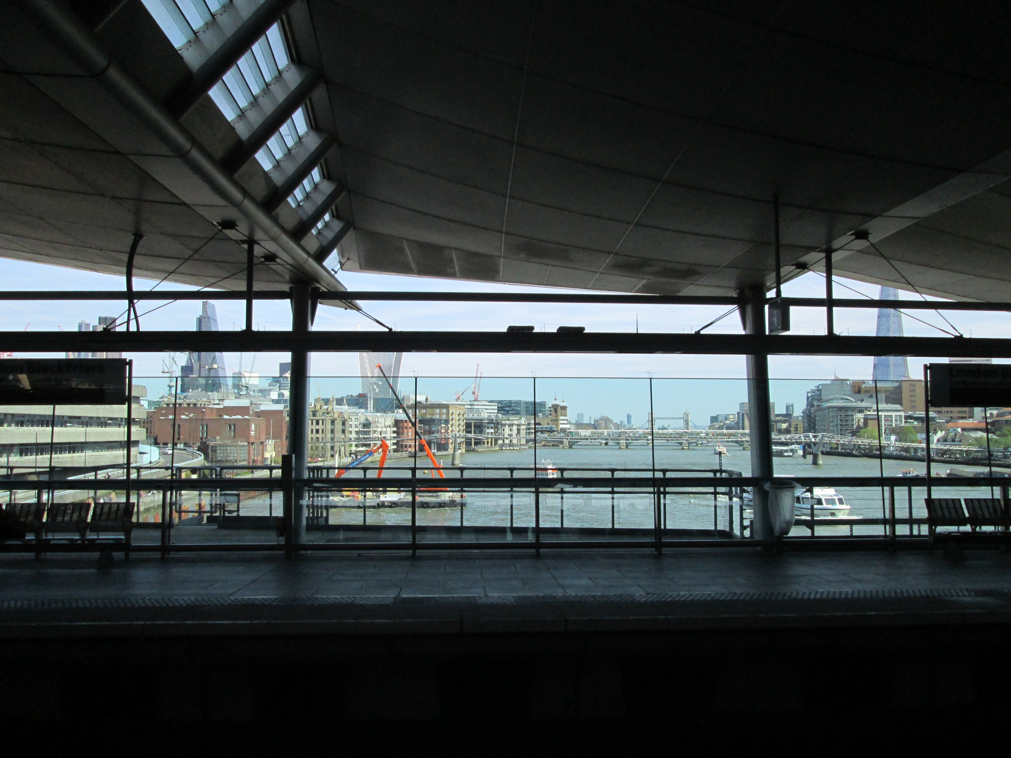
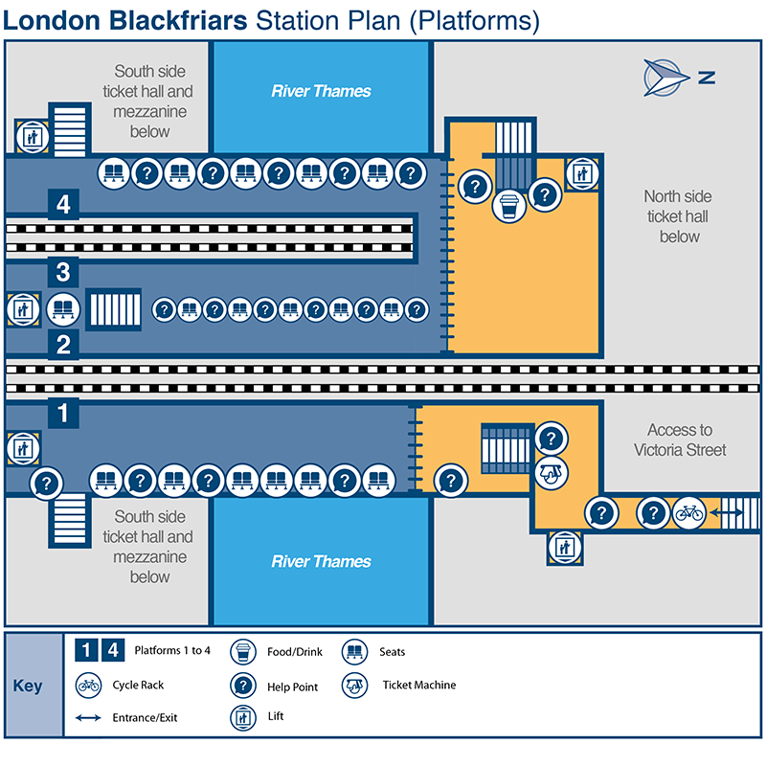

Evidence:
- Research and analysis of task
- Design Sheets for the frontage and layout of the inside
- Development of an idea – improving the idea and showing variations
- Final design of frontage – to a scale of your choice
- Final design of internal layout – to a scale of your choice
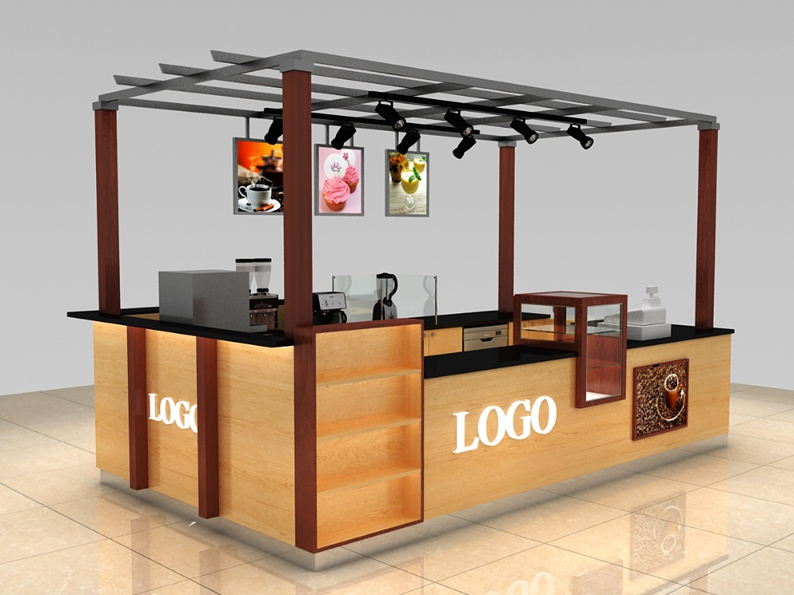
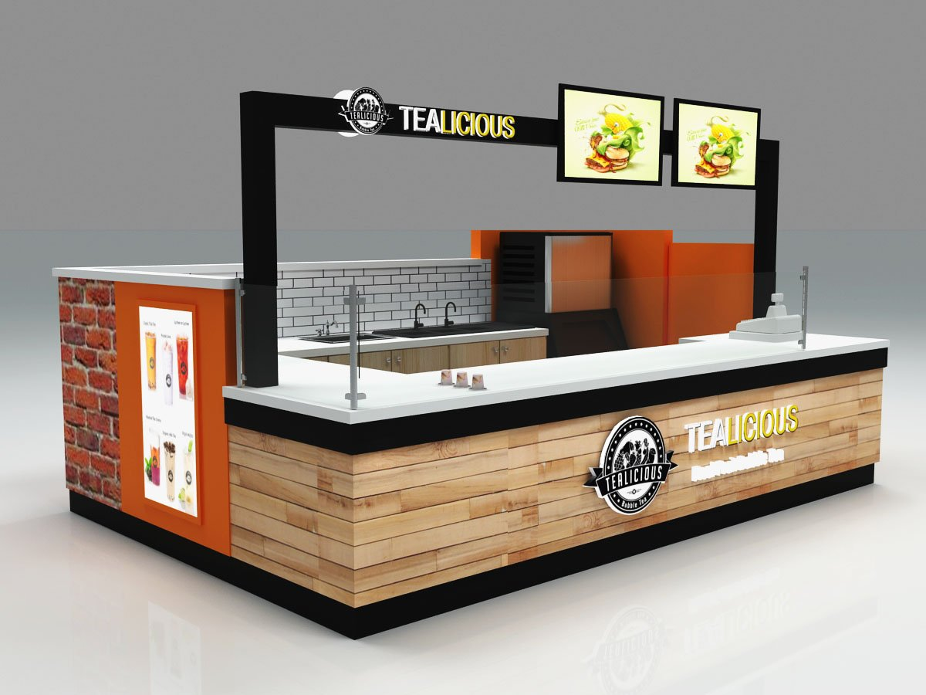

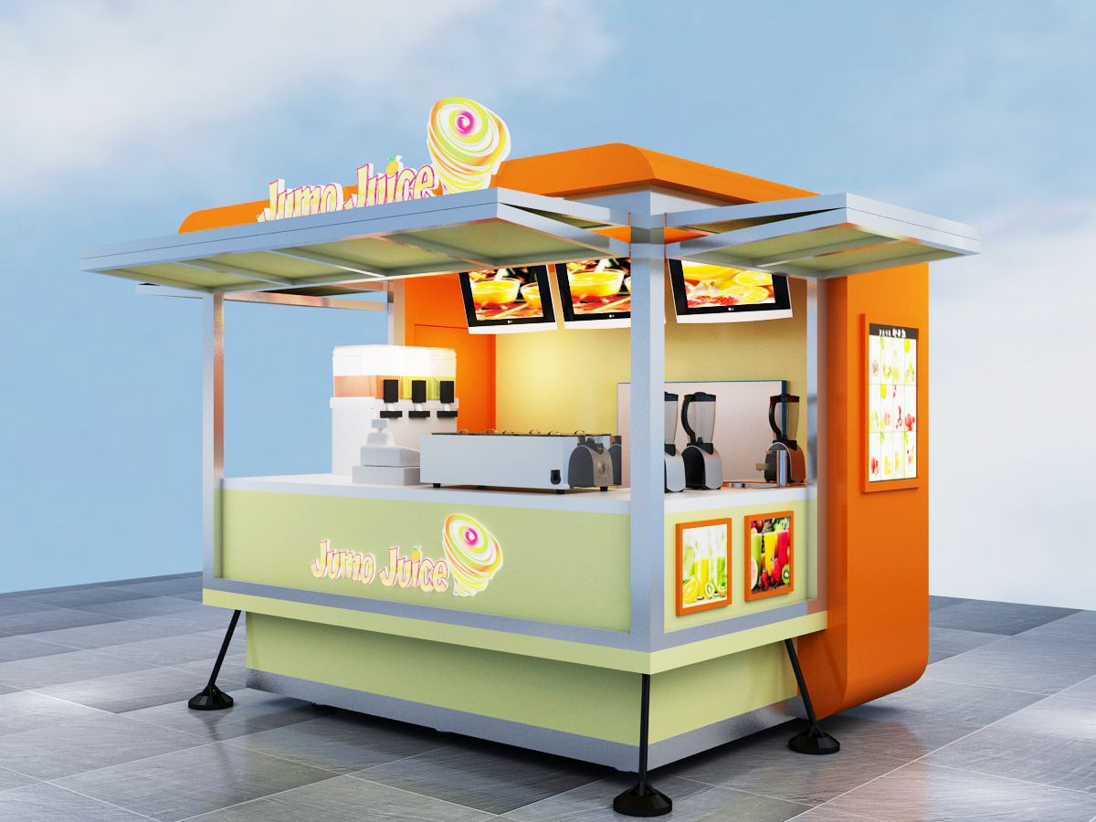

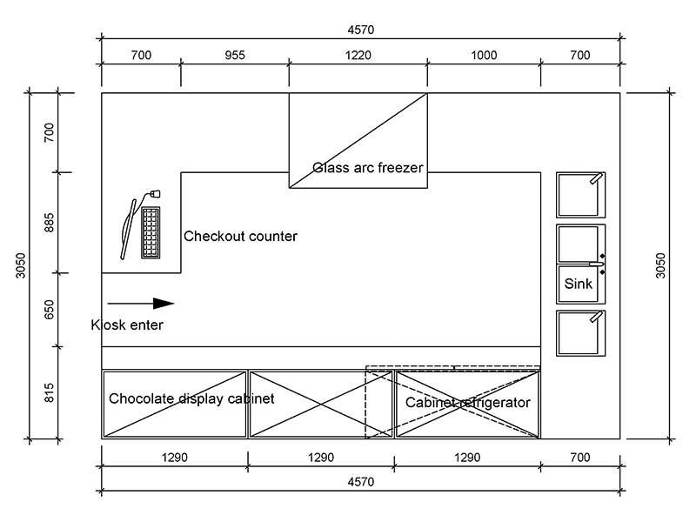
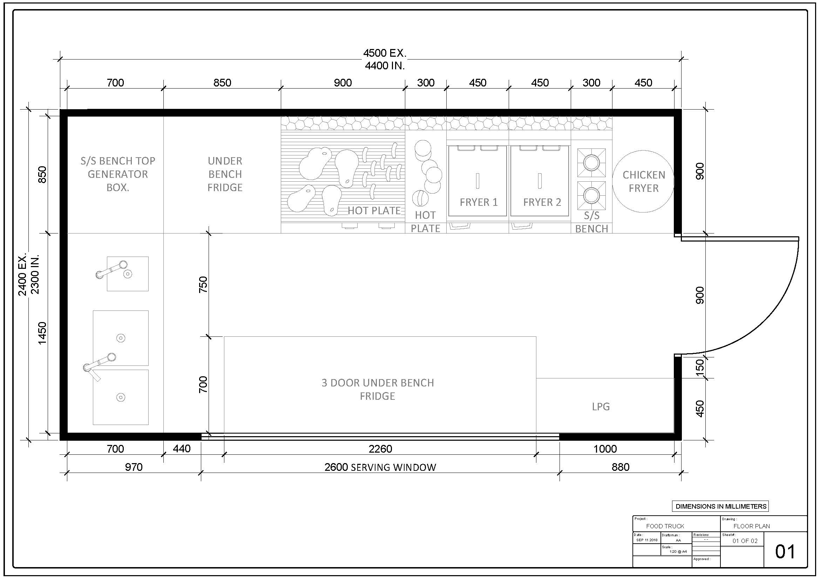

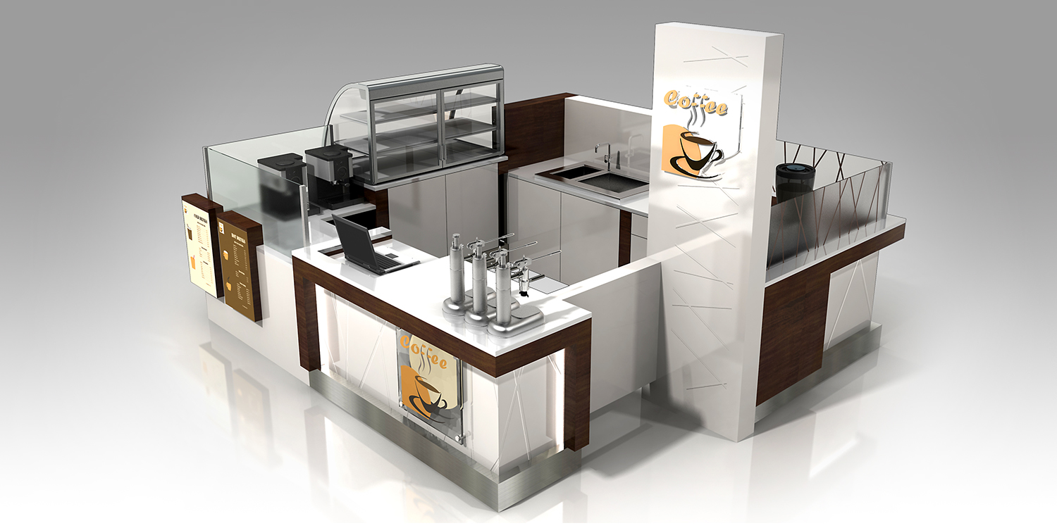

Assessment:
The marks will be for the
- Research 20%
- Design Ideas 40%
- Net/Development sheet 10%
- Final Solution Sheet 10%
- Presentation 10%
- The quality of the final outcome/model. 10%

Hand in Date – Friday 5th September 2025 – by 4.00pm

