

Design

Task – Building Study

Task – Contextual Design – Building Study

In design, the more you see, the more you grow as a designer. Travel feeds the mind and your design understanding. It is essential to get out and about and see things that not only inspire you, but also feed your imagination, which in turn leads you onto exciting and interesting designs in the future.

Aim:

Your task is to study a building of your choice, this is to help develop the way you see things and lay the foundations for future assignments.

Either use a building you have or will visit, locally (such as the development in the town centre), nationally (Visit to a big city) or when you travel on your holidays (Visit to Rome or Paris).

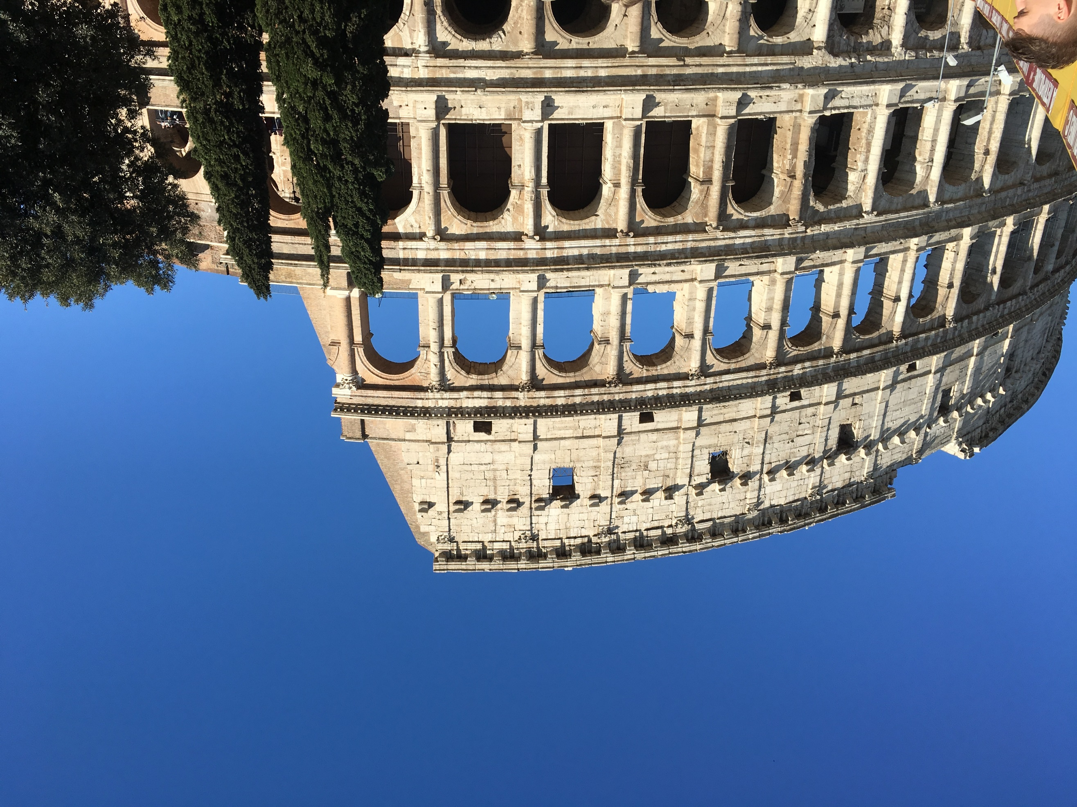

Write about it, adding photos and information you collect, but a visit to the building is essential as you will see things no internet page can show

* It is essential you identify the style of the building
* Explain any special features, the reason for it to be built
* Find out about any technical details, such as cost or the Architect used, etc.
* Try and extract something you have learned from studying the building, which could be useful in a future project or just for the sake of learning

Consider layout & presentation of your work & write in your own words, although photos can be taken from the internet, the photos you take will be preferred. Imagine it as an article in a design magazine, so it needs to be eye catching and hold the attention of the reader.

Outcome:

A Study on a Building

Evidence:

This must be supported by research, notes and visuals. This study can either be presented using either A4 or A3 sized paper. Although sometimes you may need to get photos off the internet, it is preferred you use your own and marks will be awarded for this

Assessment:

The marks will be for the

1. Content, pictures, and information 50%
2. Presentation and the quality of the final outcome. 40%
3. Primary Research, source materials and own photos 10%

Hand in Date – Friday 5th September 2025 – by 4.00pm

Planning for Next Year

**Essential Equipment needed by students:**

* USB pen or access to a OneDrive/iCloud Account
* Range of HB/B Pencils
* 300m or 500mm Rule
* Colouring pencils
* Compass
* Sharpener
* Eraser

Items above are needed every lesson

**Extras supplied to students by the department**

* A3 Card Folder, stored at school – Each group has a designated box
* A4 Card Folder to store notes and information
* A3 Plastic Flip File to be issued for assessment

**Extra Requirements**

* Mobile Phone with scan app, such as Adobe Scan
* A3 Carrying Case – To bring work to and from home
* A4 Carrying Case/Plastic Wallet for design work
* A4 Folder for notes and resources
* Computer & Email Access
* Minimum 5 hours a week extension time – work issued in class, with additional copies online

**Google Sketchup**

* Use the resources on Sketchup from the DT website, have a go and see what you can create!

ICT & Design Studios can be accessed at school during lunchtime, before and afterschool

**Support Mechanisms**

All assignments, resources, homework tasks and any additional materials will always be posted on the DT website. It also has a dates and information page for major events and deadlines. Students can contact staff through their school email if they need further assistance.