Task – Contextual Design – Museum/Exhibition Study
In design, the more you see, the more you grow, the more you open your mind. Looking and studying others helps develop your design understanding. It is essential to get out and about and see things that not only inspire you, but also feed your imagination, which in turn leads you onto exciting and interesting designs in the future. Visiting exhibitions and museums is one way to feed you imagination and see how those from the past, present and future use design in their worlds to create, solve and inspire the people around them.
Aim:
Your task is to visit a museum or an exhibition, which has some relation to Design, either in content or in design of the exhibition/gallery itself, this is to help you develop a way to see things and lay the foundations for future assignments. Seeing other’s work gives you an insight and shows you how others design and overcome their problems. If you visit a museum, just focus upon one gallery, or one aspect of the museum, this will help you get the most from the visit
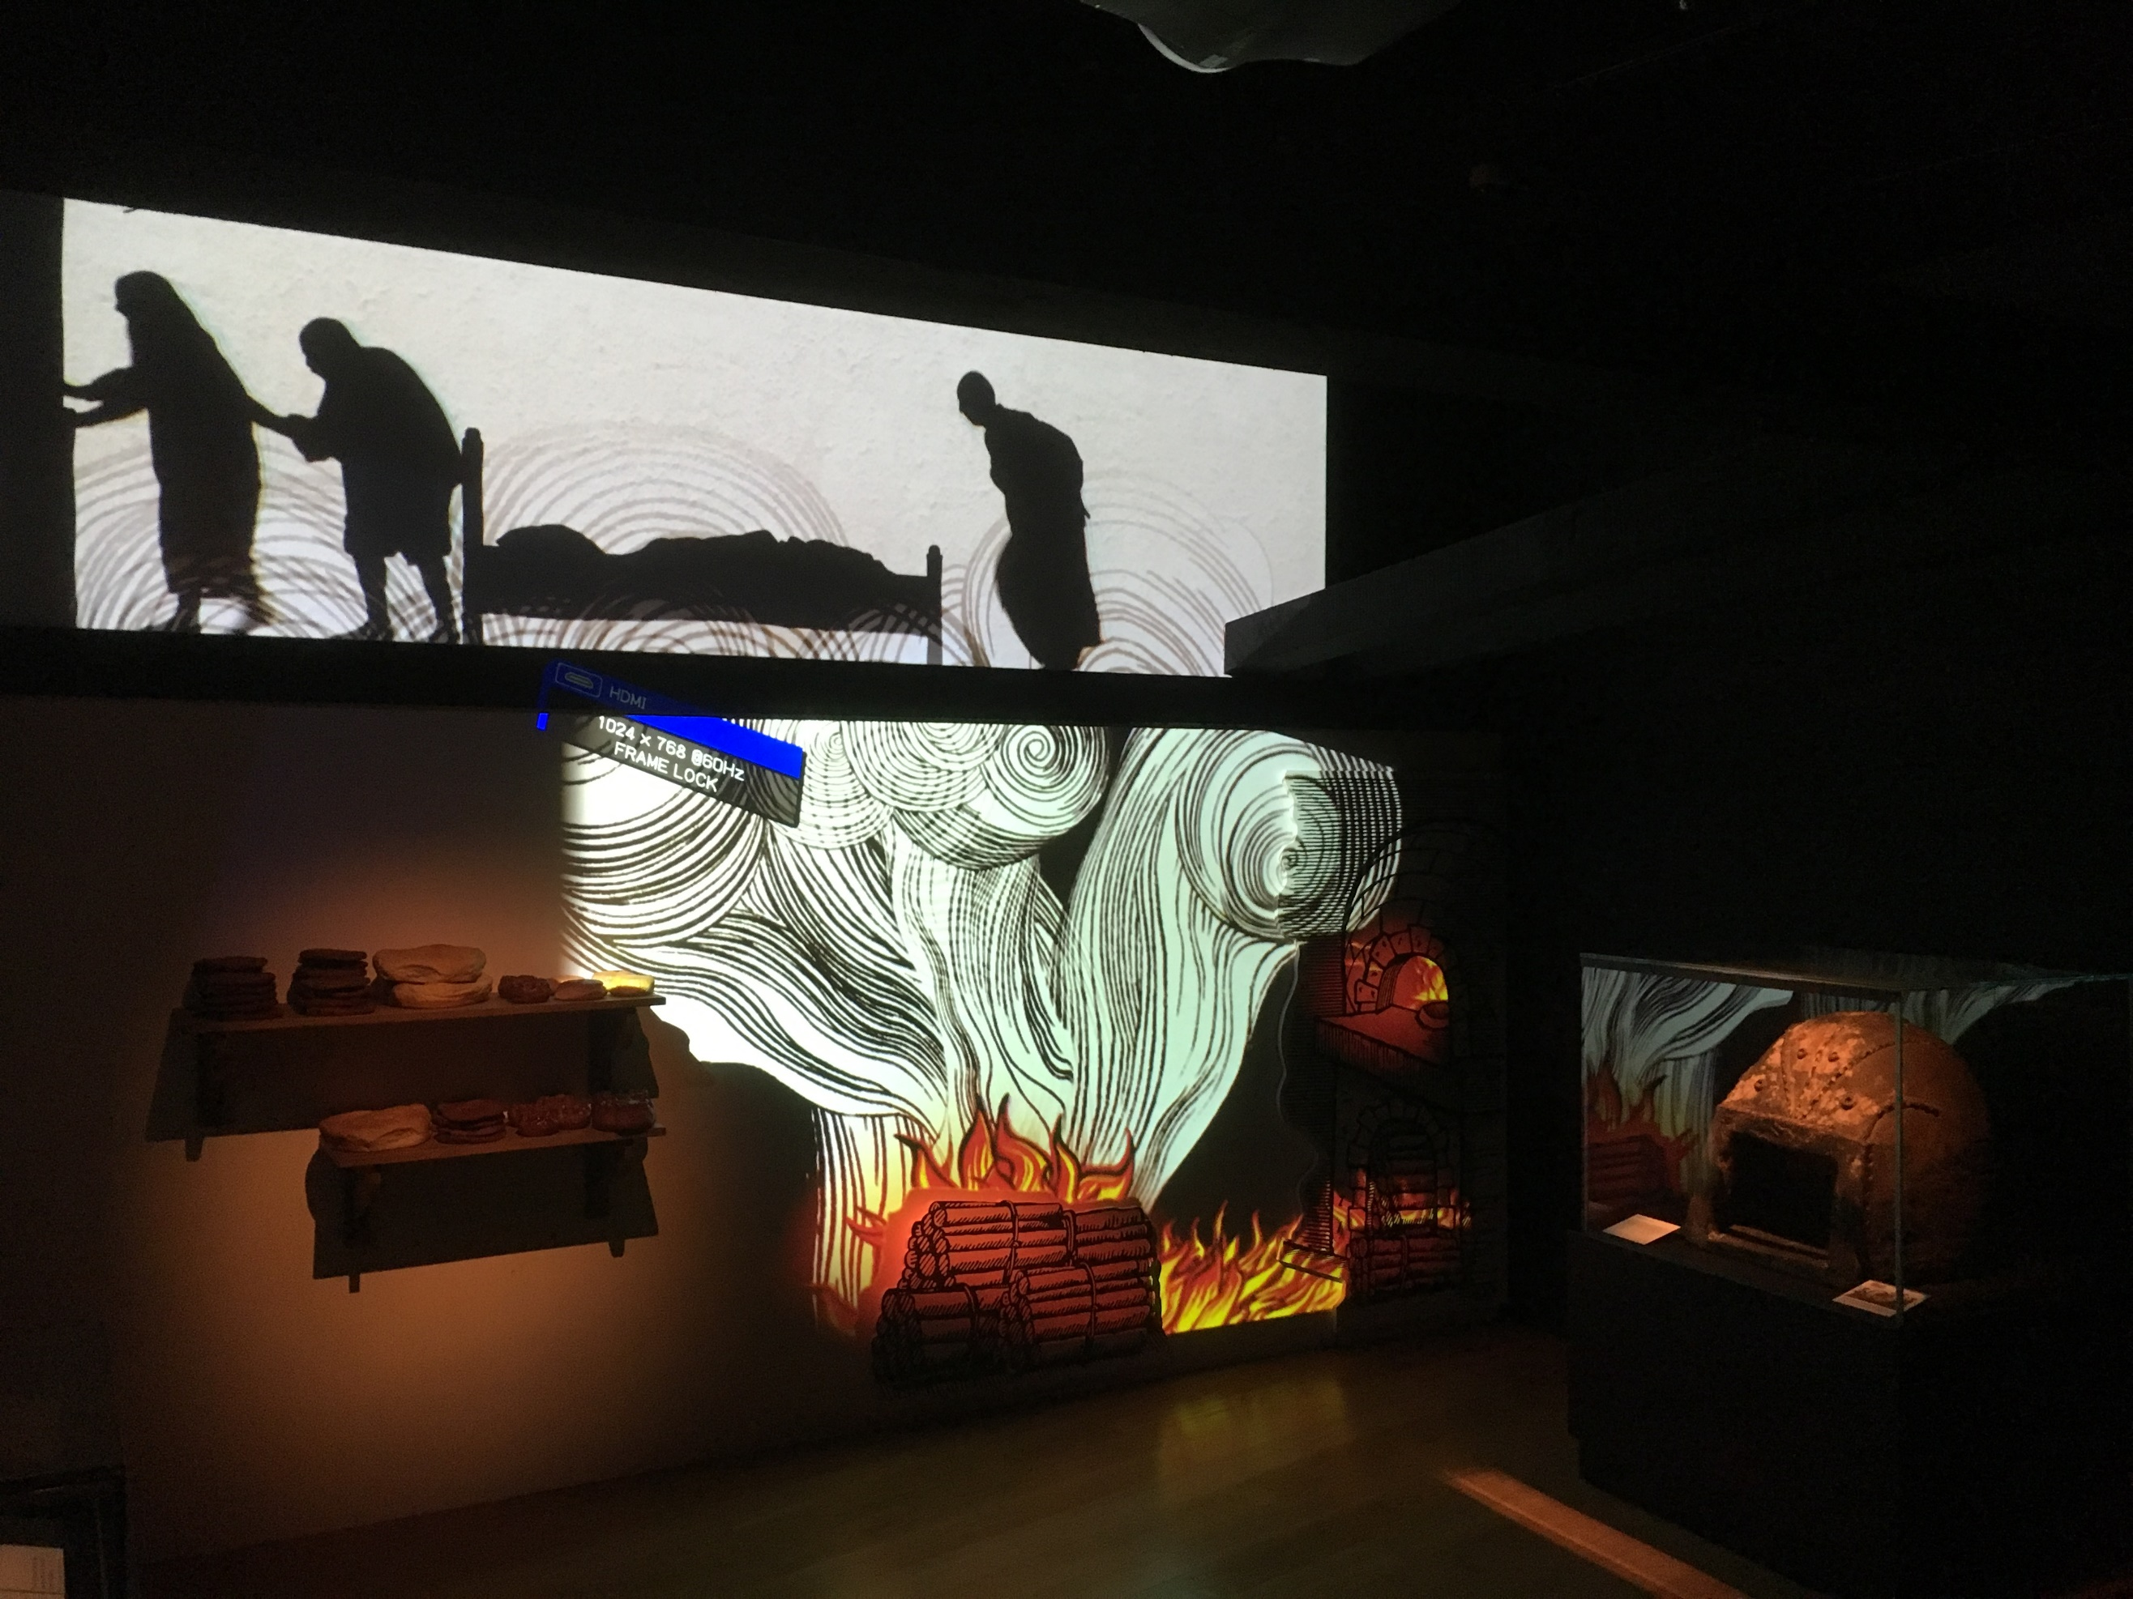
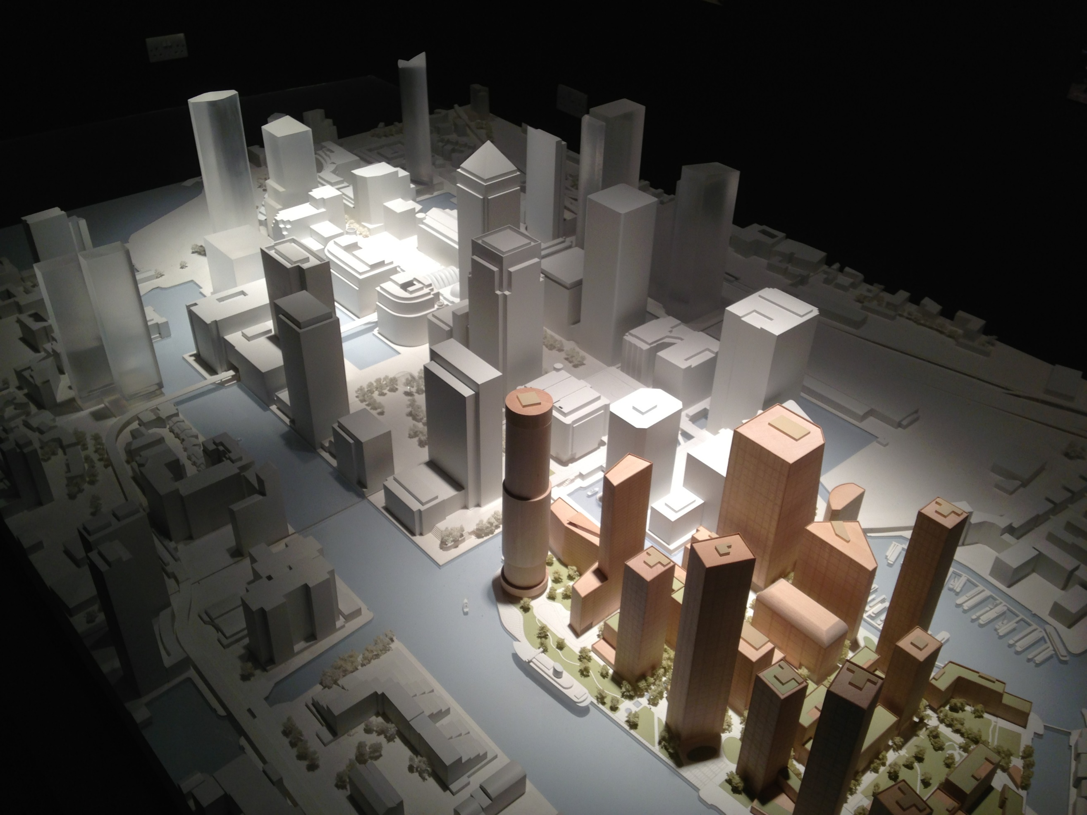

Write about it, adding photos and information you collect, but a visit to the museum/exhibition is essential as you will see things no internet page can show
- It is essential you identify the purpose of the gallery/exhibition; do they achieve this?
- Explain any special features and how things are presented, good or bad
- Find out about any technical details, such as cost or the designers used, etc.
- Try and extract something you have learned from studying the gallery/exhibition/museum, which could be useful in a future project or just for the sake of learning
Consider layout & presentation of your work & write it in your own words, although photos can be taken from the internet, the photos you take will be preferred, be aware some museums/exhibitions restrict this. Imagine it as an article in a design magazine you are producing, so it needs to be eye catching and hold the attention of the reader.
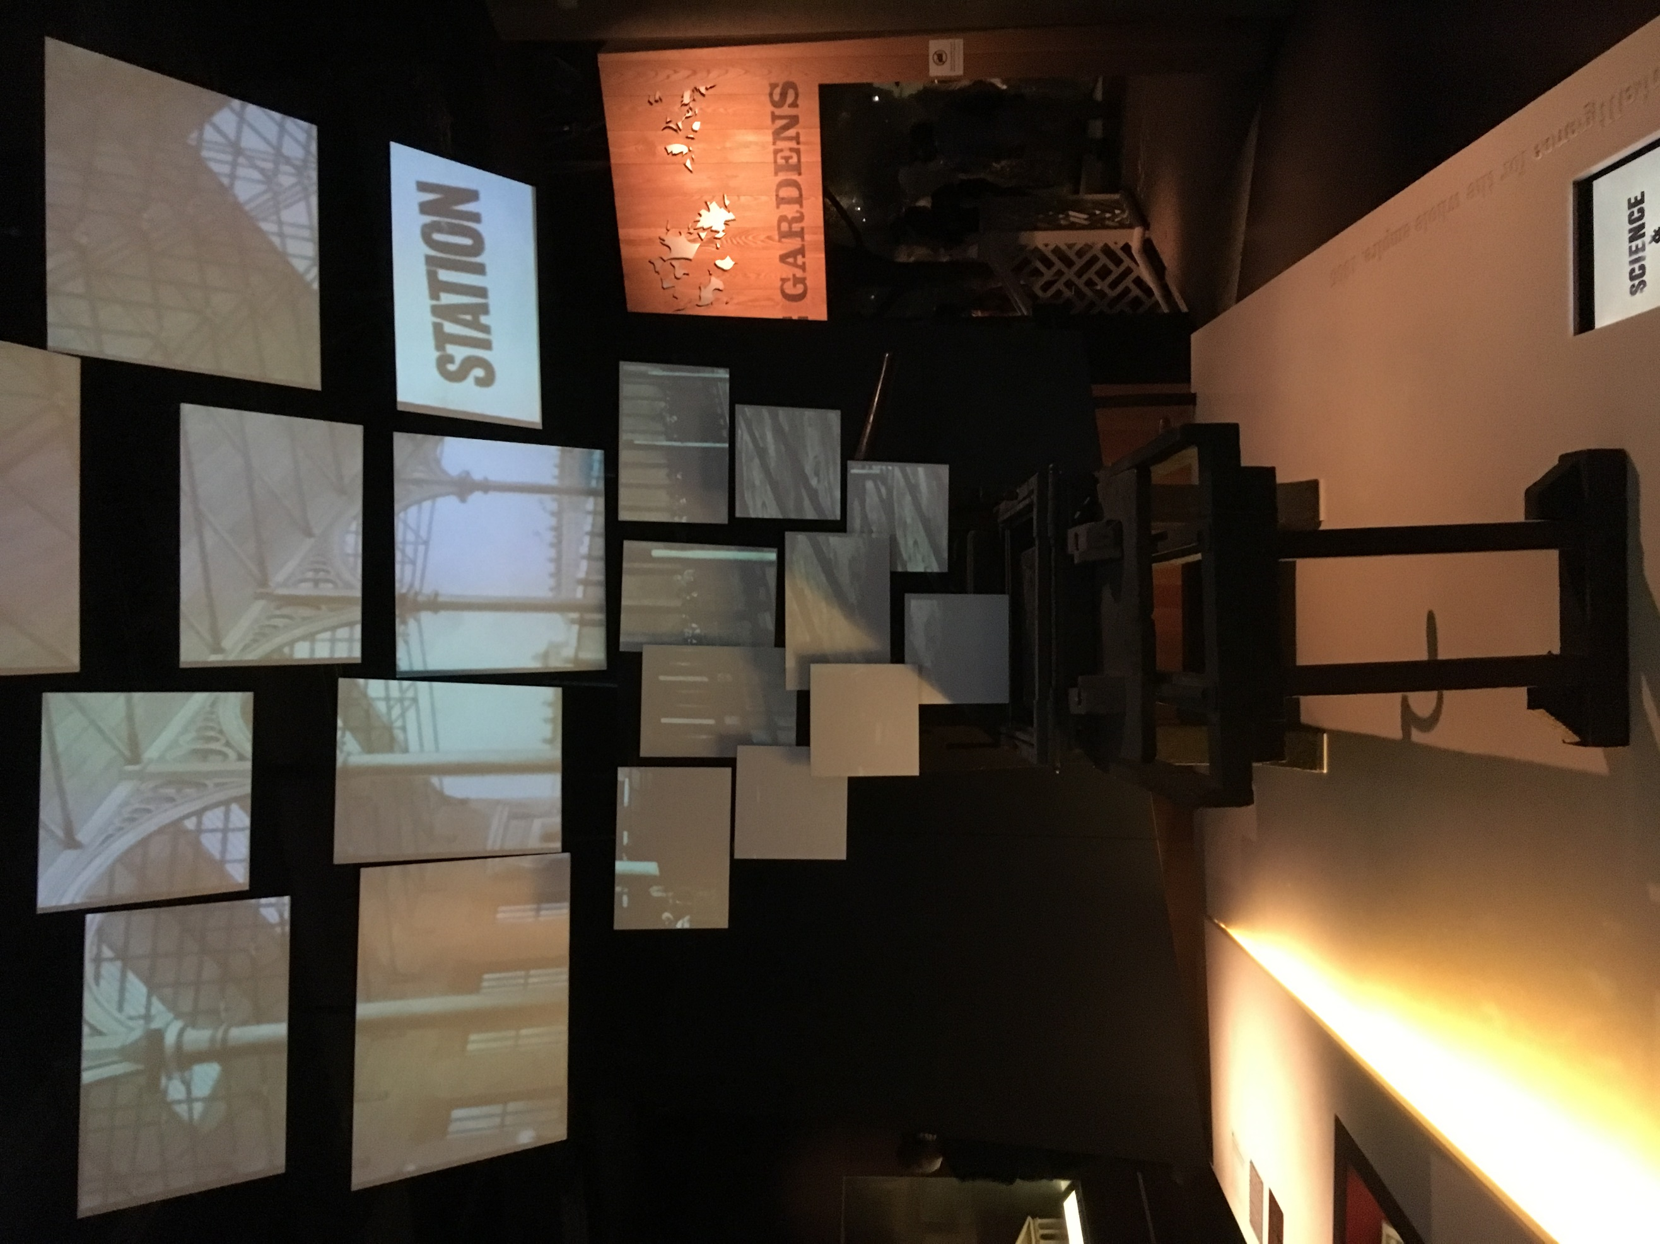
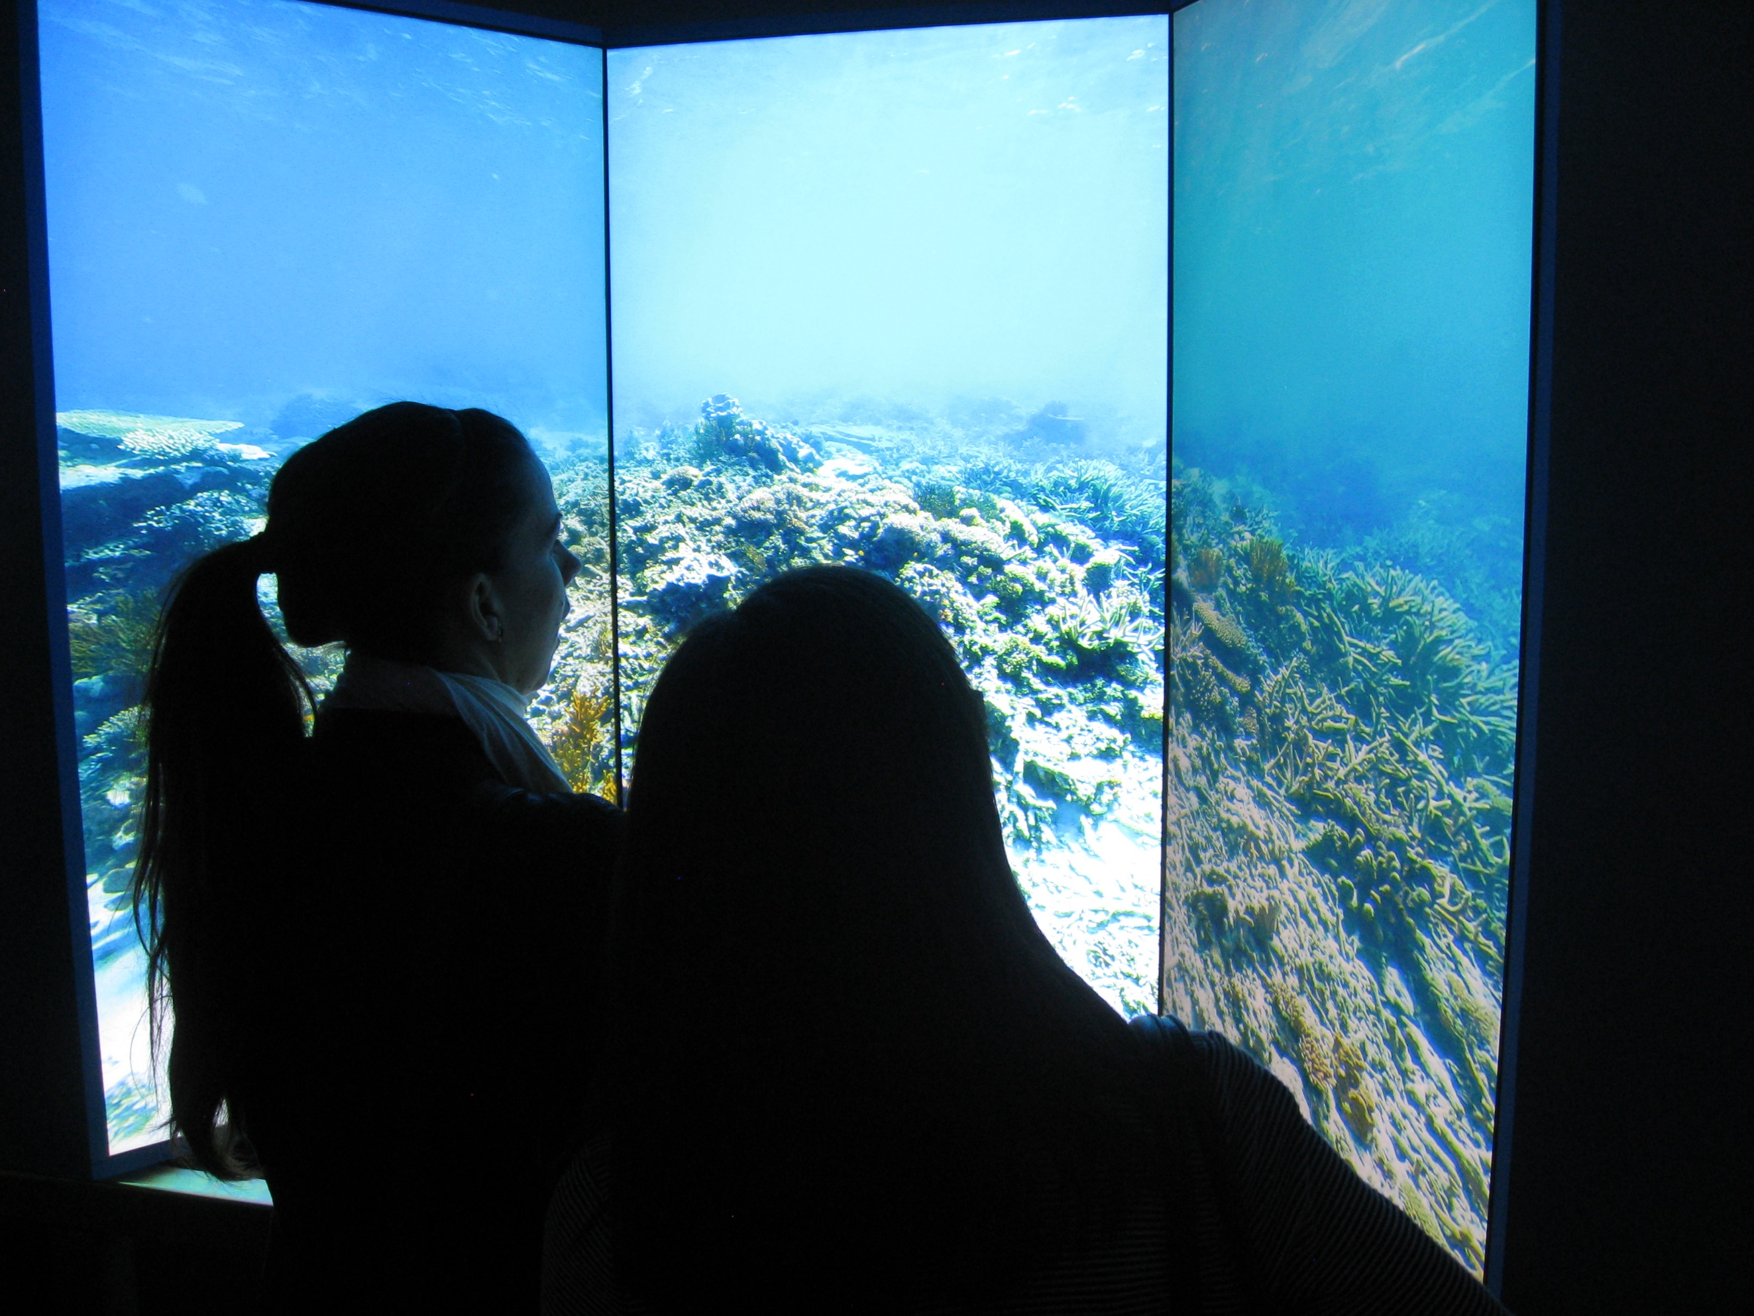

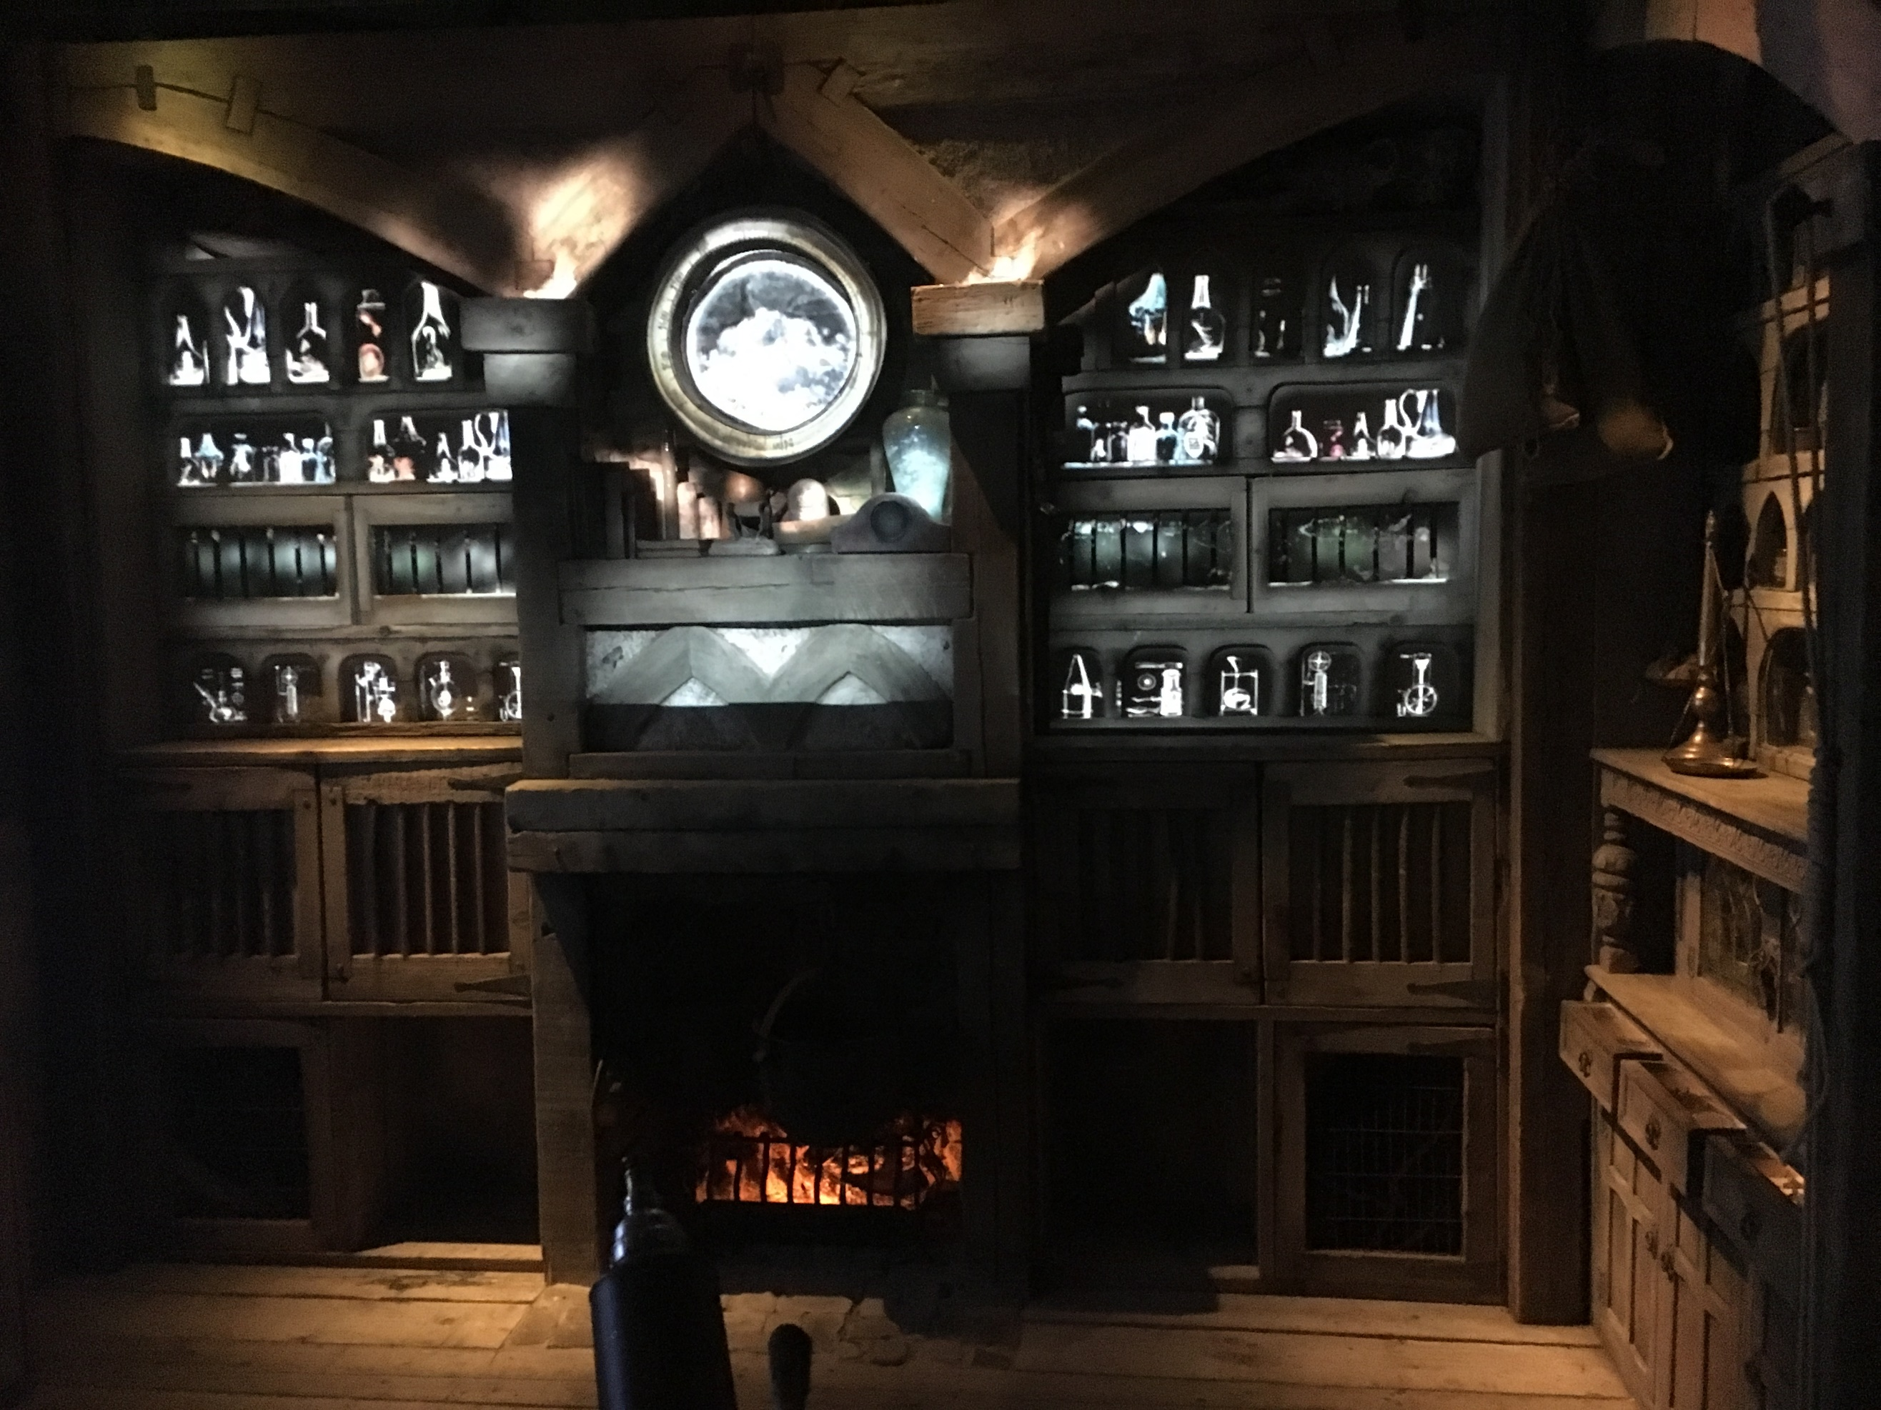

Outcome:

A Study on an Exhibition/Gallery/Museum
Evidence:
This must be supported by research, notes and visuals. This study can either be presented using either A4 or A3 sized paper. Although sometimes you may need to get photos off the internet, it is preferred you use your own and marks will be awarded for this
Assessment:
The marks will be for the
- Content, pictures, and information 50%
- Presentation and the quality of the final outcome. 40%
- Primary Research, source materials and own photos 10%

Hand in Date – Friday 5th September 2025 – by 4.00pm

