Task – Contextual Design – Building Study
In design, the more you see, the more you grow as a designer. Travel feeds the mind and your design understanding. It is essential to get out and about and see things that not only inspire you, but also feed your imagination, which in turn leads you onto exciting and interesting designs in the future.
Aim:
Your task is to study a building of your choice, this is to help develop the way you see things and lay the foundations for future assignments. Either use a building you have or will visit, locally (such as the development in the town centre), nationally (Visit to a big city) or when you travel on your holidays (Visit to Rome or Paris).

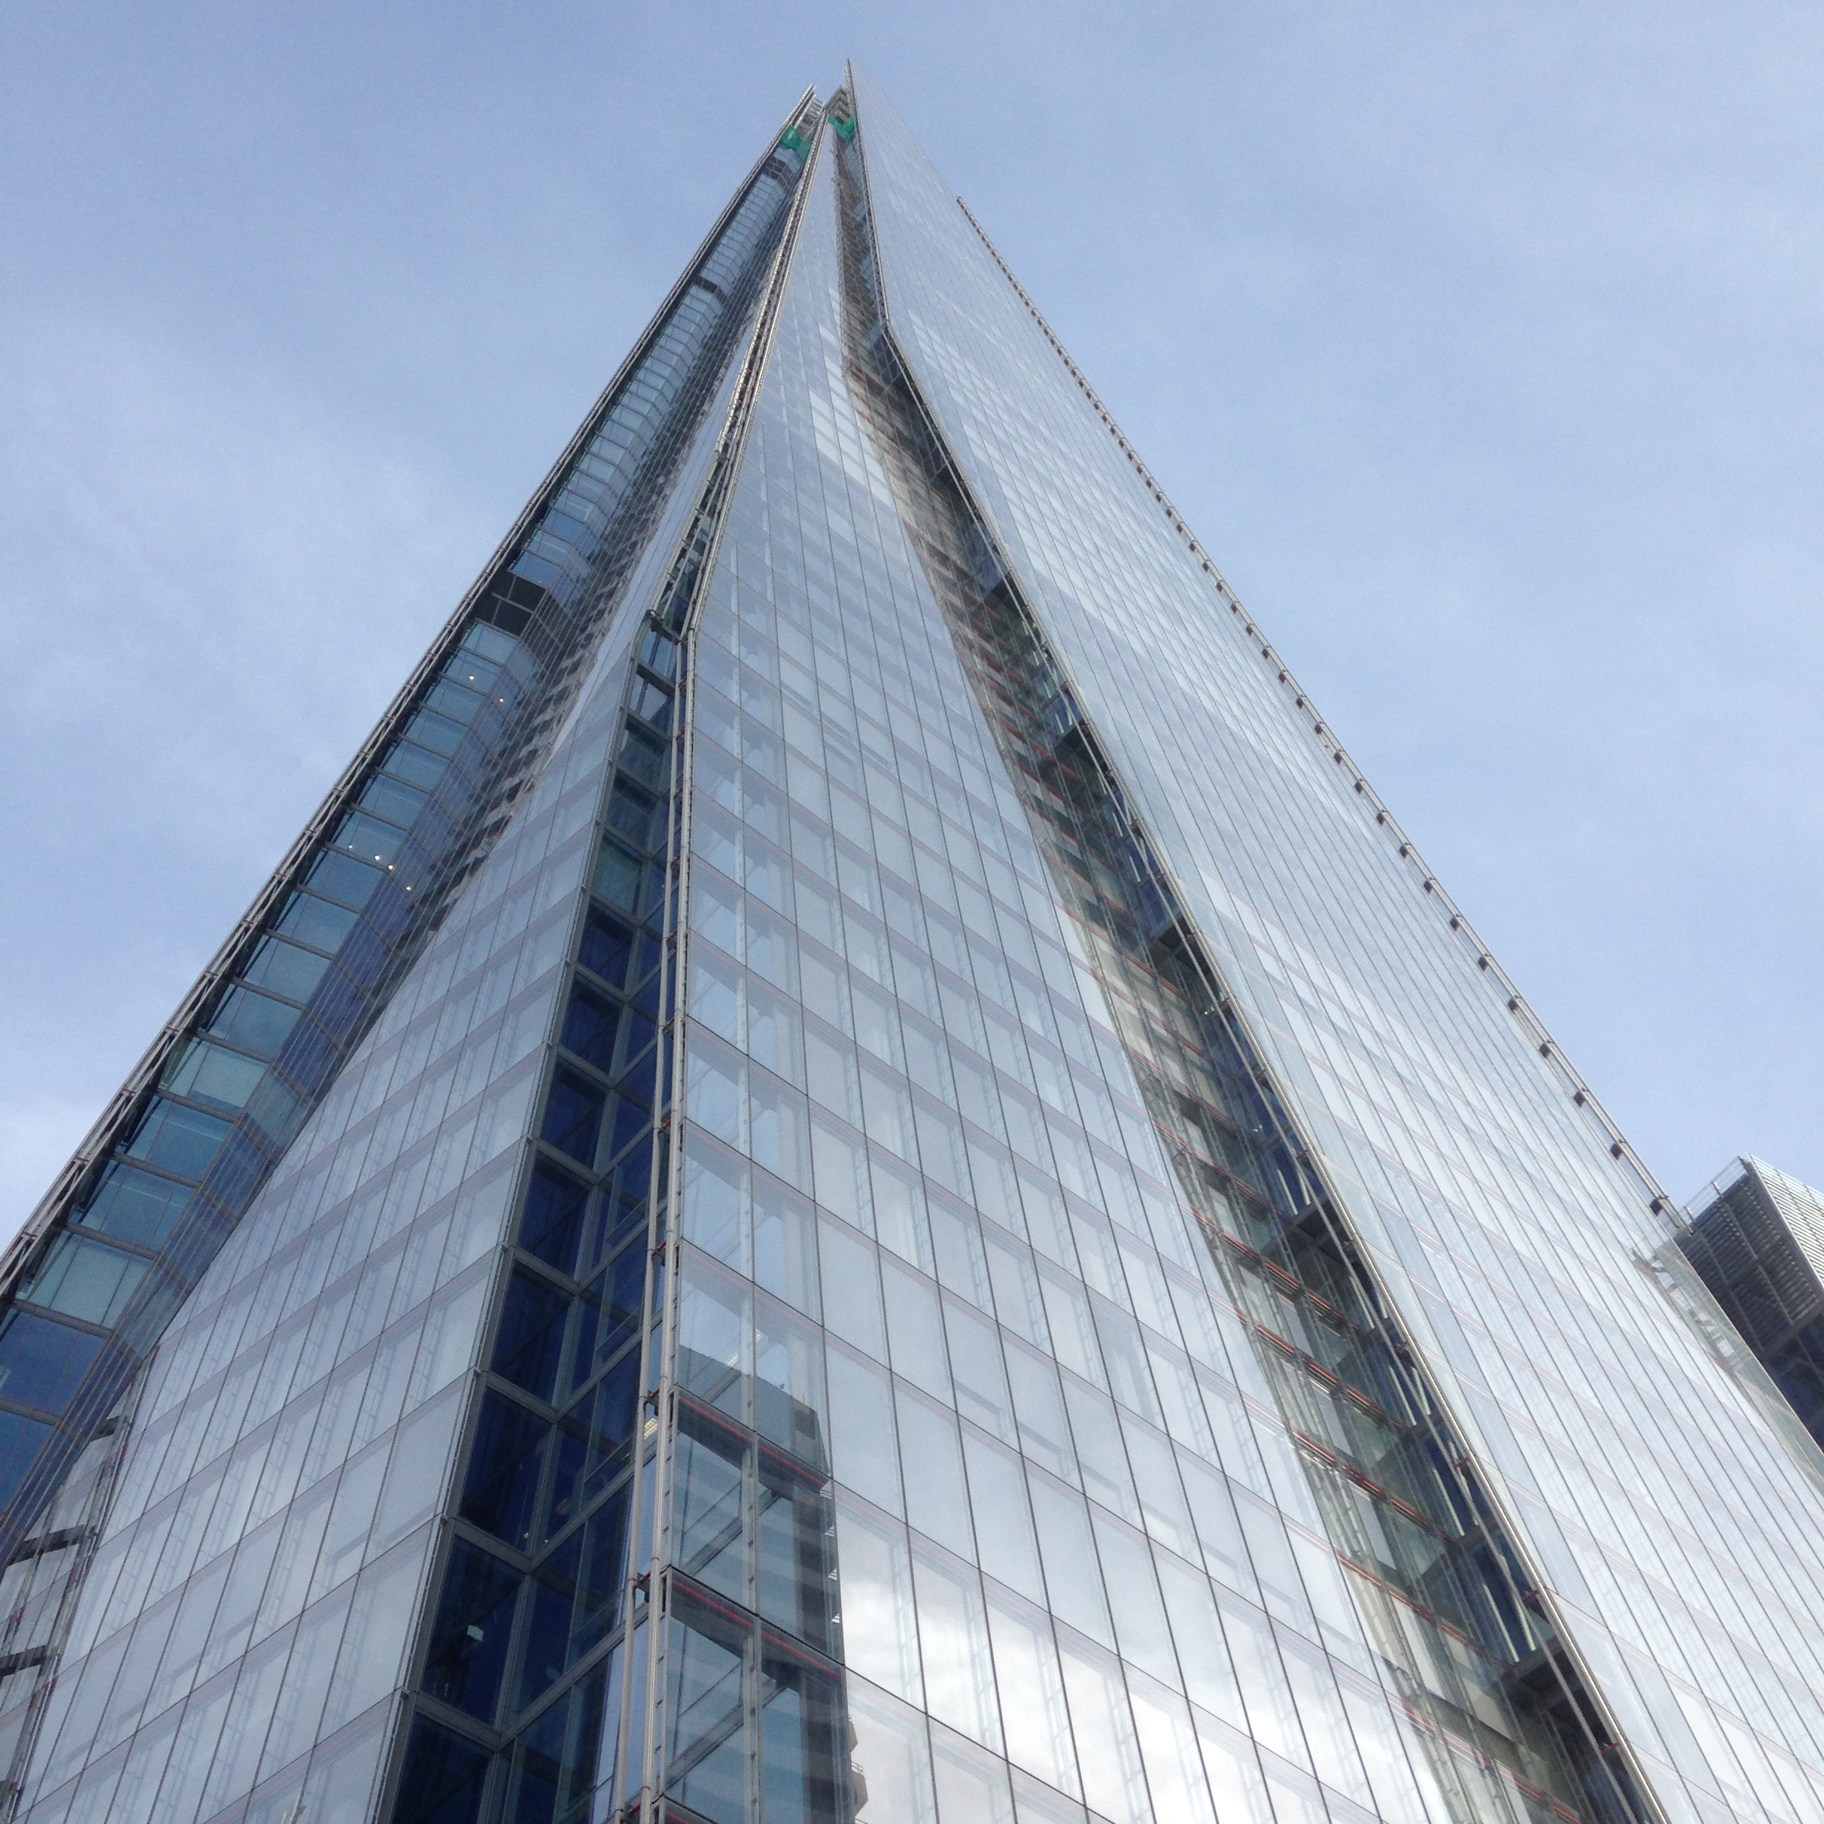
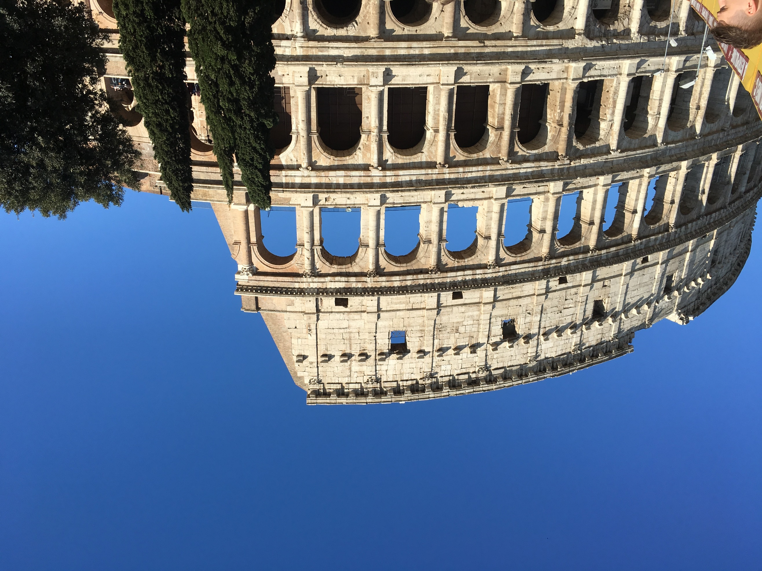

Write about it, adding photos and information you collect, but a visit to the building is essential as you will see things no internet page can show
- It is essential you identify the style of the building
- Explain any special features, the reason for it to be built
- Find out about any technical details, such as cost or the Architect used, etc.
- Try and extract something you have learned from studying the building, which could be useful in a future project or just for the sake of learning

Consider layout & presentation of your work & write in your own words, although photos can be taken from the internet, the photos you take will be preferred. Imagine it as an article in a design magazine, so it needs to be eye catching and hold the attention of the reader.

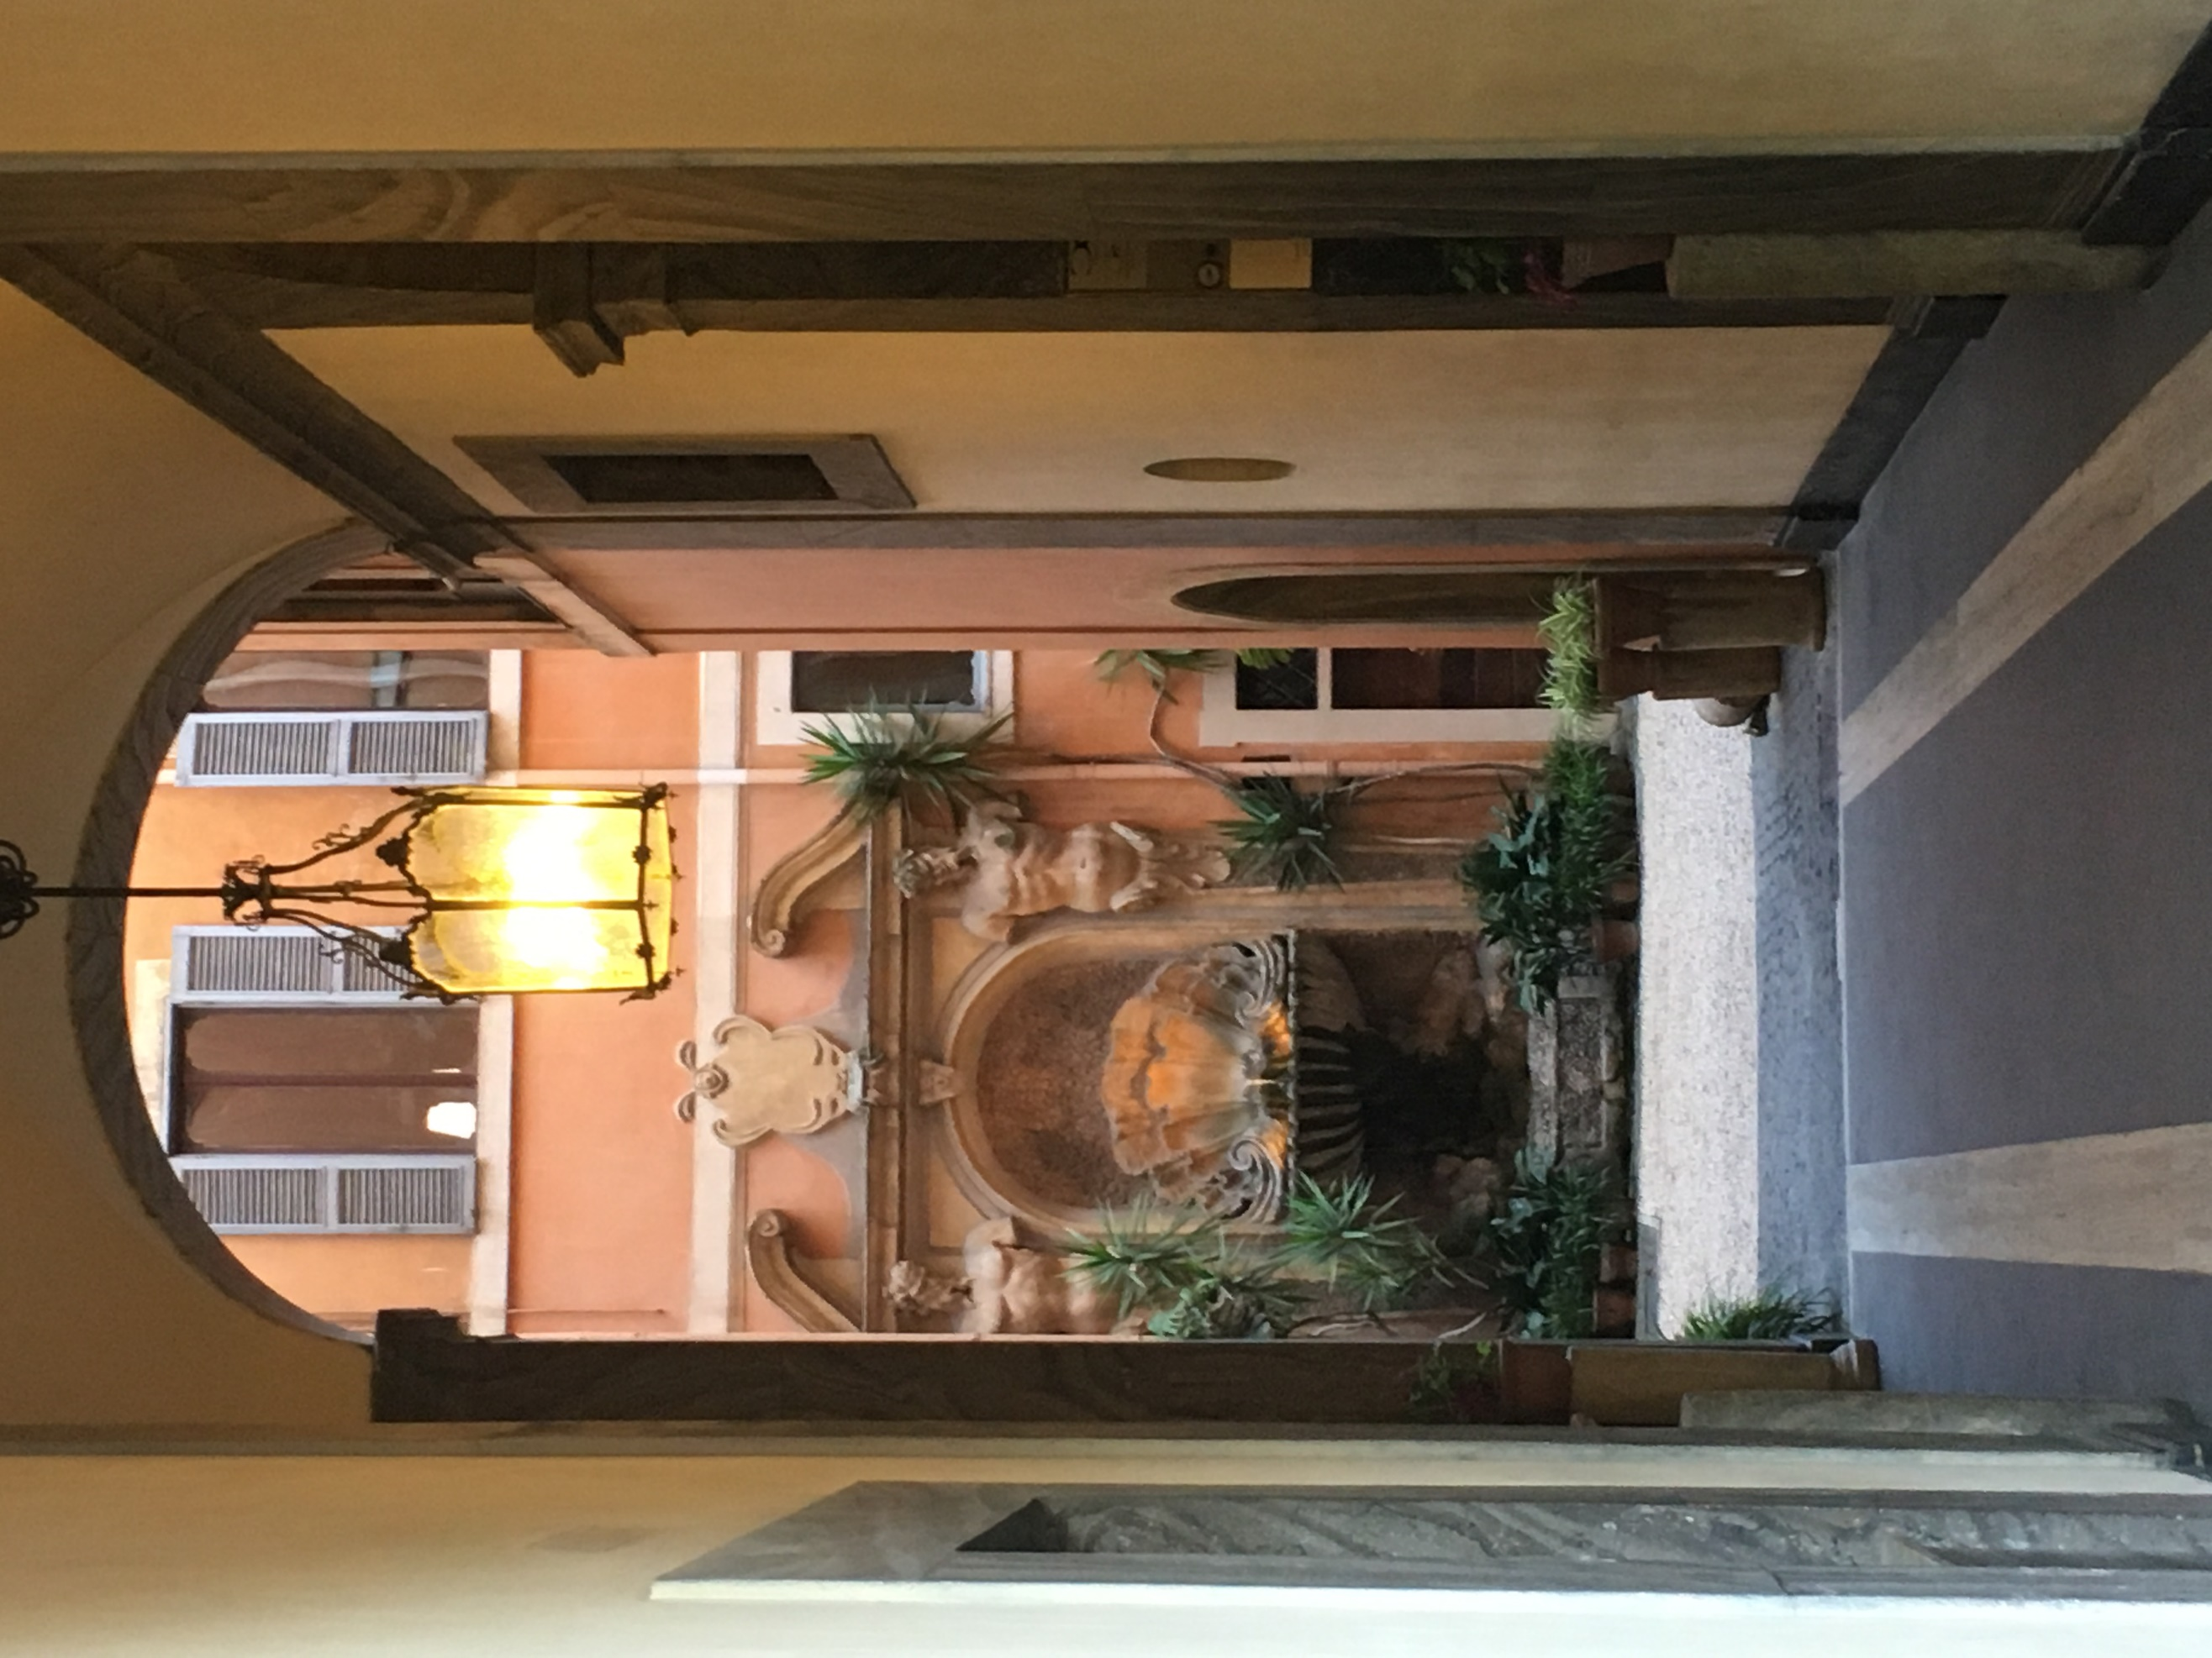
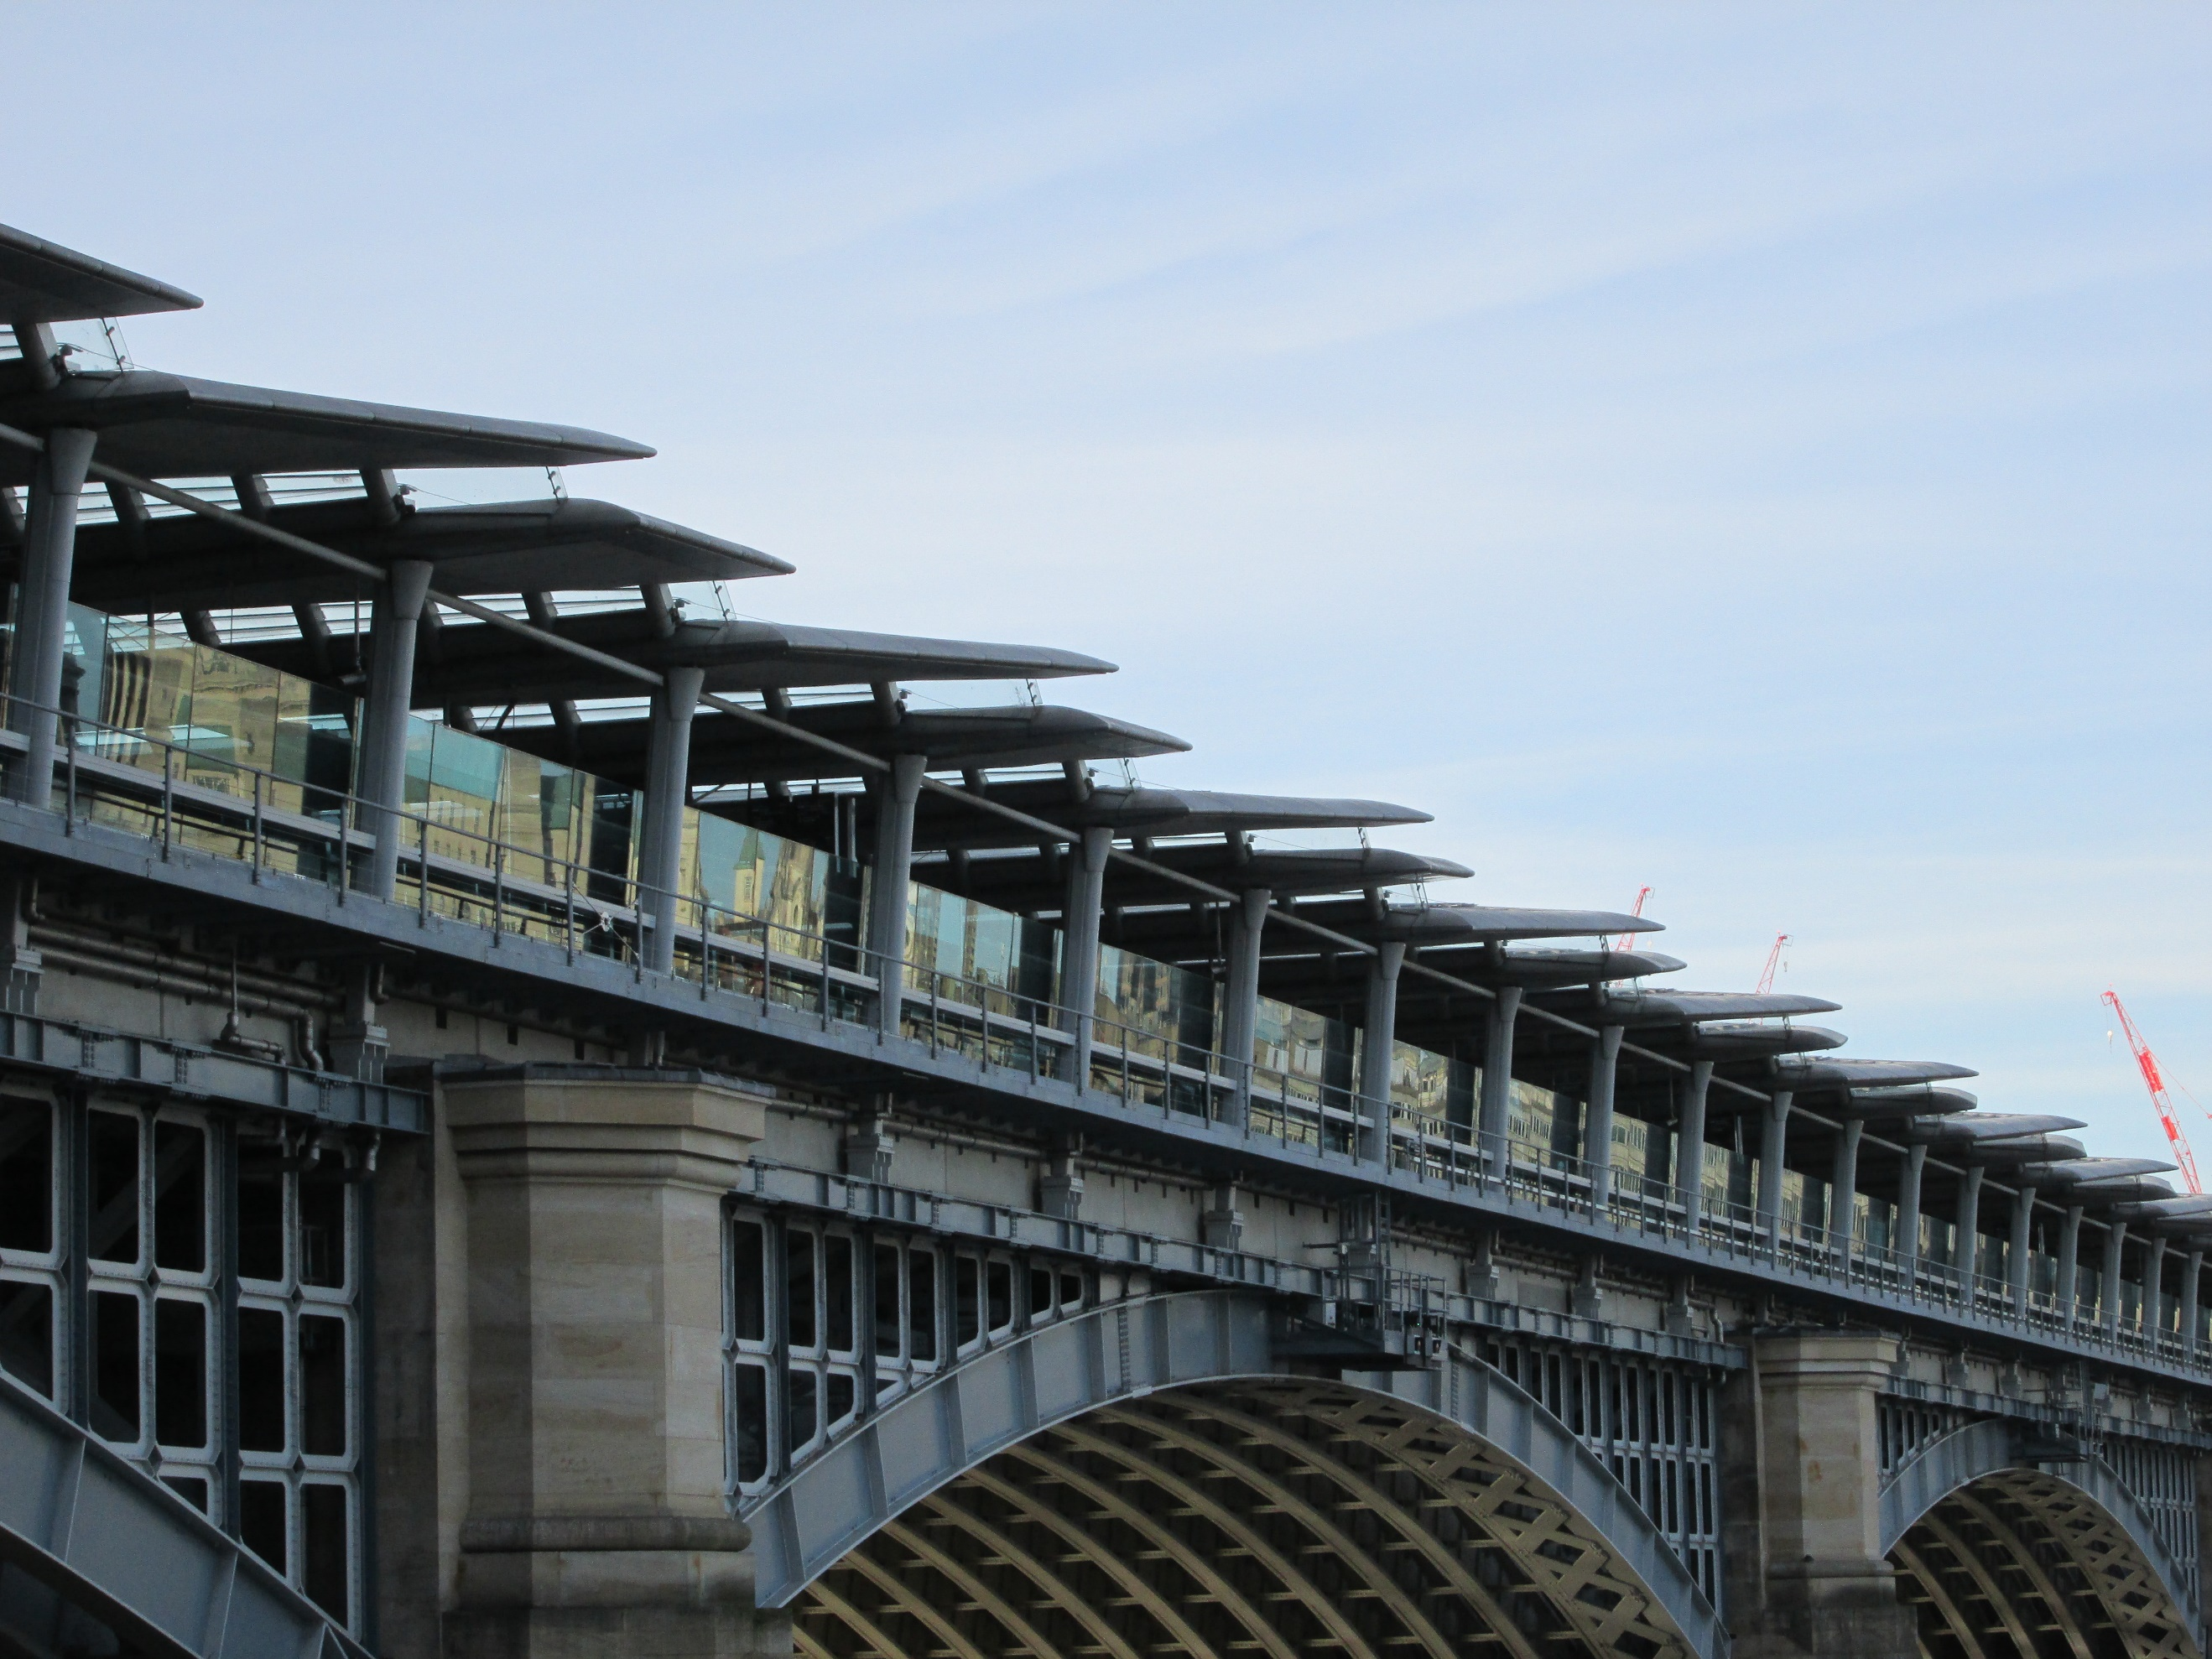

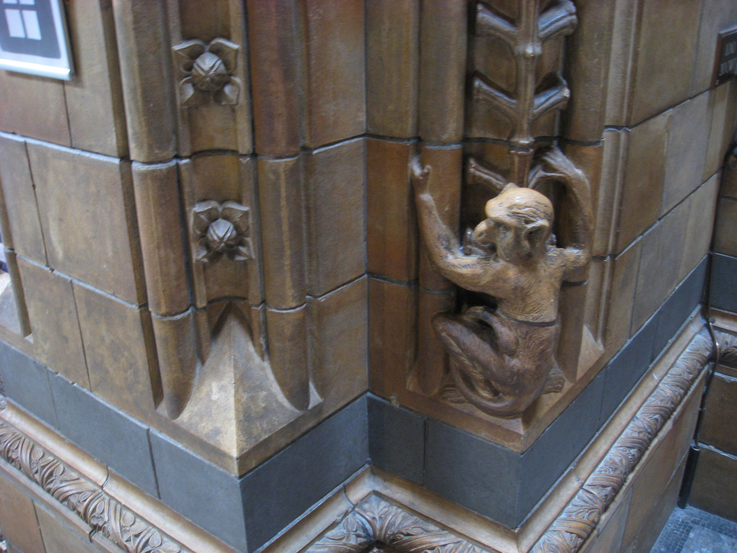

Outcome:

A Study on a Building
Evidence:
This must be supported by research, notes and visuals. This study can either be presented using either A4 or A3 sized paper. Although sometimes you may need to get photos off the internet, it is preferred you use your own and marks will be awarded for this
Assessment:
The marks will be for the
- Content, pictures, and information 50%
- Presentation and the quality of the final outcome. 40%
- Primary Research, source materials and own photos 10%

Hand in Date – Friday 5th September 2025 – by 4.00pm

