Task – To Produce a ‘Green’ Burger Box

A fast-food takeaway company has decided that “Green” Issues are now important, as customers have been making comments about this on social media. One way of supporting this is, is by improving the type of packaging they currently use to hold their burgers.

At present they use a non-biodegradable material, which is difficult to dispose of, but is a good insulator, keeping the burgers warm.

However, they wish to replace this with some form of paper/card-based product.

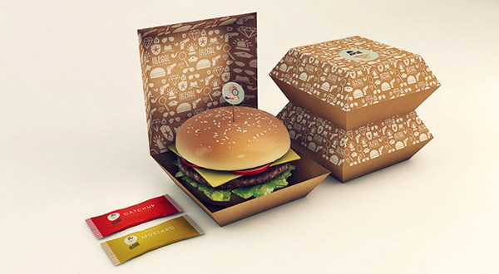

Aim:
Your task is to re-design the packaging for the burgers, and you will need to consider how to project the “Green Awareness” image that the company wishes to put over as well as resolving the need to keep the burger warm.

The Outcome:

New packaging promoting ‘Green Awareness’ for the range of burgers they offer fully realised

Evidence:
You must produce minimum:

Sheet 1
Analysis Sheet – List out main issues, either as a mind-map or brainstorm format, followed by relevant research, which should then be analysed. All points must relate to supporting and helping the designing.
Sheet 2
Ideas Sheet – A wide range of ideas explored, drawn in 2D or 3Dn using any drawing method you wish and supported by clear notes explaining your thinking.
Sheet 3
Net/developments sheet – research and possible nets that can be used as well as information with regards to keeping the burgers warm
Sheet 4
Final Solution Sheet – The final solution accurately drawn out with measurements. There should be notes on materials to be used and possible production methods.
Model
Made up net with full graphics

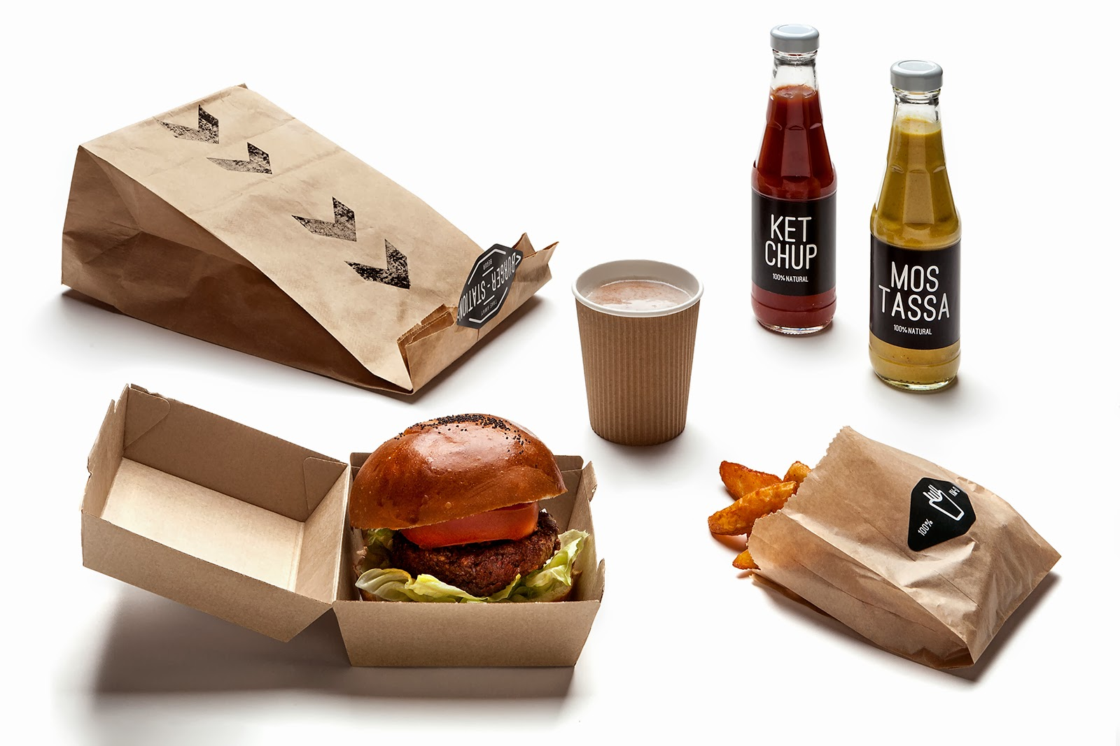
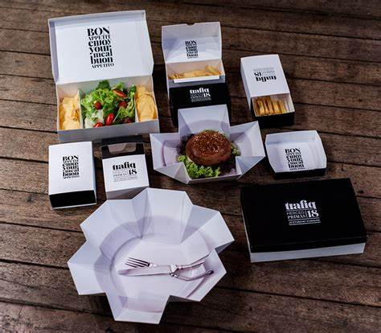

Restrictions

3 Sheets minimum
Sheet Size - A3 only
Colour is necessary
ICT can be used
Fold outs can be used

Assessment:
The marks will be for the
- Research 20%
- Design Ideas 20%
- Net/Development sheet 20%
- Final Solution Sheet 10%
- Presentation 10%
- The quality of the final outcome/model. 20%

Hand in Date – Friday 5th September 2025 – by 4.00pm

