Task – To Produce a Travel Information Guide

You will need to produce a guide/information booklet for a place you have visited during the break. It can be a building, location or urban environment and it would not be wise to pick a big area, such as a city, as this would be too much for a little booklet/leaflet like this.

It can be anywhere, home, or abroad, local, or national. You need to talk about the place and give details both visual and verbal, focusing upon:

- The design, what style it is, what design features make it special or supports the style
- The history of the place (i.e. Glasgow School of Art being based upon the Art Nouveau style and designed by the famous designer/architect Charles Rennie Mackintosh).
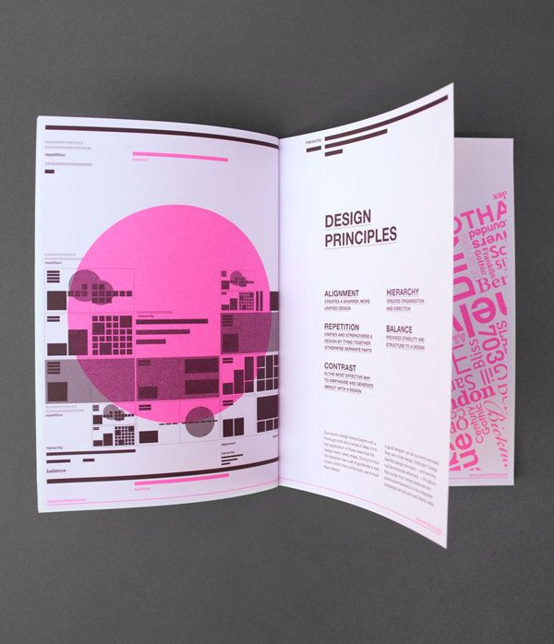
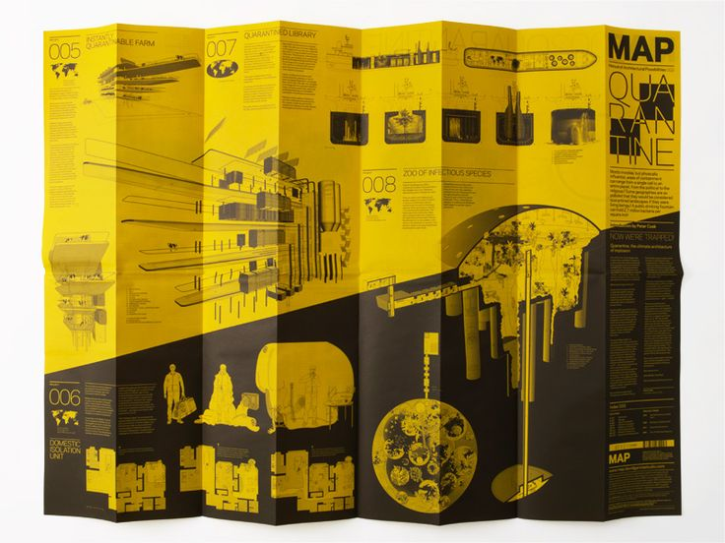

It can be no bigger than A4 and maximum 4 sides, it can be a flyer, leaflet, or a small booklet. It must be written in your own words.
It must include pictures, text, and information, as well as how to find it and further information such as a website. Using your own photos will be essential
The target group would be visitors to this place and the idea is that this would be given to them when they arrive to explain the place they are visiting.
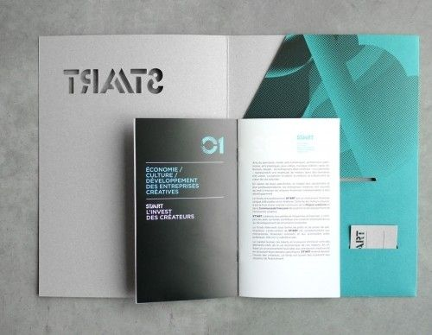
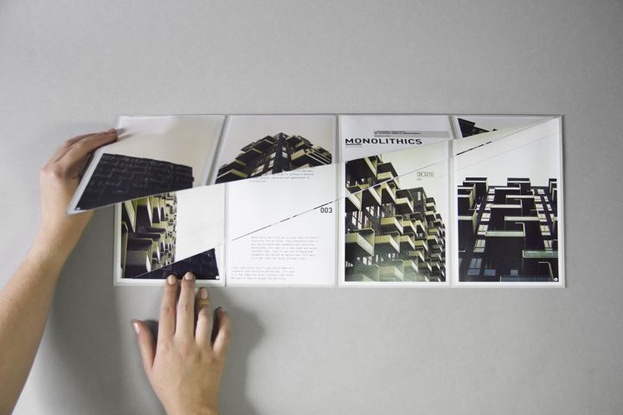

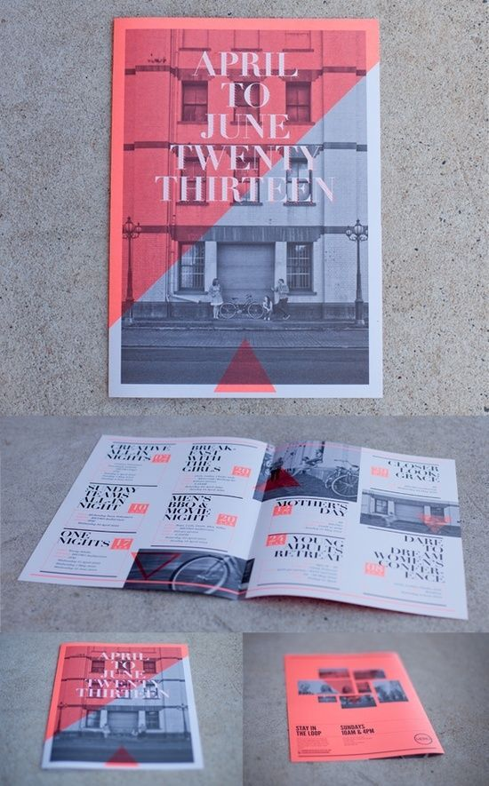

Outcome:

A Travel/Visitors Information Guide

Evidence:
This must be supported by research, thumbnails, and some basic roughs. You also need to show any ICT work through screen shots. This section can either be presented using either A4 or A3 sized paper.
Assessment:
The marks will be for the
- Content, pictures, and information 40%
- Presentation and the quality of the final outcome. 60%

Hand in Date – Friday 5th September 2025 – by 4.00pm

