Adventurer’s Rescue Alarm

An Invitation has gone out from the International Climbing & Adventurers’ Institute for companies to bid for a major contract in the re-design of their emergency rescue alarm unit.

Their current unit is too large and heavy and has limited range and use.

This alarm is used by those on major expeditions where contact is difficult, and the environment is hazardous. The unit will be worn by climbers and other people and is used to signal for help when things go wrong.

An alternative company has already developed the electronics for the unit, which can be simply activated and will send a distress signal as well as a location to the central monitoring station via a range of satellites across the world. The unit is intended to be completely sealed, this is because the electronics inside need to be completely safe and waterproof, and a special material has been developed to surround the electronics, make it shockproof and resistant to heat and cold.

The navy and the armed forces are also interested in its use and there could be possible sales in the shipping and sailing fraternity. A special battery has been developed, which can in turn is monitored. It has a battery life of 21 days, unfortunately when this runs out a new unit will need to be purchased.

It is also intended to keep the price reasonable to increase sales, which will allow large manufacturing runs to take place so reducing the costs all round. The battery issue will ensure repeat sales.

You will need to produce a range of concept models as well as a final, more detailed model to present to the client.

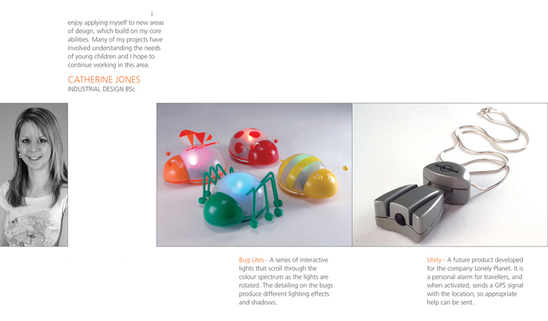

Resources – DT Library, DT Website
Resources – 2D Design, Sketchup, Photoshop
Resources – Design Studio, ICT Suite, Workshops

