Model Making
Always use a scale either –

1:12 – Same size as used for the shop fronts and used a lot on model shops & houses, so we can get lots of spares and accessories to lift your model.
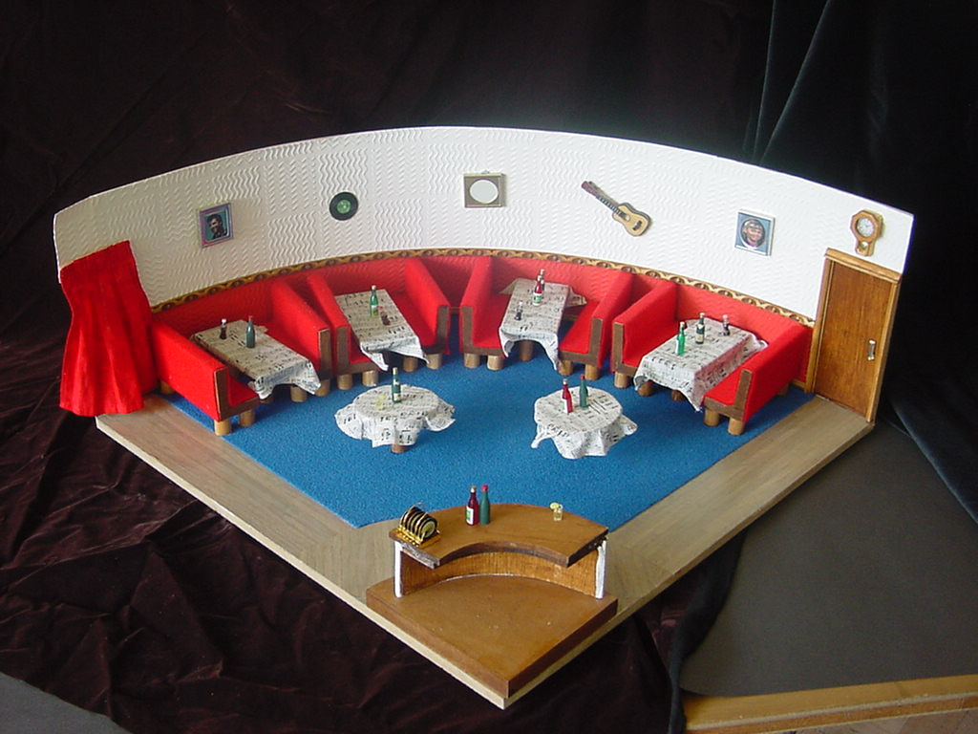

1:72 – We need to use this scale for large buildings, mainly exteriors. We can get lots of spares and materials, especially figures as this is the scale used for 00/H0 model railways.
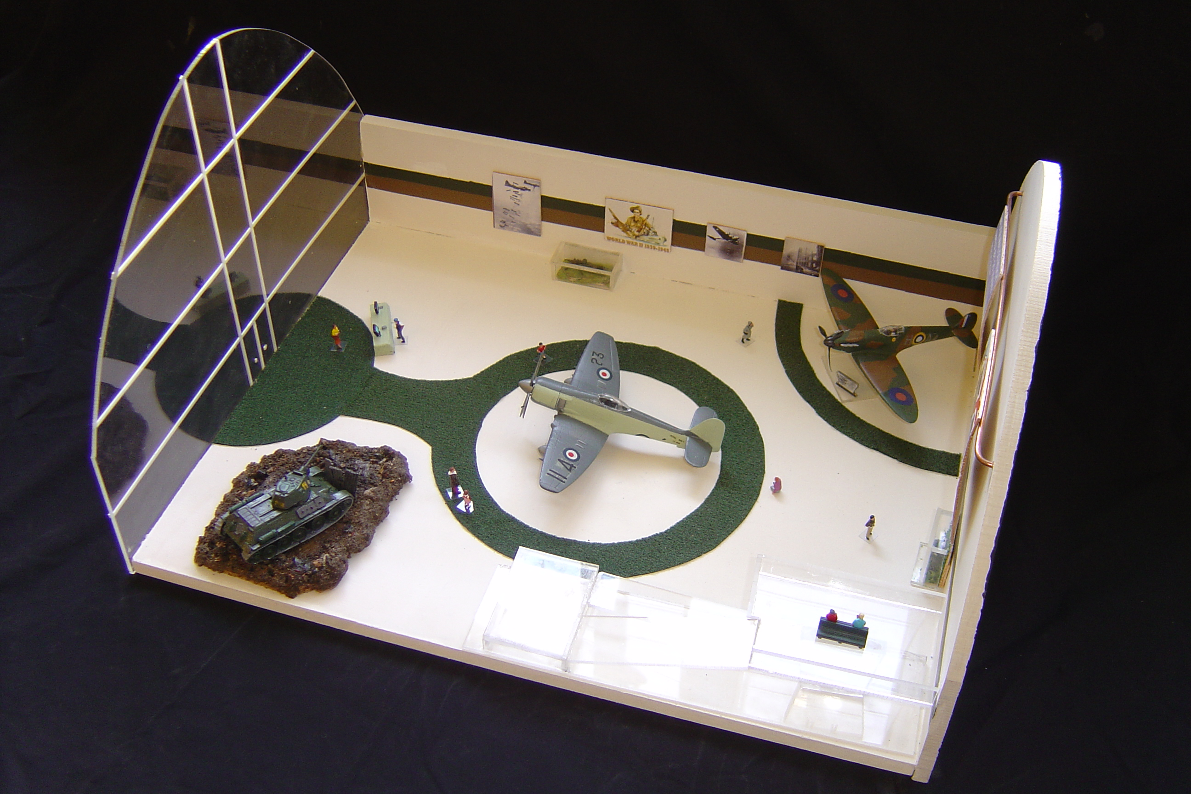

In industry the following scales are recommended by BSI – 1192
On location (block plans on a map) | 1:2500
 | 1:1250
Site Plans | 1:500
 | 1:200
General Location | 1:200
 | 1:100
Component size range | 1:100
 | 1:50
 | 1:20
Component detail | 1:10
 | 1:5
 | 1:1
We do not tend to use these as materials and accessories tend to be very expensive.

