Working Drawings & Dimensioning

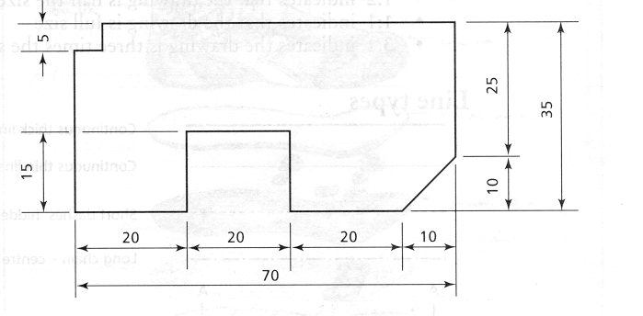
Some points to remember:

- dimensions are written above the dimension line
- vertical dimensions are read from the right-hand side (turn the drawing through 90")
- you should use millimetres at all times and note it only once in the title block
- arrow heads are long and thin and do not dominate the drawing
- dimension limit lines stop short of the object by 2mm
- the smallest dimensions are put nearest the object
- do not dimension inside the object

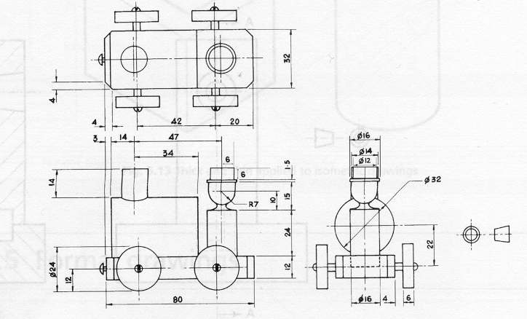

You will need to produce a working drawing for your project, this is best done by using a CAD programme, but sometimes you will have to draw it by hand

