Post-16

Design

Contents

Study Skills for Learning

Introduction 3

Organisation 4

Courses 5

Independent study 6

Motivation 7

Time Management 8

Learning Styles 10

Different Methods of Learning 13

Note Taking 19

Reading Skills 21

Revision strategies and Exam preparation 22

Dealing with Stress 26

Appendix

Q & A 27

Checklist for organisation 29

Independent learner Assessment 30

Revision/Exam checklist 31

**Post-16**

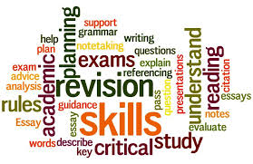

**Design**

**Study Skills Guide**

**Introduction**

Most of you will find that learning in the Sixth Form is completely different, with new approaches to studying that you may not be used to. It is important to start with a positive frame of mind and keep motivated throughout your course. This booklet is here to help you with that, giving you strategies and ways to enable you to focus upon what is important to ensure success.

It might not be easy, but the Sixth Form will provide you with opportunities to build self-confidence and develop new skills, preparing you for the outside world.

You will be given work that is more demanding than you have previously been used to and you will be put into unfamiliar situations, which you may find challenging. But remember, we are here to support you and help you grow as individuals and learners. View it as an exciting new adventure.

The most important new skill you will learn will be how to become an independent learner, driving your work forward and developing a deeper understanding of Design

You will need to get used to spending time studying in the evenings and at weekends and organizing and managing your own time.

Not all your studying will be directed by your teachers and you will need to initiate your own studying, for example reading around the subject, making regular revision notes, visiting related places, such as exhibitions, museums, and galleries, etc.

It will also be important for you to take the initiative and explore the subject, growing not only your interest, but also your passion for design as well.

**Organisation**

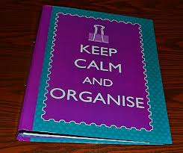

**Preparation**

Make sure you have all the essential equipment that you need before the start of term: files, dividers, pens, highlighters, note pad, diary, plastic wallets, memory stick, dictionary/thesaurus etc.

* Find out which exam board runs the course you are studying and download a copy of the specification.
* Buy study guides.
* Do background reading.
* Complete checklist in Appendix

**During the week**

Keep your planner/diary up to date. Write down when work is set with a due date. Also, keep track of work completed and work outstanding.

From the start of your course make sure that you have separate files for each subject with file dividers for each topic.

Make sure all notes are dated and add them to your file straight away

Add all handouts to your file as you get them; keep some plastic sleeves in your file in case they are not hole-punched.

Keep to a regular work rota. Do small chunks of study often, rather than leaving large amounts of work to do at the last minute. Work that is done late is often rushed and not good quality.

Get a dictionary. Either book format or phone app. Always proofread your work, checking spelling and grammar before you hand work in.

Make use of all resources available to you – teachers; Internet; textbooks; newspapers; libraries; Podcasts; Education websites; television; radio; VLE

Prioritise what you need to do; do not put off harder pieces of work.

Make sure you work in an environment where you will not be distracted or disturbed.

It is advised that most students need to do **4-5 hours** of extension study per subject each week.

Make sure you understand what you need to do. Ask for advice if you are not sure!

**Courses**



‘A’ level and BTEC courses will be taught in relatively smaller groups than at GCSE.

Lessons may be slightly less formal, but will still require a high standard of work, commitment, and behaviour.

Your subject teachers will give you support, and guidance and you must talk to them about any concerns or difficulties before it becomes a problem. If you are unsure, do not leave it, act immediately, if you get an early answer or solution to your concern or difficulty, you will feel happier and less stressed in the long term. This will build your confidence and enjoyment with your learning.

It is essential that you check the assignment requirements and that you have answered what is required. Also, proofread your work and check for spelling and grammar mistakes before handing in completed work.

If you have any questions, speak to your teachers, **DO NOT LEAVE IT.**

**This booklet includes notes and information on how to manage formal written examinations. Not all design courses have a written examination, however, you may still find some of the advice useful. You may also have small written timed assessments even if you do not have a large formal written examination at the end of you course, so it is still important you know how to approach this type of assessment.**

Fill in the grid below about the qualification you are doing to help with future reference:

|  |  |  |
| --- | --- | --- |
| **Examination Board** | **Specification Title** | **Specification Code** |
|  |  |  |

|  |  |
| --- | --- |
| **Assessment Method** | **Details** |
|  |  |
|  |  |

**Independent Study and Independence**

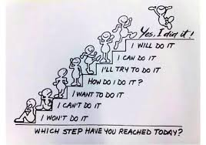

Studying in the Sixth Form will involve a great deal of time spent in independent study. You will need to take responsibility for your own learning.

This will involve you working at home in the evenings and at weekends. You must learn to manage your time effectively as it is now required.

It is a good idea to make a home learning timetable at the start of the year so that you make sure you are spending enough time on your work, as well as giving yourself time to spend on other activities. Remember to include your school non-contact time as well

You may start a part time job, but make sure that it does not get in the way of your academic studies.

You will have time on your timetables when you are not in lessons; these are **not** free periods, but time when you should be studying independently. It is recommended that you spend 4-5 hours of independent study for each subject per week. You may need specialist access to materials and equipment, so discuss this with your teacher.

Some study periods may be supervised study in the Sixth Form Study Centre, where a member of staff is available if you require help.

You will need to plan your study time carefully to make sure you meet deadlines and do not fall behind with your work.

You will also need to organise where you go to study.

**Where to Study?**



Silent Study: Quite Zone, in Sixth Form or Department

Group Study: Sixth Form Study Centre, Library

**Motivation**



Your attitude to learning is EXTREMELY important.

Positive feelings will help brain cells connect which improves learning.

Your brain learns valuable information faster if it is important.

So, think - what will I get out of learning?

It might be going to college or university; good job prospects; an apprenticeship; improving your future; a good career; improving your confidence or proving to yourself that you can do it!

Give yourself short term and long-term goals.

Make sure you give yourself rewards for short term goals. Do something you enjoy, such as going to the cinema; going out for a meal; spending time with friends etc.

A short-term goal could be completing a piece of coursework so that you are free for the weekend.

Build up your confidence by setting short achievable targets, which will help create a positive attitude to learning.

A long-term goal may be working towards a place at university, college, or an apprenticeship.

Regularly remind yourself of your long term and short-term goals.

**People who lose motivation usually lack confidence, direction, and focus, but this can be overcome by using the above simple techniques.**

Think of the bigger picture!



**Time Management**

**Workload and Meeting Deadlines – Planning**



* Many students feel that time management is the hardest aspect of study skills. The best way of managing it, is good planning.
* Successful people see time management as one of the most important reasons for their success.
* If you fail to prepare, you will prepare to fail!

**Yearly Planning**

It can be helpful to fill in a year planner at the beginning of the academic year. This can be attached to your wall where it is a visual reminder of the year ahead. It will help you plan for long term deadlines.

You can add holidays, school trips, modular and end of year exams, unit deadlines, careers conventions, university open days and any other event that will affect private study.

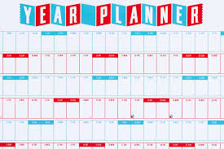

**Weekly Planning**

You will have a timetable of your lessons for the week ahead.

Plan at least one hour of study time for each hour of lesson time for each subject.

Try to create regular study times for each day. This will help make studying a habit.

Make sure you plan what you are going to do in your study periods for the week.

It is very easy to waste time if you have not planned what you need to do. Work out where you are going to go; look up which rooms will be free at the times required.

At the beginning of the week decide what research; reading round the subject; writing up of notes; essay planning; drawing, designing, etc. you need to do.

Try to balance your activities so that you get free time for friends, family, sports, television etc.

Keep your schedule flexible, so that when unexpected events occur swap your times around rather than getting rid of study hours.

Make a weekly ‘To Do’ list on Sunday for the week ahead.

Keep your weekly plan realistic!

Reward yourself for using study time effectively!

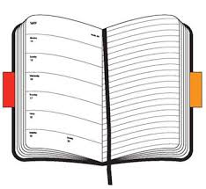

**Daily Planning**

Make sure you record homework and coursework deadlines as soon as you get given them in your diary.

You can then prioritise which pieces of work need to be done first.

Make a daily ‘To Do’ list each night or first thing each morning.

Keep the list with you.

Prioritise the most important things on your list, marking them with an Asterisk

Break down large tasks into smaller achievable chunks

Cross out things you have completed to help you visualise what is left to do and give yourself a sense of achievement.

**If you use these methods of time planning, along with your own determination, you will become organised in all areas of your life and you will be up to date with all your work at school.**

**Learning Styles**

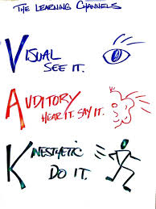

To become a good independent learner, you need to know what your preferred learning style is.

Most of you may already know your preferred learning style, but if you are not sure try as many different methods of learning as you can, until you find something that works for you.

Our senses are extremely important in the way we learn. Most people are visual learners, auditory learners, or kinaesthetic learners; however, some use more than one style of learning.

Each time you work in a different way you will make stronger brain cell connections and stronger memory links, therefore using a multi-sensory approach will make learning easier and quicker.

**Visual learners**

Learn by looking, watching, drawing, reading, and writing

When trying to remember, they imagine the image of page or screen

**Auditory Learners**

Learn by talking, discussing, and listening

When trying to remember, they will imagine who said it and the discussion

**Kinaesthetic learners**

Learn by doing, moving, exploring

When trying to remember, they will imagine where they were when they learnt it

**Tips for Visual learners**



Make your notes colourful; highlighter pens are good for this.

Make mind maps, spider diagrams, posters, diagrams, flow diagrams, charts, word walls, flash cards

Use DVD’s, visual programmes for revision, YouTube

Display key words and information around your room to improve memory.

Convert text/key information into a picture or diagram

Look, cover and learn

**Tips for Auditory learners**



Do any activities which involve reading **and** listening or speaking

Group discussion and debate

Describe out loud what you are doing as you do it

Make rhymes, songs, raps from key ideas

Use Mnemonics and Acronyms, for example AFOREST, SURF CREST, PEEL

Discuss plans, ideas, and answers with a partner

Teach someone else what you have learnt

Use podcasts, record yourself speaking and listen to them while you are on the bus or in the car etc.

Use rhythm to learn key information such as spelling

Link music to learning, the same piece of music for the same subject each time

Create your own quizzes

Listen and learn

**Tips for Kinaesthetic learners**



Use models, take them apart and build them back up.

Use paper-based activities, such as drawing things out or card sorts.

Write notes or key words on post it notes or cards and organise, sequence, plan, classify or turn into mind maps.

Turn card sorts into games.

Use movement while listening, reading, or talking out loud.

Physically repeat/practise key things that you want to remember.

Point and follow with your finger.

Do and learn.

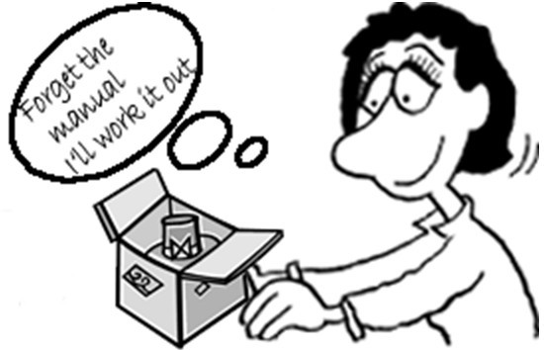

**Different Methods of Learning**

You need to look after your brain properly if you want to be an effective learner. It needs the right amount of nourishment, food, and water, as well as plenty of rest and exercise. Try to get eight hours sleep per night, exercise regularly and always eat breakfast!

Your brain is split into two hemispheres, the left and the right.

The left side deals with order, sequences, logic, numbers, words, lists, analysis, and language and prefers a step-by-step approach.

Whereas the right-side deals with imagination, colour, shape, 3D pattern, rhythm, meaning/experience, awareness and prefers to look at the whole picture.

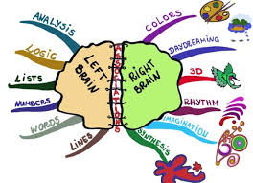

Many people prefer one side, but if you use both sides of your brain, it will increase your ability to learn and remember.

At school, you probably use the left side of your brain more than the right.

You use lined paper; you make lists; the main item in your notes will be words and you try to be logical in what you do. This means you are only using half of your brain’s potential!

Your brain thinks and remembers in colours and pictures, so it is important to use these when you are learning and revising!

**How to improve your memory**

See it 🡪 visualise or draw it

Personalise it 🡪 make it unique to you

Exaggerate 🡪 learn or practice in an unusual way

Connect it 🡪 compare it to something else

Share it 🡪 teach it to someone else

**Mind Maps**

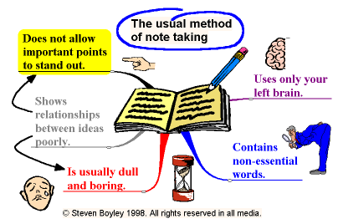

Mind Maps are a brilliant method of learning; they allow you to use both sides of your brain so that you unleash your brain’s amazing potential!

Mind maps are made up of words, colours, lines, and pictures which help you to remember. They are

* an excellent way to plan and come up with new ideas
* an alternative way to make notes that is not boring!
* a quick and effective way of revising
* a brilliant way to help plan and structure an essay
* an important tool for learning

**Advantages:**

* You only need to write down what is important
* You can use pictures and diagrams
* You can easily show how things link together
* They help you to think about how different concepts are linked
* All the information you need is on one page
* The visual pattern will help your brain to remember the important points

**How**

All you need are coloured pens, paper, and your brain.

They are very easy to construct.

Start with one central picture.

Draw the main branches of the mind map expanding the key focus into a set of sub points.

Draw sub-branches as your ideas move on by association.

Use imagination to develop the map using picture and word associations.

Keep adding branches until you run out of ideas.

Use What, Where, When, Why, Who and How to help you

The aim is to reduce a page of text by approx. 90% so that you learn the essential details.

**Mnemonics and Acronyms**

Mnemonics are words or abbreviations that help you to remember.

Acronyms are words made up, using the first letters of other words.

They are especially useful when remembering order is important.

e.g. Richard of York gave battle in vain – colours of the rainbow

AFOREST FLAP

**A**necdote **F**orm

**F**act **L**ayout

**O**pinion **A**udience

**R**hetorical Question **P**urpose

**E**xaggeration

**S**tatistics

**T**riples

**These are easy to remember, and you will probably remember the information forever!**

**Flow Charts**

These are diagrams showing steps in a process.

Each step leads on to the next one and gives alternatives to show there can be different outcomes, depending on the choices you make. e.g. Steps you need to follow in a computer program or a Science experiment.

There are three main symbols used:

Elongated circles, which show the start or end of the process

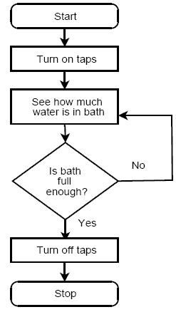

Rectangles, which show instructions or actions

Diamonds, which show decisions to be made

Within the symbols write down what the symbol represents

The symbols are connected to each other by arrows which show the flow of the process.

**Wall Posters/ Word Walls**

You can make these with key points and words to help you learn the language used for your ‘A’ Levels and BTEC courses.

Put them up in your bedroom and around the house.

You will subconsciously look at these throughout the day.

You could use different rooms for different subjects.

**Revision cards**

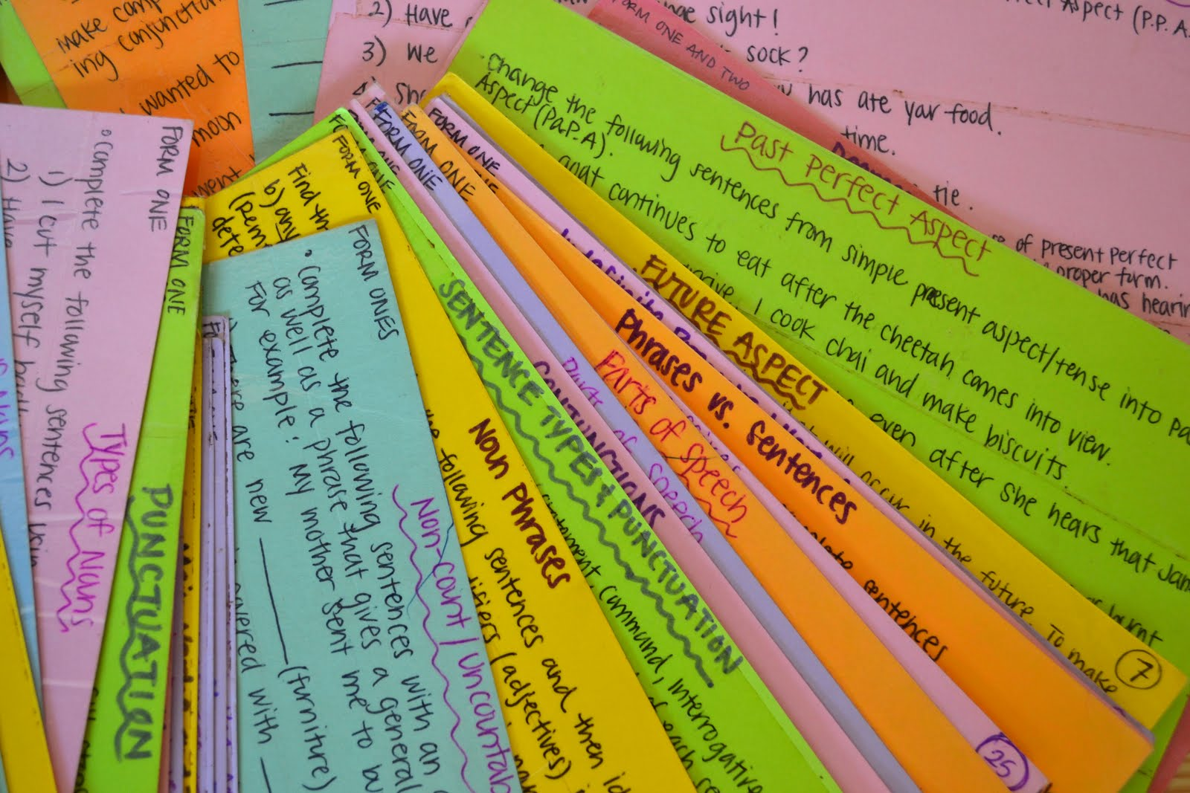

These can be helpful in remembering information.

You could make a different coloured set for each subject.

You could put a question on one side and the answer on the other or….

List key facts, words, points, dates, formulas, key exam words etc.

For example: analyse, compare, contrast, describe, justify, evaluate.... know what they mean and what the examiner is looking for.

Cards can be linked together by a key ring or treasury tags.

Carry them around with you, going over them in any spare time.

**Revision Cards are an effective way to increase your performance and an effective use of your free time.**

**Past Papers**

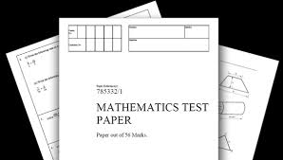

These are an extremely important resource.

Go to the Design website, or the exam board’s site, and download the past papers, mark schemes and examiner’s reports.

You need to practise plenty of past papers. Identify areas where you are not so confident, practise techniques and sort out problems before you try the next paper.

Try and test yourself against the clock, this will help you with timing as well as the style of question.

Remember to check the examiner’s report afterwards for comments and guidance, the more recent ones have tips and exam advice as well.

**The more past papers you complete and understand, the better prepared you will be**.

**Teaching someone else**

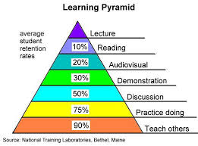

One of the most effective ways methods of learning is to teach someone else.

As you explain the information to others, it helps you to process and understand it.

Teach a friend or family member.

**Music**



Music can help get your brainwaves into the right rhythm for learning.

Listening to classical music can help some people relax and focus.

Background music can help you make associations with particular pieces of information.

Always use the same piece of music for the same subject you are revising.

**However, research has shown that many people find that studying in silence is the most effective way to revise.**

**YouTube, Podcasts, and audio recordings**

Record key points onto your phone or download relevant podcasts.

Listen to these while travelling by car, on the bus or walking home etc. Remember, YouTube may have good examples of the industrial processes you need to understand.

**Note taking**

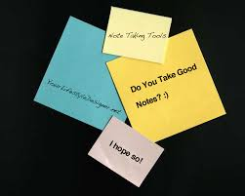

**Importance**

Helps you think about the key ideas and issues

Focuses your attention

Helps you understand text

Helps you memorise things that you need to learn

**How**

Make your notes visual and colourful, using pictures, symbols, and diagrams.

Mind Maps are a great way of doing this.

Highlight and underline key ideas to focus your attention but do not highlight too much!

Make notes clear and neat. Maybe, number the key points

Use abbreviations to make notes more concise.

Present notes in point form or under subheadings.

Do not write everything that the teacher has said or written; add your own comments to help you understand.

Make notes detailed enough for Sixth Form study, but not too detailed and lengthy.

When taking notes from the internet make sure the source is reliable.

Be careful not to copy and paste information straight from the web site, you must be able to take it in and understand what you are writing.

If you do copy information from the internet/book, you must acknowledge the site in your references, footnote, bibliography, or appendix. It is **plagiarism** if you fail to do this, and you may be disqualified from modules or subjects! Also, you may want to return to the source, either for clarification or seeing if there is anything else. It is infuriating if you cannot find it again!

Keep your notes in subject folders in date order.

Finally read over your notes as soon as you can to underline key points and add in any extra notes so that they make sense when you come back to them for revision.

**Style**

Make sure the notes you make are in a style that suits you!

Either:

- Mind maps showing connections between ideas

- Spider diagrams

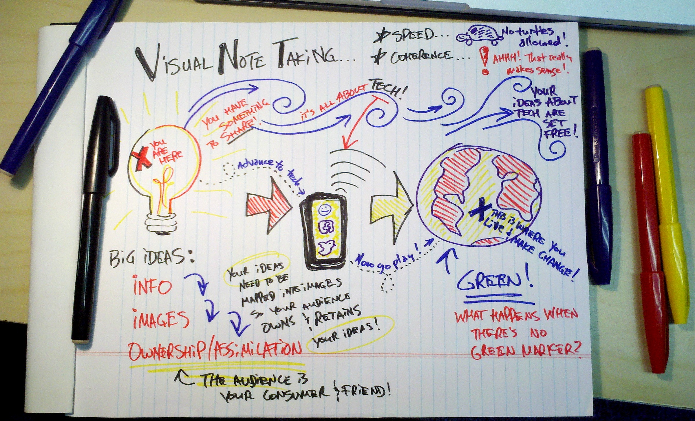

- Subheadings and key points

- Bullet points (can be numbered)

- Visual – story board, poster

- File cards

**Try to be as visual as you can!**

**Benefits**

Do not forget, visual methods of note taking will allow you to use both sides of your brain making it easier for you to remember them!

A good set of notes is invaluable, they give you evidence of the work you have done and are an effective form of revision.

**Reading skills**



Reading is essential at Sixth Form level.

You will need to come to terms with the amount of reading you will be required to do as well as understanding and trying to remember what you have read. You will be introduced to new words, so make sure you take time to use a dictionary or textbook glossary to help you understand new language and technical terms.

**Different approaches to reading:**

**Skimming**

This is looking quickly through the text to get a rough idea of what it contains. Look at titles, sub-headings, diagrams, illustrations, summaries, and footnotes.

**Scanning**

This is a quick search for important points or particular information. You need to scan your eyes across the page until you find a specific word or phrase and then read that section carefully to see if it is relevant. Ignore everything except for the information you are looking for.

**Detailed reading to understand**

This involves careful reading and studying of the passage or article you have found, by skimming and scanning. You need to read carefully in order to understand and take in the main facts and ideas.

You may need to read it more than once and take notes to summarise if you want to study something thoroughly.

Ask yourself questions about what you have just read to check your understanding.

**To study effectively you need to be able to vary your reading style and switch from one method to another.**

**Revision strategies and Exam Preparation**

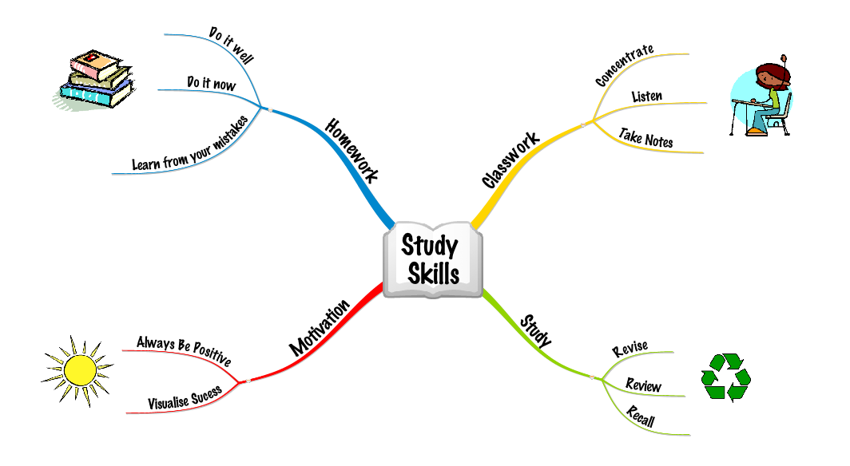

Your brain works best in 35-40 minutes bursts, followed by a 5 – 10-minute break of a completely different activity. Reward yourself with something you enjoy!

Many people find that revising early in the morning works well, try starting at 9.00am or earlier!

Plan your work in bursts, have only a few key points in each burst.

People learn best at the beginning and end of revision sessions so make sure you revise in lots of short bursts.

Always review your learning. Recall after learning will be improved if you leave10 minutes for it to sink in and then go over it again.

**80% of what you put into your long-term memory is lost after 24 hours unless you review it again.**

**The trick to successful revision is the 6x rule**

* Test yourself straight away
* Test yourself an hour later
* Test yourself the next day
* Test yourself after 3 days
* Test yourself after 3 weeks
* Each time, learn again the bits you have forgotten

**Making it memorable:**



Listening to a lecture 5%

Reading 10%

Audio-visual 20%

Demonstration 30%

Discussion 50%

Practice by doing 75%

**Teach/immediate use 90%**

**Start revision early!**

Use as many of these different methods of revision as you can:

* Revision cards
* Mind maps
* Highlighting
* Past papers
* Word walls
* Posters
* Teaching someone else
* Revision websites
* Post-it notes around the house
* Revision buddies
* Listening to podcasts or self-made recordings of key points etc.
* Recite things out loud
* Revise to music – same subject, same piece of music

**For details see Methods of Learning - P13-20.**

**Where to study**

Study in a well-lit place, which is quiet and where you will not be disturbed. Either at home or at school (again discuss this with your teacher)

**OR**

Study with friends. This can sometimes be helpful as you can share ideas and help each other with areas you find difficult. This can also be helpful with motivation.

**Make a Revision Timetable**

**Traffic Light your topics.**

* No idea - red,
* Ok – amber,
* Confident – green

Identify what you do not know and revise those areas

* Make a list of subjects you need to revise
* Work out which subjects need the most revision
* Concentrate on the areas you are weakest on
* Break down revision subjects into smaller parts
* Include break times
* Do not leave the hardest subjects till the end of the day; get them out of the way first.
* Cross off revision periods when they are completed
* Review your progress at the end of the week and adjust plans accordingly.
* Use colour to show different subjects, or order of importance.

Do not spend too long revising one subject.

Revise in bursts of 30 – 40 minutes

Your brain is most receptive in alpha rhythm. It is in this rhythm for 15 to 20 minutes before you fall asleep at night and after you wake up in the morning; Use these times for a final look at your revision notes.

**Exam Technique**



* Remember timing
* Read questions carefully
* Keep calm
* Plan your answers
* Check your work

**Remember to get enough sleep and food before the exam!**

**Do not leave revision to the last minute!**

What?

Traffic Light your topics; No idea - red, Ok – amber, Confident – green

Identify what you do not know and revise those areas

Download past papers, mark schemes and the specification from exam board websites

Use online resources

Mind map key concepts for each topic

Use the 6 ‘W’ questions Who, What, Why, Where, When, How

How?

Effective revision goes hand in hand with your preferred learning style

**Visual learners**

Learn by looking, watching, drawing, reading, and writing

When trying to remember, they imagine the image of page or screen

**Auditory Learners**

Learn by talking, discussing, and listening

When trying to remember, they will imagine who said it and the discussion

**Kinaesthetic learners**

Learn by doing, moving, exploring

When trying to remember, they will imagine where they were when they learnt it

Who?

Involve as many people as possible,

Study groups work well

Teach someone else and then let them teach you

When?

Have your revision timetable on the wall

Work in 30-minute chunks with 5-minute breaks

Give yourself rewards

Avoid distraction

Where?

A distinct study area with your timetable clearly displayed

Ideally somewhere with natural light and good ventilation

No distractions

Revision resources, organised notes and study guides nearby

Why?

Research shows that if you link your learning to your goals, you will go on to achieve better results.

**Dealing with Stress**

Make sure you eat five helpings of fruit and vegetables each day; vitamins are very important!

Exercise for 20-30 minutes at least 3 times per week.

Give yourself time to rest and relax.

Be proactive with dealing with problems; talk to someone about how you feel and what your worries are. DO NOT LEAVE IT

Believe in yourself

Do not try to be perfect

Do not keep things bottled up

Keep things in perspective

Talk to friends, family, and teachers (anyone you can trust)

Get regular amounts of sleep

See mistakes as positives

Exam stress: It is ok to feel some nerves, if you forget something or go blank, close your eyes, and breathe deeply and tell yourself you can do it! Remember, breath in for 4, hold for 2 and breath out for 4, this helps reduce the tension

Finally, if things get too much, talk to someone, never leave it, remember, we are here to help you and school should be fun!!!



**Appendix**

**Questions & Answers**

1. **Q**. How much time should I spend on independent study for each subject per week?
2. *Approx. 4-5 hours per subject, usually the same number of hours as lesson time per week.*
3. **Q.** Where can I go to study?
4. *Silent study: Quiet Zone in the Sixth Form Study Centre, Library, free rooms.*

*Group study: Sixth Form Study Centre, free rooms*

*Computer access: In Sixth Form Study Centre and you can book a computer/laptop.*

1. **Q.** What is the ideal length of time that I should split my study/revision into?
2. *30 -45 minutes sessions of active study. Give yourself a break/reward before you start your next study session.*
3. **Q.** How can I keep my study notes organised?

**A**. *In Folders/Files with dividers, date each piece of work, keep notes in order, hole-punch handouts/sheets and add to your files as soon as you get them.*

1. **Q**. How can I use my study time effectively?
2. *Out of your study periods in the week, you should use 7 or 8 of them for active studying – get into this habit early on, do not be tempted to sit around and chat.*

*Plan where you are going to go to study.*

*Look ahead each week and plan what you need to do, to get work completed on time.*

*Create a clear timetable of when to study at home.*

1. **Q.** What do I need to do before the beginning a course?
2. *Buy resources e.g. Design equipment (Check with teacher) files, pads of paper, file dividers, plastic wallets, pens, etc.*

*Do relevant background reading and buy study guides.*

1. **Q**. How can I make sure that I keep up to date with work?
2. *Plan time effectively by using yearly, weekly, and daily planning. Use study periods effectively*.
3. **Q**. What should I do if I am really struggling with a subject or a particular piece of work?
4. *Speak to your subject teacher first or the Head of Sixth Form*

*Do not leave it and pretend everything is alright, the situation will get worse, and you will drop further behind. ASK FOR HELP!*

1. **Q.** How can I improve my ability to study/learn?
2. *Make good effective notes to help recall; read actively; work as a group to share ideas, help with understanding and motivation to complete assignments; re-read notes after taking them and test yourself on your understanding each night; use strategies e.g. Mnemonics; visual revision techniques and note taking.*
3. **Q**. Where can I find information to help me to complete work?

***A.*** *Internet (remember to save the website as a reference to your source of information), Design website, VLE, Library books, study guides.*

**11. Q**. What do I need to do if I am not going to be in a lesson?

1. *If it is a planned absence, you will need to inform the school before you go.*

*If the absence is unplanned, you must contact the school by phone or email on the day. Whatever the reason for your absence the school must be informed.*

*When you return, talk to your design teacher to see what you have missed and then catch up the work.*

**12. Q.** What is the best way to prepare for exams?

***A.*** *Make a revision timetable. Revise effectively, in short bursts with breaks in between. Always review what you have learnt, to help you remember. Use revision strategies that work best for you and work in a quiet place where you will not be disturbed. And do not forget to discuss it with your teacher*

**Organisation Checklist**

|  |  |
| --- | --- |
| ***Item*** | ***Tick*** |
| **Folders** |  |
| **Dividers** |  |
| **Pens & Highlighters** |  |
| **Note pads** |  |
| **Design equipment, pencils, etc. (Check with teacher)** |  |
| **Memory stick** |  |
| **Plastic sleeves** |  |
| **Weekly Planner/Diary** |  |
| **Study Guides** |  |
| **Year Planner** |  |
| **Background reading list** |  |
| **Quiet place to work** |  |
| **Deadlines for work written into diary** |  |
| **Check Design websites and access (Passwords)** |  |

**Successful Independent Learner Assessment**

|  |  |
| --- | --- |
| ***I regularly do:*** | ***Tick*** |
| **Organise my work/folders/notes** |  |
| **Have at least one folder for each subject** |  |
| **Plan ahead** |  |
| **Spend 4-5 hours private study per subject each week** |  |
| **Make a timetable of when and where I do my private study** |  |
| **Ask for help when needed** |  |
| **Take effective notes** |  |
| **Proofread my work** |  |
| **Use a variety of ways to learn and revise** |  |
| **Organise and use my time effectively** |  |
| **Meet deadlines** |  |
| **Use different sources of information to complete tasks** |  |
| **See mistakes as part of the learning process** |  |
| **Set myself high, but achievable goals** |  |
| **Do not give up when work is challenging** |  |

**Revision/Exam Checklist**

|  |  |
| --- | --- |
| ***Item*** | ***Tick*** |
| **Exam timetable & Dates/deadlines identified** |  |
| **Revision timetable ready** |  |
| **Past papers printed** |  |
| **Mark schemes printed** |  |
| **Examiner’s reports printed** |  |
| **Past papers answered & completed** |  |
| **Past papers marked** |  |
| **Using a variety of methods to revise** |  |
| **Organise a quiet place to work** |  |