A4

A5

Paper Sizes

A0 841 x 1189

## A1 594 x 841

A2 420 x 594

A3 297 x 420

A4 210 x 297

A5 148 x 210

A6 105 x 148

This is made up of three basic elements:

(a) Hue, which is the actual colour or complexion, i.e. whether it is red, yellow, orange etc.

(b) Chroma, which in the brilliance of colour (intensity)

(c) Tone, which is the amount of black or white in a colour. The maximum contrast one can gain is by the use of black and white alongside each other.

Primary colours are the basic pigments from which other colours (secondary colours etc.) can be mixed.

Complementary colours are those colours that are opposite each other on the colour wheel (spectrum). They give maximum contrast.

Harmony comes from using colours that are close to each other around the colour wheel. Harmony can also be gained when using complementary colours, by toning down both colours with equal amounts of black or white.

Opacity. If we can see through the material, it in transparent. If we cannot see through it, but light shines through, it in translucent. If we cannot see light through the material at all, it is opaque.

HARMONIUS COLOURS - ADJACENT COLOURS

COMPLEMENTARY COLOURS - OPPOSITE ON CIRCLE

PRIMARY COLOURS – Red – Yellow – Blue

SECONDARY - Orange (Red & Yellow)

- Green (Blue & Yellow)

- Violet (Red & Blue)

TERTIARY - PRIMARY & SECONDARY MIXES

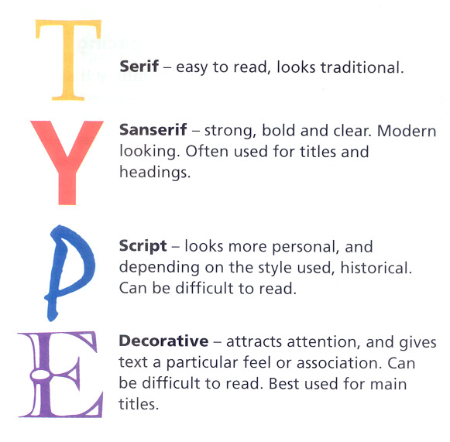

SECONDARY

##### BLACK

TERTIARY

PRIMARY

SECONDARY

TERTIARY

TERTIARY

TERTIARY

PRIMARY

TERTIARY

SECONDARY

TERTIARY

PRIMARY

##### WHITE

#### BLUE

#### YELLOW

Red/Orange

Red/Violet

Yellow/Orange

Yellow/Green

Blue/Green

Blue/Violet

ORANGE

VIOLET

GREEN

#### RED



# **Key Words**

Consider:

## Function - How well does it work? Does it do the job? How does it do the job?

### Shape - Outline, edges, curves, size. Has the whole shape been considered?

### Colour - Primary, secondary, complementary, harmonious, contrast, focal point, bright, pastel. Soft, hard.

### Ergonomics - How it suits the user, the relationship between user and item. Special ergonomic features.

## Texture - Feel, surface, finish, how is it used on the product?

## Proportion - How it fits in around similar items, too much, too little, too big or too small?

A6

A2

A3