*What does it tell you - Technical Side*

The Company Logo is in top right-hand corner. This is used on all their materials. It uses 3 contrasting and primary colours, blue script italics for the first word, red bold san-serif for the second and a yellow diamond to hold them together visually. The Pizza word has a shadow and is underlined, both these are in blue. It has a copyright symbol next to the P.

Product Analysis

*What does it tell you - Technical Side*

Christmas Theme to reflect the on-coming session.

Phone number is written large and the number is selected to help you remember it as take-away as this is their main business style. The address is smaller because it mainly does home delivery. You can pay by cash, although it does show you can pay by a range of credit cards

The strap line is in a bold san-serif font to try to make you respond and feel important by calling you a “special customer”. It is white on red for maximum contrast and the letters have a slight shadow of a darker red under them. Many more colours are used inside but much of what’s on the cover is echoed throughout

*How can you use it for your project?*

A Food restaurant flyer must have:

* Strong brand image.
* Copyright Logo, which is repeated throughout.
* Be bright and eye catching to avoid rejection & the bin.
* Have an address
* Have a contact phone number, preferably one that can be easily remembered.
* Show methods of payment.
* Have a strap line
* Have a menu with prices
* Mention VAT
* Have a let-out clause incase
* Use large bold san-serif fonts to emphasis a point.
* It must use shadow on letters to strengthen their impact
* Use contrasting tones i.e. dark and light, red and white, to make a point
* Use complementary colours to attract your attention
* Perhaps have a cartoon or image to ensure a broad target group or to reinforce positive feelings towards the company.
* It must use standard size paper to keep the cost down.

*Where did you get it? What is it?*

This is a flyer that came through the door with our daily post. It is informing us about special offers at our local “Perfect Pizza” and it includes coupons that can be used. Perfect Pizza is a take away which also does home delivery. The flyer is simple and eye catching to try to stop you from throwing it away.

This is the back cover, which includes the menu. A large version of this is on the wall in the shop. Extra information is underneath informing you of VAT and another disclaimer to about prices and the menu. The last two are small so you may not notice them.

The leaflet is professionally four colour printed. I know this is because there are full colour pictures inside. Although the address and tel. no. looks as if it was added later. This must be to allow the leaflet to be used at all their take-aways. It is A5 in size, 16 pages and stapled twice on the left-hand spin.

## **Analysis of Research**

**Where** - Where did you get it? What is it? What is its purpose?

**What** - What does it tell you Emotional Technical

**How**  - How can you use it for your project? Bullet point the responses for easy access later

Remember, ask yourself **why** when trying to work out what the information is telling you i.e. Why is it red? Why is the telephone larger than the address? Always think **How** can I use this information?

Logo clear on the top left hand corner. The Free delivery is large and in white, contrasting with the red, to ensure you see it, it has a disclaimer underneath

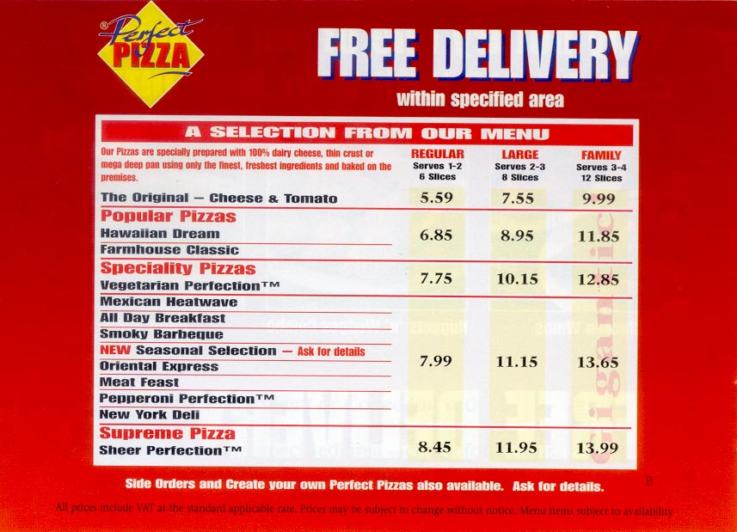

A cartoon character to lighten the style of the cover. He is wearing the uniform that they have in the shop. The green shirt compliments the overall red & focuses you in. This maybe to attract children.

The red is very strong on this and is part of the company’s brand identity. Their shops are all red. However, this does seem similar to other pizza restaurants I have seen.

