Question Types

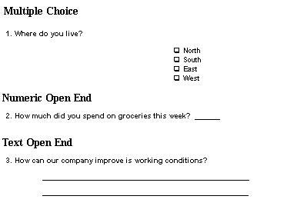
Researchers use three basic types of questions: multiple choice, numeric open end and text open end (sometimes called "verbatims"). Examples of each kind of question follow:

Rating Scales and Agreement Scales are two common types of questions that some researchers treat as multiple-choice questions and others treat as numeric open-end questions. Examples of these kinds of questions are:

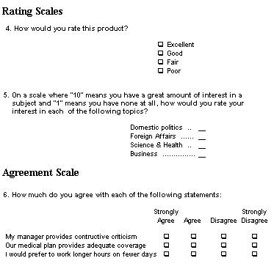

The Steps in a Survey Project
- Establish the goals of the project - What you want to learn
- Determine your sample - Whom you will interview
- Choose interviewing methodology - How you will interview
- Create your questionnaire - What you will ask
- Pre-test the questionnaire, if practical - Test the questions.
- Conduct interviews and enter data - Ask the questions.
- Analyse the data - Produce the reports.

