

Design in the Built Environment

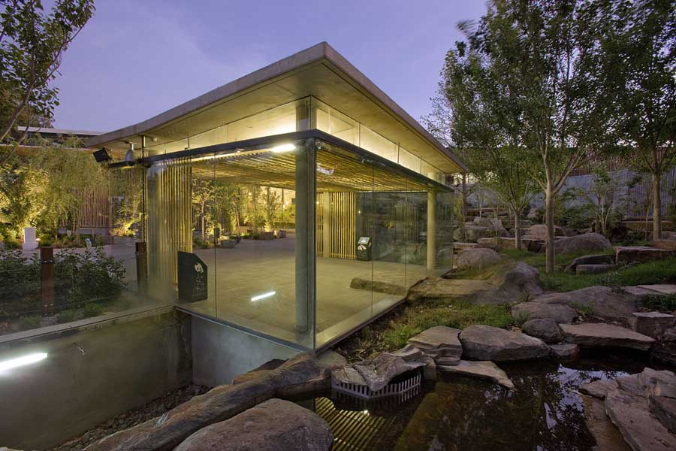

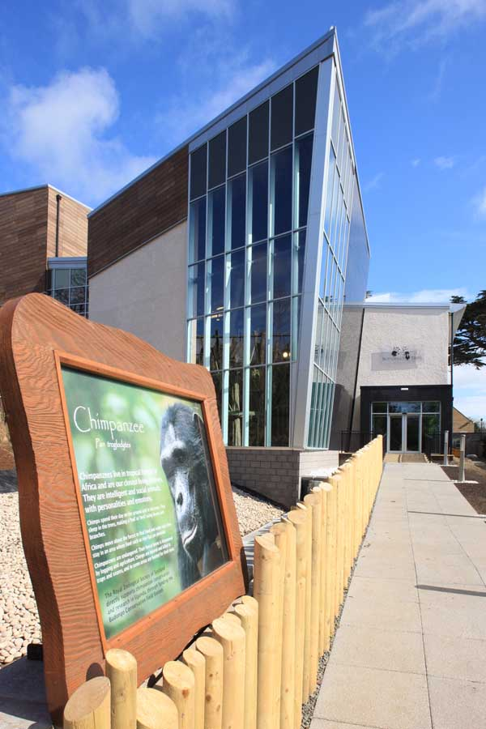

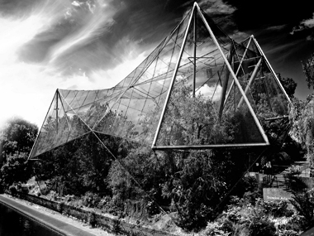

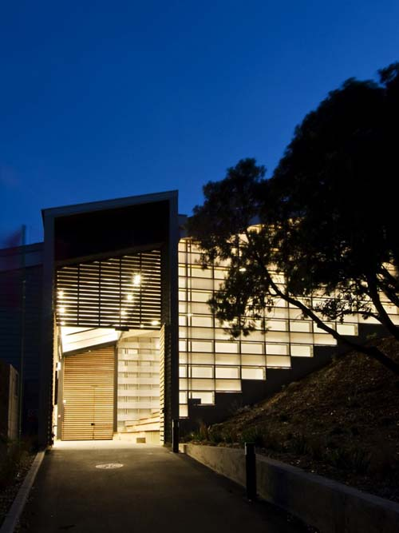

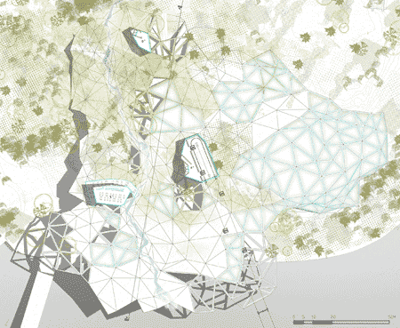

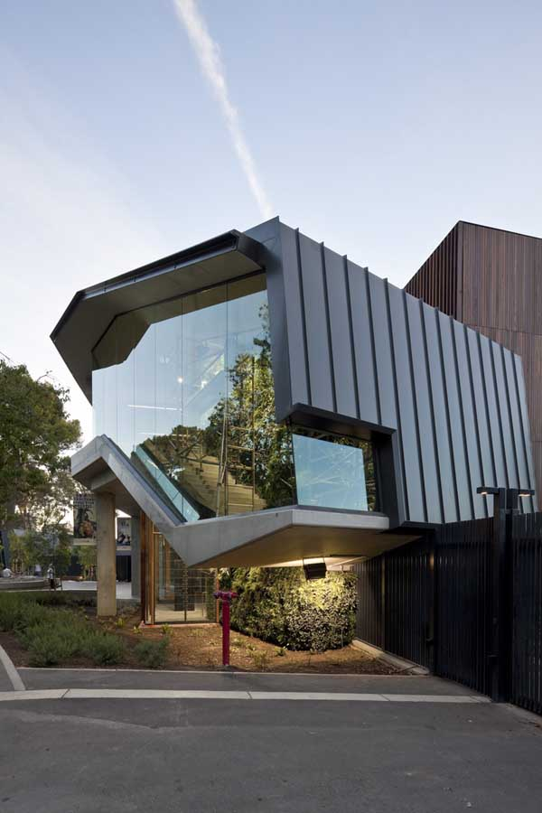



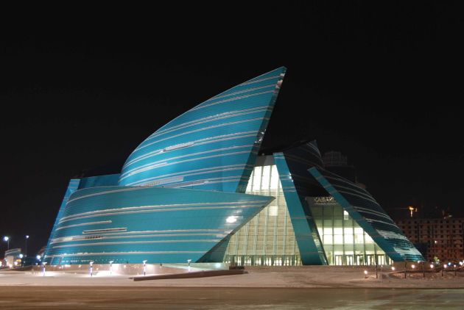

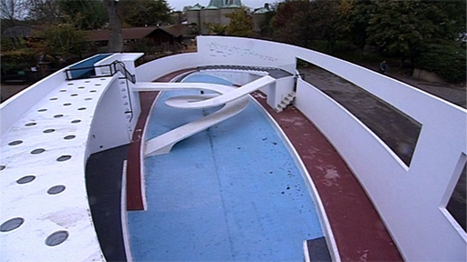

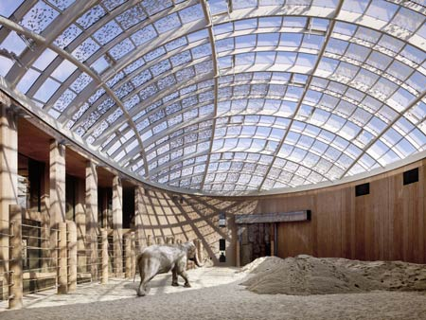

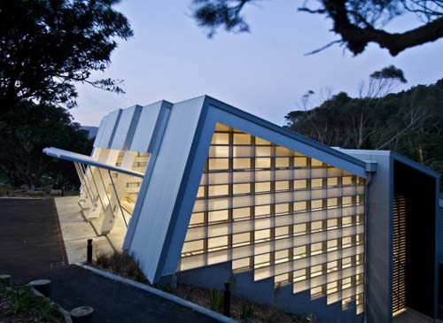

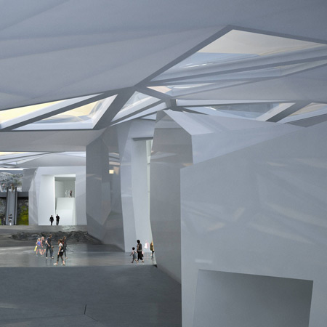

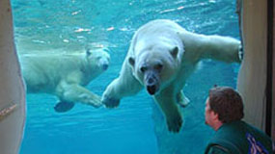

Assignment - Zoo

Task – New Zoo for Harchester

Harchester has just announced that a major new company called Zootec has completed the purchase of a large area of land north of the Harchester. It is part of a major new initiative for the town, which has been worked on for many years and has finally come into fruition.

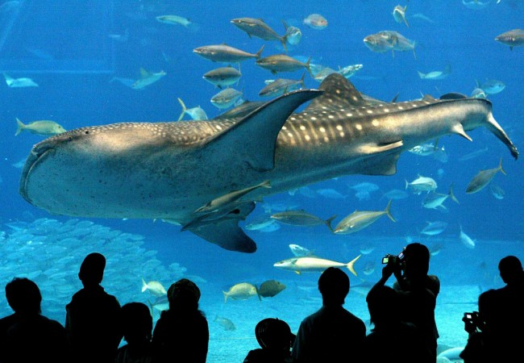

It has been negotiated by the council over the last 2 years and now there has been agreement to develop a new type of zoological park.

The project is going to be a joint venture between the initial company *Animal World* and the council and a new company has been formed called Zootec, where both are joint and equal partners.

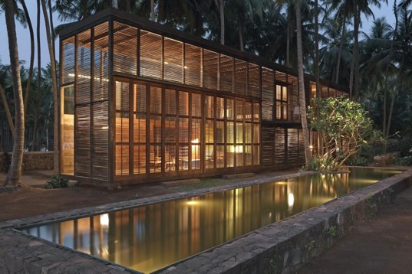

It is hoped that this venture will help increase employment in

Harchester, both directly and indirectly as it will become a major

attraction in the south of the county.

You have been the first company to be approached by the council, due to your excellent reputation and the successful work you have already done for Harchester. They wish you to put together some ideas for the zoo.

Aim:

They would like you focus on the development of one of the enclosures, the choice of which is yours. The materials you produce will be going on display at Harchester Museum next Easter if your results prove successful. Budget is not a problem as *Animal World* will be closing two of their smaller zoos and moving the animals to the Harchester zoo. The sale of the old sites will raise valuable capital needed for the development. Further money has come from a range of organisation and well as the government agency to encourage growth in the area.

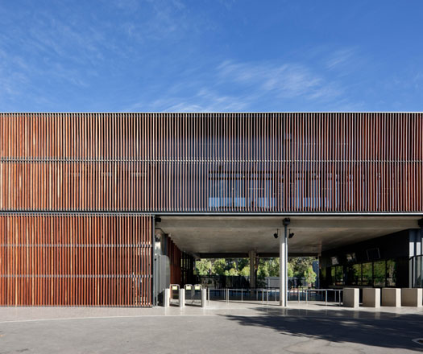

You only need to pick one area and the choice is yours

Specification:

You must produce a range of visuals and models for presentation to the client showing ideas for your enclosure. If accepted your materials will be put on display at the Harchester Museum

Expected Approach:

Stage 1 – Investigation & Reflection

1. Collect Secondary Research – Internet, Books, Magazines
2. Collect Primary Research – Visits, Photos, Sketches
3. Research & analyse existing zoos or similar animal environments
4. Research & analyse existing animal habitats
5. Research & analyse existing natural environments that can inspire ideas
6. Research & analyse existing urban environments for comparison
7. Research a related designer/architect you will influence the project
8. Identify key features from the research
9. Select animal enclosure

Stage 2 - Design

1. Explore factors specific to the enclosure
2. Rough designs
3. Explore Issues for the enclosure
4. Research possible materials

Stage 3 - Develop

1. A development of one idea, which you have selected
2. A range of designs produced on the computer.
3. Rough concept models
4. Selection of final design

Stage 4 - Final Design

1. A final design drawings with more detail
2. Presentation Drawings
3. Model/s to show detail

Stage 5 – Presentation & Exhibition

1. Evaluate project
2. Identify appropriate presentations for target audiences.
3. Research and select a range of professional presentation methods.
4. Plan and create a presentation of the work as a whole.
5. Present appropriately to Client Zootec
6. Organise display for Harchester Museum

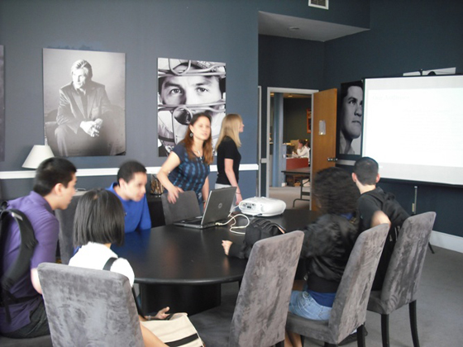

Resources - - DT Library, School Website.

Resources – ICT - Internet Access, Sketchup, Revit

Resources – Work Areas - Design Studio, ICT Suite, Workshop

Extra Support – Email –

