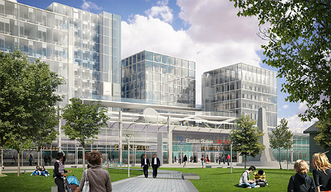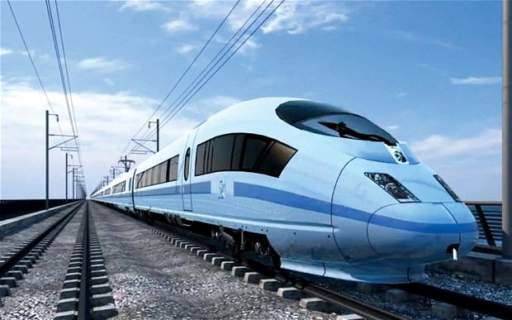

Design in the Built Environment

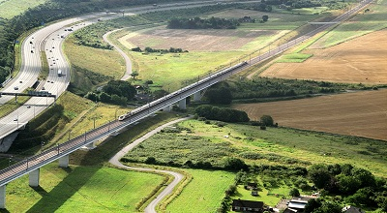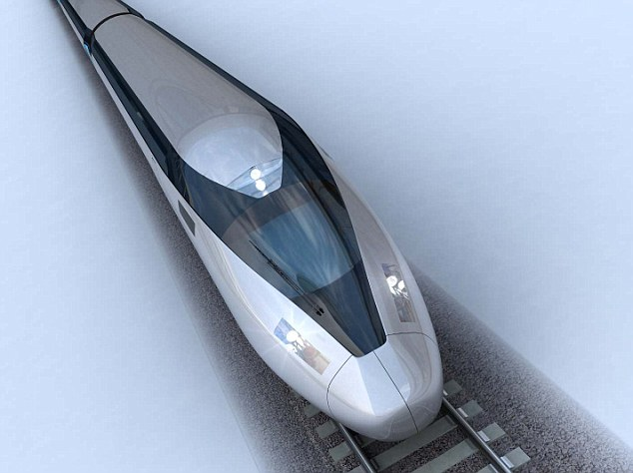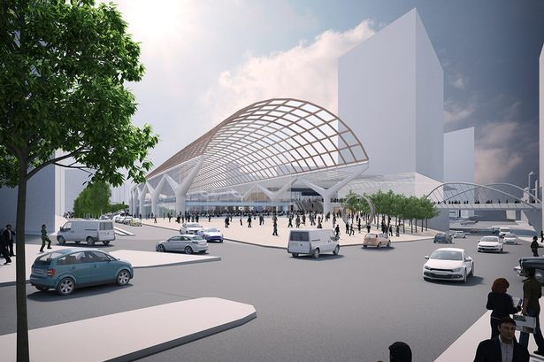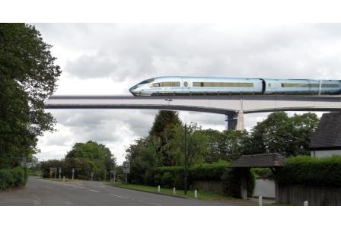

Reflection Task 3 – HS2

The Task

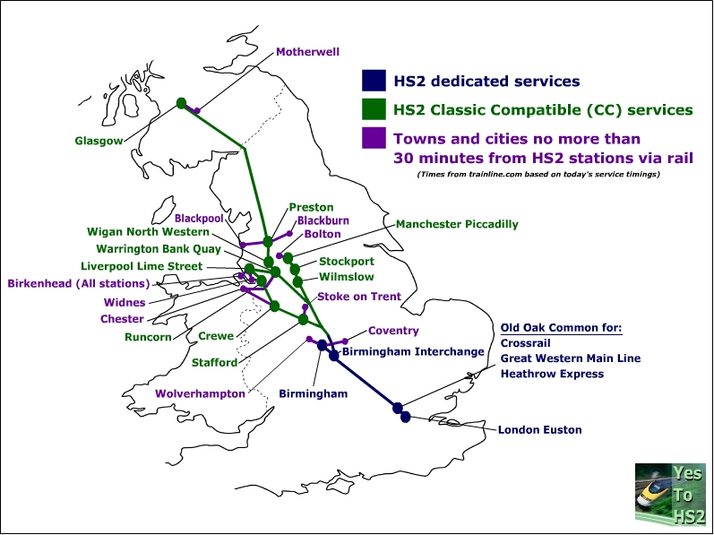

You need to produce a

document, which looks

at the High Speed Train 2

Project currently

underway. A clear

approach will be important

and you must get your

points across. Good

explanation of all the

issues is vital and good

presentation and layout

is essential in allowing

the reader to understand

your thinking.

You must look at the advantages and disadvantages, and from all angles. This building project will have an enormous affect upon you as an adult; it will have a major impact upon your working life, so what do you understand about it? and what is your view of it? You need to consider it both from the viewpoint of you as a person, as well as you as a designer. It is an important national project for the next 20 to 30 years and all aspects must be looked at in the context of you demonstrating an awareness and knowledge of the social, political and commercial relationships with environmental spaces and their modification and manipulation.

Social What are the social benefits of the project? and what are the disadvantages and to whom?

Political What is the political view of this project, both government and local, and what are the views of those people who are involved, either as uses or as people who will be affected by it.

Commercial What are the commercial benefits of the project and how will it generate regeneration as well as stimulating growth in the areas it impacts upon.

