

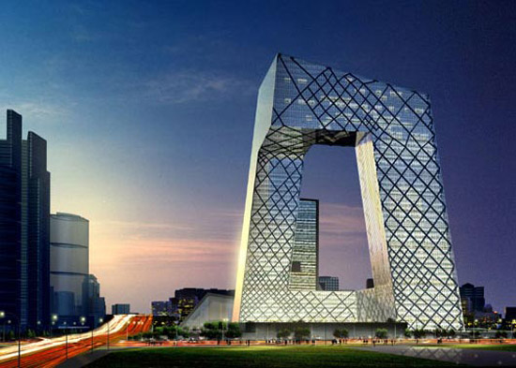

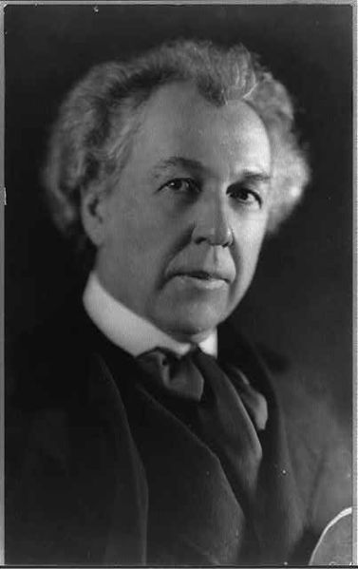

Design in the Built Environment

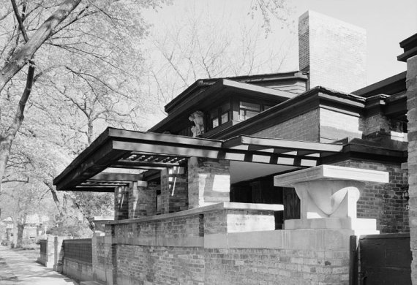



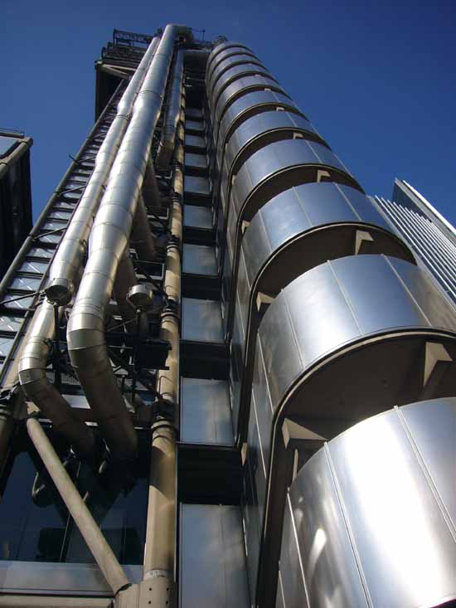

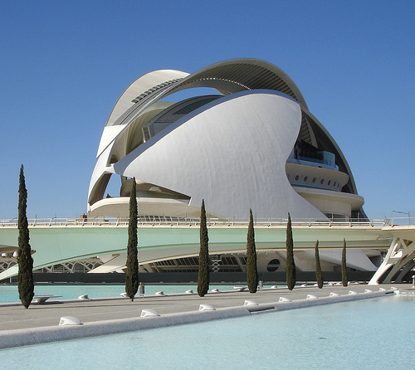



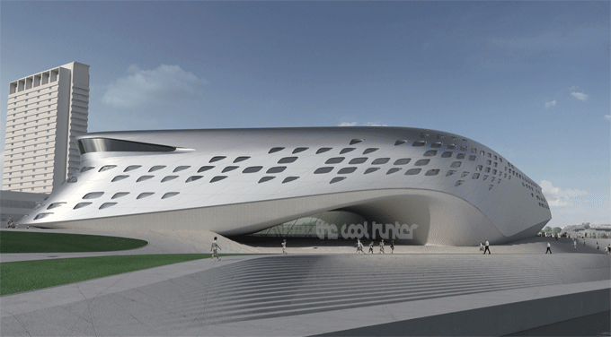

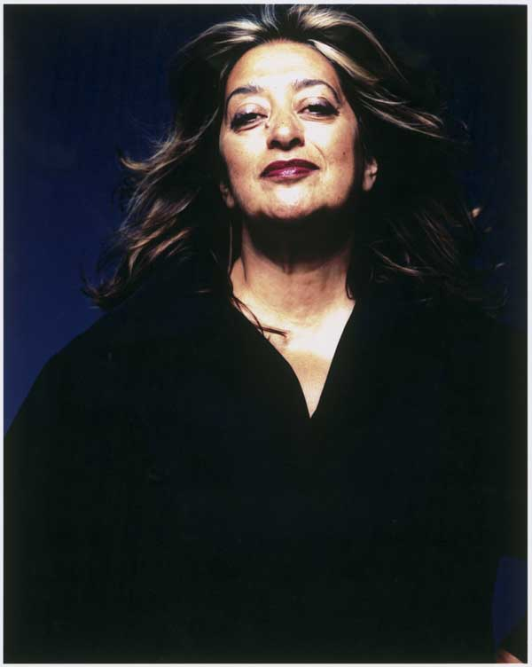

Assignment - Timeline

Aim and Purpose

The aim of this assignment is to develop your skills and knowledge of how historical and cultural influences inform design. You will achieve this by researching and recording information, whilst developing critical and analytical skills, and relating this to your own developing practice.

Artists, craftspeople and designers have always looked to the past for inspiration and innovation. In order to learn from the past and build on others’ creativity, it is important for you to appreciate some of the factors that are essential to a practitioner’s professional development by understanding the importance of historical and cultural influences on design.

Practitioners in every field of the sector also recognise the need to, and value of, keeping abreast of contemporary art, craft and design developments, within and beyond their specialist practice.

This assignment is intended to form the basis of your knowledge and understanding of contemporary and historical art, craft and design. It aims to promote and deepen learners’ contextual awareness of their own work. You will develop knowledge and understanding of key movements within an historical context, which will provide a framework for your understanding of works of art, craft and design. You will also understand why many designers are able to respond to emerging technologies and environmental issues.

You will develop skills in identifying, researching, selecting and recording appropriate references for study from primary and secondary contextual sources. Through exploring and recording from a wide variety of sources you will develop your critical and analytical skills by using combinations of visual, written and verbal presentations. This will contribute to a cycle of application, as contextual understanding contributes to your practical skills and your practice gives them inside knowledge of other practitioner’s work.

Learning outcomes

**On completion of this unit a learner should:**

1 Know about key developments and influences in art, craft and design

2 Be able to research and record historical, contemporary and contextual information

3 Be able to review, produce and present outcomes from contextual sources

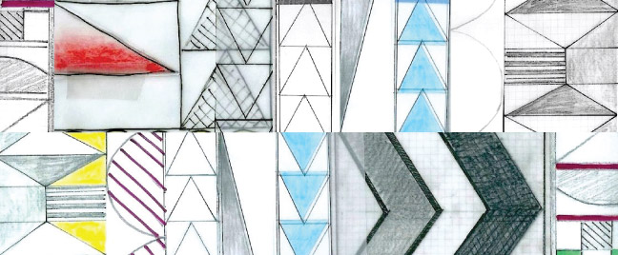

Assignment Content

**1 Know about key developments and influences in art, craft and design**

*Historical and contemporary developments*: characteristics; theories; influences; relationships; impact; technologies (inventions, manufacturing, photography, printing processes, cinema, digital)

*Movements*: 19th century e.g. Romanticism, Realism, Impressionism, Post-Impressionism, Symbolism, Expressionism, Arts and Crafts Movement, Art Nouveau; 20th century e.g. Fauvism, Cubism, Futurism, Dada, Surrealism, Bauhaus, Art Deco, Social Realism, Constructivism, Abstract Expressionism, Pop Art, Modernism, Post-Modernism, Punk Art; Brit Art; Performance Art, Installation Art, Outsider Art; 21st century e.g. digital, video art, internet, globalisation

*Influences*: e.g. fine art, photography, graphics, fashion, ceramics, other art forms, mass media, popular culture, environmental issues, the work of others

*Wider cultural context*: significant events e.g. Industrial Revolution, Great Exhibition, design reforms, colonialism, communications, trade, wars, social change, politics, migration, freedom of speech, individualism

*World cultures*: e.g. Japanese art, African tribal, Egyptian art, Celtic, medieval, folk, naive art, carnivals, fairgrounds

*Science and technology*: e.g. psychology, technology, new materials, photography, digital media, animation, computers, molecular discoveries, plastics, nylon, micro-electronics, LCD, aerodynamics, space age

**2 Be able to research and record historical, contemporary and contextual information**

*Research*: primary sources e.g. gallery visits, industries, practitioners’ workplaces, work experience; secondary sources e.g. books, journals, CDs and DVDs, the internet

*Record*: extracting appropriate information e.g. read, respond, documents, key points, phrases, quotes; notation e.g. highlighting text, notes, annotated visual studies, combinations, written, printed, audio; visual information, photography, interviews, practitioners; commentary e.g. annotated art works, vocational vocabulary

*Contextual information*: historical context; social context; key movements; key individuals; influences; changes e.g. media, materials, technology, processes, techniques; visual language e.g. formal elements; practitioners e.g. others’ work, professionals, peers, own work

**3 Be able to review, produce and present outcomes from contextual sources**

*Review*: e.g. identify, select, organise, research, plan, structure, analyse, create

*Produce*: e.g. appropriate format for presentation; academic conventions, bibliographies, references

Task 1 – Timeline – Seeing Design in the World!

The aim is for each learner to produce a visual presentation of 20th century design. The art and design movements must also be related to key events in the 20th century.

The timeline can employ the use of drawings, collage, photocopies and self-generated computer images and needs to be as interesting and informative as possible.

* Having established some of the subjects for research, individuals could then take reference material from the research, the library and other sources and use this in the studio to compose their own version of events.
* Spend some time considering how you will put the timeline together.

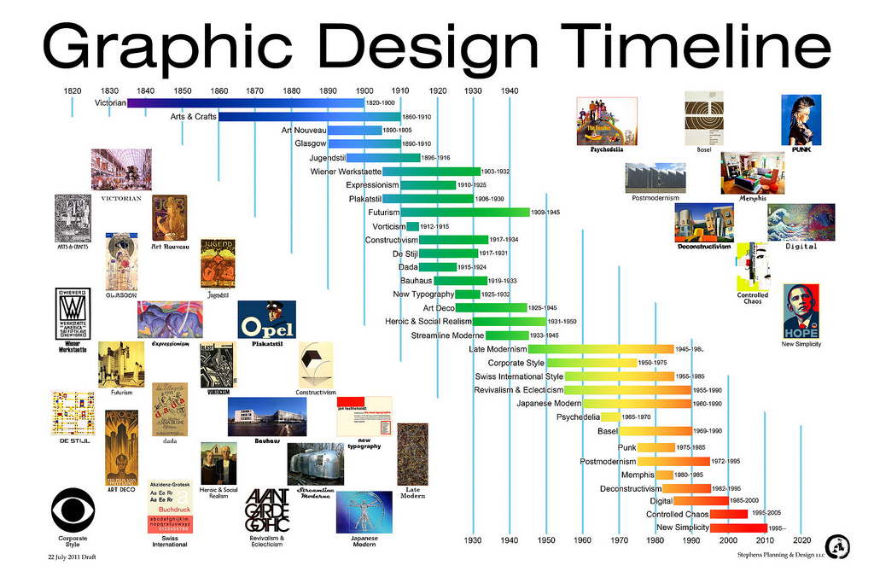

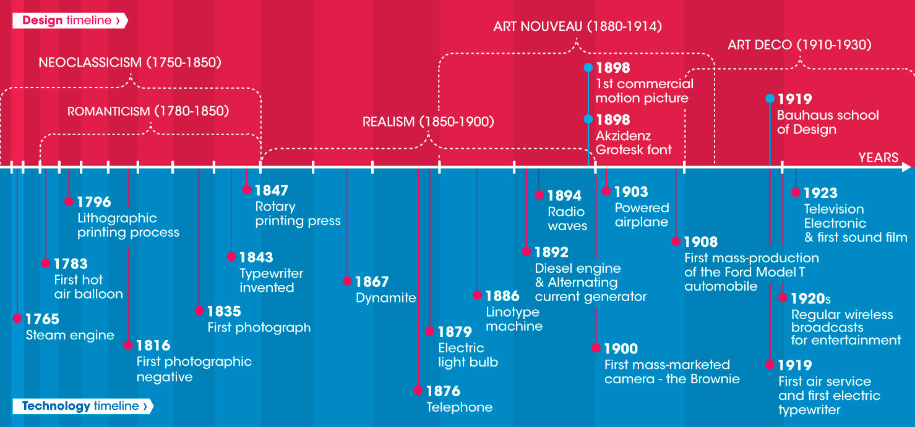

The Timeline must consist of 4 strands:

Strand 1 - The main design movements

* Arts & Crafts 1850-1900
* Art Nouveau 1890-1905
* Modernism 1900-1930, including The Bauhaus (1919-1933)
* Art Deco 1925-1939
* Streamlining 1935-1955
* New Design Style 1975-present
* Post-modernism 1975-present
* Memphis 1981-1988

Important Names related to the movements

• Arts and Crafts – William Morris  
• Art Nouveau – Charles Rennie Mackintosh  
• Bauhaus Modernist – Marianne Brandt  
• Art Deco – Eileen Gray  
• Post Modernism – Philippe Starck  
• Streamlining – Raymond Lowey  
• Memphis – Ettore Sottsass.

Strand 2 – Some Key events – For example

* Queen Victoria
* The Railway
* 1st World War – 1914-1918
* 2nd World War – 1939-1945
* World Fairs (The Exposition des Arts Decoratifs, Paris 1925, The Festival of Britain, London 1951)
* New Technologies

Strand 3 - Architecture Styles – For example

### Neoclassicism

* Revivalism
* Arts and Crafts

### Modernism

### Post-Modernism and the 21st century

Strand 4 - Important people in design and architecture – For example

# Charles Rennie Mackintosh

# Frank Lloyd Wright

* Renzo Piano
* Norman Foster
* Richard Rogers

Task 2 – Understanding the Past

INTRODUCTION/SCENARIO:

Harchester Museum has been impressed by your work you on the design timeline project and would like you to be involved in a new project as part of the refurbishment of a gallery at Harchester Museum. This can be tied into the UB2–2a - Museum Project – Task 2 - Gallery

CLIENT:

Harchester Museum, part of County Museums Service.

Finance to come from the County Council, the Design Council, the V&A Museum and the Design Museum, which are both based in London

TASK

You have been asked to help put together a museum gallery, based upon a design movement of your choice; the name of the gallery will be - ‘Understanding the Past’.

LOCATION

The gallery is large with skylights to bring in natural light and one wall with large windows overlooking the park. To enter you need to go through a small passage, which has a very high ceiling and is about 12m long and 4m wide.

BACKGROUND

Now that you have completed your Timeline you now need to look at a design movement in a lot more detail. The idea of this is to develop your understanding of design and so help you when you to develop your own ideas in the future.

You must select a design movement and research it thoroughly. You must look at a range of products, people and places comparing them and explaining their impact, it may be useful that you relate these to other items from different periods which they have influenced to show their impact.

The movement can be any period and we suggest you focus on architecture and products of that time. You must also pull in key designers and architects and relate what they did and how they impacted upon the design movement as well as the world.

It will be essential that you explain the context and time of the movement, as design not only influences the world it is in, but also the world can influence and impact the design movement itself.

All sources must be acknowledged in a bibliography.

OUTCOMES

You must produce

* Visitors guide (Booklet which would be sold, colour and detailed)
* Visitors guide (Pamphlet which would be given free)
* Two slideshows which will be projected on the walls as people enter the gallery
* A list of suggested products/models/graphics items which could be used
* Sample title cards for the display items with a small explanation for the visitors

EVIDENCE YOU MUST PRODUCE FOR THIS TASK

Portfolio containing:

* records of relevant research, especially primary with supporting analysis
* progress journal/folder – your ideas/designs and experiments
* annotation throughout – what skills, materials, techniques, process have been used and what messages are being communicated and how?

Final Outcomes

* Visitors guide (Booklet which would be sold, colour and detailed)
* Visitors guide (Pamphlet which would be given free)
* Two slideshows which will be projected on the walls
* A list of suggested products/models/graphics which could be used
* Sample title cards for the display items with a small explanation for the visitors

All sources must be acknowledged in a bibliography.

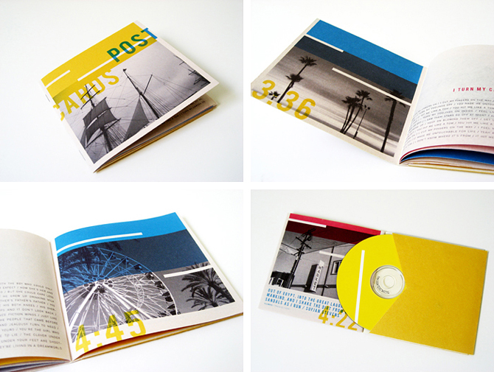

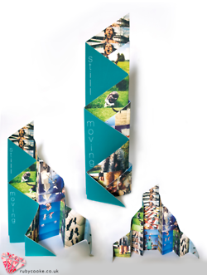

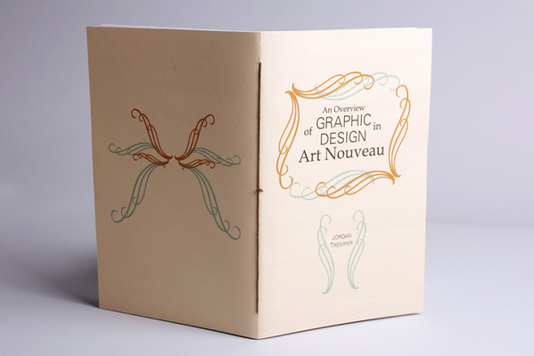

Assessment Criteria

|  |  |  |
| --- | --- | --- |
| Standard Level  All should achieve | Intermediate Level  Majority achieve | Advanced Level  Most able achieve |
| Standard 1 - describe the characteristics  and influences of key movements and the work of  individuals | I1 research and organise  information about art, craft  and design developments,  effectively linking the contexts  in which works were produced | O1 extract and analyse complex information independently, from comprehensive research |
| Standard 2 - show how cultural contexts  relate to historical and  contemporary art, craft and  design | I2 express coherent opinions, supported by examples drawn from established sources. | O2 express informed judgements and argued conclusions, using specialist language fluently. |
| Standard 3 - produce primary and secondary research |  |  |
| Standard 4 - review information and  produce outcomes |  |  |
| Standard 5 - present outcomes. |  |  |

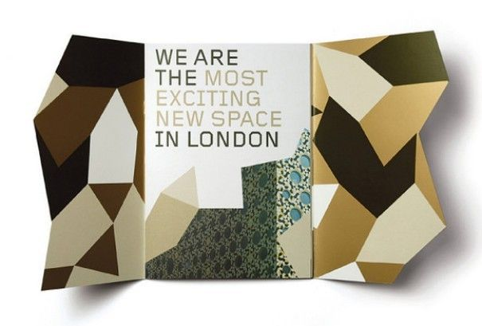

Assessment

**Standard 1 describe the characteristics & influences of key movements & the work of individuals**

For P1, learners should demonstrate their knowledge and understanding of developments in art, craft and design by explaining the characteristics of selected movements and selected individuals’ works, and the materials and processes used. That should describe the formal elements of the selected works and catalogue associated artists and art influences. Learners should explain the connections between different art forms and movements and wider cultural influences. Evidenced for P1 may come from a range of activities where learners have undertaken on-going, annotated, visual contextual study and integrated this unit with their specialist pathway.

**Standard 2 show how cultural contexts relate to historical and contemporary art, craft and design**

For P2, learners need to show that, with tutor support, they have explored several examples of different kinds of information around a given subject. They should demonstrate an understanding through written and visual recording from selected sources using different approaches through annotated visual study, notes and descriptive written pieces. Learners should show some evidence of analytical ability, for example by deconstructing an image, object or film clip to demonstrate their understanding of how it has been created, what qualities are communicated and its wider contextual connections. There should be evidence of selection from a variety of sources.

**Standard 3 produce primary and secondary research**

For P3, it requires the production of a body of relevant research. This may include appropriate lecture notes, research recording from primary and secondary sources, video evidence from an oral presentation, annotated visuals, presentation boards, written assignments or other recordings. Evidence should show the progressive development of learner understanding of the purpose of research recording. It is expected that primary experience from gallery or workshop visits will form part of the evidence, together with the use of secondary sources.

**Standard 4 review information and produce outcomes**

For P4, learners will need to show they can select relevant information from their recordings to develop and produce completed outcomes. Verbal evidence sheets and witness statements from individual tutorials, seminars and group discussions could be used to gather evidence of understanding the process of review and refinement in developing a study need for and similarly of the effective presentation skills.

**Standard 5 present outcomes**

For P5, learners might use varied presentation methods such as written essays, annotated illustrations, video, film or on-screen presentation or poster presentations to the class. Learners should use their understanding of art and design developments to identify and select subjects for research.

**Intermediate 1 research and organise information about art, craft and design developments, effectively linking the contexts in which works were produced**

For M1, learners should research a broad range of information using different sources, and produce articulate explanatory notes, descriptive and analytical pieces of text or detailed annotated visual studies. There should be evidence of effective organisation of information and a planned approach to selecting and focusing ideas for outcomes. Works researched should always be considered in relation to the context in which they were produced.

**Intermediate 2 express coherent opinions, supported by examples drawn from established sources.**

For M2, learners need to synthesise their understanding using examples and quotes from established sources to support their personal opinions. Evidence might be through a carefully structured an essay where each paragraph moves the text forward without digressions or repetitions or by investigating and collating visual and written critical analyses and developing a range of well-planned presentation methods as suggested in the unit content.

**Advanced 1 extract & analyse complex information independently, from comprehensive research**

For D1, learners will, independently, select and comprehensively record from an extensive range of contextual sources, investigating and reviewing alternative opinions and interpretations.

**Outstanding 2 express informed judgements argued conclusions, using specialist language fluently.**

For D2, learners will express informed judgements and argued conclusions using specialist language confidently and fluently. Outcomes produced for presentation may be creative and relevant to their specialism. This will demonstrate that the learning and contextual influences have been fully embedded in their own work.

Recommended Reading List

Textbooks

* Britt D – Modern Art Impressionism to Post Modernism (Thames & Hudson, 2007) ISBN 978-0500238417
* Buehler et al – Essential Art: The History of Western Art (Herbert Press, 2007) ISBN 978-0713687866
* Collings M – This is Modern Art (Phoenix, 2000) ISBN 978-1841881003
* De Olivera N, Oxley N and Milhae P – Installation in the New Millennium (Thames & Hudson, 2004) ISBN 978-0500284513
* Dormer P – Design Since 1945 (Thames & Hudson, 1993) ISBN 978-0500202616
* Dormor R, Holmes S, Mott T, Schofied J, Thomas L, Wicks S, Wilson G – Edexcel Level 3 BTEC National Art and Design Student Book (Edexcel, 2010) ISBN 978-1846906374
* Dormor R, Holmes S, Mott T, Schofied J, Thomas L, Wicks S, Wilson G – Edexcel Level 3 BTEC National Art and Design Teaching Resource Pack (Edexcel, 2010) ISBN 978-1846906374
* Gay P – Modernism: The Lure of Heresy – From Baudelaire to Beckett and Beyond (Vintage, 2009) ISBN 978-0099441960
* Hopkins D – After Modern Art 1945-2000 (Oxford University Press, 2000) ISBN 978-0192842343
* Hughes R – The Shock of the New (Thames & Hudson, 1991) ISBN 978-0500275825
* Julier G – The Thames & Hudson Dictionary of Design Since 1900 (Thames & Hudson, 2004) ISBN 978-0500203798
* Little S – Isms: Understanding Art (A & C Black Publishers Ltd, 2004) ISBN 978-0713670110 Livingston A and I – The Thames and Hudson Dictionary of Graphic Design and Designers (Thames & Hudson, 2003) ISBN 978-0500203538
* Noe C, et al – Young Chinese Artists: The Next Generation (Prestel, 2008) ISBN 978-3791341088
* Poli F – Post-Modern Art 1945 – 2008 (Collins Design, 2008) ISBN 978-0061665776
* Sparke P – Design in Context (Bloomsbury, 1991) ISBN 978-0747510949
* Wilk C – Modernism Designing a New World (V&A Publishing, 2008) ISBN 978-1851774777 Woodham J M – Twentieth Century Design (Oxford University Press, 1997) ISBN 978-0192842046

Websites

* www.design-council.org.- UK the national strategic body for design in the UK
* www.designmuseum.org.uk - website of the Design Museum, dedicated to contemporary design
* www.hayward.org.uk - website for the Hayward gallery
* www.hillmancurtis.com - website for film and web-based company
* www.nationalgallery.org.uk - website for the National gallery
* www.onedotzero.com - digital arts organisation promoting use of moving image
* www.tate.org.uk - website for the Tate galleries
* www.vam.ac.uk - website for the Victoria and Albert museum



