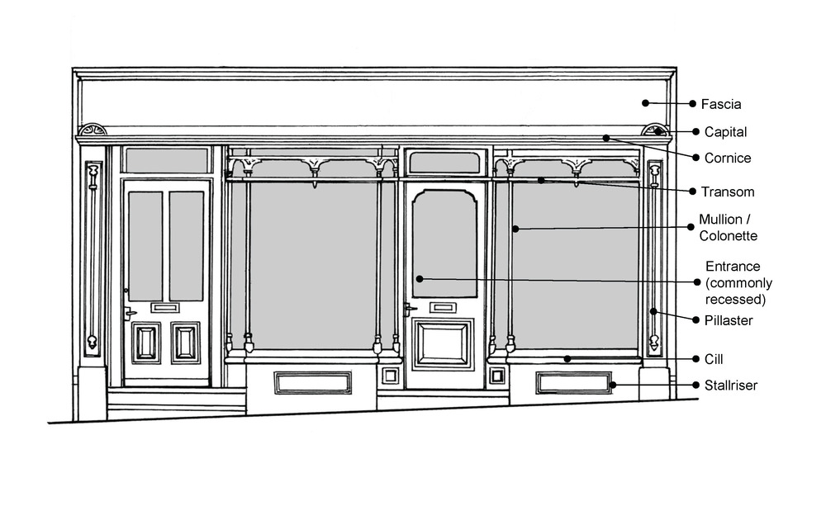
Materials –
(What is used, not only to create the brand, but also functions, with regards to the structure)
What materials do they use on the frontage?
How have they added colour?
How have they done the Name of the facia?
What signs are there used on or in the window?
Shape – (Form of an object produced by its outline)
What type of entrance have they used?
What shape & size are the windows and what effect does it allow?
What is the shape and type of the doors used?
What is the positioning and shape of the shop’s name?

Text – (Used to support the brand and on the facial of the shop)
What type of font is used for the shops name and branding?
How has the size and colour been used to show the text?
What other types of information on displayed and what type of text is used on it?
How do the different type of font relate to each other?

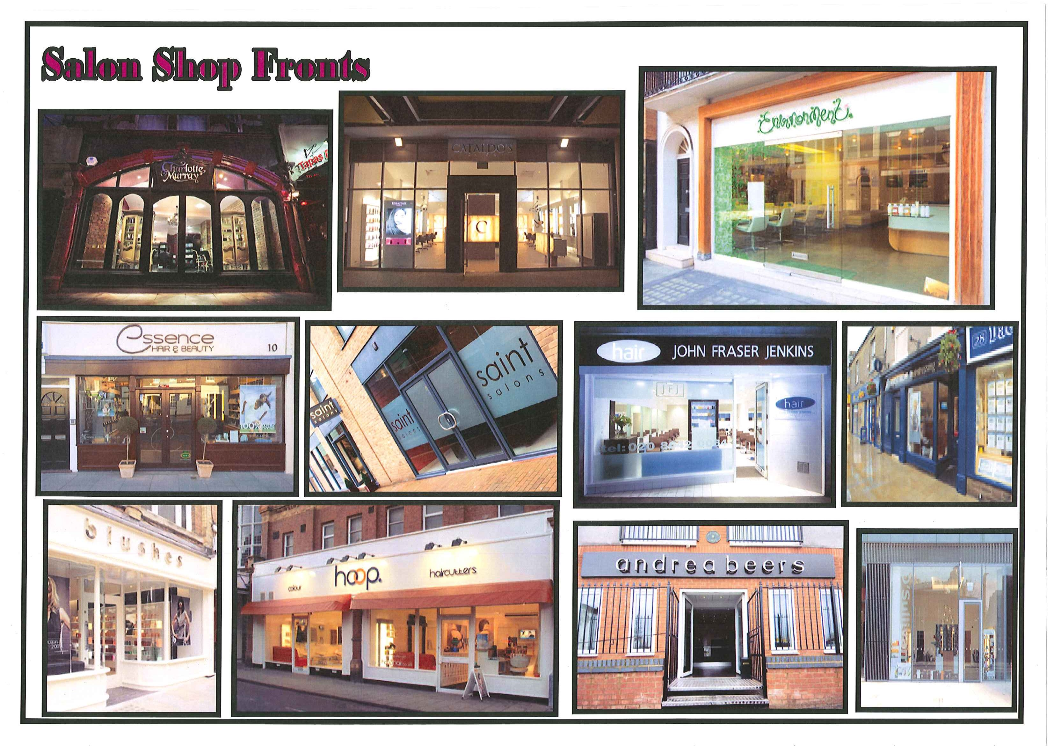
Colour – (Used to support the brand and create a strong theme)
What types of colour have been used?
Why do you think the colours have been used?
How do they make you feel?
Are the colours effective and how?

Ergonomics – (Study of how artefacts and environments can be matched to the needs of people)
What special features are there to enable disabled access?
How is the layout of the shop helping sell the products?
Are there any special features to help or encourage the customers to spend?
Are there any visual aspects to help or encourage the customers to spend?

Target Group –
(The people the item is intended for and aimed at)
Who is the shop’s target group?
Who do they attract customers?
How have they attracted the customers to spend in the shop?
How are they trying to broaden their target group?

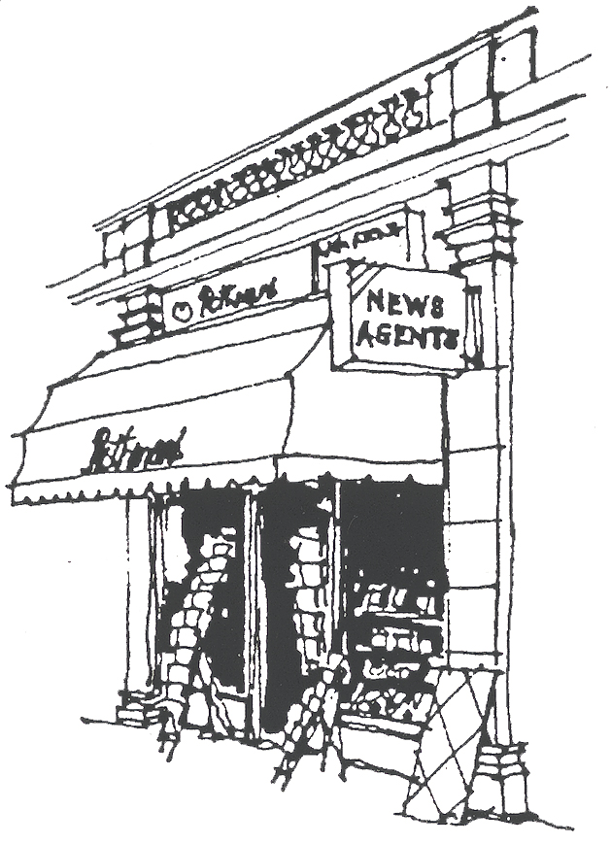
Shop Front - Product Analysis

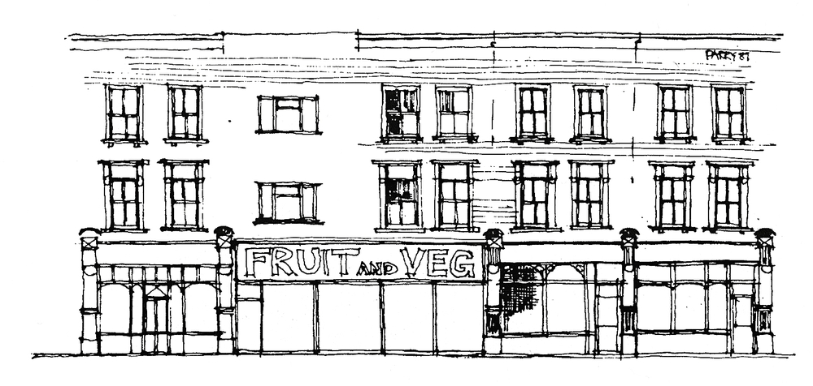
Function – (The intended use of the product)
What is the shop selling?
How do they convey this?
What and how is the name presented?
How does the name relate to the products it’s selling?
What is style of the Frontage?
How does the frontage support the products it’s selling?
How large is the space?
How do you get access to the shop?
How far can you see inside and what is the effect?



