Shop Front
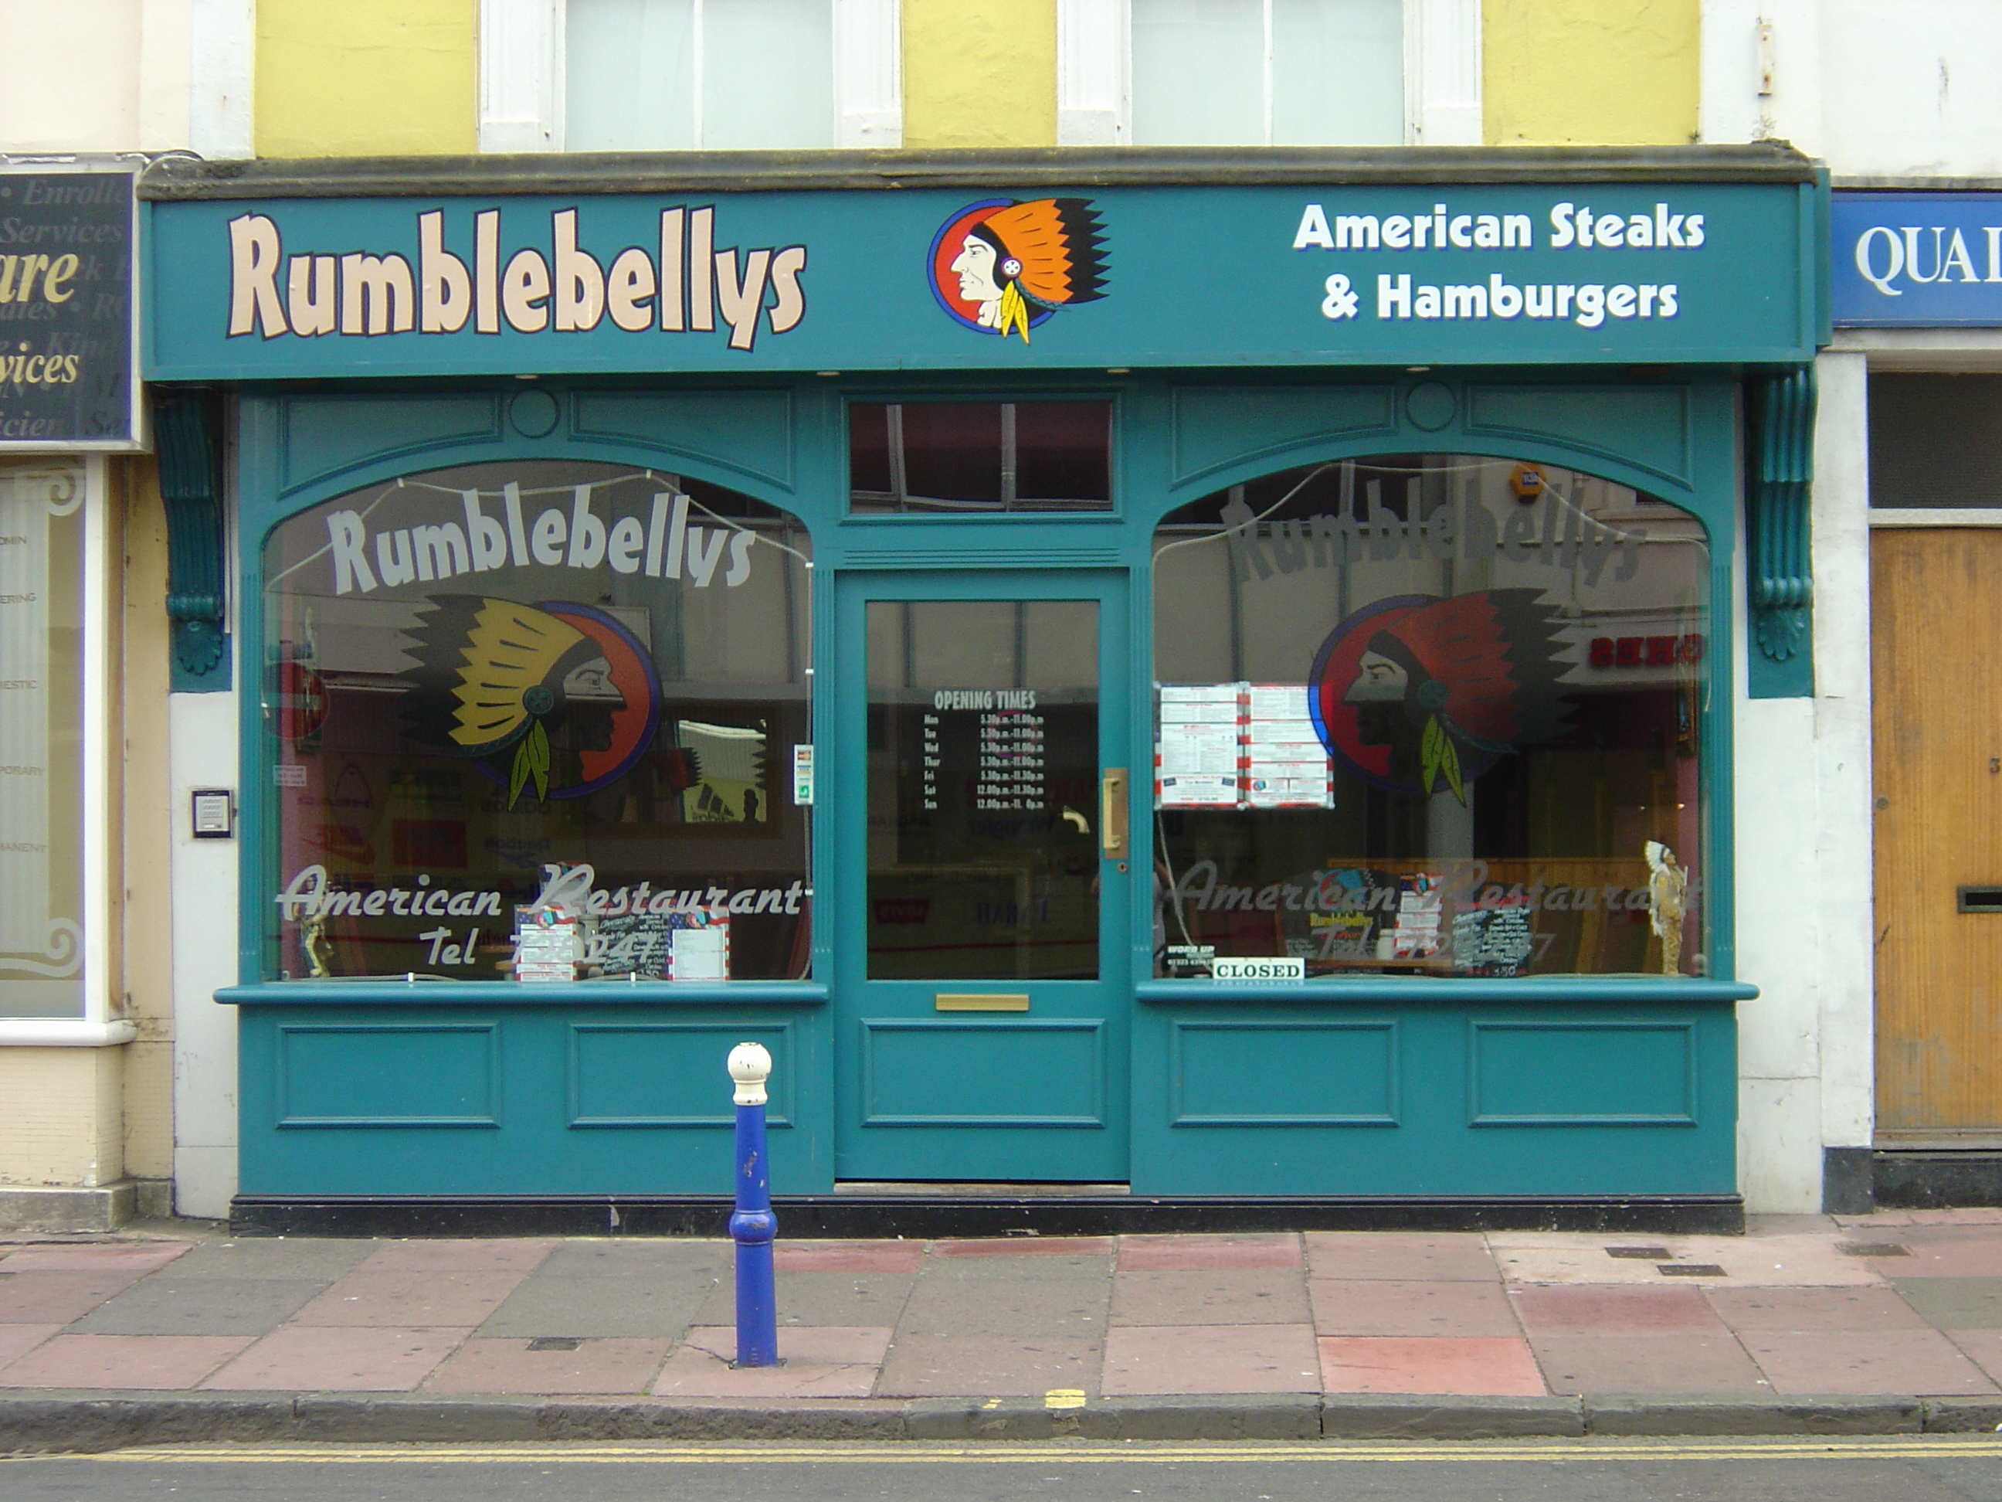

Rating

Ten Features Five Good Points
______________________________________ ____________________________________
______________________________________ ____________________________________
______________________________________ ____________________________________
______________________________________ ____________________________________
______________________________________ ____________________________________
______________________________________ Five Bad Points
______________________________________ ____________________________________
______________________________________ ____________________________________
______________________________________ ____________________________________
______________________________________ ____________________________________
____________________________________
Do you like the design? Y/N Would it make you want to go there? Y/N
Reason

What features could you use for your shop front?

