Shop Front Analysis
3
2
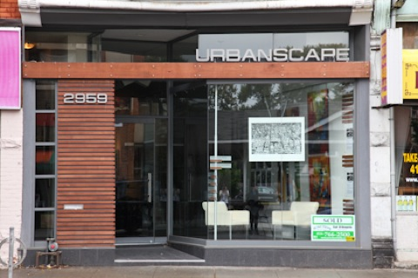
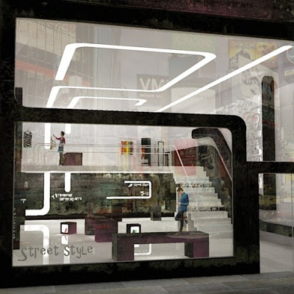
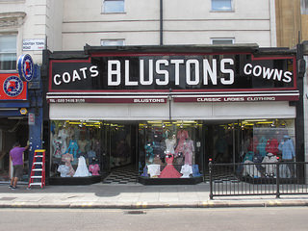

1

Which one is the best design? __________ Why___________________________________________
__________________________________________________________________________________
List Five Features you like from any of them List Five Good Points from any of them
______________________________________ ____________________________________
______________________________________ ____________________________________
______________________________________ ____________________________________
______________________________________ ____________________________________
______________________________________ ____________________________________
List four Bad Points from any of them
______________________________________ ____________________________________
_____________________________________ ____________________________________
11 1 | Y / Y/N | 2 | Y / Y/ N | 3 3 | Y / Y/ N
Would you want to go in any of them?
Reason

What features could you use for your shop front?

1. ______________________________________ 2. __________________________________
3. ______________________________________ 4. __________________________________
5. ______________________________________ 6. __________________________________

