Reflection Task 2

Produce an article/study/reflection based upon the following question:

Has High-Rise Living failed in the UK?

You must discuss the issue and illustrate it with examples and visuals; you must present it in an interesting and eye catching way to encourage the reader. You must try to support your views and opinions by evidence.

It must be between 800 to 1200 words.

You must quote **all** your sources, including pictures, in a bibliography, without this the work will not be accepted.

You have two weeks to produce this and it is to be added to your design diary after marking.

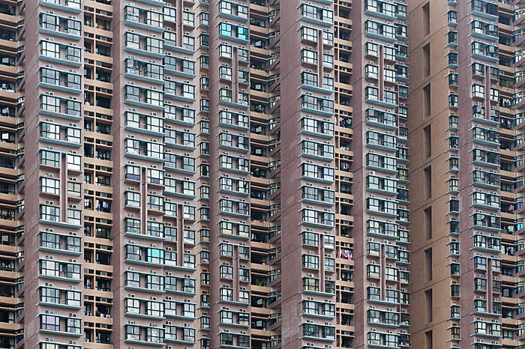

Key Words

Park Hill Brutalism Slums Environment

Concrete Improve Ronan Point

Tower block View Help City Quality

Beauty Style Function Hong Kong

