Reflection Task 1

Produce an article/study/reflection, based upon the following question:

What is Design?

You must discuss the issue and illustrate it with examples and visuals; you must present it in an interesting and eye catching way to encourage the reader. You must try to support your views and opinions by evidence.

It must be between 800 to 1200 words.

You must quote **all** your sources, including pictures, in a bibliography, without this the work will not be accepted.

You have one week to produce this and it is to be added to your design diary after marking.

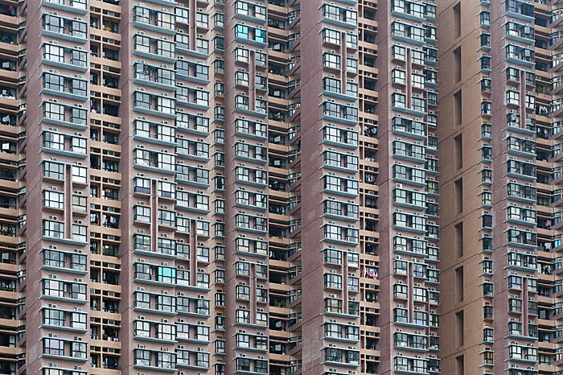

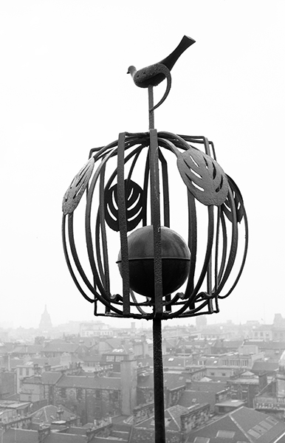

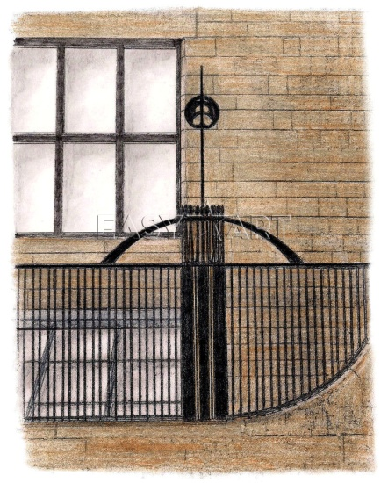

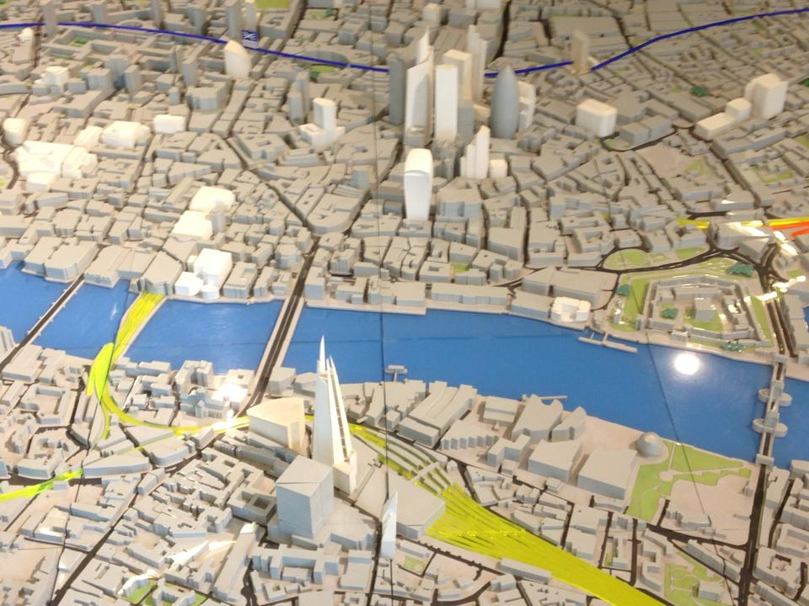

Key Words

Process System Product Environment

Benefit Improve Opportunity

Problem Solve Help Defence Quality

Beauty Style Function