

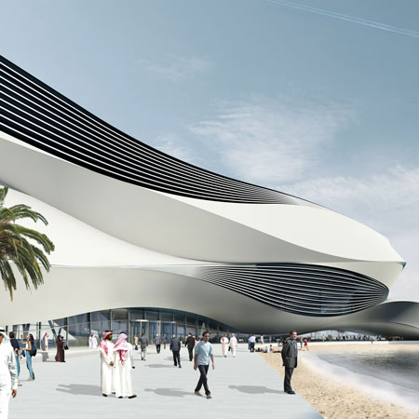

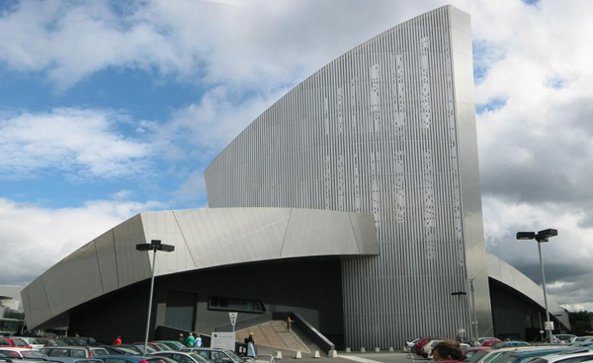

Design in the Built Environment

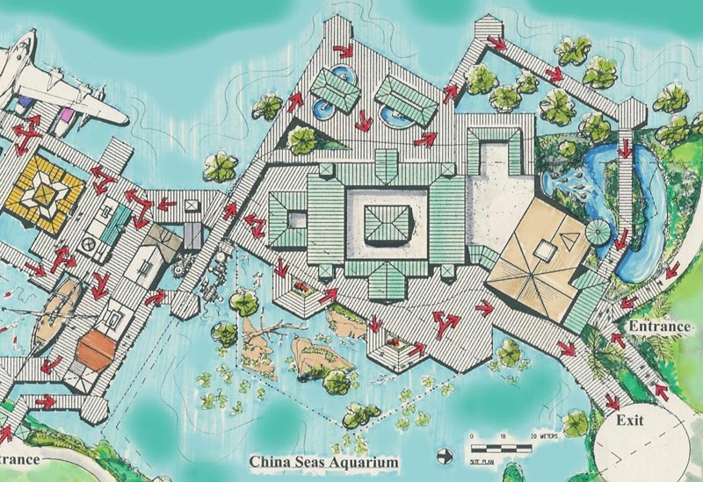

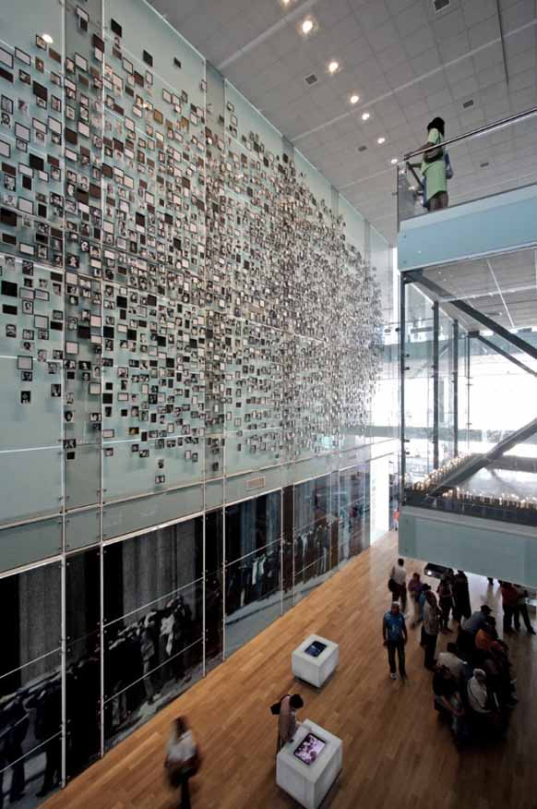

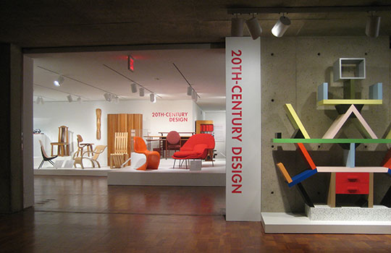

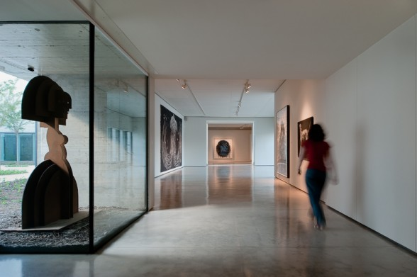

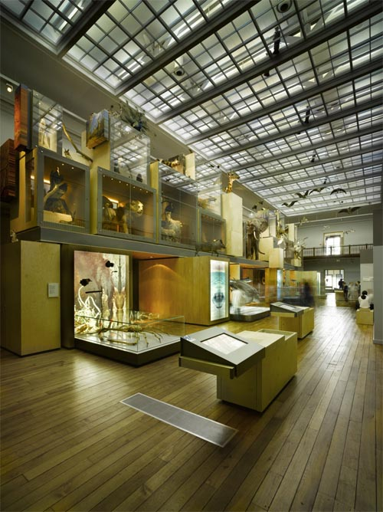

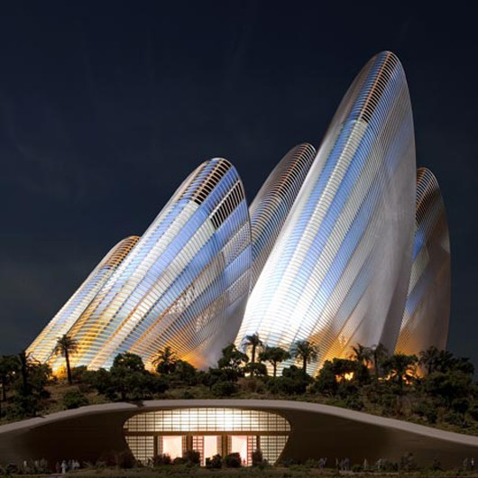

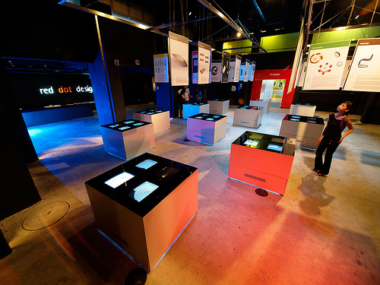

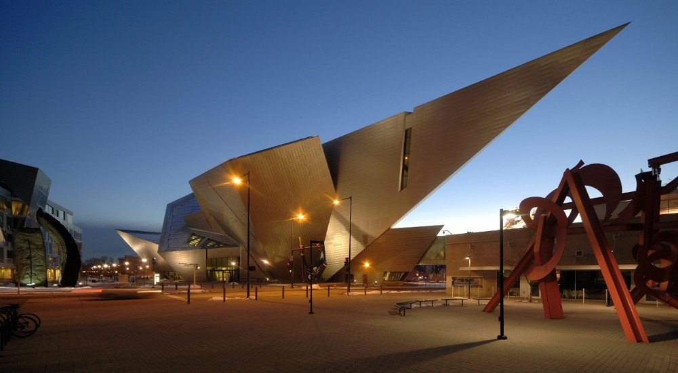

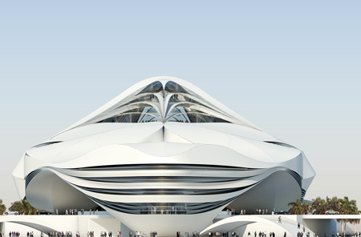

Assignment – Museum

Task 2 – The Gallery

The Museum – Task 2 – The Gallery

You need to create some designs for a new gallery of your choice, followed by the production of a quality concept model of your final design to present to the client and for the public consultation.

Stage 1 – Research & Analysis

A detailed study of an existing museum/gallery and a focus for that gallery as well as any current or recent projects in this field. Consider examples of new and innovative designs which could offer a project like this something new.

Stage 2 – Ideas

Produce a range of ideas based upon informed research supported by explanations and direct research suggesting materials and processes

**Presentation 1 – Design Ideas**

From the range of ideas you have produced who need to present the best ones to the client. You must explain the concept of the designs with the pros and cons for each one explained. From this meeting the best design must be selected for further development.

Stage 3 – Development

The final idea needs to be taken forward to a final design which must have as much detail as possible, including features and materials.

**Presentation 2 – The Final Plans**

You need to present the final design and details to the client for final approval before the model can be started

Stage 4 – Final Details - Model

From the final design a scale concept model needs to be produced, the scale is of your choice.

**Presentation 3 – The Final Model**

This is where you put together all the information for the final Presentation, supported by the final model, to be put on display for the public consultation. The purpose of the exhibition is to promote and inform the public of the benefits and details of the project as this will be part of the major consultation process before the building programme will begin.

Some movements which could be looked at as a basis:

* Arts & Crafts/Art Nouveau
* Bauhaus Modernist
* Art Deco
* Post Modernism
* Streamlining
* Memphis

Resources - - DT Library, DT Website.

Resources – ICT - Internet Access, Sketchup

Resources – Work Areas - Design Studio, ICT Suite, Workshop



