

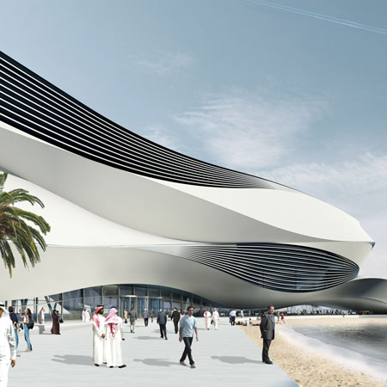

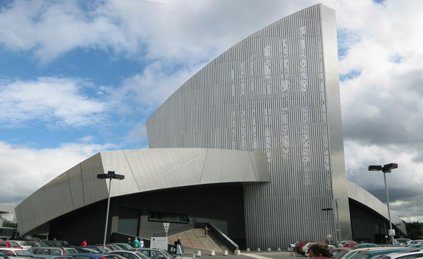

Design in the Built Environment

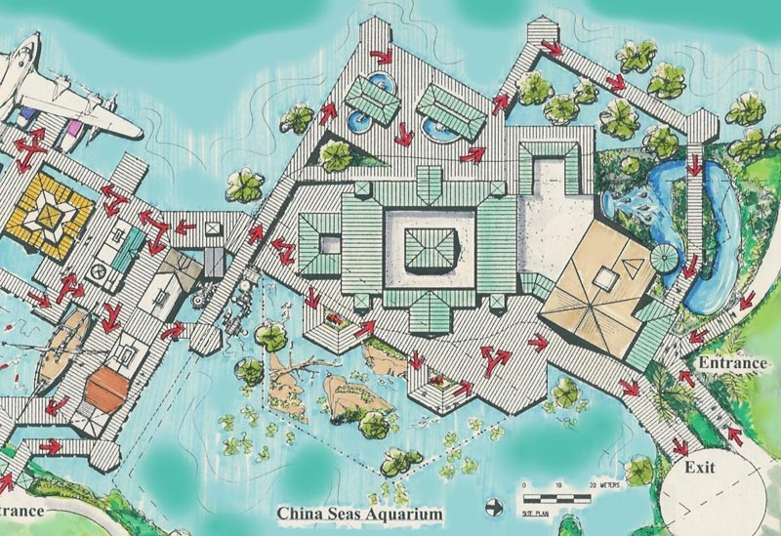

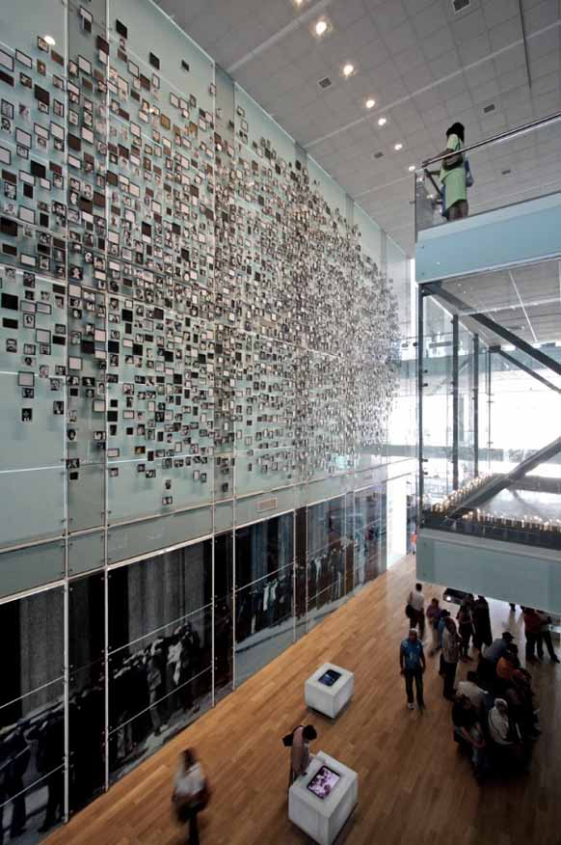

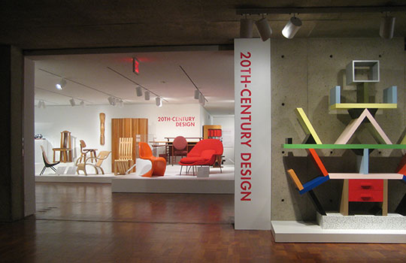

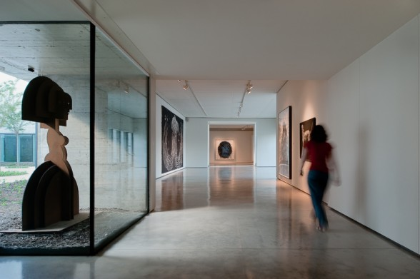

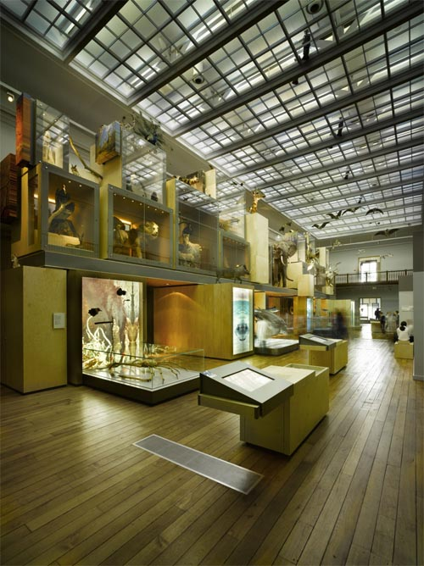

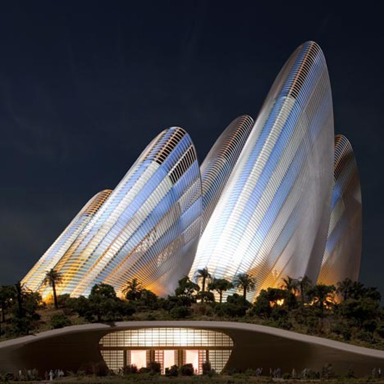

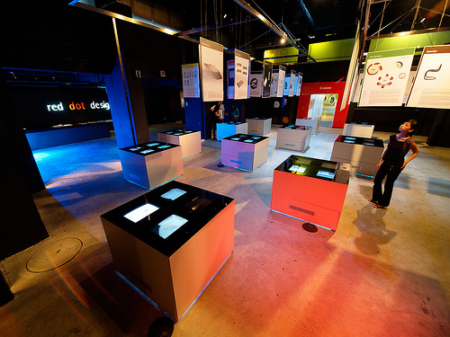

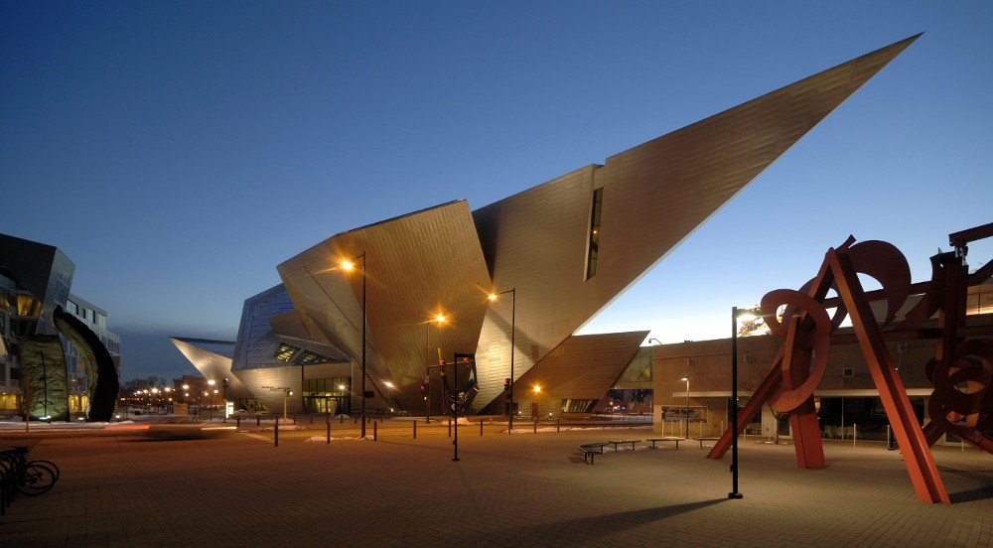

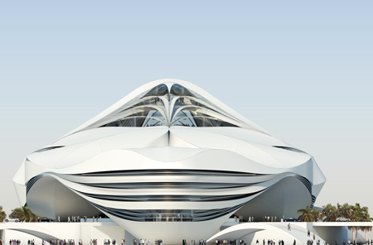

Assignment – Museum

Task 1 – The Building

The Museum – Task 1 – The Building

You need to create some designs for the Museum building, followed by the production of a quality concept model of your final design to present to the client and for the public consultation.

Stage 1 – Research & Analysis

A detailed study of an existing museum and any current or recent projects in this field. Consider examples of new and innovative designs, which could offer a project like this something new.

Stage 2 – Ideas

Produce a range of ideas based upon informed research supported by explanations and direct research

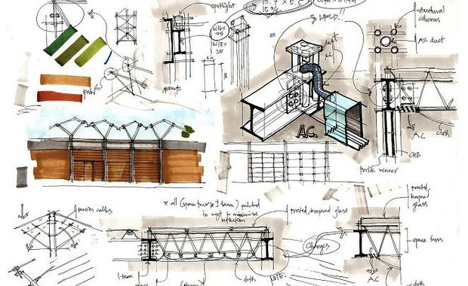

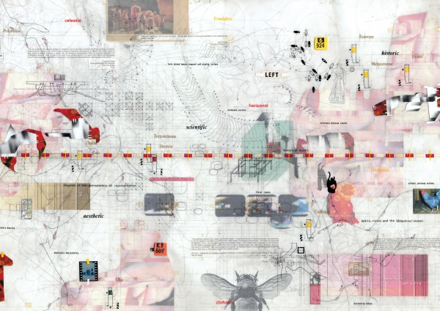

**Presentation 1 – Design Ideas**

From the range of ideas you have produced who need to present the best ones to the client. You must explain the concept of the designs with the pros and cons for each one explained. From this meeting the best design must be selected for further development.

Stage 3 – Development

The final idea needs to be taken forward to a final design which must have as much detail as possible, including features and materials.

**Presentation 2 – The Final Plans**

You need to present the final design and details to the client for final approval before the model can be started

Stage 4 – Final Details - Model

From the final design a scale concept model needs to be produced using a scale such as 1:144 or 1:200

**Presentation 3 – The Final Model**

This is where you put together all the information for the final Presentation, supported by the final model, to be put on display for the public consultation. The purpose of the exhibition is to promote and inform the public of the benefits and details of the project as this will be part of the major consultation process before the building programme will begin.

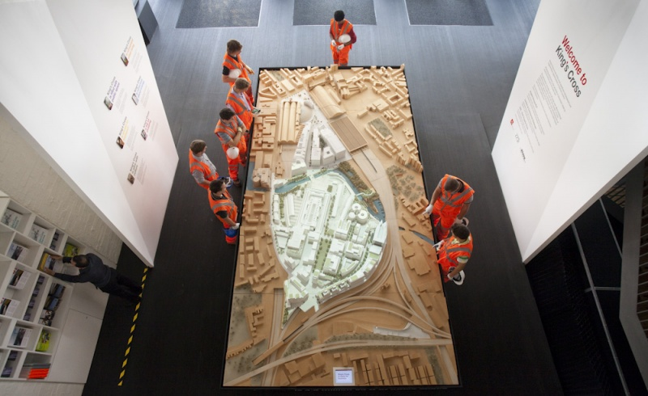

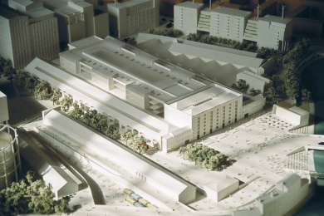

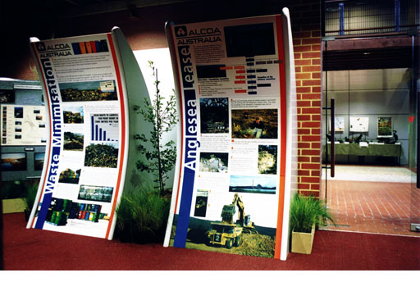

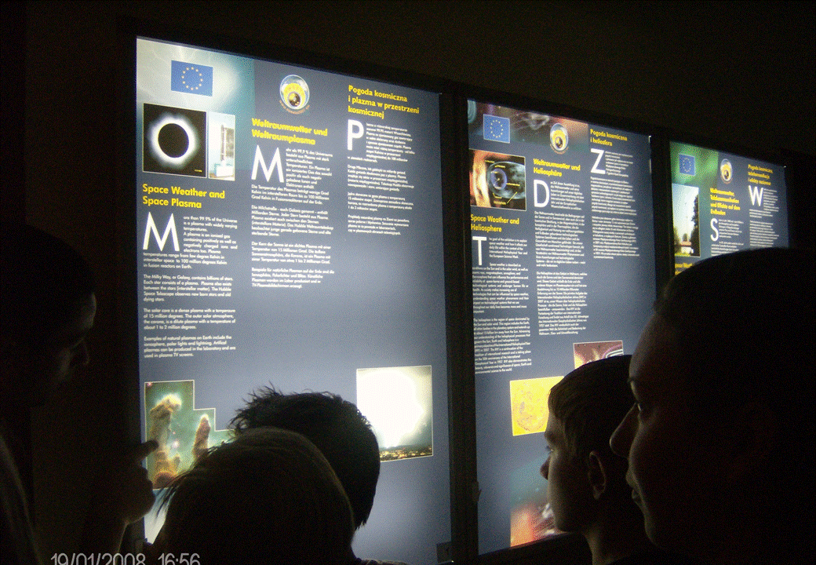

Suggested Approach:

Stage 1 – Investigation & Reflection

1. Collect Secondary Research – Internet, Books, Magazines
2. Collect Primary Research – Visits, Photos, Sketches
3. Research & analyse existing museums or similar environments
4. Research & analyse existing natural environments that can inspire ideas
5. Research & analyse existing urban environments for comparison
6. Research a related designer/architect you will influence the project
7. Identify key features from the research

Stage 2 - Design

1. Explore factors specific to the building
2. Rough designs
3. Explore Issues for the enclosure
4. Research possible materials

Stage 3 - Develop

1. A development of one idea, which you have selected
2. A range of designs produced on the computer.
3. Rough concept models
4. Selection of final design

Stage 4 - Final Design

1. A final design drawings with more detail
2. Presentation Drawings
3. Model/s to show detail

Stage 5 – Presentation & Exhibition

1. Evaluate project
2. Identify appropriate presentations for target audiences.
3. Research and select a range of professional presentation methods.
4. Plan and create a presentation of the work as a whole.
5. Present appropriately to Client Harchester County Council
6. Organise display for County Hall

