Extra Information - Harchester Tram System

The development of the new tram system for Harchester, heading from Wickminister in the north, through Harchester then south towards to the seaside town of Lyndome Bay, via the Airport. For the majority of the route it will be using the old rail track bed which was decommissioned in the 1960s as part of the Beecham Report, as well as some of the old tramways that already exist but have fallen out of use.

Money has come from both the County and a major government grant and will link key elements of the County together, the main seaside town, the airport, Harchester, Wickminster and the motorway.

Money has also come from the airport authority, which is looking for a major explanation and needs additional transport links to improve access as it doesn’t currently have a rail link. Whatever happens the link between Harchester railway station to the airport will be built.

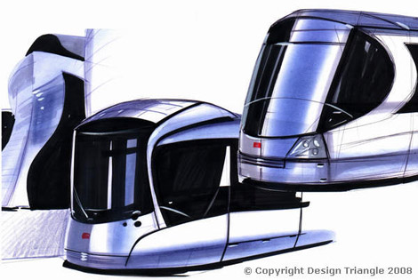

List of main stops agreed:

- Lyndome Bay Pier
- Lyndome Town
- Lyndome Bypass
- Forrest Raise
- Waxmore Village
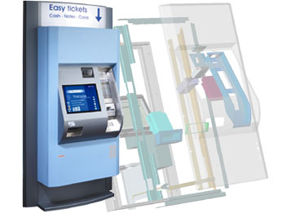
- Harchester Airport
- Saxum Village
- Lowcester Village
- Harchester Southern Park & Ride
- Harchester Canal
- Harchester Museum
- Harchester Station
- Harchester Northern Park & Ride
- Syndale Village
- Northlime Village
- Wickminster Industrial Park
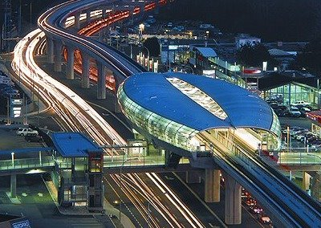
- Wickminster Retail Park
- Wickminster Town
- Wickminister South
- Wickminster M16

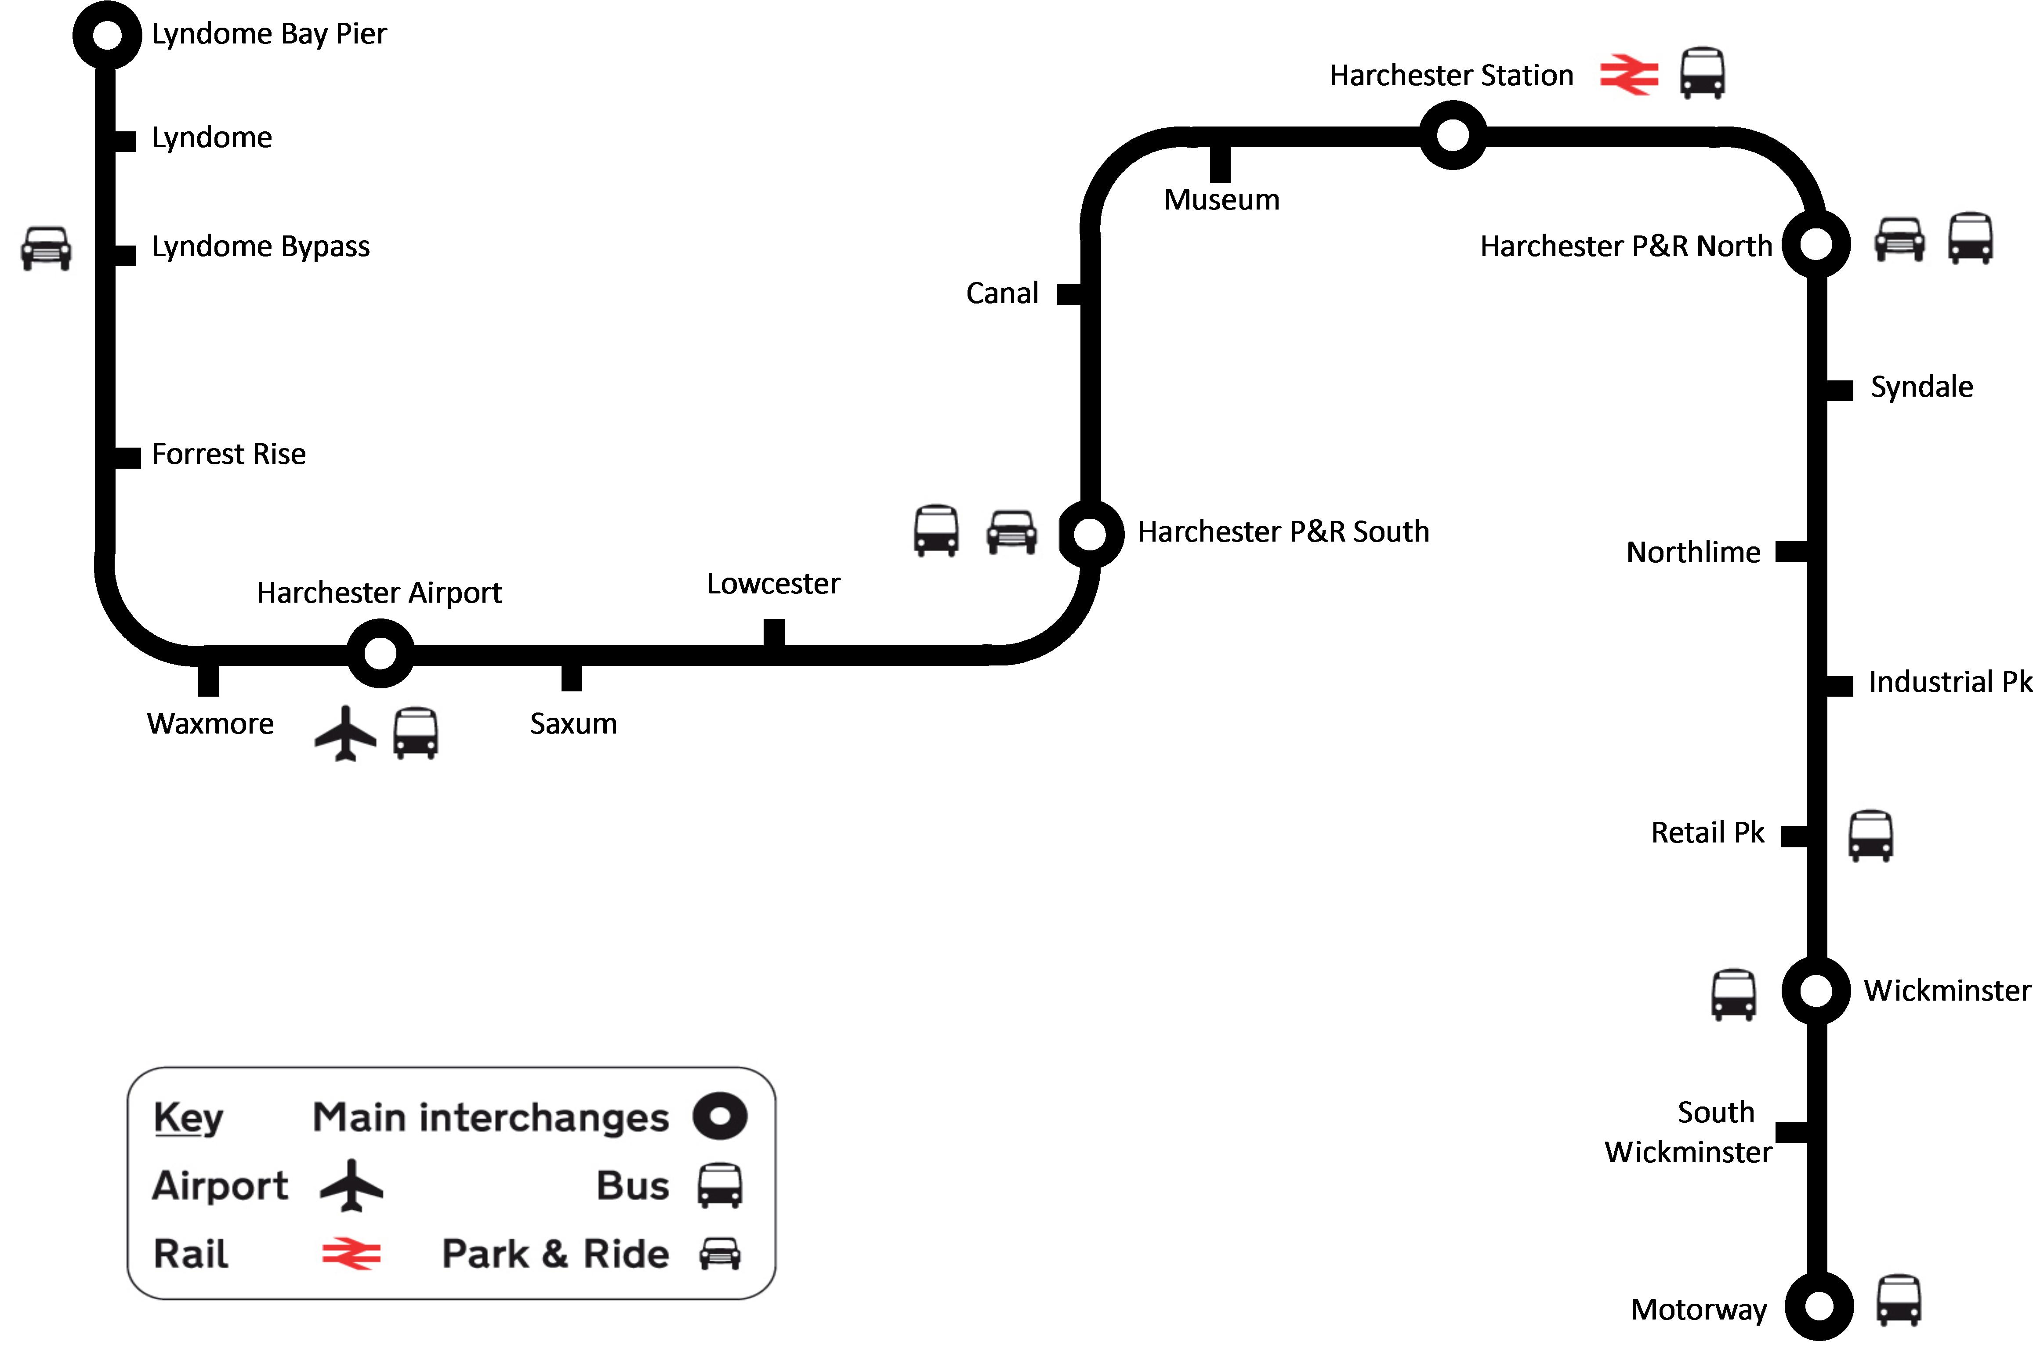

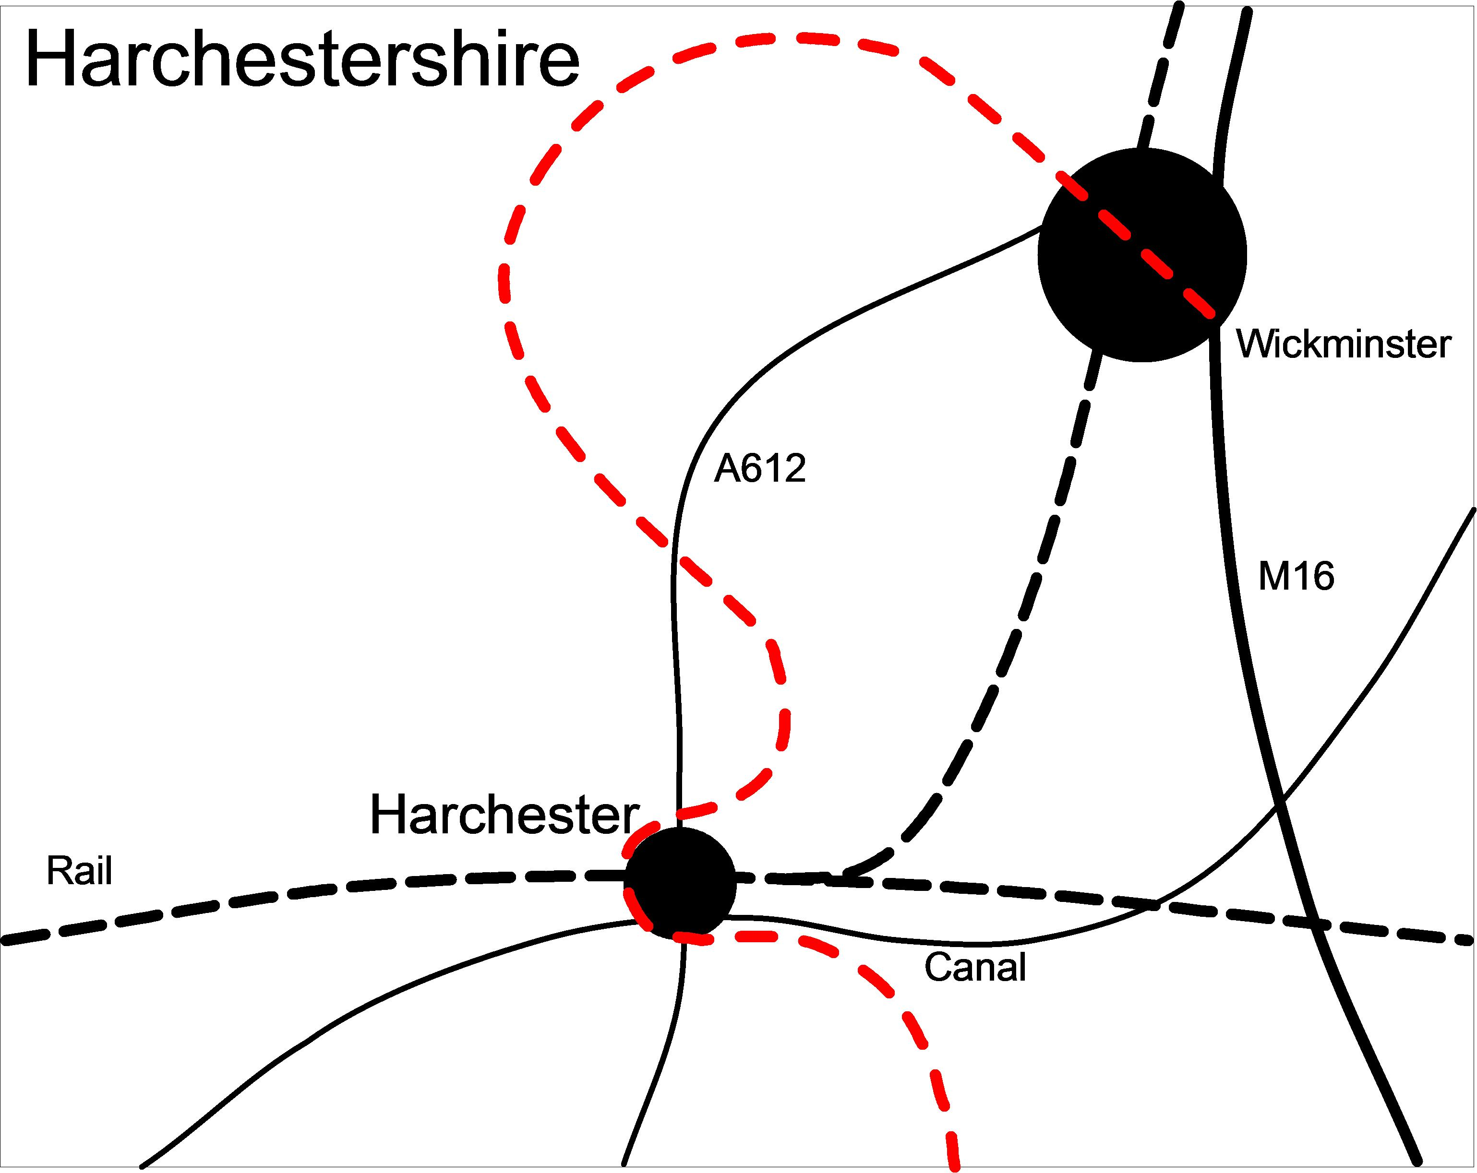

Tram Stops
There are a range of small stopping points where people can wait, purchase tickets and have shelter from the elements. They have information points as well which include live transport information, access to further information and contact facilities. These electronic information displays will be used to inform passengers of times and any additional promotions taking place. Ticket machines need to be available to cover cash and card purchases. Tickets will also be available at local shops as well as at the stops.

These tram stops will be modern, and have visual impact sending out the message that this is a transport system of the 21st Century. They must be of various sizes, but have a common design between them.

There are at least 3 basic sizes:

- Small - to accommodate up to six people – these will be at the villages
- Medium – this is the standard size which will accommodate up to 12
- Large – These are stopping points for the tram for staff change over

The Route through Harchester

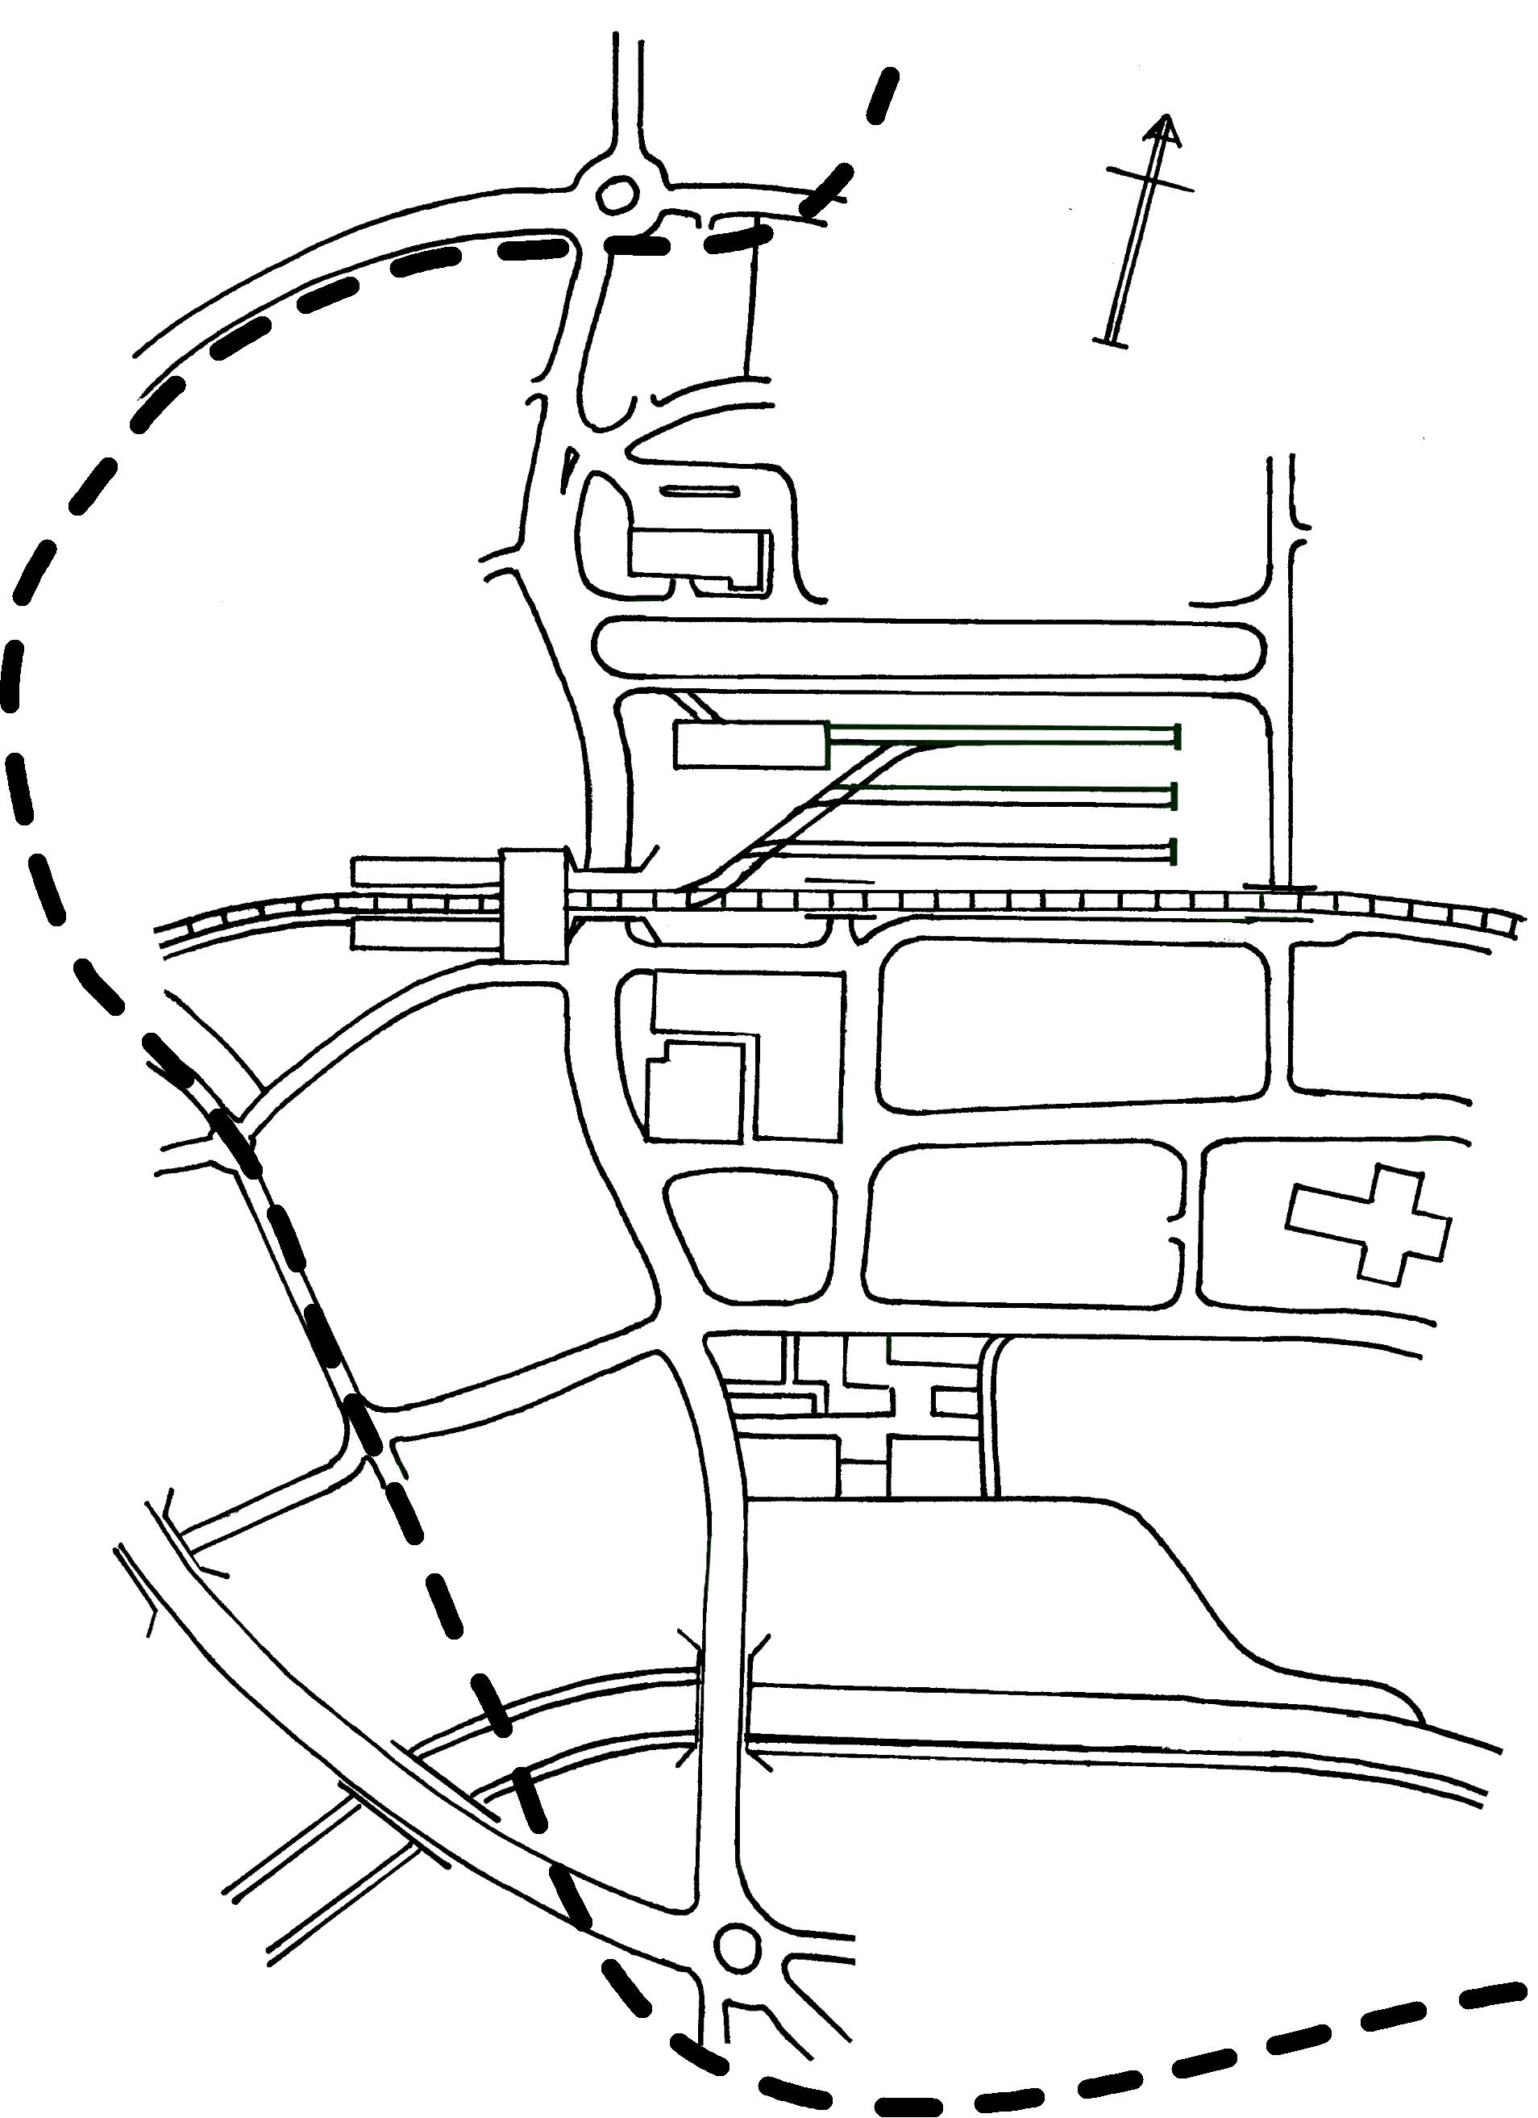
Harchester
P&R North

Proposed
Museum
Development

Harchester
P&R South

Tram Main Stations
These are major intersections on the line and have to have far more advanced layout and facilities. There are two main types:

General- These are larger than the large stops mentioned above and are fully staffed with more facilities such as toilets, they tend to be where minor interchange points are.

These stations are:

Lyndome Bay Pier | End of the pier, end of the line for the southern end
Lyndome | Main town, they would like to use the old railway station which closed in 1966
Lyndome Bypass | The P&R for Lyndome & Lyndome Bay
Harchester P&R South | The P&R for Harchester
Harchester P&R North | The P&R for Harchester
Motorway | This is a P&R facility that connects the line to the M16 motorway. End of the line for the northern end

Main – These are points which have all the general facilities already mention but are major interchange points with additional facilities such as shops and café facilities.

These stations are:

Harchester Airport | Large complex interchange for the airport and coach station, currently not served by the railway. The airport is contributing to the development ot the tram system.
Harchester Station | The development can take in the railway station as well as it is up for development. Main line to London as well as Wickminister
Wickminister | The main town of the county. It will link the main tourist feature of the of Wickgate shopping centre and the 12th Century Cathedral

The depot for the trams is to be based at Saxum, which is a small village just outside Harchester airport. It is using some of the land surrounding the airport and this will enable them to share or call upon additional support from the engineering departments and facilities based on the airport site

