Task GD04b - Promotional Leaflet Stand

INTRODUCTION/SCENARIO
With the leaflet the council would like you to produce a leaflet stand (Point of Sale - PoS) to go with it. The PoS must be made of card and flat packed to be assembled by those using it. The PoS will be used in shops and public buildings and you must ensure that the leaflet is not lost amongst all the other promotional materials available.

TASK: You need to design and produce a leaflet stand, which can be distributed with the leaflets and can be self-assembled.

CLIENT: Harchester Council

Specification
- The PoS display must stand out.
- Must hold the leaflet you have designed.
- Must be flat pack and easily assembled.
- Must be made of card.

Outcomes
- Research on Leaflet stand and some product analysis.
- Rough designs with a development of one idea, which you have selected.
- A range of design models for the PoS.
- A final design/outcome
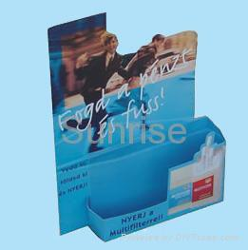

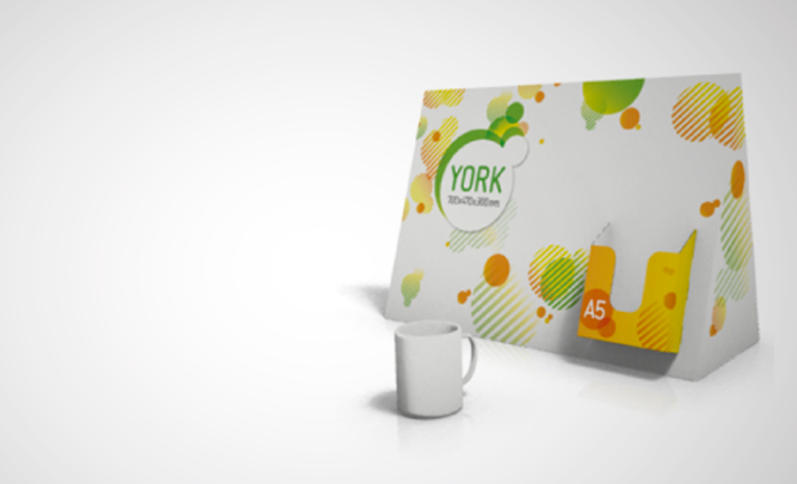

OUTCOMES:

A clear final leaflet stand

EVIDENCE YOU MUST PRODUCE FOR THIS TASK:

Portfolio containing:
- records of relevant research, especially primary with supporting analysis
- progress journal/folder – your ideas/designs and experiments in card (how could you make your PoS display stand more interesting?)
- annotation throughout – what skills, materials, techniques, process have been used and what messages are being communicated and how?
Models
- Final leaflet stand
- Rough Models
