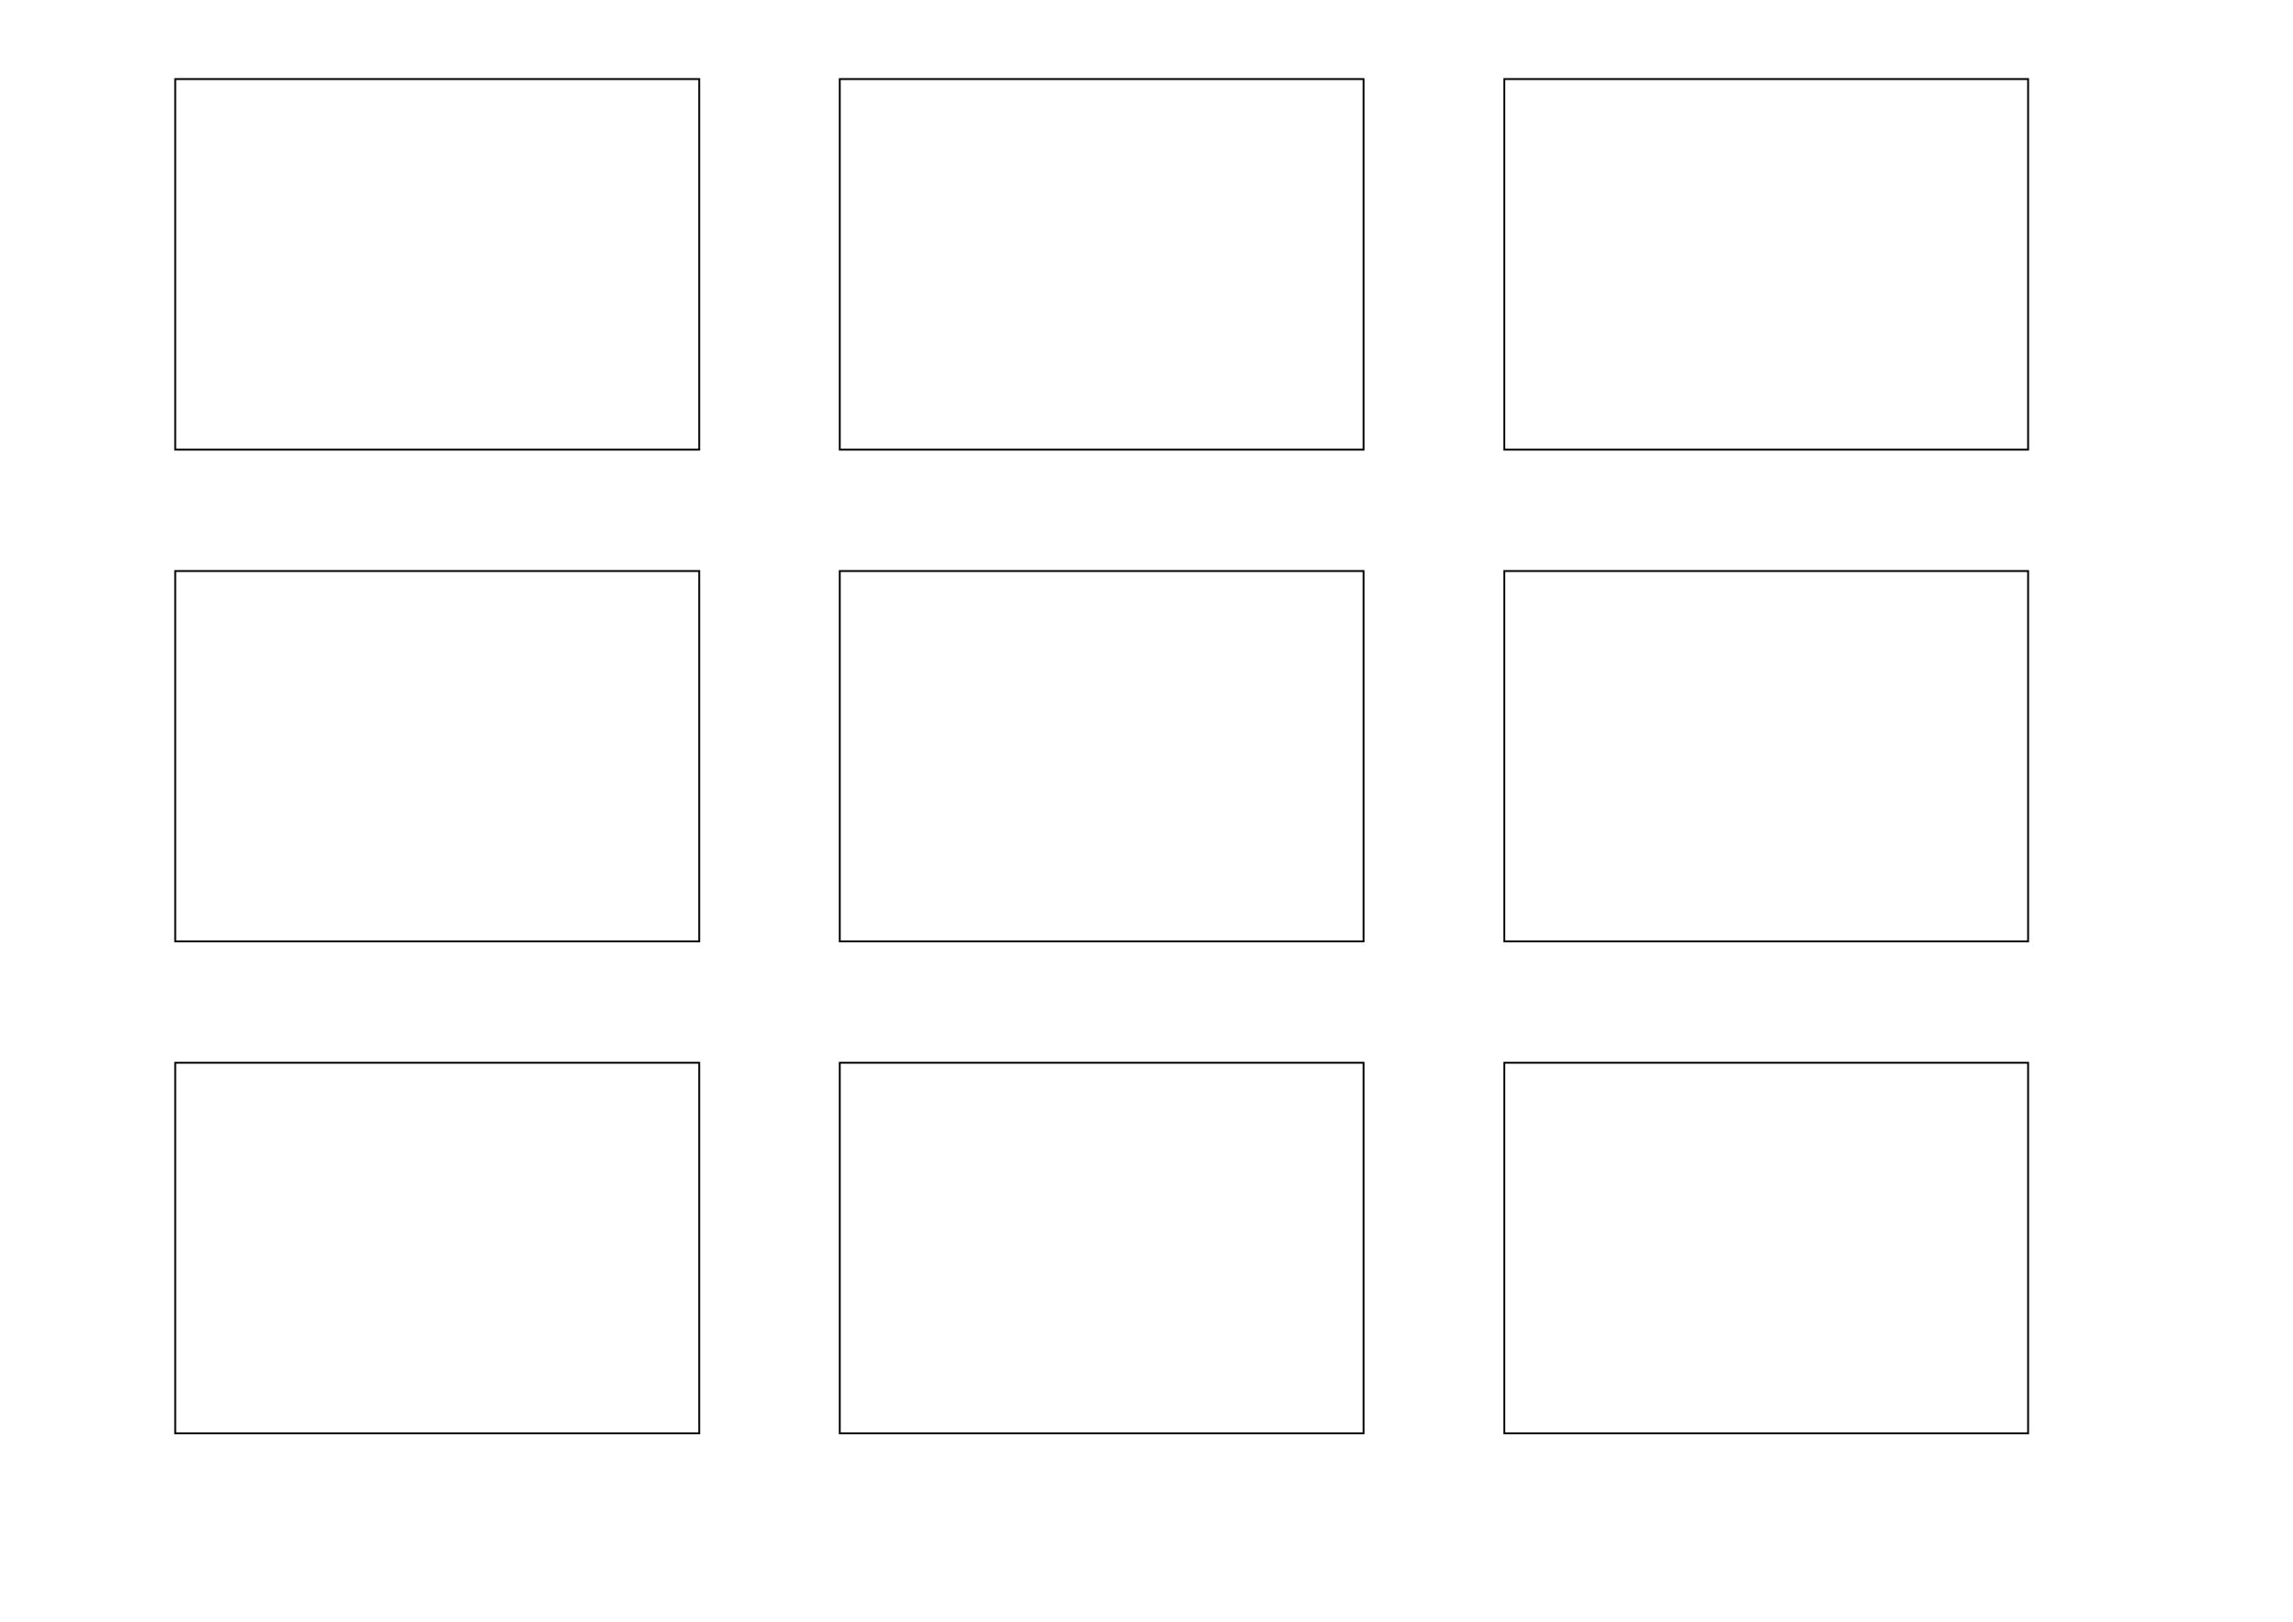
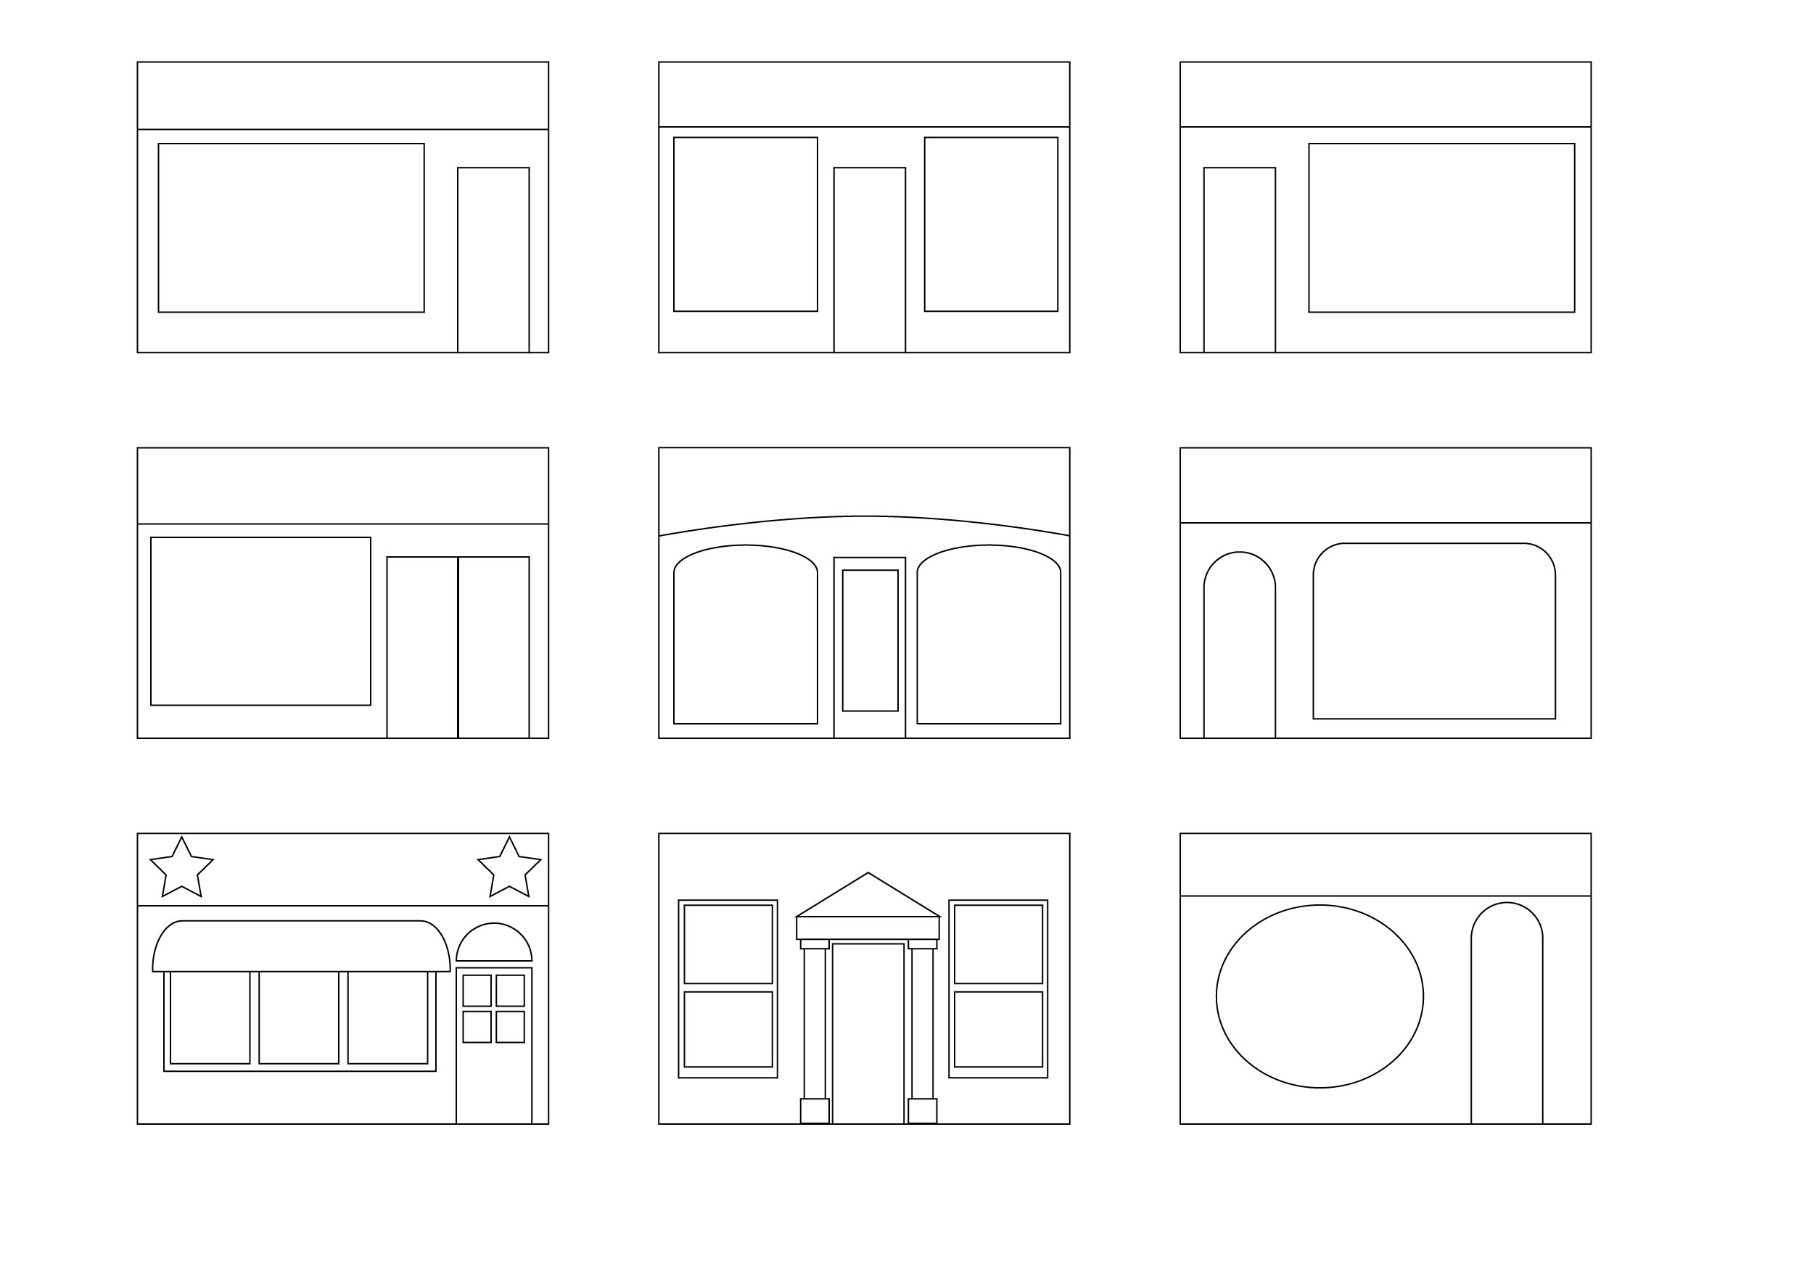
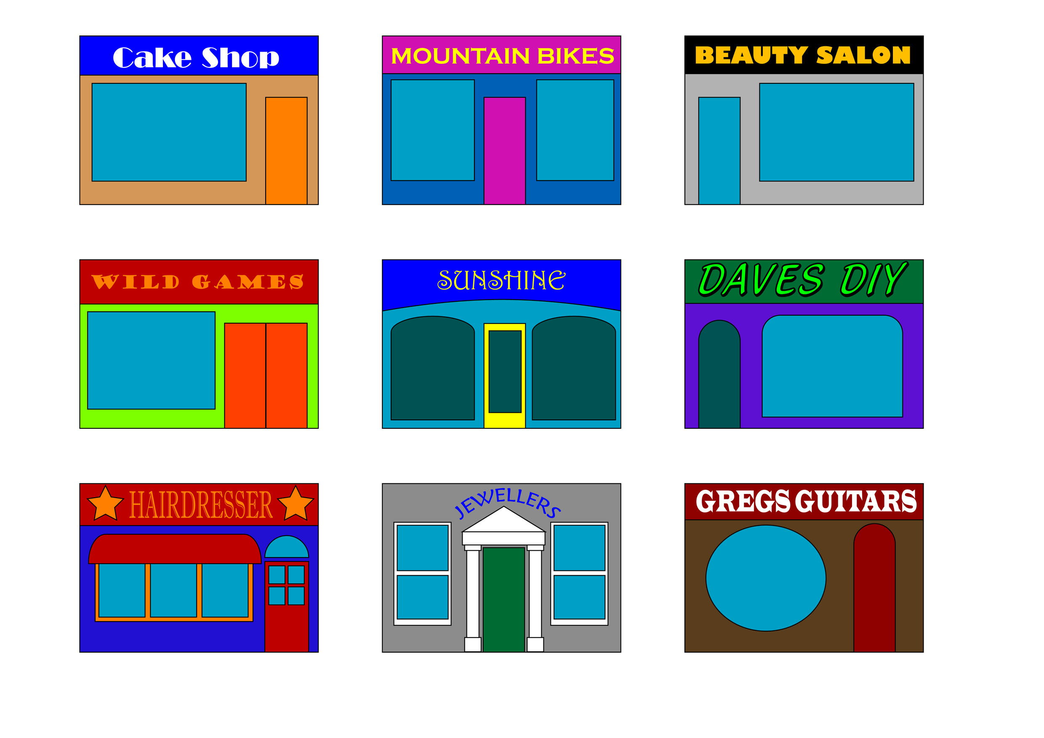

Stage 1

Draw out nine boxes 60x100
Stage 2

Draw out the designs as neatly as possible using drawing equipment
Stage 3

Do names and colour in the nine shopfront designs

