Assignment ED02 - Shop Front

You have been approached to design a shop front for an existing shop. The brief is open and you can do pretty well what you want. The shop is based in the new Wickminster Shopping Centre and the local planning committee is sympathetic about using interesting and exciting designs.

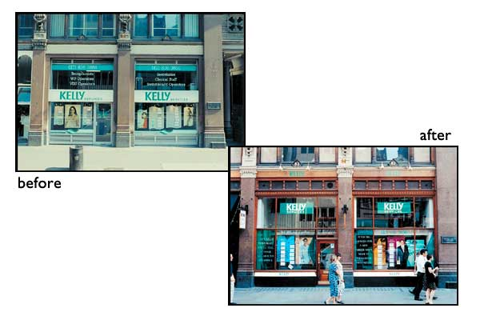
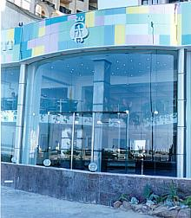
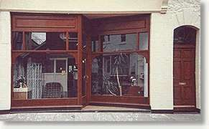

Websites:

http://www.ukshopfrontspecialists.co.uk/ - Specialist manufacture of shop fronts

http://www.theoneoff.com/ - Shop Designers

http://www.design4retail.co.uk/ - Shop Designers

https://www.shopfrontdesign.co.uk/ - Shop Front Designers

CLIENT:
Wickminster Shopping Centre

TASK:
To design a new shop front, which is exciting and has an impact upon its location.

SPECIFCIATION:
1. You must choose a striking name.
2. You must develop a strong brand image, projecting the products it is selling.
3. You must produce a scale model (1:12).
4. You must produce a range of visuals for presentation to the client.

OUTCOMES:
- A range of annotated ideas to be presented to the centre team, in a form of your choice. Portfolio of work to support the project.
- You will need to produce a scale model of your preferred design, which will be presented to the management team at Wickminister Shopping Centre.

RESOURCES:

- DT Library, DT Magazines, DT Website
- 2D Design, Photoshop, Sketchup
- Design Studio, ICT Suite, Workshops

