Design in the Built Environment

Assignment 00 – My Company

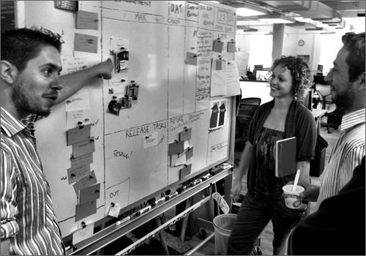
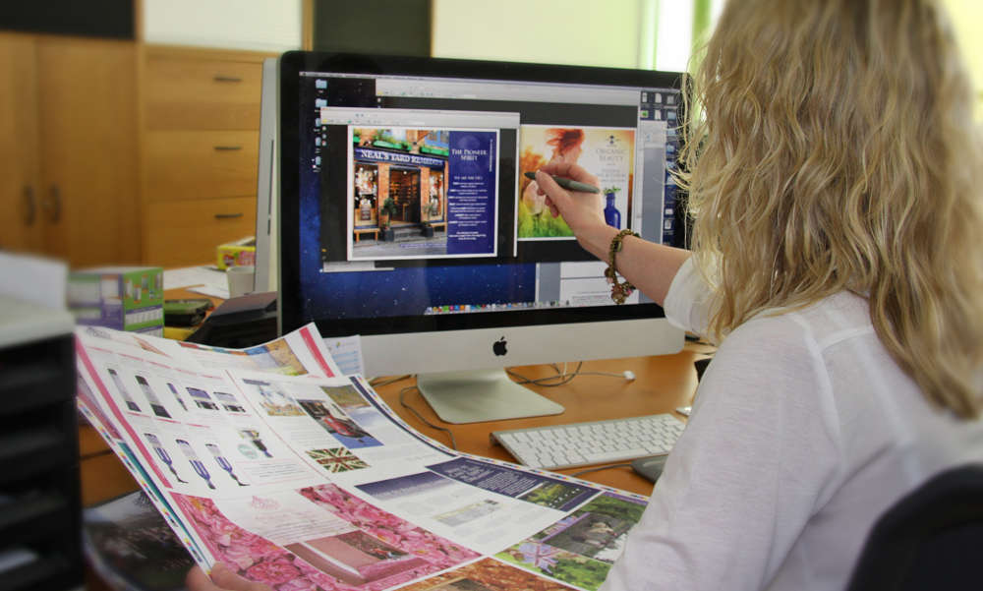

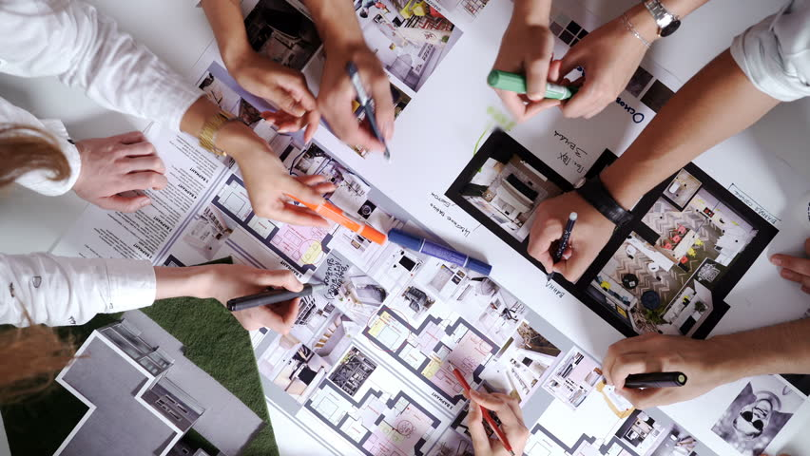

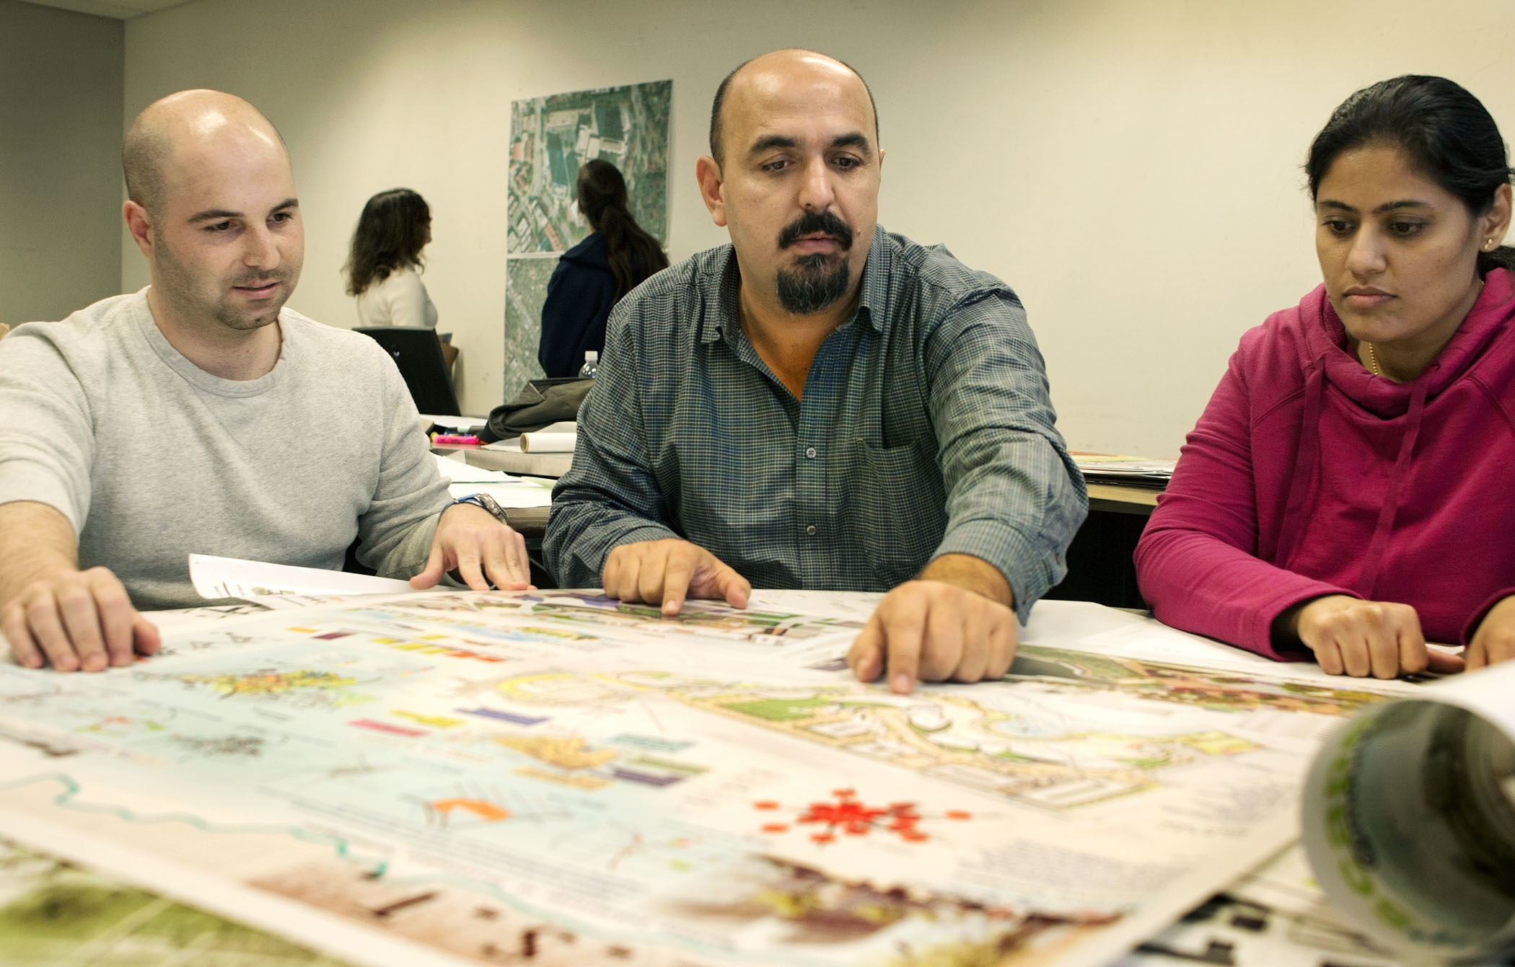

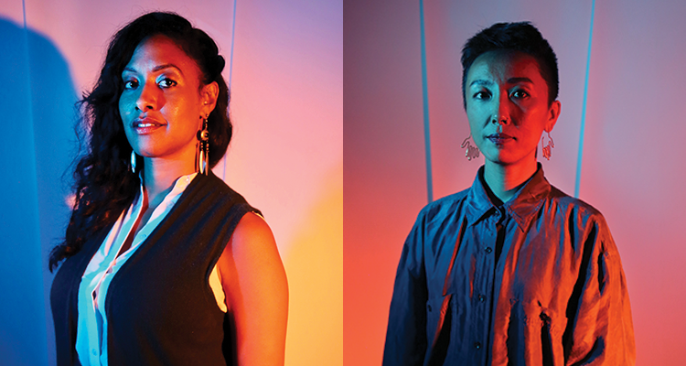

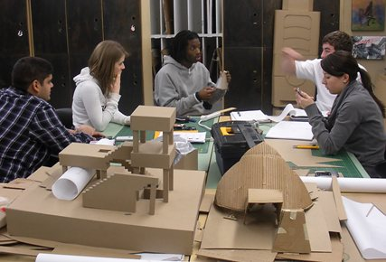

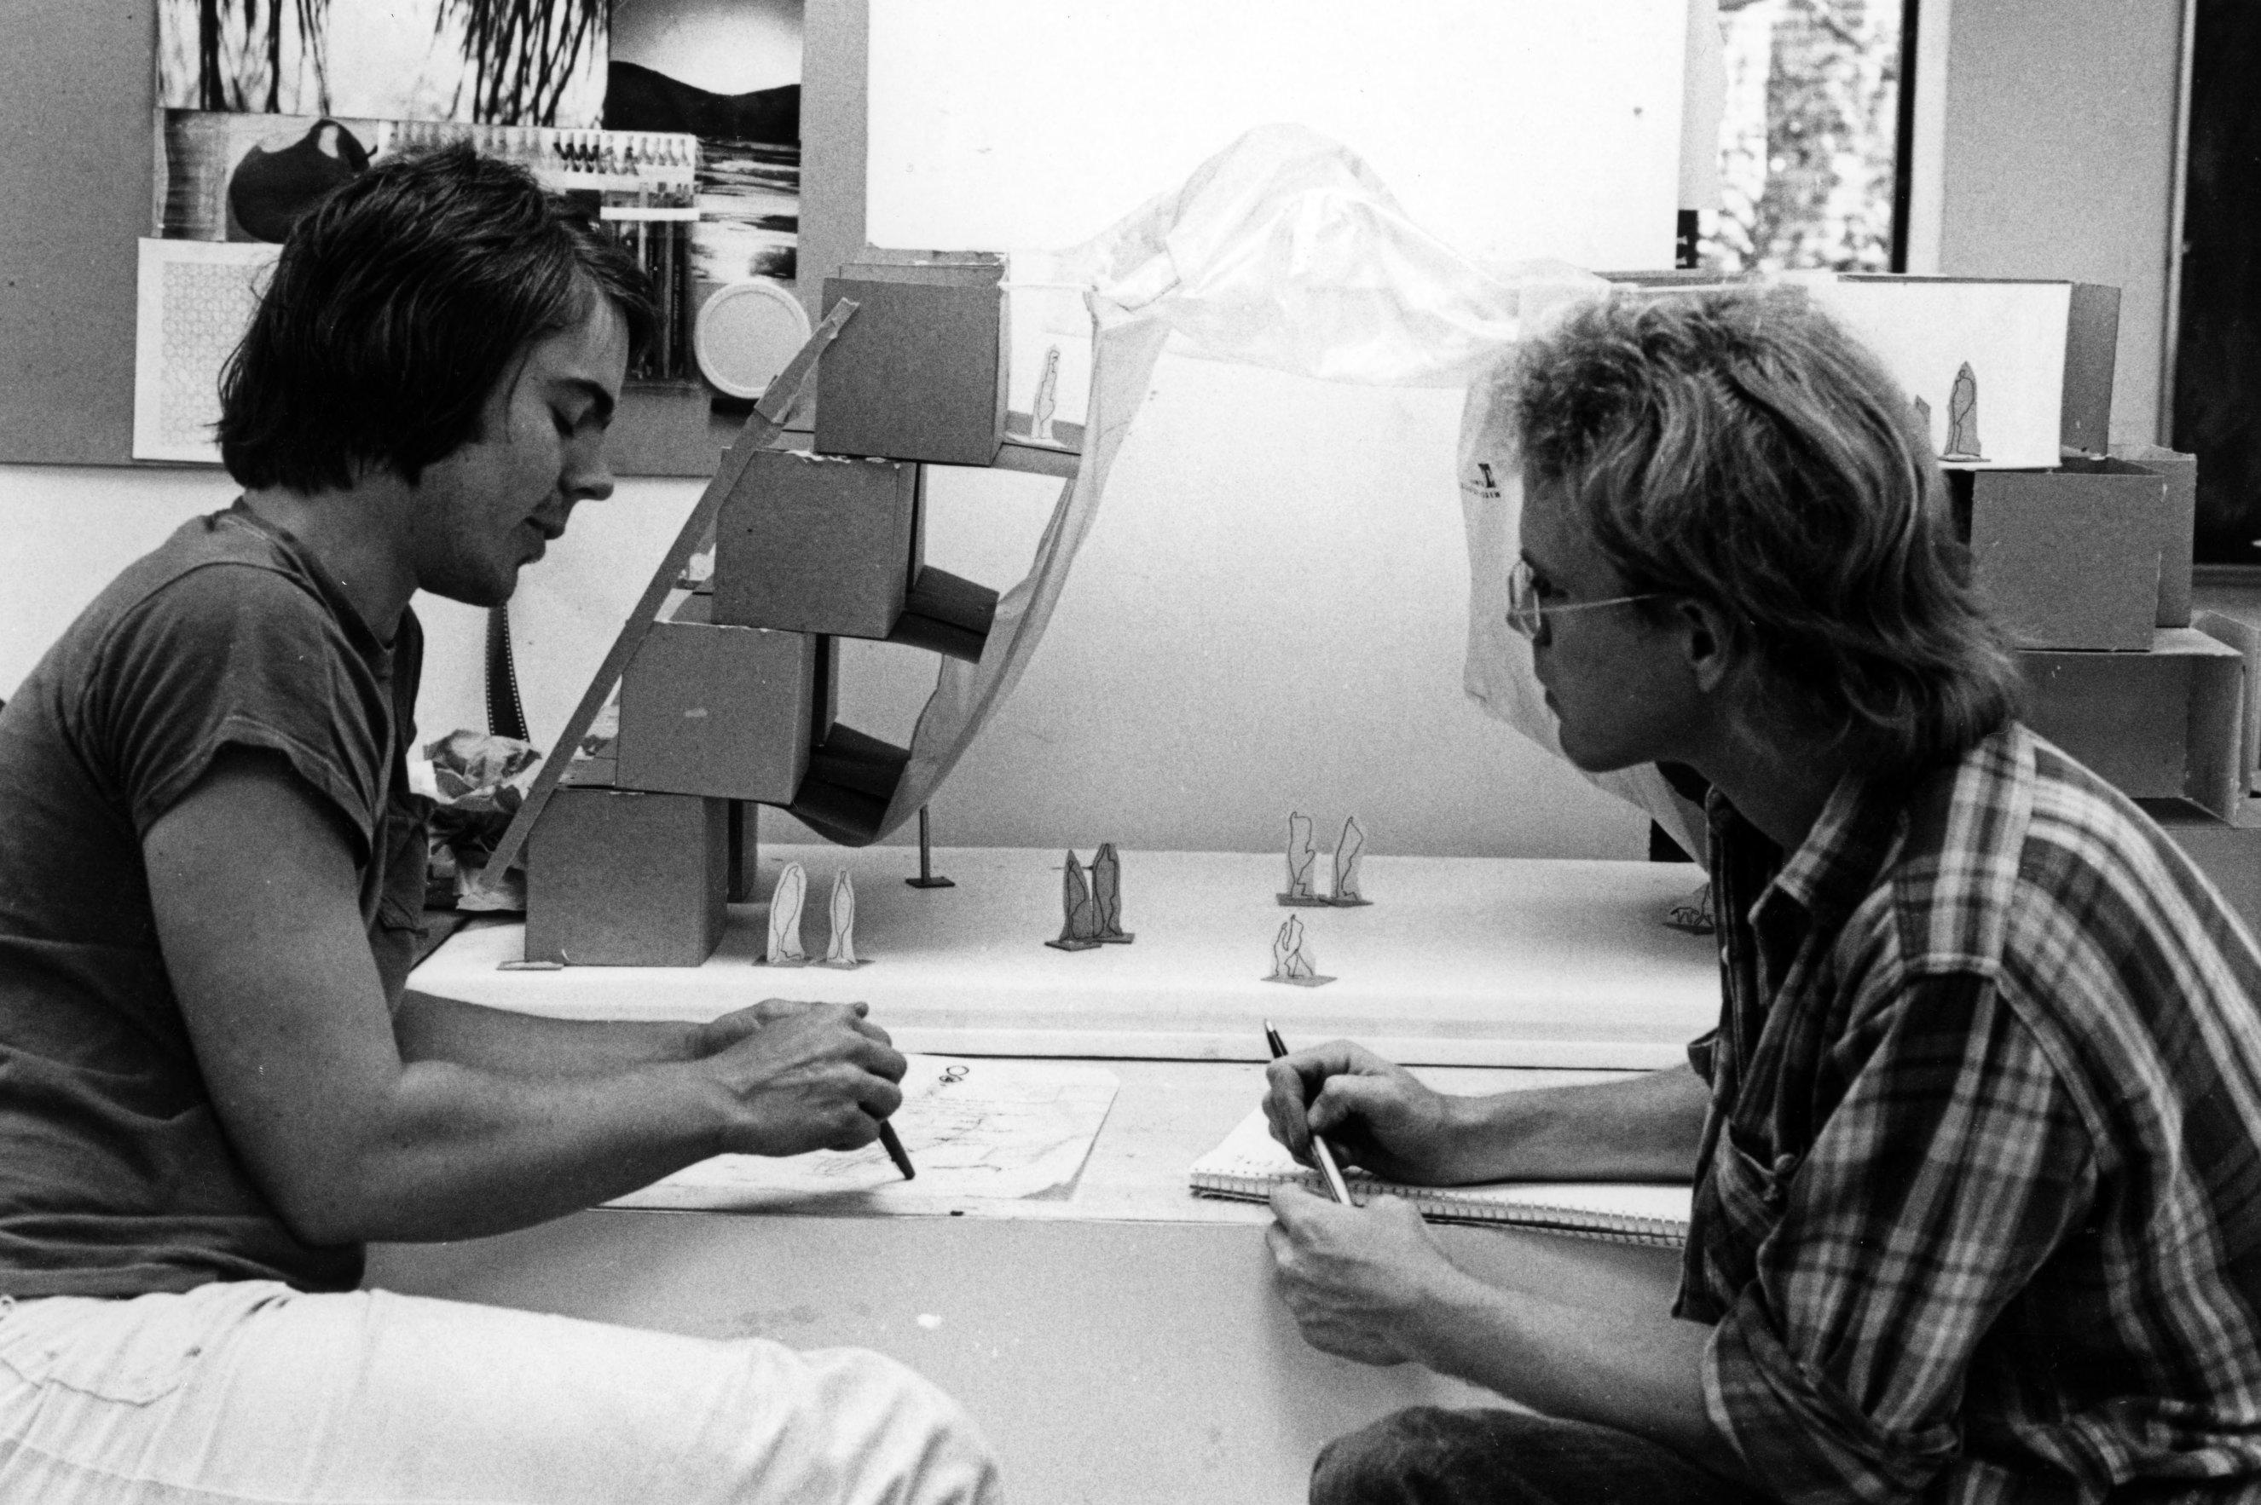

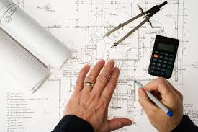

Purpose:
The purpose of this assignment is to set the scene for you and your experience of Design. To start at the beginning, you will be asked to set up your company and create its Corporate & Brand Image, as well as giving you an initial understanding into the world of design.

The first section is intended introduce you to the design industry. Looking at design organisations & possible careers in this field. It is important you have some understanding of how things work in the outside world, and this information will help you in your future, whether or not you go into a design-based career. The second section is where you apply what you have done in section 1, leading into you developing your corporate image.

It is intended to give you an understanding of the possibilities design has to offer and be the starting point for you in setting up your design company, which will take you into the projects for the next few years.

Structure:
There are three sections or stages you need to go through, each with several tasks that need to be undertaken:

Section 1 – The Outside World
Task 1 – Mind map on jobs in Design
Task 2 – Research 6 Design related jobs
Task 3 – Produce an organisation plan for a private company
Task 4 – Produce an organisation plan for a public institution

Section 2 – My Company
Task 5 - Produce an organisation plan for your new company

Section 3 – My Image
Task 6 – Develop your company corporate identity
Task 7 – Develop a promotional pack

Pathways Addressed:

Pathway 2 – Contextual Design
Strand 3 – Organisations
Strand 4 – Jobs
Strand 5 – Communication

Pathway 4 – Graphic Products
Strand 1 – Design
Strand 2 – Studio Techniques
Strand 3 – Digital Techniques

Assignment – My Company

Section 1 – The Outside World

By the end of this section you should be able to:

- Identify different career paths within the design industry
- Demonstrate how to search for further information about desired career paths.
- Understand what education route you need to take to achieve a career path

You must present the outcome in an interesting and dynamic way.

Keywords: industry, presentation, aesthetically pleasing, dynamic, contemporary.

Tasks

Task 1 – Mind map on jobs in Design
Task 2 – Research 6 Design related jobs
Task 3 – Produce an organisation plan for a private company
Task 4 – Produce an organisation plan for a public institution

Task 1 – Mind map on jobs in Design

Create a mind map of possible career paths within design, one has been started above. You need to complete a page that will display the same type of information, expanding on points made to fill the page. You could add images to make your page more aesthetically pleasing.

Task 2 – Research 6 Design related jobs

Choose 6 jobs within the art and design industry that you would consider as a career choice.

Using the following web links below, research each of the six jobs you have chosen. You should find the following about each career choice:

  - Job title
  - Qualifications needed to enter that career path
  - Pay scales/ salary
  - What the job requires you to do/description
  - Career prospects
  - Images

You could try and use the following web links:

http://jobs.designweek.co.uk/
http://www.totaljobs.com/
https://creativepool.com/design-jobs
https://www.careersindesign.com/

Web Addresses correct as of September 2020

Present each job on a separate page, an example is shown below;

Task 3 & 4
Produce an organisation plan for a private company
Produce an organisation plan for a public institution
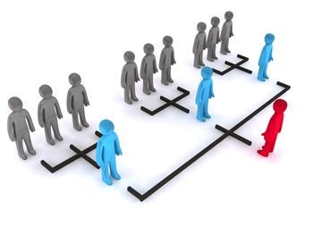

You now need to look at an actual company, such as a design consortium or architects as well as a public institution, such as a Museum or Gallery. You need to see how the company is structured. Try to get a plan of who does what and the sort of work they undertake.

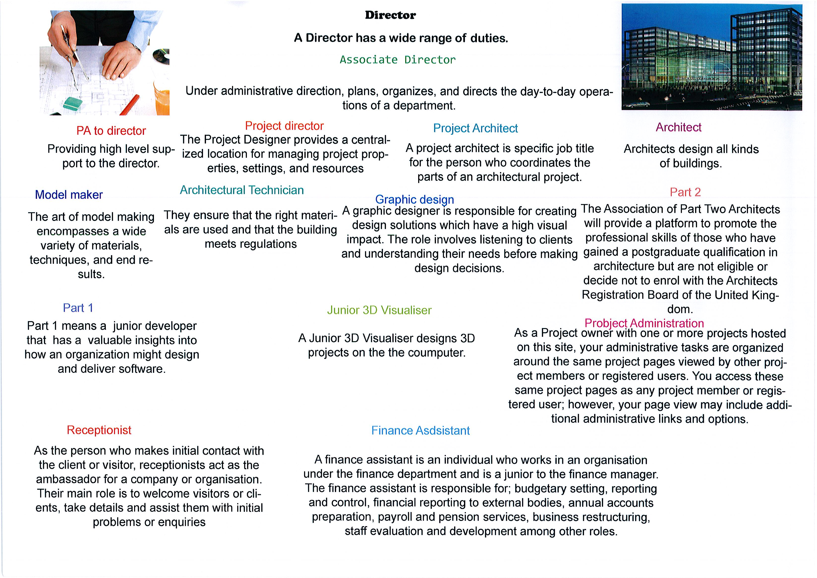
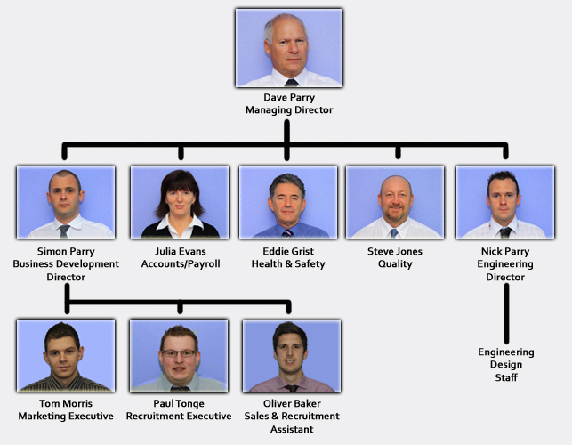

You can find a design-based company from the
websites below

http://www.designdirectory.co.uk/

http://www.designdirectory.com/

Web Addresses correct as of September 2020

Final Stage

This information now needs to be put together in some form of presentation, which explains to others the industry, as well as showing your understanding of what you have learnt. You are free to choose whatever method you wish to achieve this, but it must be of high quality, clear, accurate and informative.

Section 2 – My Company

Task 5 – Produce an Organisation plan for you new company

Now you have an understanding of the design industry, you now need to build your team for your design company.

You can employ six people, excluding yourself & Administration Staff. You need to put together an organisation plan and job descriptions for each post.

Remember the company offers:

Architectural Design
- Regeneration Projects, Urban Systems, Transport Systems, Interior Design - Commercial
Engineering Design
- Transport Design
Industrial design
- Working, Home and Industrial Equipment. Heavy Transport
Product Design
- Medical Equipment Design, Household Products
Urban Environment Design
- Urban Design, Street Furniture, Signage
Graphic Design
- Corporate Identity and Branding, Product Packaging & General Packaging
Ergonomic Design
- User Interfaces

You need to say why you have selected the posts you have and what they will offer the company

Here you will be able to use what you have learned in section one and create your company structure. Remember, in the outside world this would be constantly under review and amended as needed. Here is a good example:

https://acumen-da.com/the-team/

Below is a company I have followed for many years. They are constantly evolving and changing with the times. Have a look at what they are about:

https://www.creactive-design.co.uk/
Web Addresses correct as of September 2020

Aims for Section 1 & 2 – Pathway 2 - Contextual Studies

The aim of section 1 and 2 is to provide you with a broad understanding of the design industry and the employment opportunities available within it.

This section aims to give you an awareness of the employment roles, opportunities and possibilities within the design industry.

Learning Outcomes – Pathway 2 - Contextual Studies

On completion of this section you should:

1 Know about organisations in the design industry

2 Know about job roles in the design industry

3 Be able to present information about the work studied in an appropriate format

You will consider the roles of people working in organisations. You will develop research, based upon the characteristics of the different job roles you investigate and explain how these roles relate to each other. You will develop an understanding of how organisations use individuals, whether they are freelance or employed directly, and how goals are achieved by the organisations and individuals.

Understanding Assessment for Section 1 & 2
 | Basis Level  All should achieve | Good Level  Majority achieve | Outstanding Level  Most able achieve
Strand 3:  Organisations  2.3 | Basic 3 - identify how organisations operate in the design industry | Good 3 - explain how organisations operate in the design industry | Outstanding 3 - independently and fluently analyse how diverse organisations operate in the design and art industry, reaching informed conclusions
Strand 4:  Jobs  2.4 | Basic 4 – list job roles and describe the characteristics of job roles within the design industry. | Good 4 - explain the characteristics of job roles within the design industry. | Outstanding 4 - independently and fluently explain the characteristics of diverse job roles within the design and art industry, reaching informed conclusions
Strand 5:  Communication  2.5 | Basic 5 - present information about others work studied appropriately. | Good 5 - consistently present well-organised and effective information about others work studied. | Outstanding 5 - imaginatively and independently present complex information about other work studied.

Assessment Levels for Pathway 2 – Contextual Design

Basic Level – All students should achieve
To achieve Basic Level – Strand 3 the learner must be able to explain how organisations operate in the design and art industry. For example, the learner may describe the development and production of an advertising campaign, produced by an advertising company.
To achieve Basic Level – Strand 4, learners will need to be able to list job roles within the design industry. The range of roles that they list will show some understanding of the industry, although some of the examples may tend to be obvious. There may not be much development or amplification of the subtleties indifferent job roles within certain areas; for example. they may list ‘graphic designer’ as a job role, and not exploit the opportunity to develop their list of roles in this area through analysing the field in more detail such as ‘junior designer; art director; artworker’ and so on. Learners will need to explore the characteristics of the identified job roles. Some information is available on industry websites, but learners will be able to cite first-hand evidence through work placements or visits to practitioners, studios, and workshops.
For Basic Level – Strand 5, learners need to be able to present their research findings clearly. Their visual information should be organised so that the assessor can understand what the learner was trying to achieve. Tutors will be expected to provide support and feedback in order to assist learners in generating this evidence appropriately.
____________________________________________________________________________________

Intermediate Level – Good – Majority of students should achieve
For Good Level – Strand 3, the learner must provide more detailed explanations of organisations. Their research and conclusions will show analysis of different types of operations, and they will be able to explain them in an effective manner.
For Good Level – Strand 4, learners will be able to develop their list to include a wider range of examples, and these will have been well considered and relate to their identified areas for research.
Good Level – Strand 5 requires learners to be consistent again in presenting well-organised and effective information about the work they have studied. Their presentations will be interesting and informative and include their own ideas about the work studied and how it was made. Learners will have an increased skill in the use and understanding of visual language.
____________________________________________________________________________________

Advanced Level – Outstanding – Most able should achieve
fluently, how a diverse range of organisations operates in the design and art industry. The range of examples will show a greater engagement with the tasks than work produced in the lower levels. Learners will be able to use their research to reach informed conclusions. Learners will be able to explain the characteristics of job roles within the design and art industry. They will identify the main characteristics and purpose of the job roles. They may not extend this analysis to consider how roles might interrelate in any detail. The range of characteristics described will be limited.
For Outstanding Level – Strand 4, learners will be able to extend their list independently; this will show an ability to develop research beyond the obvious and demonstrate an awareness of the field in more detail. Learners will be able to identify and explain the characteristics of a wider and more diverse range of job roles. They will be able to explain the function of the roles and explain the specific characteristics relating to them. Learners will be able to articulate independently the characteristics of a wider range of more diverse roles within their chosen areas. They will be able to explain fluently how the roles work within the organisations, and how the roles may interrelate.
For Outstanding Level – Strand 5, learners would be expected to present personal, coherent, and well-structured information about the work studied.

Resources List

Websites

http://www.designdirectory.com/ Excellent directory of Design Businesses

http://www.designdirectory.co.uk/ Excellent directory of Design Businesses

https://www.designcouncil.org.uk/ National organisation that supports design

https://nationalcareers.service.gov.uk/ Information and advice for young people

https://www.careersindesign.com/ Site advertising jobs

https://www.allaboutcareers.com/careers/industry/art-design

https://discovercreative.careers/#/ Creative and Cultural Skills arts career pages

https://www.brightknowledge.org/ Help with Career advice

http://www.guardian.co.uk/education/artanddesign

https://careertrend.com/list-7539810-careers-virgo.html

https://www.theartcareerproject.com/careers/

www.vocationallearning.org.uk Learning and Skills Network

https://www.ccskills.org.uk/ This portal has a range of information about careers in the design sector, including job descriptions.

Web Addresses correct as of September 2020

Indicative reading for learners - Textbooks

Writers’ and Artists’ Yearbook 2021 (Bloomsbury; 2020)

Second Steps: A One-stop Resource for all who are Setting Up a Business in the Applied Arts - Mornement C (BCF Books; 2006)

Becoming an Architect: A Guide to Careers in Design – Waldrep L

(John Wiley & Sons; 2009)

Becoming a Graphic and Digital Designer: A Guide to Careers in Design – Heller S , Vienne V (John Wiley & Sons; 2015)

The AIGA Guide to Careers in Graphic and Communication Design - Cezzar J

(Bloomsbury; 2017)

Section 3 – My Image

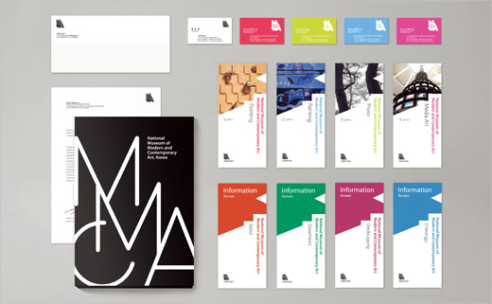

Your Background
You are a successful designer/architect/urban designer and you have worked at a large company in London for several years. The company employs about 30 people and has given you experience in working and creating teams, using consultants and extra outside specialists for whatever project you undertake. You have been a project manager on several of their important projects.

The types of projects you worked on have ranged from medical equipment, right through to transport systems and city infrastructures as well as large building & engineering projects such as Crossrail and the Kings Cross regeneration.

You have now decided to leave your existing company and set up on your own. You have decided to set up just outside of London as there are good transport links to London and the South in general, with good train and motorway access i.e. M25, East Coast Main Line. This will enable you to create a solid client base in London and the surrounding area.

From Task 5 you should have your organisation structure to support the main body of work but remember you can still buy expertise in as and when you require it.

Your Context
Your small design company is now established. Although you deal with all general design projects, your name and reputation are well known as a specialist in Urban Regeneration, Transport, and architectural design.

However, you have been involved in a number of product design based projects, which you feel extends the company’s skill set and hopefully it will broaden the type of projects you can undertake, so securing work in alternative fields.

However, you need to establish a strong and clear brand image. The brand image of company you want to create is that of a creative group, that comes up with imaginative and sometimes unusual and dynamic solutions. A company that is trustworthy and that can be relied upon. You meet deadlines and have excellent communication skills with all those involved.

You are developing close links with a lot of major manufacturing industries and many national-building contractors. You are well-supported by a good range of local companies, so you are well covered to handle any element on the production side. You have made links with the local University, which has a Manufacturing, & Rapid Prototyping Centre attached to it and it is hoped that students from there can come to you for work experience.

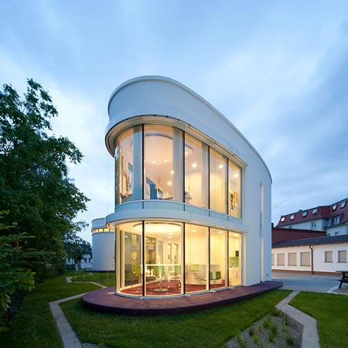

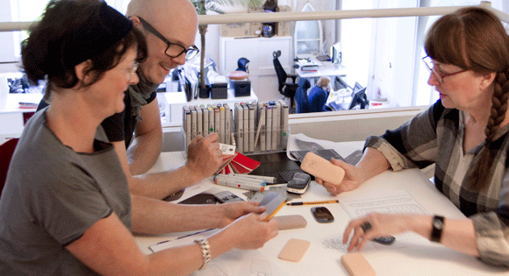

Task 6 – Your Company’s Corporate Identity & Brand

INTRODUCTION/SCENARIO
As the success of your company has grown, it is now time to address the issue of branding and the corporate image of your design company. You now need to update and present a strong and modern image for your design company, to reflect the success you have achieved and putting over the flexible and creative approach you company has become known for.

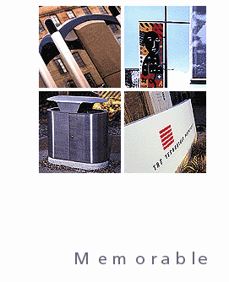
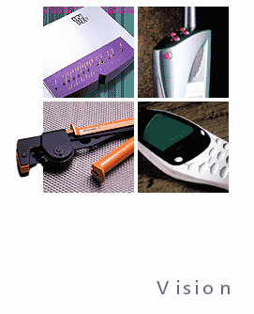
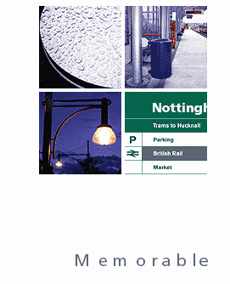

CLIENT:
You and your company

TASK:
To produce a strong brand for your design consultancy

OUTCOMES:
- A range of annotated ideas, in a form of your choice, exploring & explaining your ideas
- A strong, final logo, in presentation format and with a colour and B/W version
- Colour associate for further branding

EVIDENCE YOU MUST PRODUCE FOR THIS TASK

Portfolio containing:

- records of relevant research to inform the design
- Your ideas (supported by what you have learnt from your research)
- annotation – what skills, materials, techniques, processes have been used and what messages/concepts/ideas are being communicated?

Final Outcome:

- A clear final logo available for a range of formats, presentation style and uses
- A colour associate, which can be used within the company

Task 7 – Promotional Pack

INTRODUCTION/SCENARIO
Following the establishment of the new brand, you now need to produce your stationary and a promotional folder.

These promotional folders are given to clients or those who show an initial interest. They are used either to promote the company, so including previous projects and examples in handout format, or to present an initial quote and project plan. Of course, these folders can be also used when you must issue an invoice!!

CLIENT:
You and your company

TASK:
To put together a promotional folder, which is exciting and has impact, as well as a range of stationary which may be necessary.

OUTCOMES:
- A range of annotated ideas, in a form of your choice, exploring and explaining your ideas
- You will need to produce a promotional folder, which includes the main items of stationary

EVIDENCE YOU MUST PRODUCE FOR THIS TASK

Portfolio containing:

- records of relevant research to inform the design
- Your ideas (supported by what you have learnt from your research)
- annotation – what skills, materials, techniques, processes have been used and what messages/concepts/ideas are being communicated?

Final Outcome:
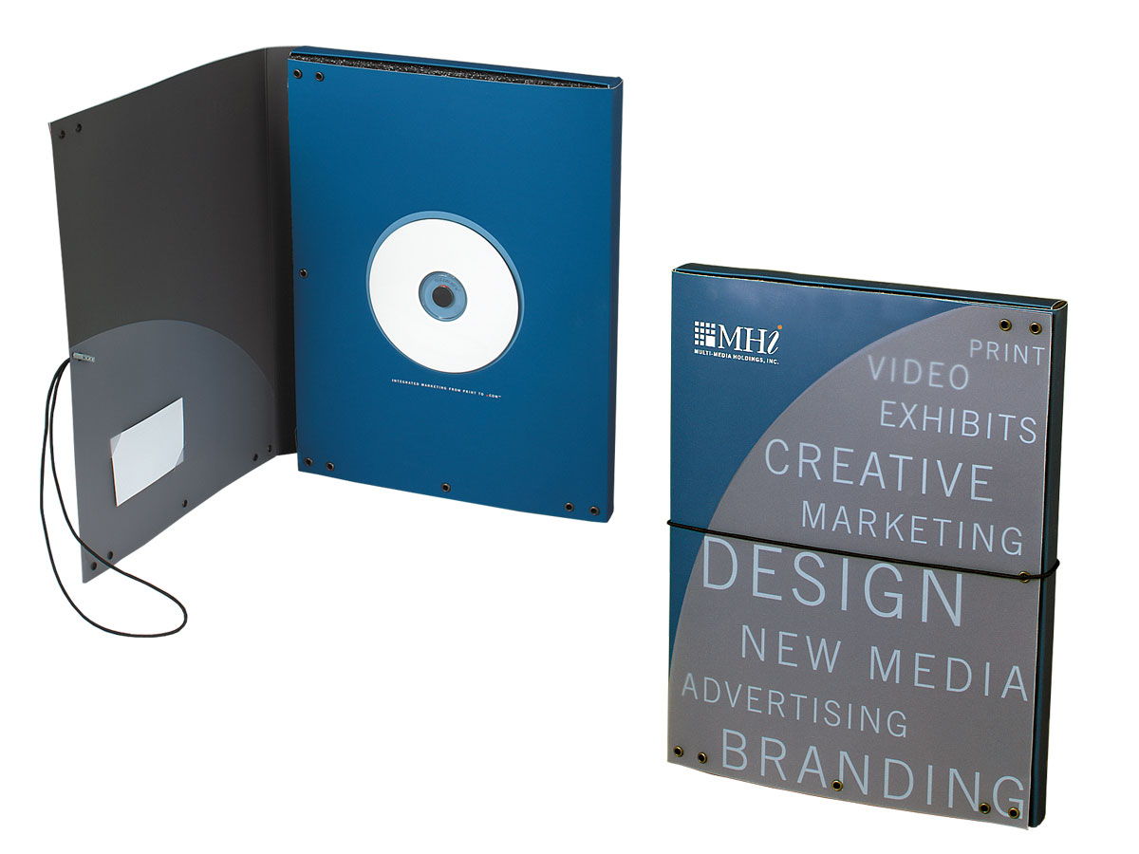
- A Promotional folder, with a range of stationary
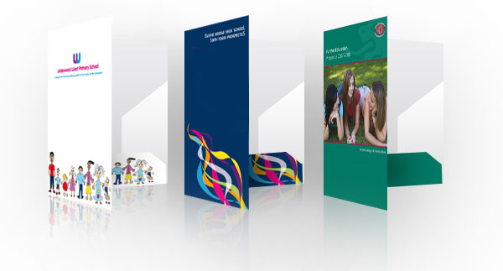

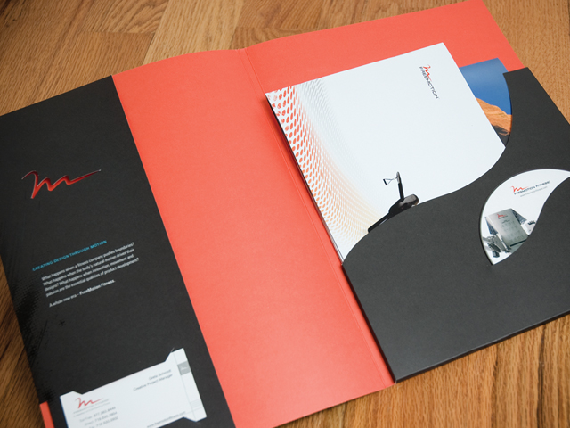

Aims for Section 3 – Pathway 4 - Graphic Design

The aim of section 3 is to start to provide you with a broad understanding of graphic design and its impact. You will begin to build your skills into the purely visual aspect of design and this will help support all future work, both 3D and graphical

Learning Outcomes – Pathway 4 - Graphic Design

On completion of this section you should:

1 Know how to develop ideas and final outcomes to meet graphic design briefs by selecting materials and techniques

2 Be able to use studio materials and techniques

3 Be able to use digital techniques and processes.

Understanding Assessment for Section 3 – Graphic Design
 | Basis Level  All should achieve | Good Level  Majority achieve | Outstanding Level  Most able achieve
Strand 1:  Design  4.1 | Basic 1 - develop basic ideas and final outcomes to meet graphic design briefs by exploring appropriate materials, techniques and processes safely | Good 1 - develop effective ideas and final outcomes to meet graphic design briefs by exploring a range of alternative materials, techniques and processes safely | Outstanding 1 - develop imaginative ideas and final outcomes to meet graphic design briefs by exploring a wide range of alternative materials, techniques and processes safely
Strand 2:  Studio Techniques  4.2 | Basic 2 - use studio materials and techniques basically and safely | Good 2 - use a range of studio materials and techniques effectively and safely | Outstanding 2 - use a wide and appropriate range of studio materials and techniques creatively, independently and safely
Strand 3:  Digital Techniques  4.3 | Basic 3 - use digital techniques and processes basically and safely. | Good 3 - use a range of digital techniques and processes effectively and safely. | Outstanding 3 - use a wide and appropriate range of digital techniques and processes creatively, independently and safely.

Assessment Levels for Pathway 4 – Graphic Design

Basic Level – All students should achieve
For Basic Level – Strand 1, Learners will be expected to be able to develop basic ideas and outcomes to given briefs. Learners at this level should be able to select appropriate materials, techniques and processes for investigation and exploration, but will need some guidance. This could be achieved via a presentation to the class, a witness statement, an observation record or within annotated sketches or worksheets as part of a project. They will also be expected to demonstrate safe handling of materials, tools and equipment.
Basic Level – Strand 2 requires learners to use specific graphic design studio materials and techniques. At this level, the learners’ skills will be basic.
Basic Level – Strand 3 is closely linked, as the learners’ evidence should demonstrate a basic and safe ability to use digital techniques and processes. It is envisaged that this may involve learners in a variety of tasks to develop their skills and understanding. If assessed directly by the teacher, suitable evidence from guided activities would take the form of observation records completed by the learner and the teacher.

Intermediate Level – Good – Majority of students should achieve
For Good Level – Strand 1, learners should demonstrate development of effective ideas and final outcomes to given briefs. They will explore a range of creative and alternative materials, techniques and processes. Learners will have a sound understanding of the relevant health and safety issues.
Good Level – Strand 2 and 3 require learners to use a range of studio and digital materials, techniques and processes effectively. The tasks carried out could be similar to those undertaken for Basic Level – Strand 2 and 3, but teachers would additionally expect learners to carry out more in-depth and varied experimentation. Assessment evidence for this criterion could take a similar format to Basic Level – Strand 2 and 3.

Advanced Level – Outstanding – Most able should achieve
For Outstanding Level – Strand 1 learners are required to independently develop imaginative ideas and final outcomes to graphic design briefs by exploring a wide range of alternative materials, techniques and processes.
Outstanding Level - Strand 2 and 3 require the learner to use a wide range of specialist studio and digital materials, techniques and processes creatively, independently and safely. Assessment evidence for these criteria could take a similar format to that for Good Level – Strand 2 and 3.

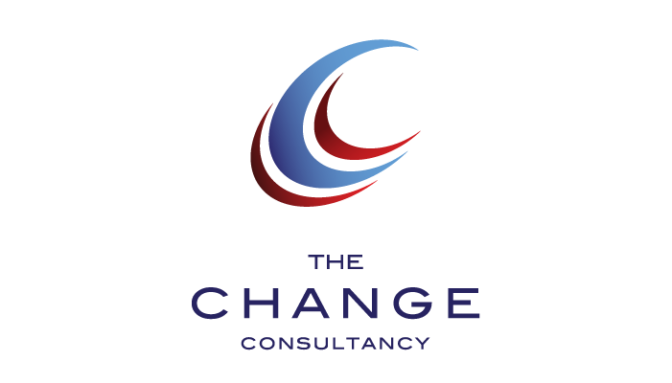
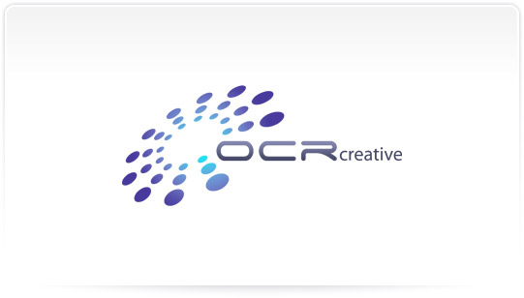
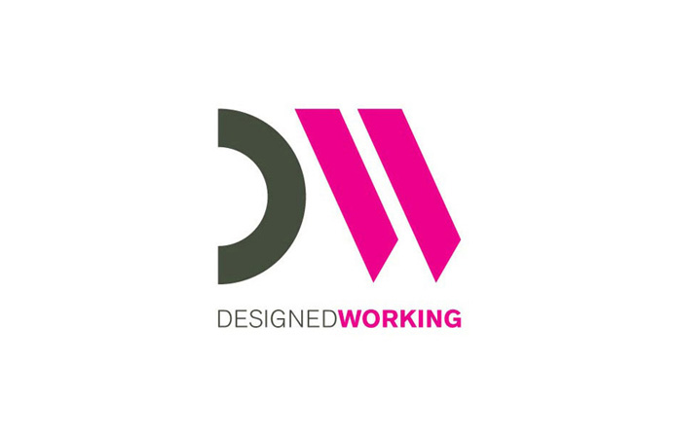

Resources

SCHOOL – Specific – DT Website – www.inspirationindesign.uk

- General support sheets

SCHOOL - Department

- Equipment: General design equipment, Design Studio, ICT facilities including A3 & A4 colour laser printers, workshop, general manufacturing facilities.

- Main ICT Programme Focus: CAD - Sketchup, 2D Design V2, REVIT
DTP - Photoshop, Illustrator

- Texts: Product Design Book, DT Library, Design Magazine library back issues.

SCHOOL – DT Library

- Powell K – New London Architecture (Merrell 2001)
- Powell K – City Reborn (Merrell 2004)
- Murray P – Contemporary British Architects (Prestel 1994)
- Morris M – Models: Architecture and the Miniature (Wiley 2006)
- Mills C – Designing with Models (Wiley 2000)
- Bairstow J – Design Modelling (Hodder & Stoughton 1999)

SCHOOL – Magazines

- Creative Review
- Blueprint
- AJ
- Architectural Review

