Answer Sheet – Design Question 8 (2017 Paper)
POS for Chip Shop
Candidates may answer any specification point in either graphical form or by annotation. No marks are awarded for the quality of graphical communication.
- Hold four cones of chips (1) e.g. side by side in a row / 2 x 2 / use of dimensions
- Stop the cones from falling over (1) e.g. held in holes (40-60mm dia) / cut outs / two holding points / rings / pegs
- Have a stable base (1) e.g. large surface area / number of contact points
- Be easy to wipe clean (1) e.g. shape / material selection / no internal sharp corners
- Be easy to get cones in and out of (1) e.g. space around each cone of chips / clearance to lift out
- use a display method to show the name ‘Sue’s’ (1) e.g. engraved / vinyl transfer / permanent marker
- be produced from materials readily available (1) e.g. specific name material
- be manufactured using processes available in school (1) e.g. specific named process that relates to the named material above
Examiners Report Comment on Question:
Many candidates achieved between 6 and 8 marks for at least one of their designs. Some of the better candidates showed how each specification was answered by numbering the responses on their design, often supporting these with annotations that provided fuller details of how the design(s) met the specification point. This is good practice and candidates are encouraged to take this approach. Many students were able to gain 6 marks immediately on this question; however there were many repeated responses between design 1 and 2. Almost all candidates produced ideas that were capable of holding four cones of chips, although a small minority presented designs to hold ‘4 chips’.
Different approaches were required for each idea; therefore, a linear arrangement could not be repeated and gain credit for both designs. Bullet 2 and 5 proved difficult for the students to include either within their sketching work or through annotation. Although some students did attempt to include a measurement of the holes which would hold the food, often the stated measurement would be too large and the hole would not support the cones correctly, and so no mark could be awarded.
Bullet 5 was rarely outlined either by annotation, with the mark being awarded solely on the drawn evidence. In general, students showed a wide range of understanding of workshop materials and processes; however in some cases it appeared that students were not thinking through their choices and combining inappropriate materials and processes – for example, suggesting line bending on a product made of MDF. Some candidates included commercial production and printing methods such as flexography, lithography and injection moulding for either the display method or the processes available in school, which meant zero marks could be awarded. The higher marked responses tended to include a 3D pictorial sketch of the stand, supported by further sketches from the side of the display stand which clearly outlined how the chips would stand and how sturdy the base was. The weaker responses of this question were mostly sketched in 2D, therefore it was difficult to determine the sturdiness of the base, and so marks could not be awarded.
Question take from Pearson Edexcel GCSE In Design & Technology (5GR02) Paper 01 Unit 2: Knowledge and Understanding of Graphic Products – 2017
Example of candidate response:
Design idea 1
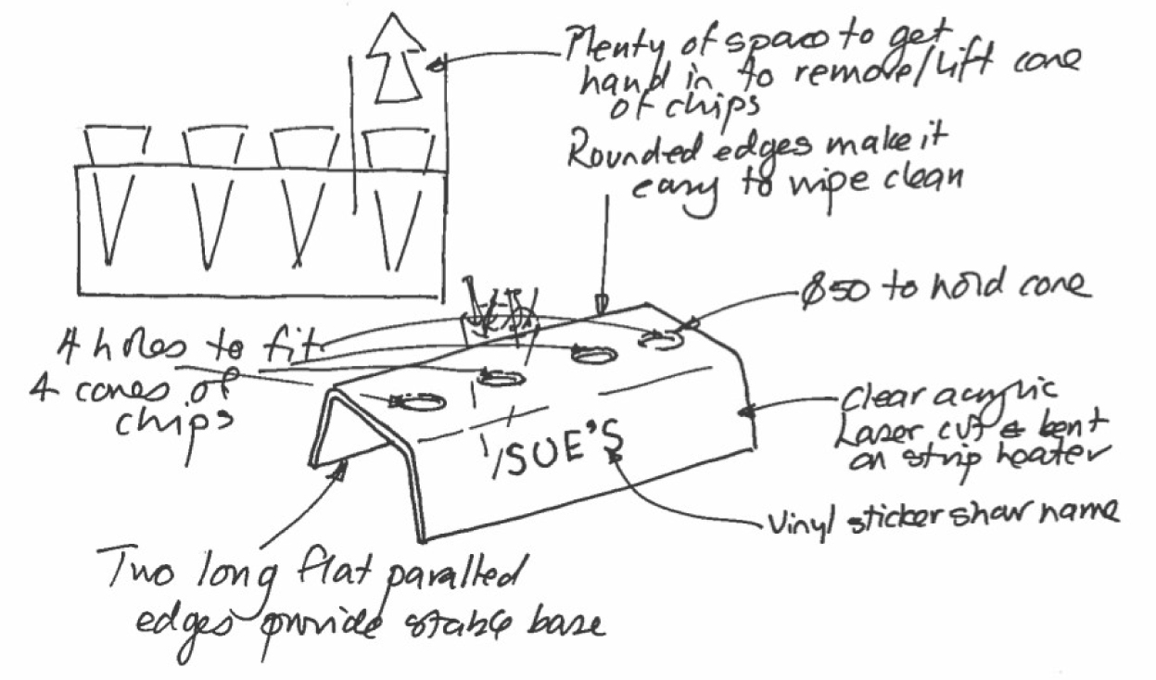

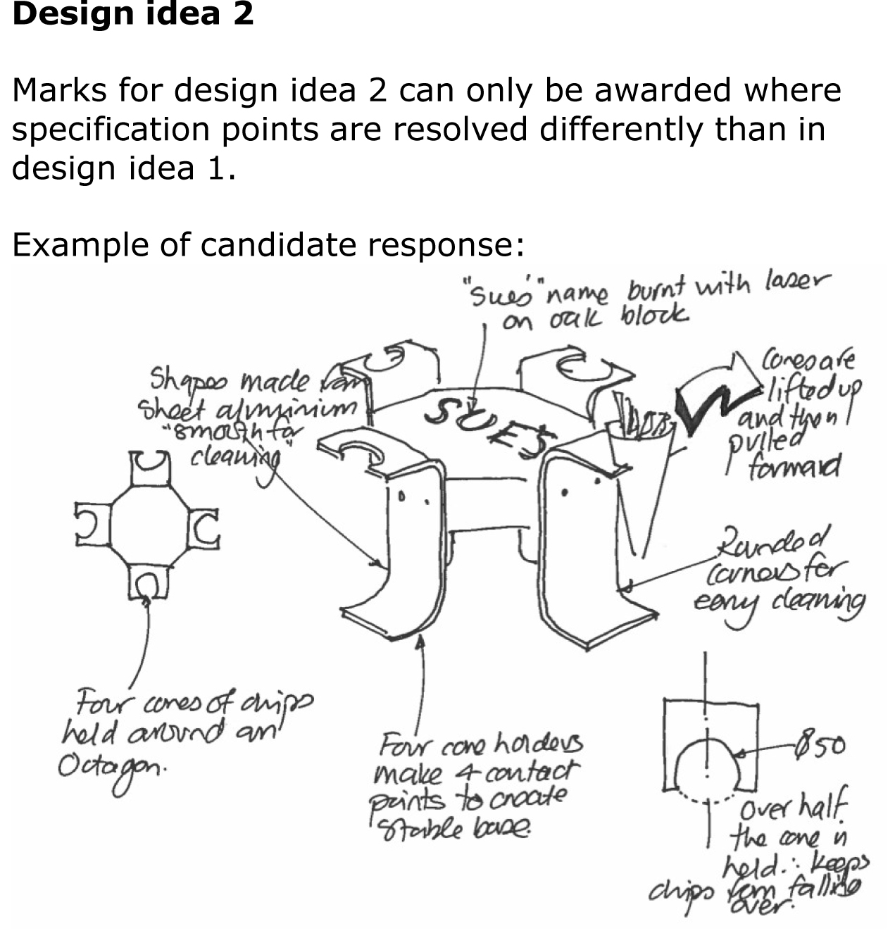

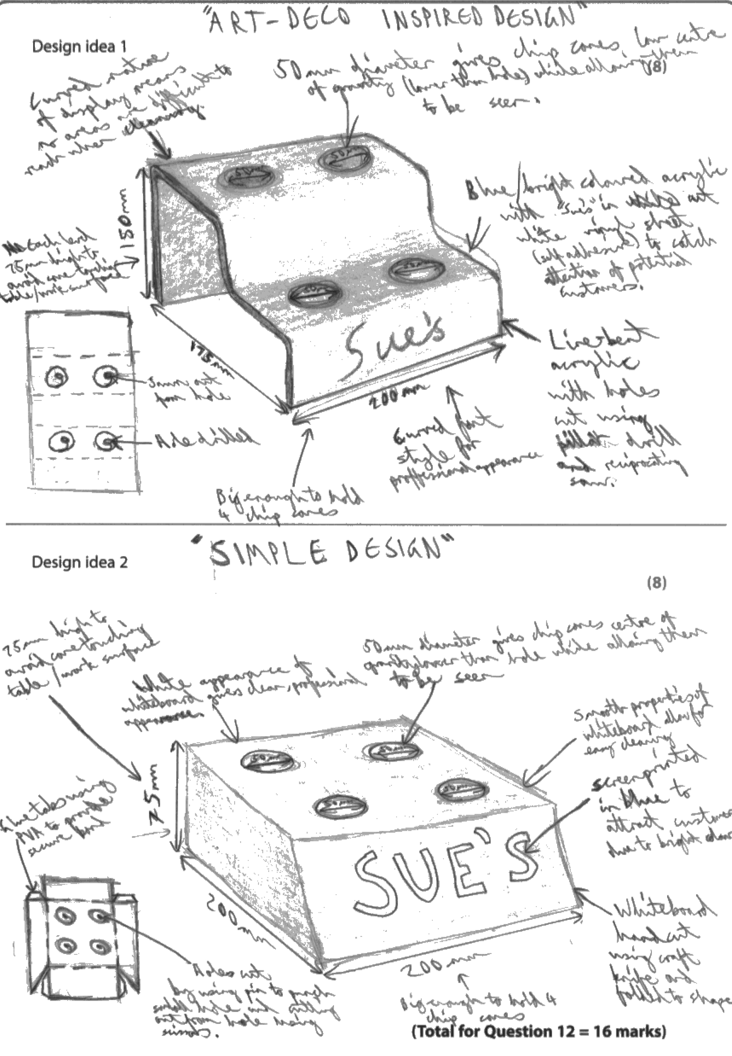

Examiners Comments
The candidate has been awarded eight marks for idea one and five marks for idea two. The designs are clearly represented, with concise and appropriate notes and annotation to explain how each design fulfils the specification requirements. The candidate has lost some marks in the second design for repetition of the layout of how the chip cones are held (2 x 2), the approach taken to support the chip cones (both holes) and the large base in both designs.
Tip: Ensure your two designs are completely different so the materials and methods used to achieve each specification point in the 1st design are not used in the 2nd design.

