Answer Sheet – Design Question 7 (2016 Paper)
Chocolate Egg Packaging
Candidates may answer any specification point in either graphical form or by annotation. No marks are awarded for the quality of graphical communication.
- Hold the egg upright e.g. vacuum formed tray / discs with holes in
- Allow the egg to be seen e.g. window in box / carton / clear box/ hole
- Have a closable lid e.g. tab on box lid / separate lid that slots over
- Show a graphic image to reflect an egg theme e.g. chicken / egg / nest
- Allow it to be hung up on display in a shop e.g. string / cut out hole/ tab
- Use a recyclable material e.g. specific named material carton board, shredded paper / named thermoplastic
- Use a commercial method of printing e.g. offset lithography / flexography / pad / transfer
- Use a commercial finishing technique e.g. varnishing / hot foil blocking / laminating

Question take from Pearson Edexcel GCSE In Design & Technology (5GR02) Paper 01 Unit 2: Knowledge and Understanding of Graphic Products – 2016
Examiners Report Comment on Question:
The vast majority of candidates attempted this question with very few blank pages. Most candidates showed a lot of imagination displaying some creative and well-presented design ideas but many struggled to design to the given specification, thus were only able to access mid-range marks.
It was somewhat difficult to award marks to some candidates who demonstrated poor communication skills, with annotation and written notes being difficult to read due to poor handwriting.
Whilst no marks are awarded for the quality of sketches, candidates ought to be reminded that graphics need to be clear and well annotated against the specification given as this certainly assists in the awarding of marks. Some candidates however lost marks due to lack of detail and repetition in the second design, where in many cases, they did not offer alternative materials, printing or finishing methods and simply noted identical solutions.
Hold the egg upright: Lots of candidates were clear on showing how the egg would be held upright, showing vacuum formed trays, folded card holders, as well as more creative methods. Candidates lost out here when they did not make the method clear – those with supplementary sketches or nets were much more likely to gain marks.
Allow the egg to be seen: Many candidates did not score marks for both designs here – many simply changing the material used for their window, rather than specifying a different method.
Have a closable lid: Slightly more successful than the previous point, but some candidates seemed to struggle to come up with different closing methods. Those that gained marks were well drawn, often using additional sketches to show their lid separately. In a number of cases, some good quality 3D drawings were used here.
Egg theme: Some very creative ideas here showing dragons, dinosaurs and breakfast themes! Many candidates were able to come up with two different themes here, which were demonstrated through sketches and annotation. Some candidates relied too heavily on annotation here, with a simple note stating ‘egg theme’ with no sketched element. Where the question asks for a graphic image, this must be shown on the drawing.
Hang on display: Many candidates were familiar with the Euroslot and used it effectively and appropriately in their designs. Alternatives such as ribbons/string and simple holes were also used. Most candidates gained both marks here.
Recyclable Material: Most candidates showed knowledge (if not an understanding) of suitable materials. Some candidates still using generic terms e.g. plastic or cardboard, missing out on key marks, but most offered folding box board, solid white board and corrugated card as well as naming plastics.
Commercial Printing Method: Commercial printing methods were well demonstrated although often not necessarily appropriate for the chosen material. Screen printing, flexography and offset lithography were often used. ‘Stereolithography’ was often suggested as a printing process, suggesting some confusion with similarly named processes. The application of vinyl was also occasionally suggested as a printing process (‘printed by vinyl’).
Finishing Process: Candidates seemed to have a generally good understanding of finishing processes, giving appropriate and well-chosen methods. Occasionally, candidates appeared to have knowledge of the processes but did not use correct terminology (e.g. ‘gloss finish’ rather than ‘varnishing’.).

Example of candidate response:
Design idea 1
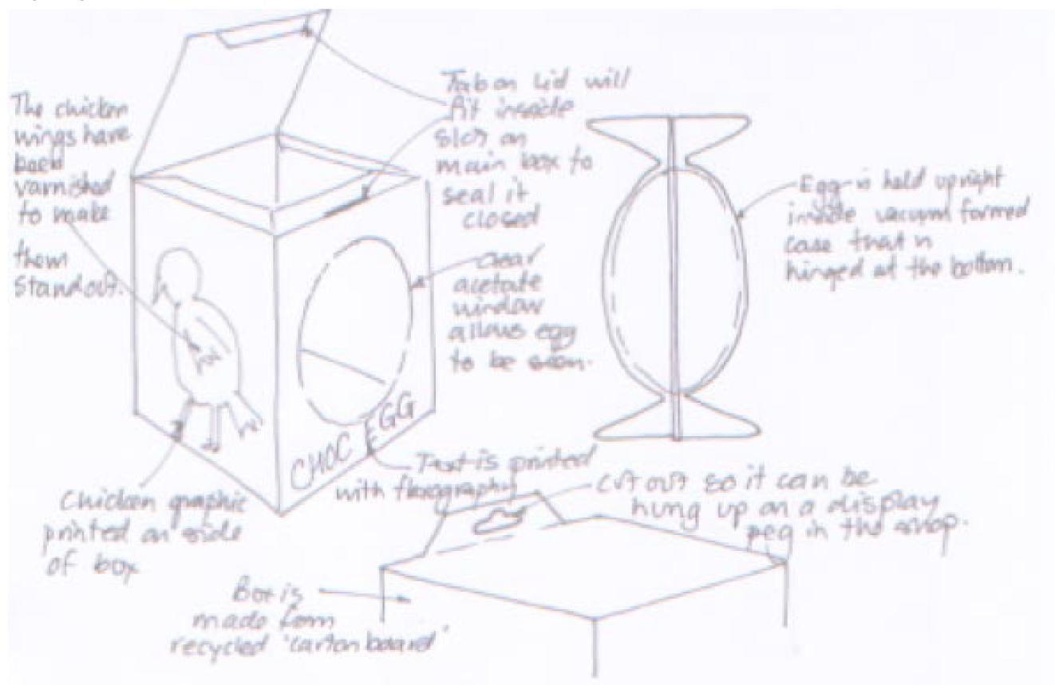

Design idea 2

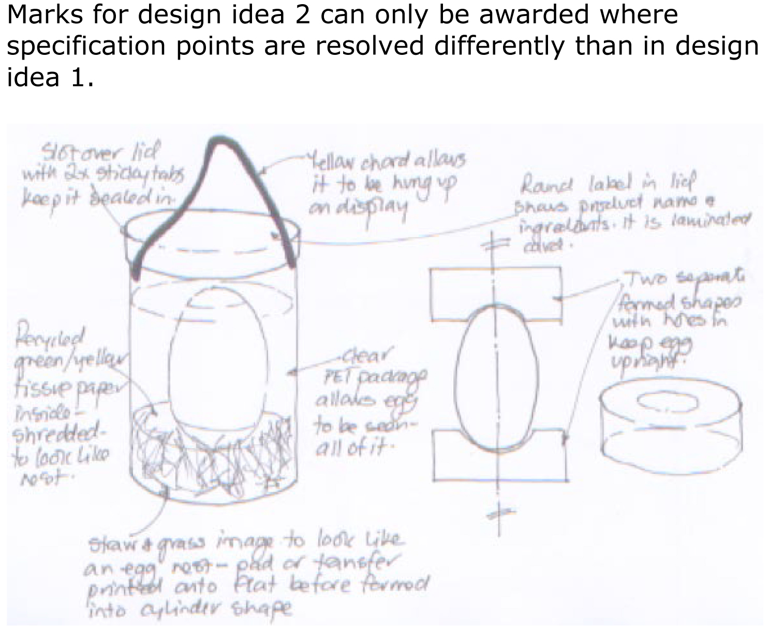

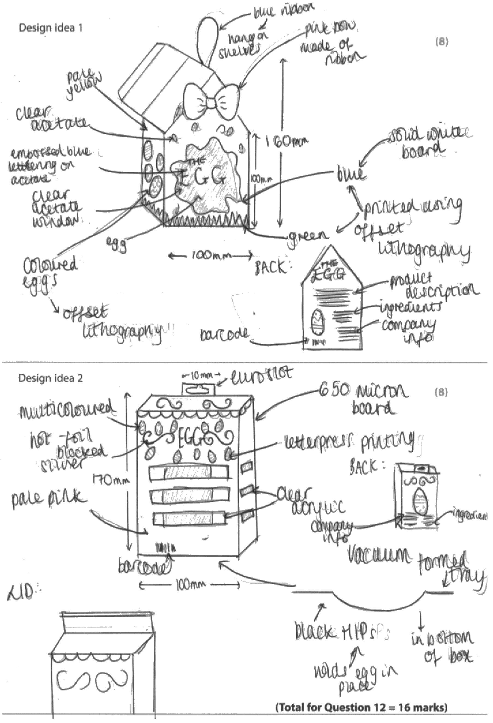

Examiners Comments
The candidate has provided two distinctly different approaches, gaining 7 and 4 marks respectively. The designs are clearly represented, with concise and appropriate notes and annotation to explain how each design fulfils the specification requirements. The candidate has lost some marks for inappropriate processes (letterpress in design idea 2), the repetition of eggs on both designs, and the use of windows on both.
Tip: Ensure your two designs are completely different so the materials and methods used to achieve each specification point in the 1st design are not used in the 2nd design.

