Answer Sheet – Design Question 6 (2015 Paper)
POS Display Stand for DVD/Blu-ray
Candidates may answer any specification point in either graphical form or by annotation. No marks are awarded for the quality of graphical communication.
- Hold 6 DVD cases and 4 Blu Ray cases e.g. drawing shows appropriate space/volume through dimension(s) or annotations Do not just accept 6+4 unsupported rectangles – must explain/show graphically how it’s held e.g. recesses/shelves/racks/box/pouches/compartments Accept exact sizes
- Clearly displays the front cover for both formats e.g. separate compartments/shelf/pouch for each format DVD/Blu-Ray covers should be facing forward, clearly visible or able to face forward e.g. rotation Alternative methods e.g. poster of front covers second idea must have different arrangement/method
- Allow easy removal and replacement of the cases e.g. one side of compartment open/finger cut outs or holds/remove back to restock/angle display
- Be stable e.g. flat bottom/wide base/weighted/centre of gravity over the middle of base
- Be easy to assemble e.g. large simple pieces/push fit/glue/fold together from one piece - draw a net accept reference to e.g. slot together/tabs or similar
- Have a wildlife theme e.g. drawing shows animal/plant shapes drawn/cut out shapes, accept different animal pictures/shapes with no technical detail Accept non-specific e.g. applied graphic and shaped/formed component
- Use a commercial method of manufacture e.g. name the commercial method to be used through annotation Accept methods of printing, cutting or forming/laser/line bending
- Be made from materials appropriate to the manufacturing method e.g. identify materials to be used e.g. box board, corrugated card, aero ply, hard board, acrylic, etc. Material must be appropriate to the method specified Accept suitable material even if the process has not been identified or is incorrect. Do not accept card/cardboard

Examiners Report Comment on Question:
Almost every candidate was able to pick up marks here. There was evidence that some centres had been successful in training candidates to adopt a methodological approach within their answers. Many used ticks against the specification points on the previous page to ensure that they had applied each design criterion to each of their design solutions. A few went on to reference the specification by numbering each of their eight annotation points for each idea.
Most candidates attempted both design ideas and many succeeded in producing some creative and well-presented design concepts. However, many others struggled to offer a technically different solution for many specification points within their alternative idea.
Whilst marks are not credited for the quality of graphical communication it is important for candidates to be able to show how they have satisfied the requirements of the specification. Annotation should be used to provide supporting evidence. While it was sufficient to identify features such as materials and manufacturing processes with a label, a response labelled as ‘easily assembled’, for example, could not attract the mark unless accompanied by a net or supplementary sketch showing assembly details. Candidates who scored highly often provided supplementary sketches to describe this and other aspects of their proposals.
‘Hold six DVD cases and four Blu-ray cases’ It was important to show an appropriate method of holding here. Most candidates tended to suggest the use of shelves, slots, boxes or trays.
‘Display the front cover for both formats clearly’ If the cases were held effectively candidates generally went on to orientate them successfully. The use of shallow trays, slots and clear acrylic holders were common solutions here.
‘Allow easy removal and replacement of the cases’ Where removal methods were not self-evident candidates needed to provide additional details such as finger slots or dimensions to justify their idea.
‘Be stable’ Most successful responses employed stands and large, flat bases as alternative solutions. However, many employed the same technique for both of their ideas.
‘Be easy to assemble’ Most responses failed to address this criterion satisfactorily. It was generally necessary for candidates to provide supplementary sketches in support of their proposals.
‘Have a wildlife theme’ Almost every candidate successfully addressed this criterion. Images of wildlife habitat were accepted. However, it was essential to draw the imagery. Simply applying the word ‘wildlife’ or annotation indicating placement could not be credited.
‘Use a commercial method of manufacture’ It was important to refer to appropriate manufacturing methods used in industry, such as die-cutting. Many candidates ignored this point or repeated the same process in both designs. Laser cutting was a common suggestion.
‘Be made from materials appropriate to this manufacturing method’ Most candidates managed to suggest a material, but some still struggled to be specific, referring to general material groups such as wood or card. Most successful responses offered folding box board, solid white board, corrugated card, acrylic or MDF.

Question take from Pearson Edexcel GCSE In Design & Technology (5GR02) Paper 01 Unit 2: Knowledge and Understanding of Graphic Products – 2015
Example of candidate response:
Design idea 1
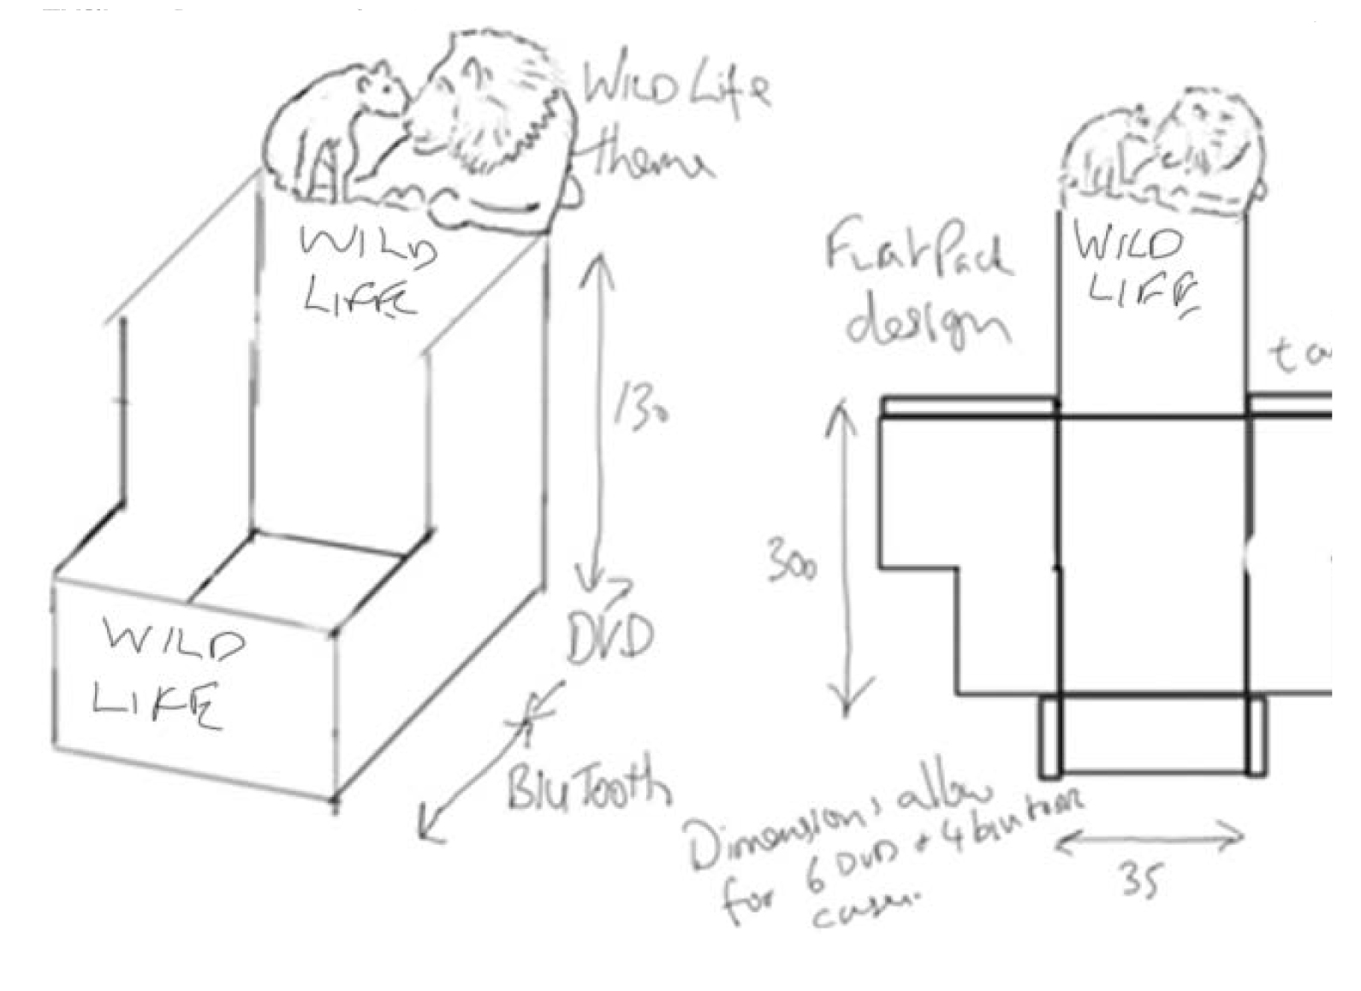

Design idea 2

