Answer Sheet – Design Question 5 (2014 Paper)
Promotional Display for Club
Candidates may answer any specification point in either graphical form or by annotation. No marks are awarded for the quality of graphical communication.
- Must have a bug theme (1) e.g. Can be graphic drawn, card cut into a shape or 3D of a bug
- fit on a surface 500 x 500 mm (1) e.g. dimensions shown or statement in annotation
- be stable in use (1) e.g. drawn 3D free standing design, or 2D with supporting stand
- hold at least 20 membership cards (100 x 80 mm) (1) e.g. Design/annotation/dimensions showing method of holding cards
- allow easy removal of membership cards (1) e.g. design/annotation showing ease of card removal
- use a method of applying the bug club logo (1) e.g. a named method of applying the logo
- use manufacturing processes suitable for one off production (1) e.g. graphically shown with dimensions or by statement in annotation
- use appropriate materials available in a school workshop. (1) e.g. cutting, joining and graphic of design to be suitable for manufacture with school equipment
Examiners Report Comment on Question:
The vast majority of candidates attempted this question with very few blank pages. Most candidates showed a lot of imagination displaying some creative and well-presented design ideas but many struggled to design to a specification and as a result were only able to access mid-range marks.
Candidates mainly found difficulty in demonstrating how to hold at least 20 membership cards, naming a specific material rather than wood or plastic and incorrectly matching manufacturing processes with identified material, e.g. strip heater for bending MDF! This was often compounded with poor communication skills, where written notes were difficult to read from poor handwriting.
Not so obvious candidates also lost marks due to lack of detail and repetition in the second design, where in many cases, they did not offer alternative materials, manufacturing or printing methods and simply noted identical solutions.

Question take from Pearson Edexcel GCSE In Design & Technology (5GR02) Paper 01 Unit 2: Knowledge and Understanding of Graphic Products – 2014
Example of candidate response:
Design idea 1
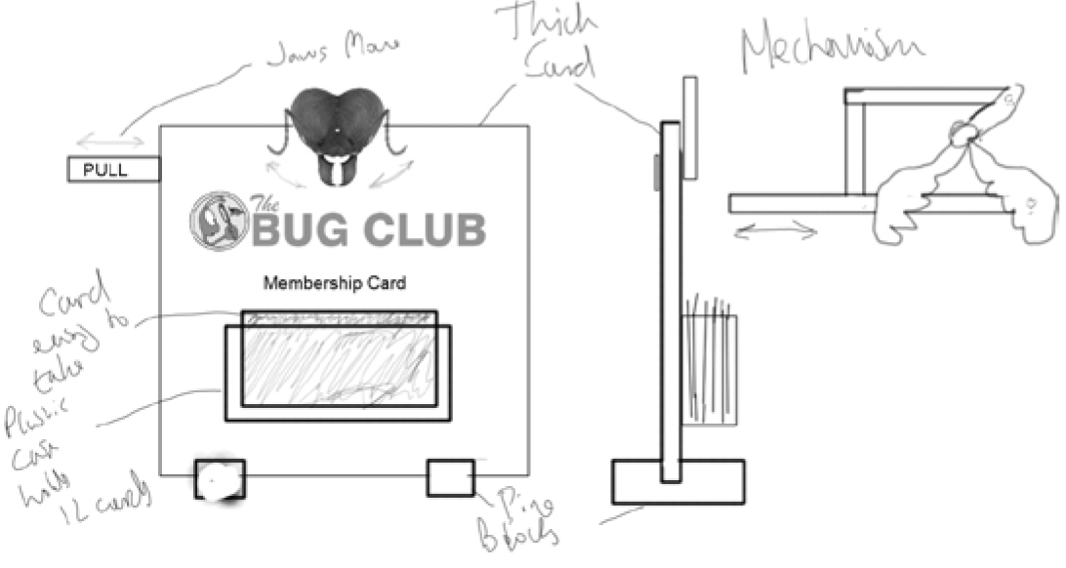

Design idea 2

Marks for design idea 2 can only be awarded where specification points are resolved differently than in design idea 1.

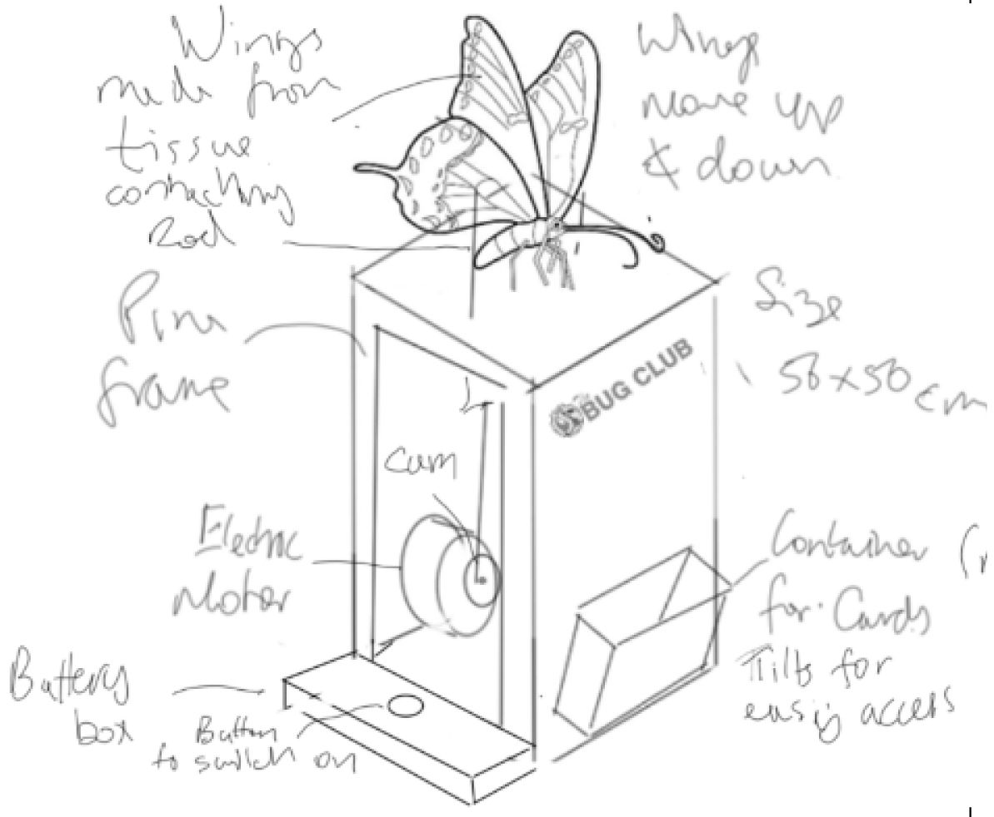

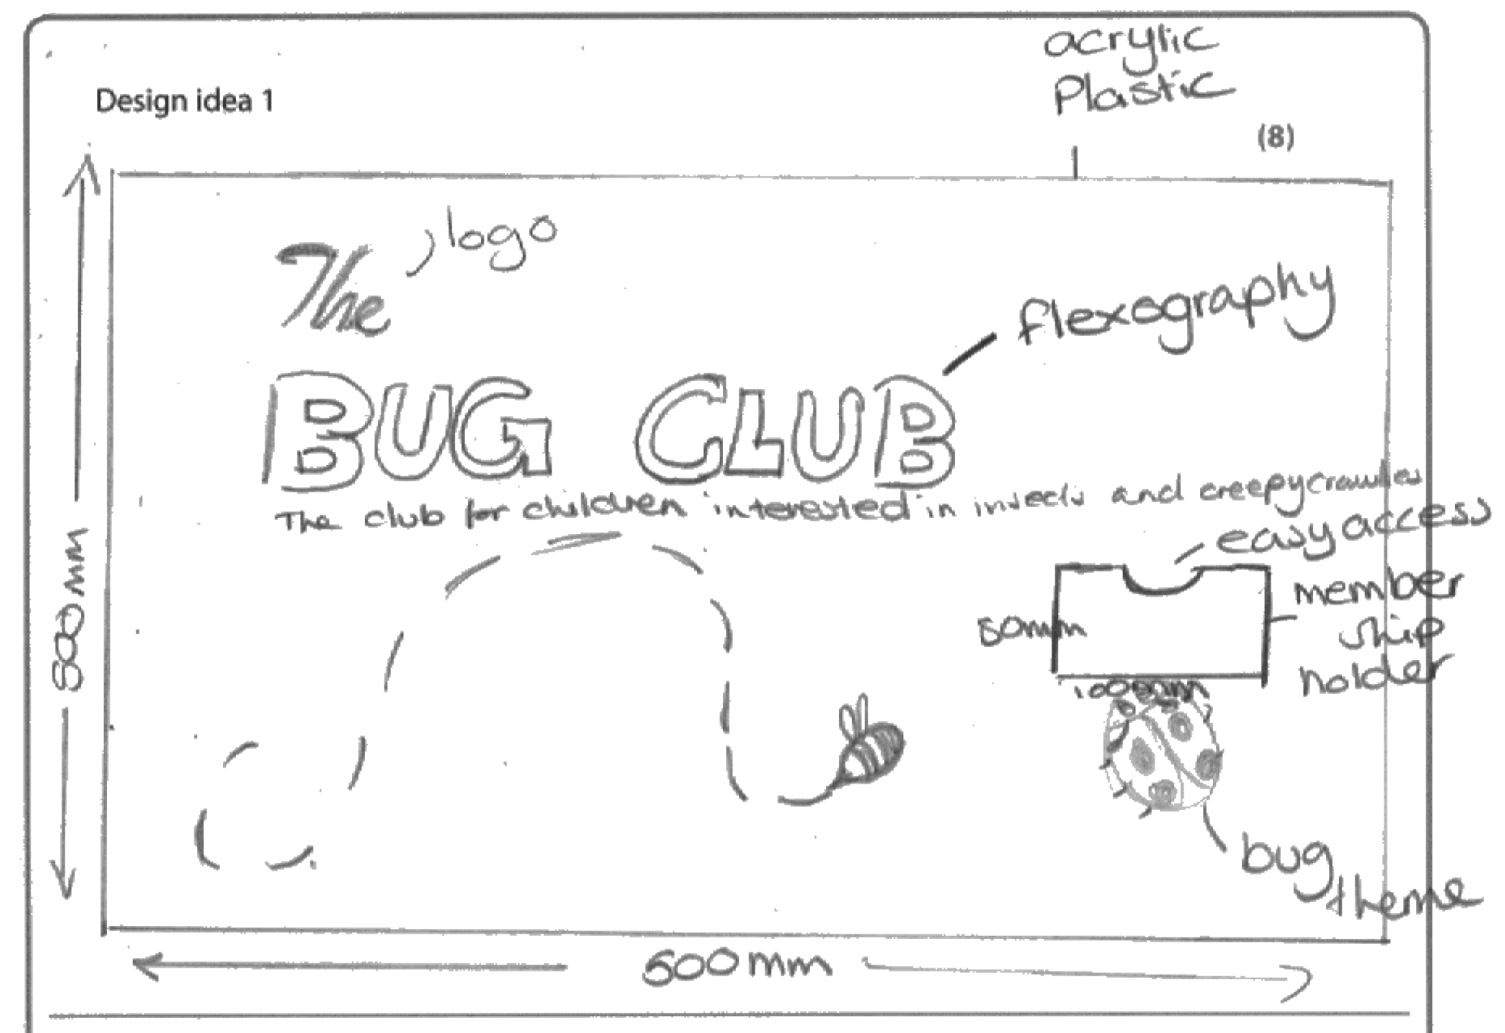

Examiners Comments
Two imaginative and well-drawn designs that has not addressed all the specification points and as a consequence only achieved half marks. The second design was mostly a repeat of the first design and only awarded 1 mark for "bug theme".
Tip: Ensure your two designs are completely different so the materials and method used to achieve each specification point in the 1st design is not used in the 2nd design.
