Answer Sheet – Design Question 4 (2013 Paper)
Pizza Box
Candidates may answer any specification point in either graphical form or by annotation. No marks are awarded for the quality of graphical communication.
- be capable of holding two pizza slices (1) e.g. side by side, rotated to tessellate, use of dimensions
- enclose the pizza slices (1) e.g. lid , box, tray
- keep the pizza slices warm (1) lid over box and insulation material e.g. polystyrene, corrugated card, foil backed
- be easy to carry (1) method specified e.g. handles, insulated bottom, case
- include a graphical image to reflect the theme of pizza (1) e.g. pizza shape image, wedges, toppings, vegetables, takeaway, Italian theme
- allow the packages to be stacked before they are used (1) e.g. flat surface, tapered sides
- be printed using commercial printing methods (1) e.g. specific named process such as digital, offset lithography, flexography, gravure, screen printing
- be made from a material that can be recycled (1) e.g. cardboard, polystyrene, aluminium foil
Examiners Report Comment on Question:
A good spread of marks indicated that this question was accessible to most candidates. It was a well-known product and a number approached the designs from using existing products. This did not preclude candidates from gaining marks. A number of candidates offered very similar designs and failed to gain the relevant marks on the second design. Graphic skills varied tremendously, there were no marks allocated to this, however, improving this skill will enable the candidates to communicate their ideas clearly. For each specification point:
- Most designs clearly showed and/or indicated how two slices of pizza were accommodated and all designs were of a “box” nature.
- Many did not clearly show how the lid was retained.
- Whilst a good number of candidates stated/sketched the insulating material others did not and only stated “keeps the pizza warm”.
- Handles/finger grips, hands were shown often in the first design but not the second for only 1 mark. A number of candidates made a basic statement “easy to carry” which did not gain any marks.
- Almost all candidates achieved the mark for the image on the first design, with the vast majority gaining it for a different image on the second design. Some candidates simply stated “graphic image here”.
- This was the most poorly answered part of the question. Only a small number of candidates sketched how the container would stack. The better candidates showed how more complex containers would tessellate.
- Print method was usually stated correctly. However, a number of candidates stated “printed by a commercial printing process”. Candidates often missed this mark in the second design because they repeated the process.
- The majority of candidates gained this mark although a number simply stated “recyclable” without any reference to the material. “Foil” was often quoted but no material description with it. Candidates often missed this mark in the second design because they repeated the process.

Question take from Pearson Edexcel GCSE In Design & Technology (5GR02) Paper 01 Unit 2: Knowledge and Understanding of Graphic Products – 2013
Example of candidate response:
Design idea 1
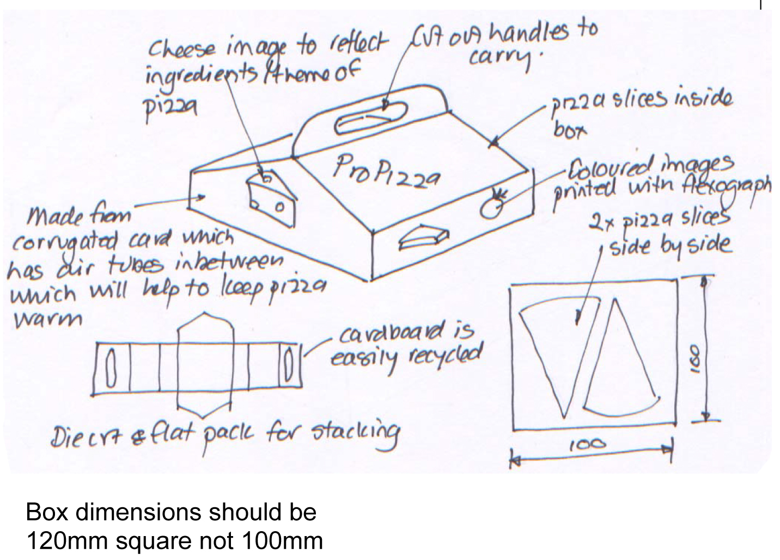

Marks for design idea 2 can only be awarded where specification points are resolved differently than in design idea 1.

Design idea 2
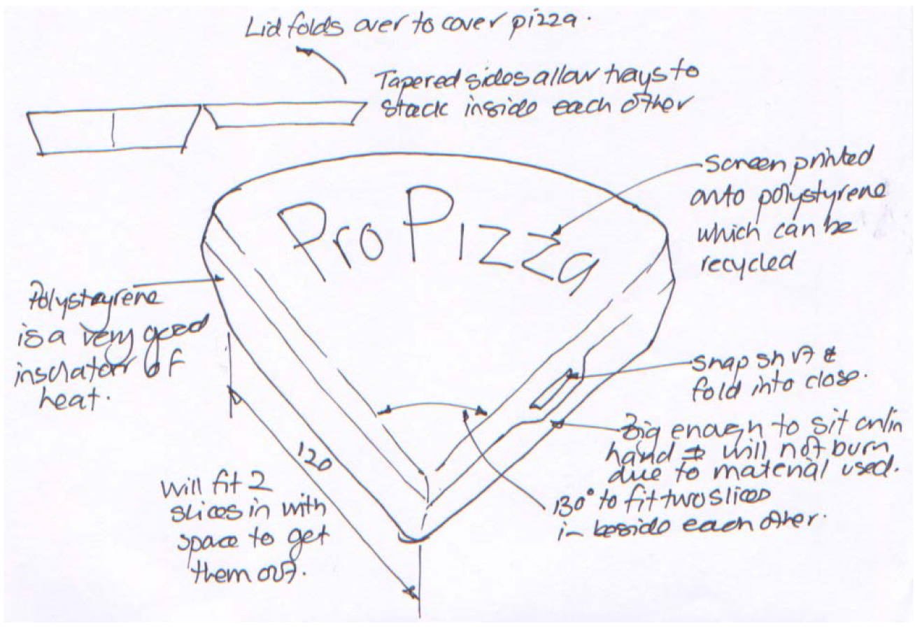

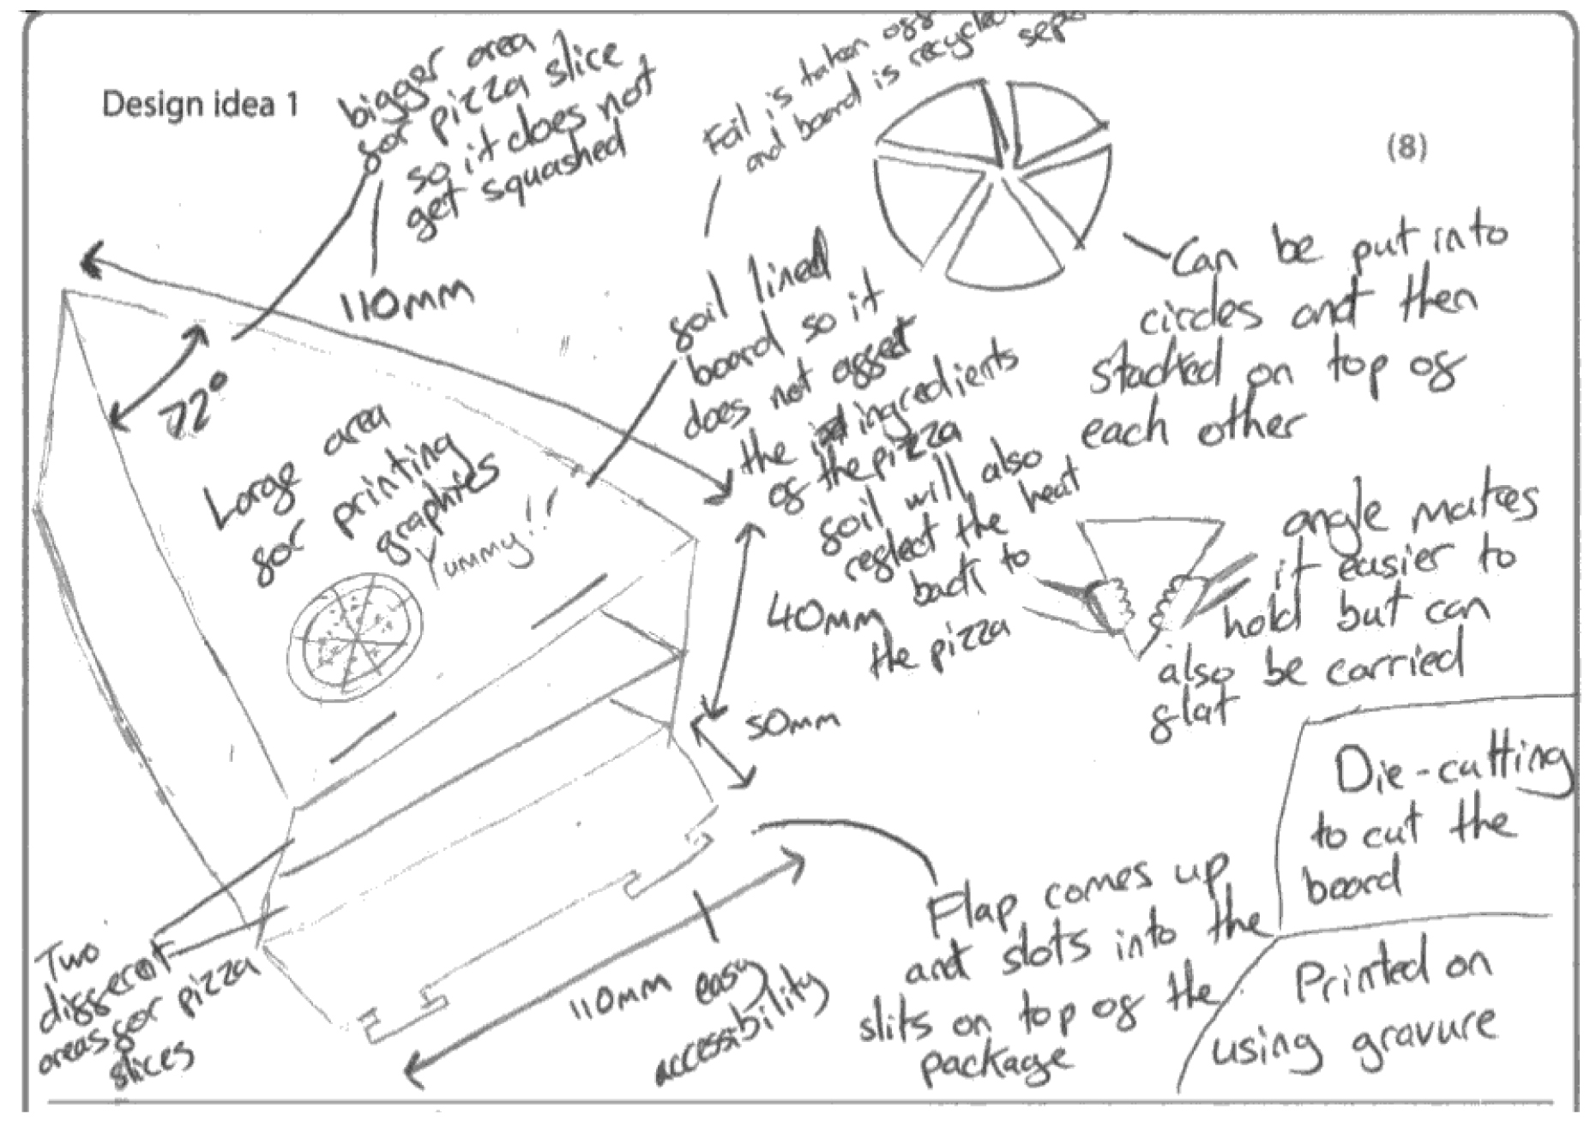

Examiners Comments
This candidate has presented two different ideas to a very good standard overall. The designs are easy to see and the short, brief notes help to convey information and detail such as materials and processes. 13 marks
Tip: Do not try to write too much, keep notes brief and to the point. It is good practice to include dimensions when drawing design ideas. Candidates should ensure that their second idea is different to the first one in that the design specification points are resolved in a different way to the way they have been solved for the design idea 1.
